**Assignment #3 RCC Spring 2019 CIS-72B CSS**

**CSS Box, Color, and Background Properties**   
**Due Friday May 24 at 11:59pm in Canvas**   
**150 Points**

Be aware that our textbook (like any book) does have a few errors. Fortunately, ours also has an "errata" page, where known errors are corrected and updated over time. For the most recent version, refer to this link to avoid problems in your work: [http://oreilly.com/catalog/errata.csp?isbn=9781491918050](http://www.oreilly.com/catalog/errata.csp?isbn=9781491918050)

**Part 0: Download & Extract the Canvas zip file**

The assignment parts for this assignment have more files than previous ones and so to keep everything together, you will download from the Canvas Assignment page, a starter "zip" file with subfolders containing the files needed for each part. As you work on each part, you will be modifying those starter files in those subfolders. When you are finished working on all of the parts of the assignment, you will zip up your solution folders and files, and submit your work by uploading the single zip file to Canvas. There will not be any screen shots, just do the work on the files. Make sure your name is on the main folder and zip file you submit.

**Part 1: Box Properties YouTube Video   
40 Points**

For this part of the assignment, you are asked to just watch the box properties video (YouTube). Box properties involve a group of CSS properties including "width", "height", "margin", "padding", "border", "float", and "clear". The link to this video appears below. After viewing this video, you are asked to answer some questions about it.

Link to the video: <https://www.youtube.com/watch?v=pzes0zq5VSw>

Warning: this video is long and is not new so you will see older editor and browser versions, but the CSS code / formatting is still relevant. Also, this is a little over an hour long, so feel free to advance it along a little here, a little there as needed.

The video shows you how to style a 2-column detail (Daily Spin) blog page, this time the 2 columns are created by using box properties instead of a table. The video makes heavy usage of the float, border, margin, padding, and width properties to achieve the desired results with this page.

To see and to answer the questions to get credit for this part, look in the A3P1 folder (part of the downloads for this assignment) and locate the file named "a3p1-questions-answers.html". (Leave the files in their given folders.) Open up the web page (with the questions and answers) in both an editor and in a browser. You can see the questions best in the browser but you have to answer them using an editor. To indicate your answer to a question, locate the paragraph (p) tag for that answer and change its given class from "answer" to "myanswer". That will trigger the formatting in the browser that will highlight that answer for grading purposes.

You will upload your work for this part (into Canvas) along with the rest of your work for this assignment when it is all complete.

**Part 2: Margins, Padding, & Borders (Chapter 7 Tutorial)   
40 Points**

For this part, you'll be asked to do various tasks related to the tutorial towards the end of chapter 7 of the textbook.

First, read through and familiarize yourself with all of the various properties associated with the "box model", covered in the first part of the chapter on pages 185-215.

When you are done reviewing the material indicated above, continue on to do the "Tutorial: Margins, Backgrounds, and Borders", on pages 216-227 (skip the section entitled "Going Further" at the bottom of page 227), using the given starter files.

When you complete the tutorial, and your page (in the browser) closely resembles that of figure 7-21 on page 227, then there are a few more changes you need to make to produce the final result. These additional changes are detailed below.

First let's identify ourselves in one of the page's existing headings. Locate the HTML for the "h2" heading that currently reads "Who Knew CSS Had Such Power?". Replace the word "CSS" with your own first and last name. For example, if your name was "Joe Student", the heading would then read "Who Knew Joe Student Had Such Power?". Save your HTML change and check your result in the browser to make sure it works as expected.

Next let's add a comment into our html code to identify ourselves and identify the beginning point for our CSS style additions. To do so, locate your page's "head" section. If a "style" section is not already there, then create opening and closing "style" tags just above the closing "head" tag.   
  
Next, just above that closing "style" tag (between the opening and closing "style" tags), create about 5 new empty lines by hitting "Enter". Then place the following comment line on about the 3rd (middle) of these empty lines -- you can just copy and paste the comment that you see below into your own page and then change the name from "Joe Student" to your own:   
  
/* A3P2 New Styles by Joe Student */   
  
Note that you should include the / and * as shown.   
  
Now the rest of our style work will be placed below this comment line but above the closing "</style>" tag.

Our first style change will be to widen the body and banner image from 760 pixels to 900 pixels. The original style rule set the body's "max-width" to 760, which would still override us if we tried to set the width to 900px, so we will override it by setting "max-width" to 900px. But rather than modifying the existing styles rules, we will just write new rules below our new "comment" to override them. That way we can see the original tutorial rules and the new ones we write here. So below the comment and above the </style> tag, write the following rules:   
  
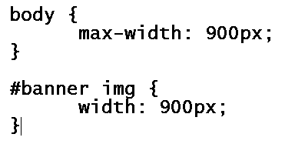  
  
The first rule widens the whole area for the page and the second one widens the banner image across the top of the page to match this new maximum width. If you then save and preview your modified page in the browser you can compare your result with the sample screen shot below -- the change you just made is represented by the red arrows at the left and right edges of the page toward the top indicating this wider result. Note that it is not always a good idea to change the size of an image using CSS because it can distort or pixelate the image but in this case it works well.

Next we will make the necessary changes to the "sidebar" note box so that its left border becomes more prominent and so that the paragraph text and green dotted heading borders do not come so close to the sidebar's left edge. To do so, we use a class-based selector as follows:   
  
  
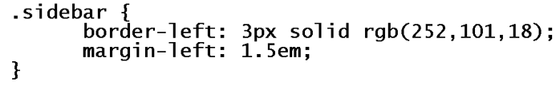  
  
Save and check your results in the browser to confirm the more emphasized solid 3 pixel left border appears on the sidebar and that there is now increased space to the sidebar's left. Compare your results to the sample screen shot below, which contains two red arrows along the left side of the sidebar to indicate the desired changes.

Next we will set off the page's paragraphs from the headings by giving them a bigger left margin. However, we do not want the paragraph inside the sidebar to be affected, so we will first set the margin for all paragraphs with our first rule and then turn it off for just the paragraph inside the sidebar with the second rule:   
  
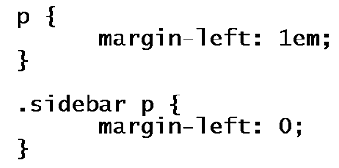  
  
Save and check your results in the browser to confirm the new left margins for paragraphs affected all paragraphs except the one inside the sidebar. Compare your results to the sample screen shot below, which contains a red arrow down the first paragraph's new margin to indicate the change.

The next changes we make will be to the copyright area at the bottom of the page. In an effort to de-emphasize this text area, we are going to separate the copyright area from the rest of the page with a top margin, we will center the text, and we will reduce its font size. But before we can write that rule, we have to figure out what selector will work to target that text. Locate the copyright area toward the bottom of the HTML file. Notice it is a paragraph just like any other. So to target that special copyright text, we will have to either insert a new "class" or an "id", or we can use the newer HTML 5 "footer" tag. The footer tag seems like the best choice, so replace the copyright text's opening and closing "p" tags with opening and closing "footer" tags instead. Then return to the bottom of the page's style area to add this new rule to format our copyright text as desired:   
  
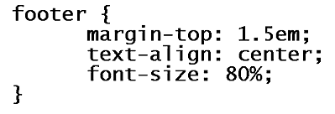  
  
Save and check your results in the browser to confirm these changes to your copyright area. Note that if you compare your results to the sample screen shot below (see the bottom red arrow), you still will not have the copyright area down so close to the bottom of the page body. You also may have a longer page than that shown in the screen shot. We will address both of these issues in our last steps below.

To shorten up our page and bring the copyright area closer to the bottom of the page body, we must first locate our "body" tag rule (the first one below our "comment"), and add these 2 new declarations to it:   
  
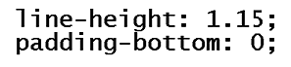  
  
The first declaration reduces the vertical space that each line takes up (reduces line spacing) and the second one eliminates the blank spacing at the bottom of the page body -- thus allowing our copyright text to sit closer to the bottom border of the main page area.   
  
If you then save and preview your modified page in the browser you can compare your result with the sample screen shot below. Your results should now look very close to this screen shot.

Note that before you are done with this work, you should copy/paste your style rules (everything inside the "style" tags) into the [W3C CSS validator](http://jigsaw.w3.org/css-validator/validator-text.html) to ensure that all of your code is valid.

When you have completed all of the above steps, your page should closely resemble the sample screen shot shown below. The red arrows are there to indicate the changes that were made after the tutorial was completed.

You will upload your work for this part (into Canvas) along with the rest of your work for this assignment when it is all complete.   
  
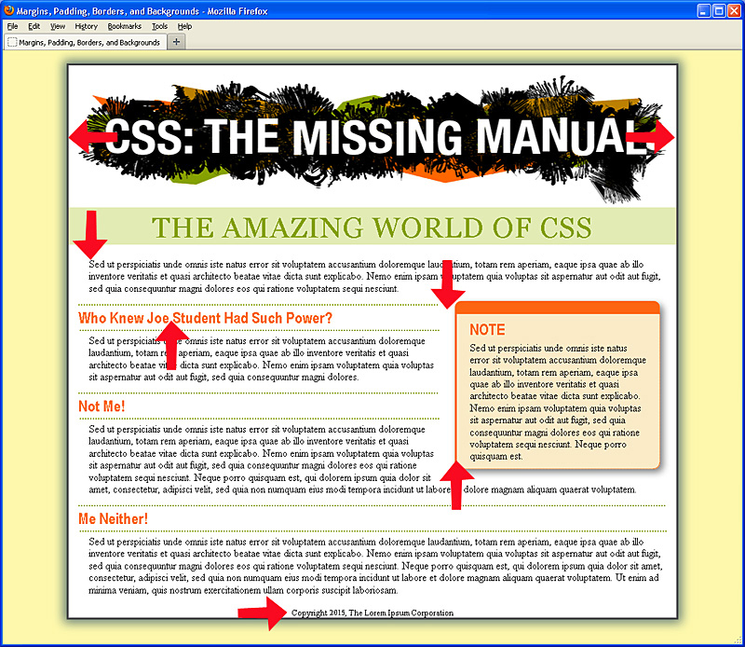

**Part 3: Adding Graphics To Web Pages (Chapter 8 Tutorial)   
30 Points**

For this part, you'll be asked to do various tasks related to the three tutorials towards the end of chapter 8 of the textbook.

First, read through and familiarize yourself with all of the various background properties covered in the first part of the chapter on pages 229-261. When you are done reviewing the material indicated above and understand how to use the various background properties discussed therein, continue on to the next step below, having to do with this chapters tutorials.

Next, review the chapter's first tutorial, entitled "Tutorial: Enhancing Images", on pages 261-266. Although there is nothing to turn in for this particular tutorial, later you will be asked to use the techniques demonstrated within this tutorial, so be sure to carefully study the examples shown.   
  
When you feel you understand the methods described for enhancing an image by using float, width, margin, padding, border, and using figcaptions to include descriptive text, then you are ready to move on to the next step.

Next, you are ready to review the chapter's second tutorial, entitled "Tutorial: Creating a Photo Gallery", on pages 266-270. Although there is nothing to turn in for this particular tutorial either, some of the techniques demonstrated within this tutorial will be helpful, so be sure to study the examples shown. When you feel you understand the methods described for using float, figcaption, display, and box-shadow, then you are ready to move on to the next step.

Finally, you are ready to follow the instructions to do each step of this chapter's third tutorial, entitled "Tutorial: Using Background Images", on pages 270-278.

After completing this 3rd tutorial, follow the instructions below to make some final changes.

First, locate the copyright paragraph and replace the words "Lorem Ipsum" with your own first and last name. For example, if your name is "Joe Student", that copyright line would read "Copyright 2015, Joe Student Corporation". (You may update the year to the current year if you like.)

Next, you should already have a textbook.png image within your given "images" folder for this assignment part. Confirm it is there. It is an image of our class textbook as shown below.   
  
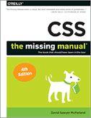[textbook.png](http://www.faculty.rcc.edu/mcleod/css/handouts/textbook.png)

Once you have the image of our textbook in your "images" folder (along with the other tutorial 3 images), you are ready to modify the HTML of your page to display this image. Locate the part of your HTML that matches the code shown and then type in the HTML shown in the "red box" between the two existing paragraphs.   
  
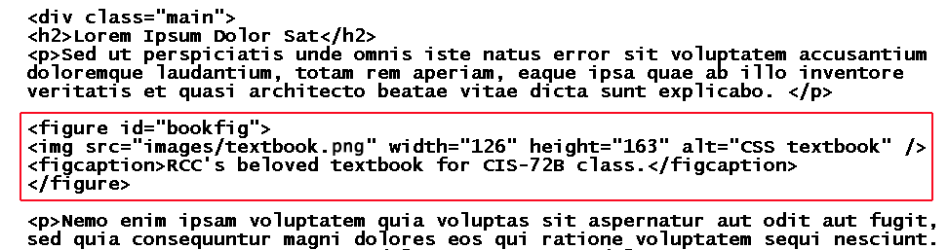  
  
Once you have typed in the HTML code in the red box into its proper location, save and preview the result in the browser. If it was typed correctly, you should see an image of the textbook, as shown above, in the middle of the text of your page. If not, double check your HTML code as well as double check the location of the image file itself. If so, you are ready to move on to the next step so that we can begin to style this figure and its caption.

The first step in styling this figure and its caption is to float it to the right hand side of the page and allow the rest of the text to wrap around it nicely. Note that since this figure is the only one of its kind requiring such formatting, we used an "id" in the HTML, using the name "bookfig". As such, our corresponding selector will be #bookfig. Here is the rule below that you should insert into the bottom part of your "styles.css" file:   
  
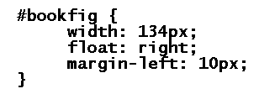  
  
Save and check your results in the browser to confirm that the figure and its caption do get moved to the right-hand side of the page and that the paragraph text is wrapping nicely to the figure's left. You can begin to compare your results to the sample screen shot below, although we still have more formatting work to do on the image border and the caption text before we are done.

The next step is to "frame" the image nicely and add a box shadow effect. (Note that these effects are very similar to the image effects shown in the previous 2 tutorials of this chapter.) Since the "img" tag is inside the "figure" tag with the "bookfig" id, the selector to use is "#bookfig img". So, at the bottom of your "styles.css" file, insert the CSS rule shown below:   
  
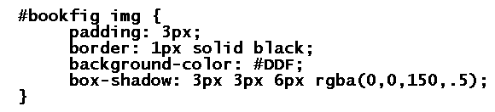  
  
Save your CSS changes and preview your page in the browser. Compare it to the sample screen shot below to confirm that the image treatment was applied as expected. Remember that the shadow effect may not work in older browsers, so try it in only the most recent standards-based browsers. (If your results are not what you were hoping for, carefully compare your own code to the code listed above, try validating your code, and/or update your browser as needed.) Once your page is looking good, it is time to move on to the last piece of CSS, which will affect the figure's caption.

Lastly, we would like to format the text that makes up the figure's caption. Since in the HTML, it is the "figcaption" tag that is nested inside a "figure" tag with an id of "bookfig", we will use the selector "#bookfig figcaption". We will center the text, decrease its font size (to 75%), and assign a sans-serif font. That CSS formatting code is shown below. Insert it below all the other rules so that it ends up being the last rule in your "styles.css" file:   
  
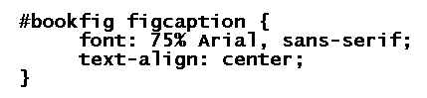  
  
Save your changes and preview your page in the browser. Compare it to the sample screen shot below to confirm that the caption text treatment was applied as expected. Your results should very closely resemble this sample screen shot now.

Before finishing this part of the assignment, you should validate your CSS within "styles.css" using the [W3C CSS validator](http://jigsaw.w3.org/css-validator/validator-text.html) to ensure that all of your code is as good as can be.

When you have completed all of the above steps, your page should closely resemble the sample screen shot shown below. The red arrows are there to indicate the changes that were made after the tutorial was completed. You will upload your work for this part (into Canvas) along with the rest of your work for this assignment when it is all complete.   
  
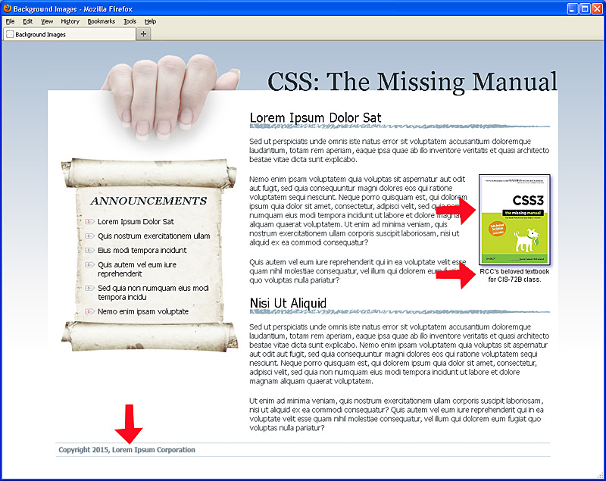

**Part 4: Show What You Know: Hotel Page With Margins, Borders, Padding, and Backgrounds   
40 Points**

Using your chosen hotel theme from assignment 2, you are asked to make some appropriate formatting changes to a given generic hotel home page. You are asked to incorporate all of the features presented in this assignment -- margins, borders, padding, and backgrounds in order to transform the plain starter page into a themed hotel page. You are also asked to try out a few other CSS features not presented in this assignment.

For this work, you are given a starter web page and style sheet in the downloaded "a3p4" folder that you downloaded from Canvas.

Note that the effort and CSS work you do on this page will be directly helpful to you in your final project. The given HTML of this hotel page will be very similar to the HTML given to you for the hotel pages of your final project. As a result, some of the CSS formatting rules and/or declarations you create here should be able to be copied/pasted into parts of your final project. So try to do a good job with this part and choose your formatting so that it fits well with your chosen theme and then you will be well on your way to having a successful final project.

Note that any images used in this assignment part can be obtained or created by any means necessary (within reason) except that they cannot be images that have been already used for earlier assignments or demos in this class in any way. Place all images in the same a3p4 folder as the html page and css style sheet file. Make a note about where you found each image so you can indicate it on the page when asked to do so in a step below.

Note that if you have not already done so from assignment 2, you should get your proposed hotel theme approved by your instructor via email before attempting this work or there will be a 5 point deduction.

Look over the code of each of the given starter files (both HTML and CSS) and make sure you understand what each line of code is doing -- especially the ones that you will be working directly with. Below is a screen shot of what your generic hotel page starts off looking like -- note that all of the existing formatting is coming from the given style sheet file:

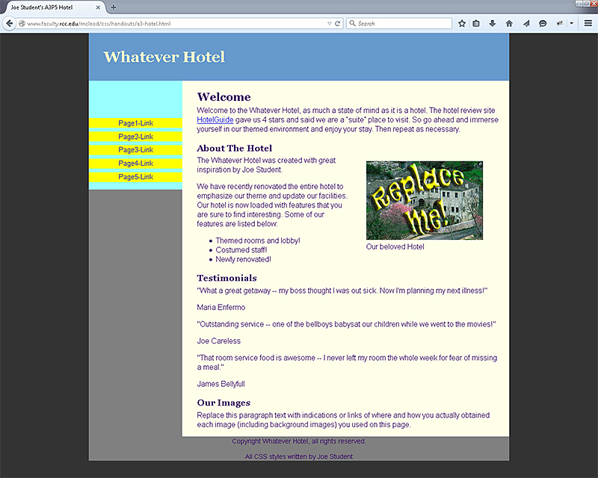  
  
Your work should include making the following adjustments to the page. Do not make any other adjustments to the text other than what is asked for below. When testing your changes, use the Firefox or Chrome browsers if possible. The points given to each of these changes are given in brackets at the end.

Replace the "Whatever Hotel" name with the name of your own chosen hotel wherever it occurs in the html (4 times). [1 point]

Replace "Joe Student" with your own name wherever it occurs on the html (3 times). [1 point]

Replace the given generic hotel image ("replace me") on this page with another one that better matches your chosen theme (just place that image in the same folder as the html file and change the image tag's "src" attribute to the file's name.) This new image should not end up being significantly bigger or smaller than the original one shown here. So if this new image's size is too big or too small, then you can use the image tag's "width" and "height" attributes to adjust the size or you can do so with a graphics program. [5 points]

To this new hotel image, apply a non-solid border of your choice (such as ridge, inset, outset, double, dashed, or dotted) using at least 3 pixels width and an appropriate border color. Also, apply good sized left margin to this floated hotel image to be sure that the text to its left never gets close to the image. Also apply some shadowing to the image (similar to but not exactly like what was done to the CSS Missing Manual textbook in part 3). [6 points]

Write a new style rule to format the image's caption (see the "figcaption" tag) so that this text below the image ("Our beloved Hotel") is centered, bold, and 85% of the font size it currently is. [6 points]

Change all of the backgrounds in the style sheet to colors and/or background images that better fit your chosen theme. Adjust foreground (text) color settings too as needed so that the text is easily readable (maintain a high degree of contrast between text and background). You can also use the "opacity" property to help you maintain proper contrast as needed. You must use at least 2 background images for this purpose somewhere on the page. [6 points]

Adjust the page's given fonts to something more appropriate to your own theme. Use at least one "Web font" that matches your theme for this purpose. As a guide to using your own web fonts, see this class handout: " [Embedding Fonts Using CSS3's @Fontface](http://www.faculty.rcc.edu/mcleod/css/handouts/about_embedding_fonts.html) ". Note that although this handout talks about using two Web fonts, you are only required to use one for this assignment. [6 points]

Using a selector of "#main ul li", and the "list-style-image" property (or the background-image property), assign a graphical image to replace the standard bullet for the existing list in the main portion of the page (above the testimonials section.) This graphical bullet image must match your hotel theme in shape and/or in color. The image should be very small -- it should not be taller than a line of text is, so no more than about 10-15 pixels in height. [6 points]   
  
Note that we are trying to affect the "ul" in the "main" area without affecting the "ul" in the "nav" area (the links in the nav bar area are part of an unordered list too.) Since each "ul" needs different formatting, we are using "#main" and "#nav" in front of those descendant selectors to target just the list we want to be affected.

Under the "Our Images" heading (just above the footer), replace the existing text with a brief note about each image you used on this page. Indicate where and how you got it or created or modified it. For example "Hotel image obtained from www.motel6.com then modified in Photoshop" or "Clown background image obtained from www.clownsrus.com using Google image search on 'clown riding Hot Wheels car'!" or "Spiderman bullet image obtained within Word using clip-art search on 'spider web' then resized in Word". [3 points]

Make any other changes you like within the CSS style sheet as suggested by some of the existing comments within the style sheet.

After making the above list of modifications and then validating both your HTML and your CSS, you are ready to submit your work.

**Lastly: submit your work into Canvas**

Double check that your set of files and folders are all working correctly. To do so, you should locate the assignment main folder's "**index.html**" page (inside the outer "YourName-css-a3" folder) and open this page in the browser. Then click on the links to each assignment part to display your assignment work. Your completed assignment pages should display for all 4 parts. If that doesn't work, you may have files that are not named correctly or not located within the correct folders. Double check the filenames against the instructions above for whatever part isn't working.

Modify that outer "index.html" page's code to replace "Your name" with your own actual name in the "title" and "h1" heading. Rename the "YourName-css-a3" folder name by replacing "YourName" with your own name (no spaces in the folder name). The result should be a folder named "JoeStudent-css-a3" where your own name is in place of Joe Student.

Once all of the your files and folders are working correctly, take the outer "YourName-css-a3" folder and create a zipped archive of it -- from within Windows Explorer, right click that folder and choose "send to compressed (zipped) folder". Change that zip file's name to include your own last name (as needed). Then log in to Canvas, go to the Assignment 3 page, and attach this zip file and submit it as your assignment. I will be unzipping it and working with those files and folders when grading it. (So you don’t need to do any screen shots or code pastings because the grading will involve your actual files.)