**X00141369 Sebastian Ichim**

**X00133683 Andrei Iancu**

**X00138499 Jack Gibson**

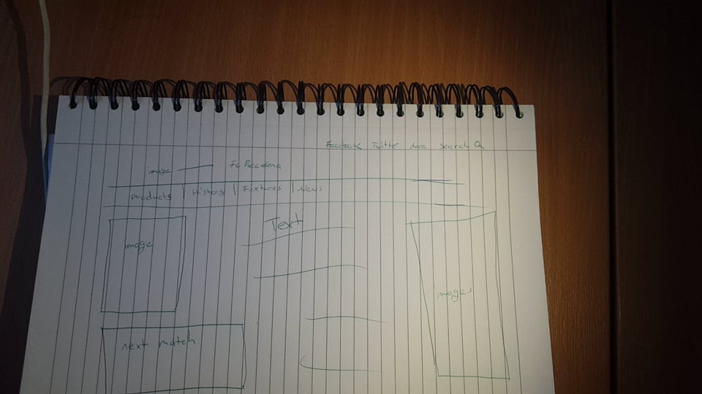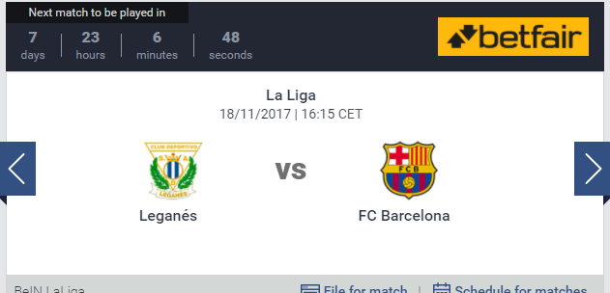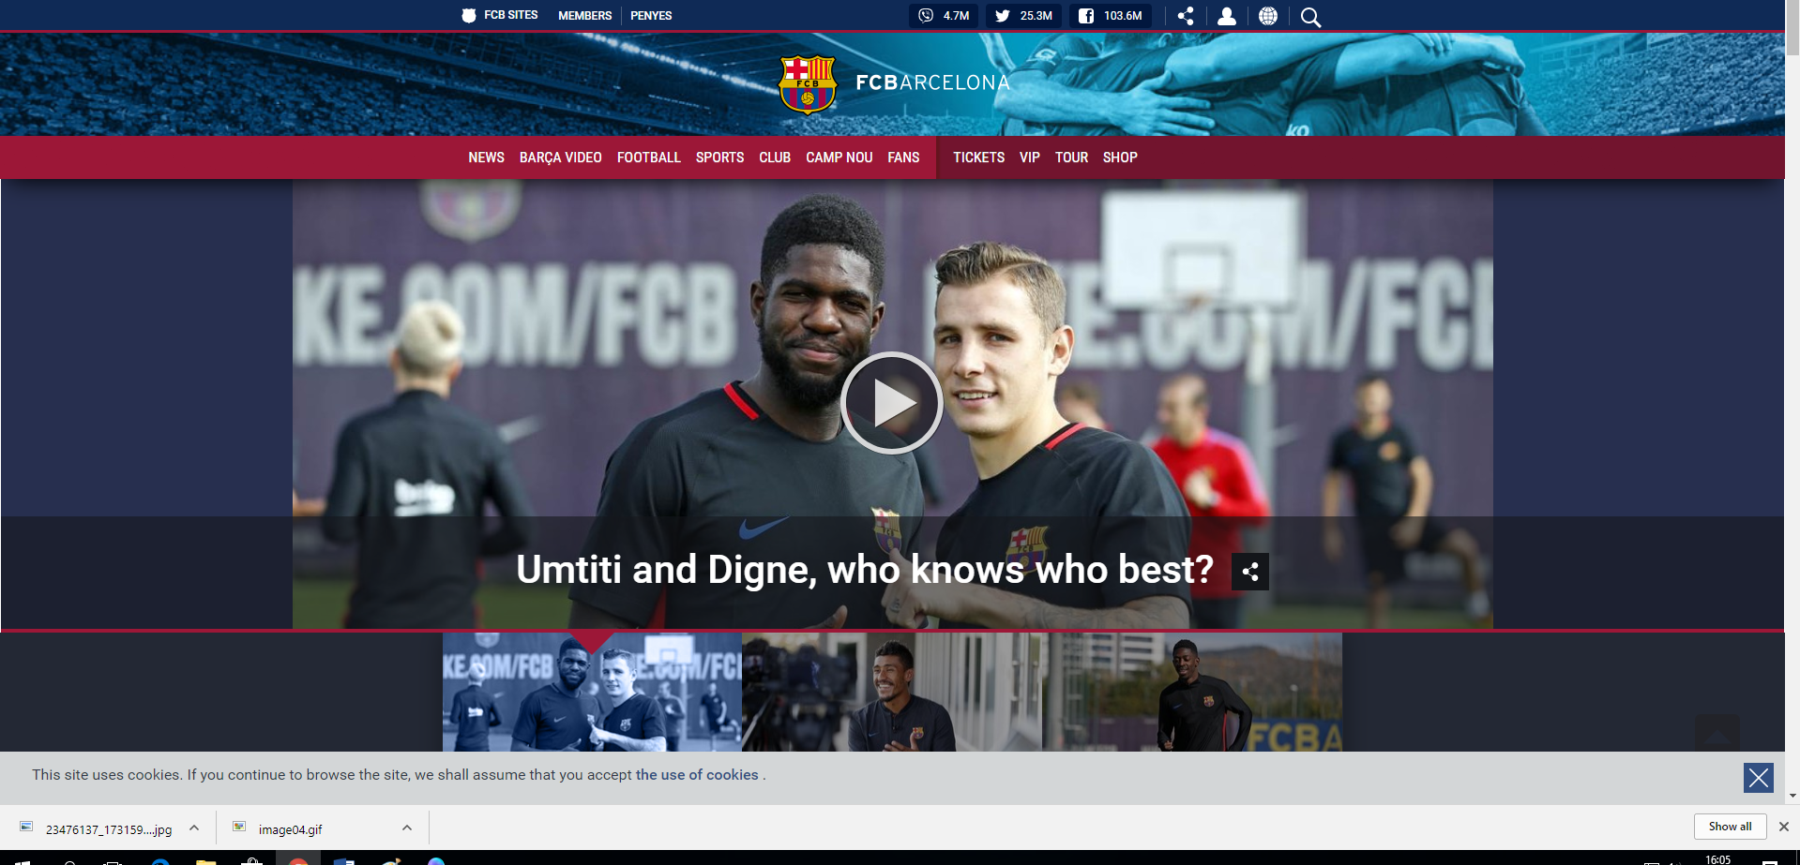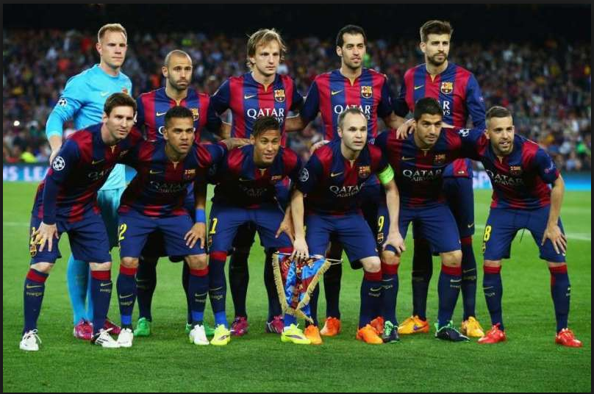

Contributions=

As a group , we will divide the different pages evenly between:

Sebastian will design the Home, Products and Shoes pages.

Jack will design the fixture , news and history pages.

Andrei will design the clothing, lifestyle and gifts pages.