**DVT Level shifter discrete HT**

**Design based NMOS8001 device from CISSOID**

|  |  |  |
| --- | --- | --- |
| **Version** | **Date** | **Created**  **by / at** |
| **1.00** | **2016-09-14** | **S.Kulik**  **2016-09-14** |

# CISSOID NMOS8001

Main features

* Temperature range: -55°C to 225°C (and still on-going)
* Drain voltage up to 80V
* Max Drain current @ 225°C: 1A DC, 3A pulsed
* Ron: o.76 @ 25°C, 1.56 @ 225°C
* Vgs= -5V to +5V, compatible with 0/+5V contro

**DESCRIPTION**

The CHT-NMOS8001 is a Medium Power 80V/1A N-channel power MOSFET’s designed to achieve high performance in an extremely wide temperature range: typical operation temperature goes from -55°C to 225°C. The CHT-NMOS8001 is available in a tiny TDFP16 hermetically-sealed Ceramic SMD package.

NMOS8001 diagram

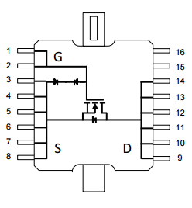

Schematics

Configuration A

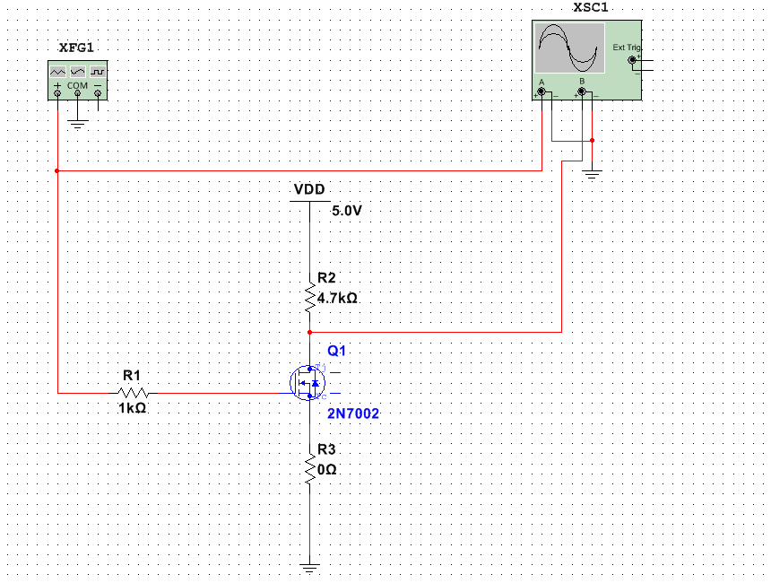

Configuration B

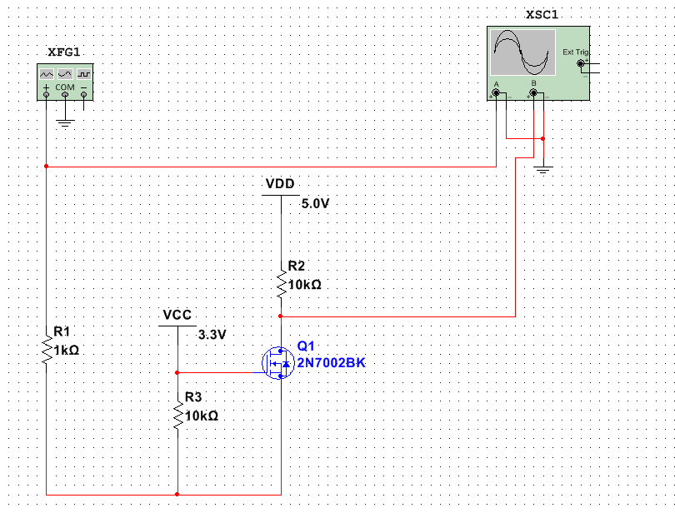

PCB Schematic

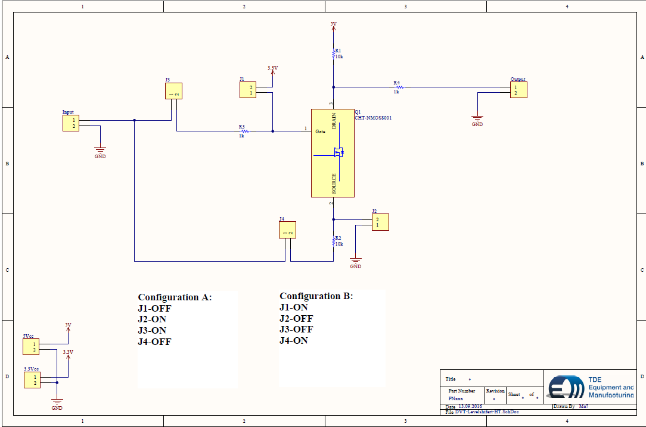

PCB

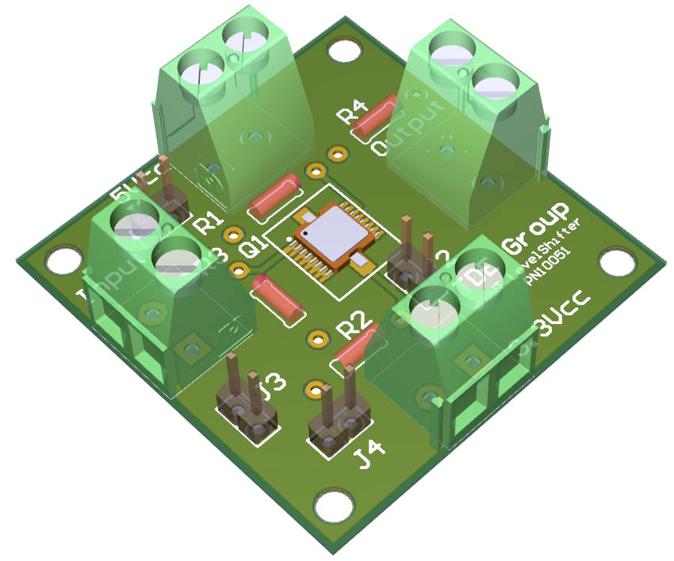

Configuration A simulation:

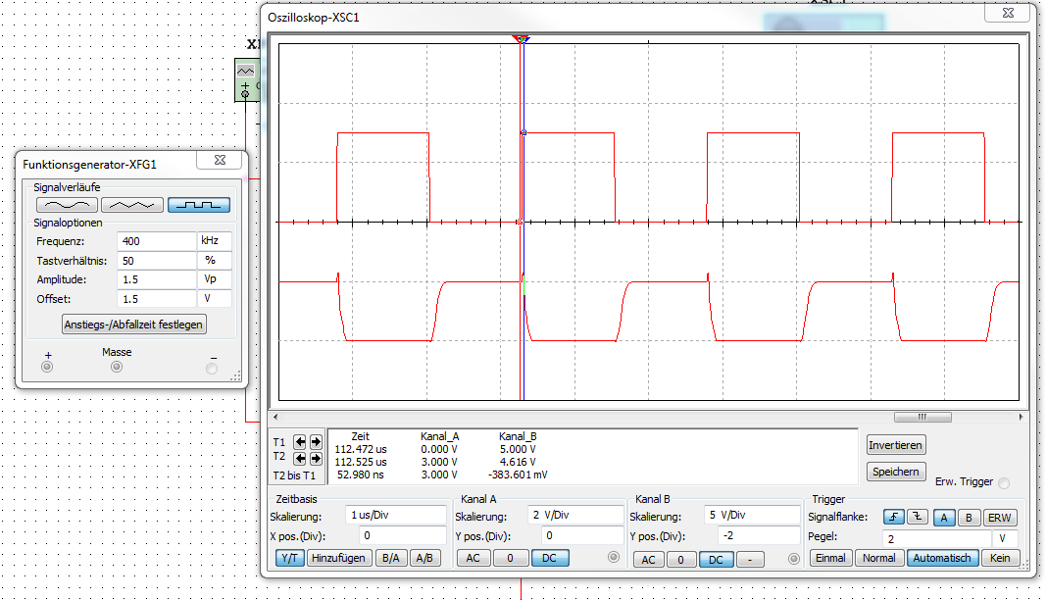

Configuration B simulation:

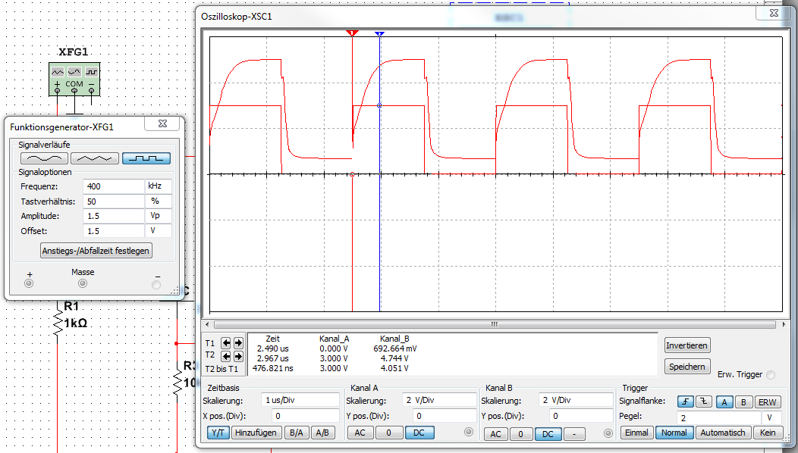

**Summary**

Simulations shown the performance from different configurations. PCB is designed to test configuration A and B as well.

As shown configuration A invert the signal, configuration B less the signal phase untouched.

Configuration B can become a problem with following Schmitt-trigger built in in Atlas device, but this version deliver the best performance in focus to frequency bandwidth and phase.

Every configuration needs to be accurate tested with NMOS8001 device in real cinditions.