**DVT comparator HT**

**Design based Volga device from CISSOID**

|  |  |  |
| --- | --- | --- |
| **Version** | **Date** | **Created**  **by / at** |
| **1.00** | **2016-08-24** | **S.Kulik**  **2016-08-24** |

# CISSOID Volga

Main features

* Temperature range: -55°C to 225°C (and still on-going)
* Validated at 225°C for 1000 hours
* Rail to Rail I/O
* Internal hysteresis: 6mV
* Push-Pull CMOS output stage +/- 16mA max
* Maximum operating frequency: 25MHz
* Supply rating: 4.5-5.5Vcc

**DESCRIPTION**

The CHT-VOLGA is a single high-speed comparator with a normal operating tem-perature range -55°C to +225°C.

The device operates from a single +5V±10% power supply, with rail-to-rail in-put / output. CHT-VOLGA features a shut-down mode, controllable through an Enable digital input pin that places the device in a low power consumption mode when the comparator function is not needed. The comparator features an internal hysteresis (6mV Typ.) for improved noise immunity.

The output stage implements a push-pull CMOS stage, that can sink /or source up to 16mA.

The CHT-VOLGA is available in a tiny TDFP16 surface mount package. The TDFP package is an SMD solution with leads, available by default in 16-pin.

Functional diagram

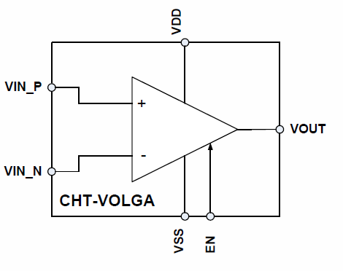

Schematic

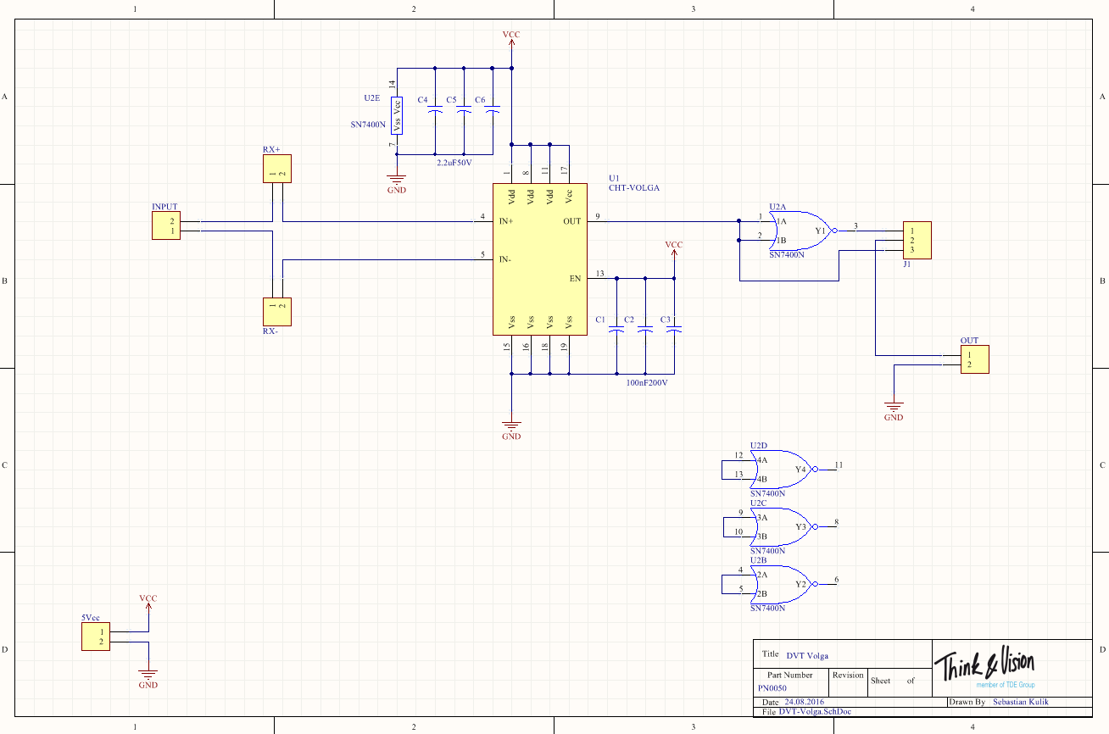

PCBs

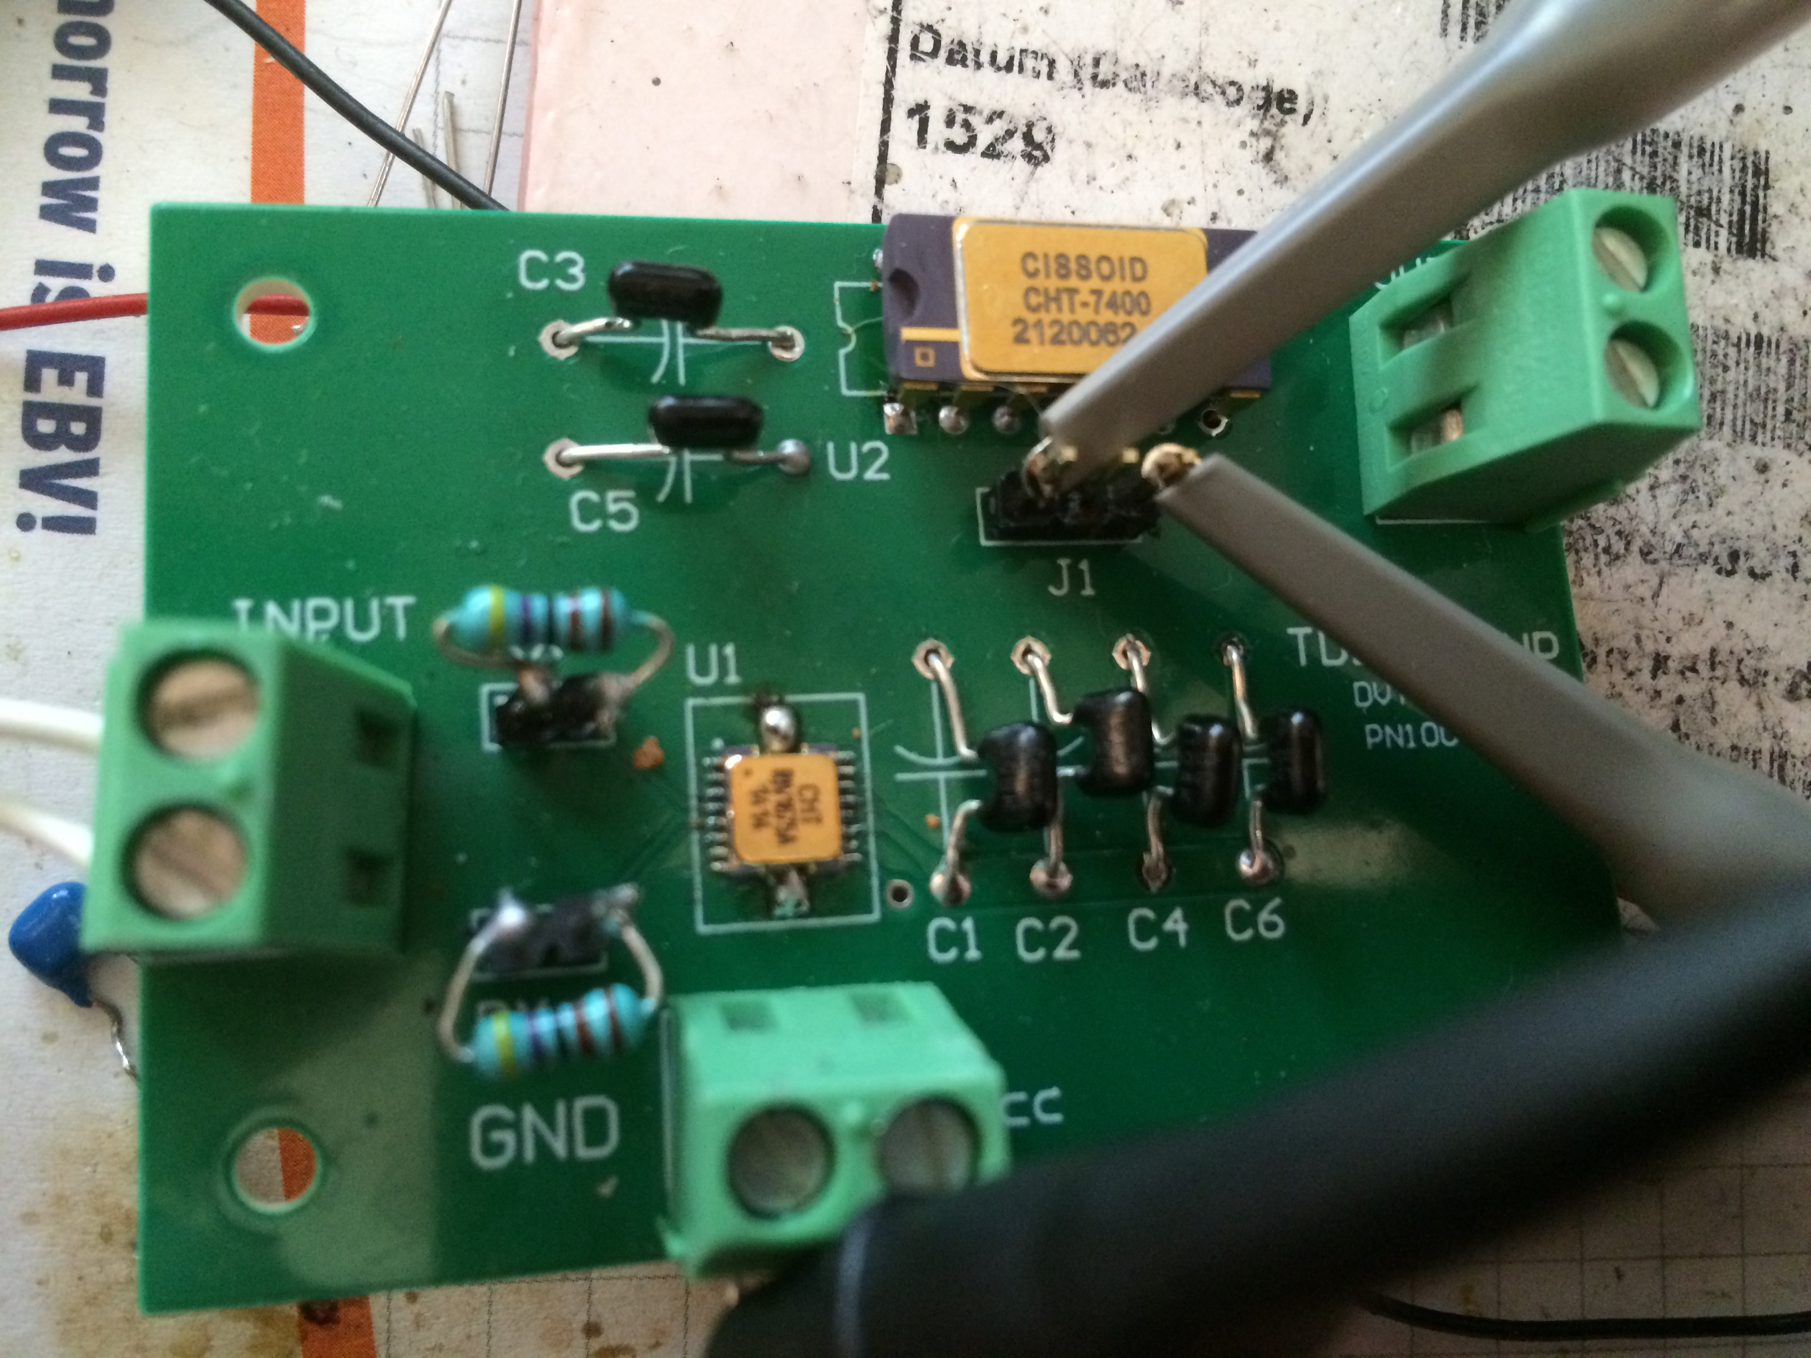

CHT-7400 inverted Schmitt-Trigger device connected on output from comparator can be used to better signal form condition.

On workbench all 5 Volga devices tested with 5 and 3.3 Volt supply and have same performance up to 3.5MHz frequency.

Color legend:

Yellow (1): direct comparator output

Cyan (2): CHT-7400 buffered output

200kHz @ 5V

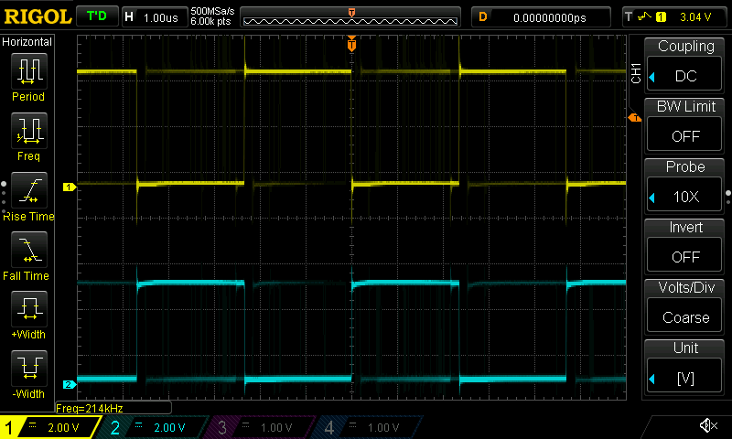

200kHz @ 3.3V

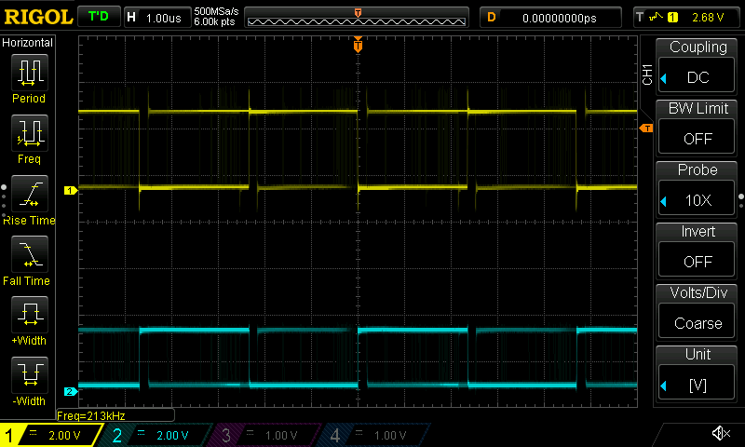

400kHz @ 5V

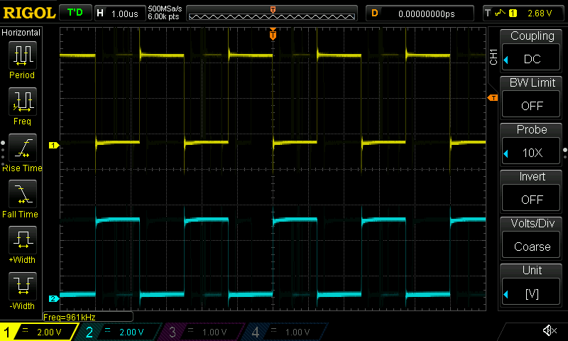

400kHz @ 3.3V

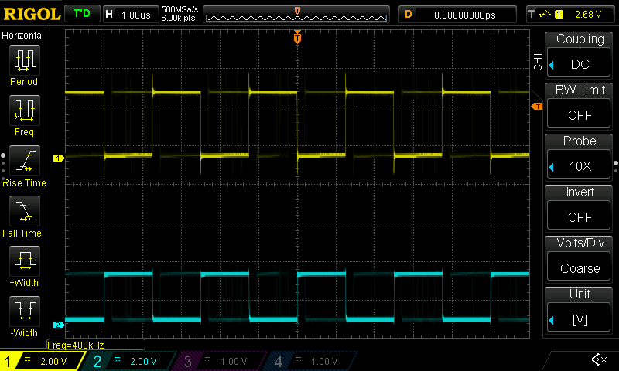

600kHz @ 5V

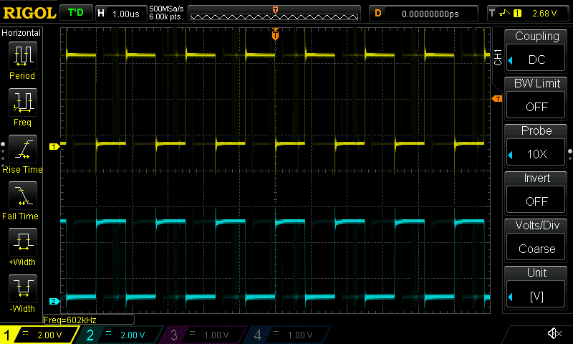

600kHz @ 3.3V

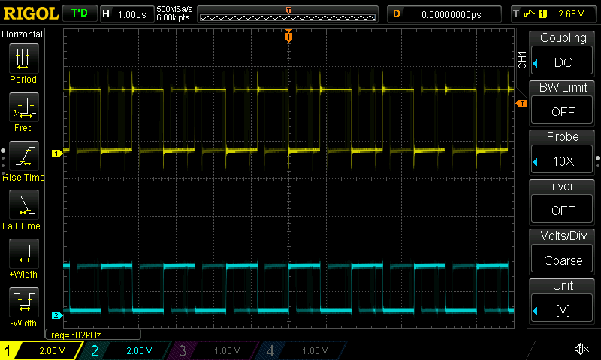

800kHz @ 5V

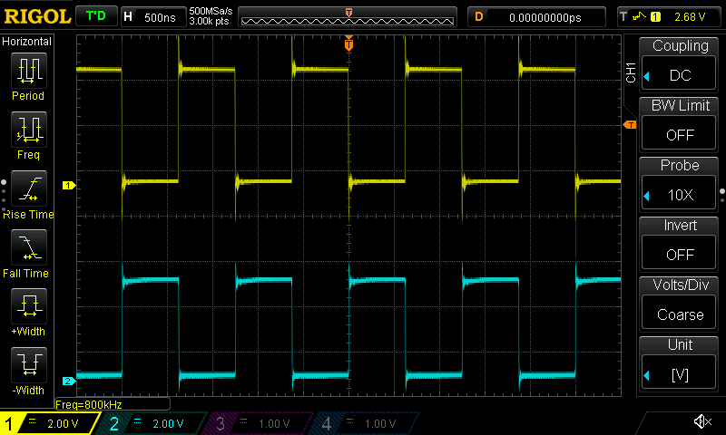

800kHz @ 3.3V

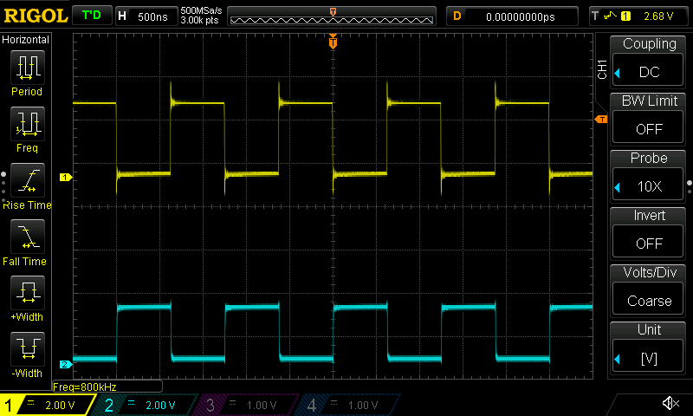

1MHz @ 5V

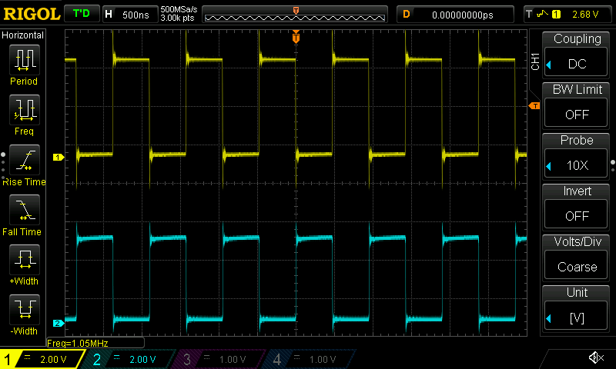

1MHz @ 3.3V

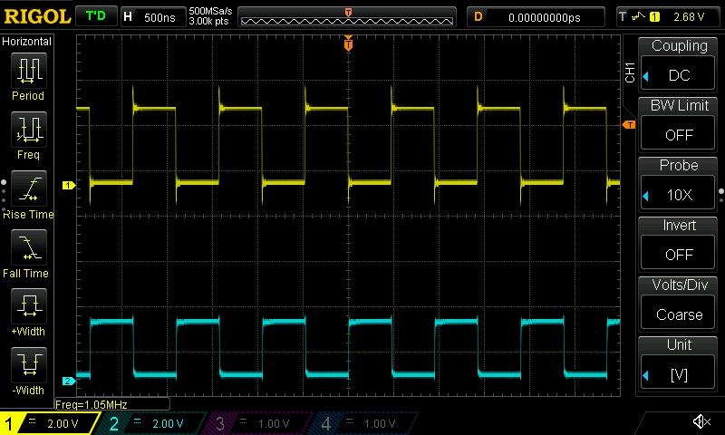

1.5MHz @ 5V

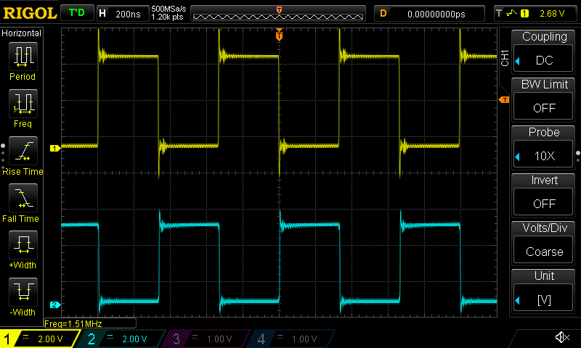

1.5MHz @ 3.3V

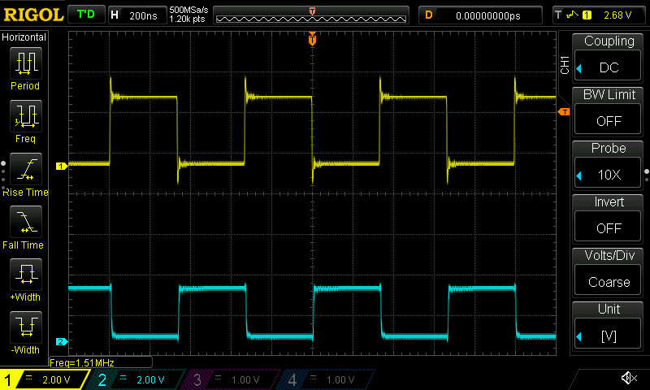

2MHz @ 5V

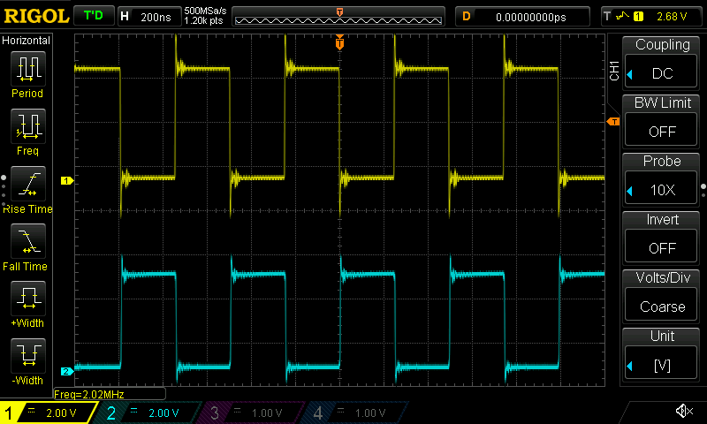

2MHz @ 3.3V

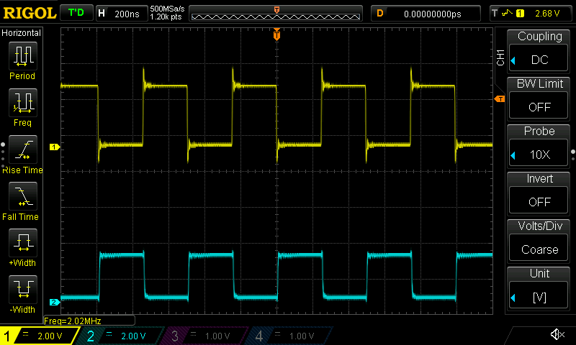

2.5MHz @ 5V

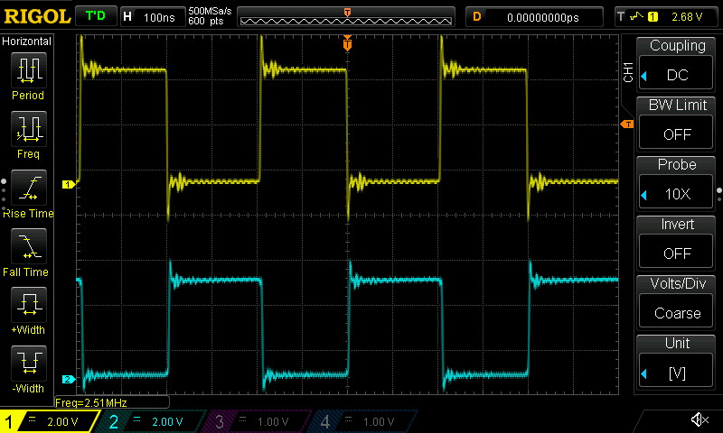

2.5MHz @ 3.3V

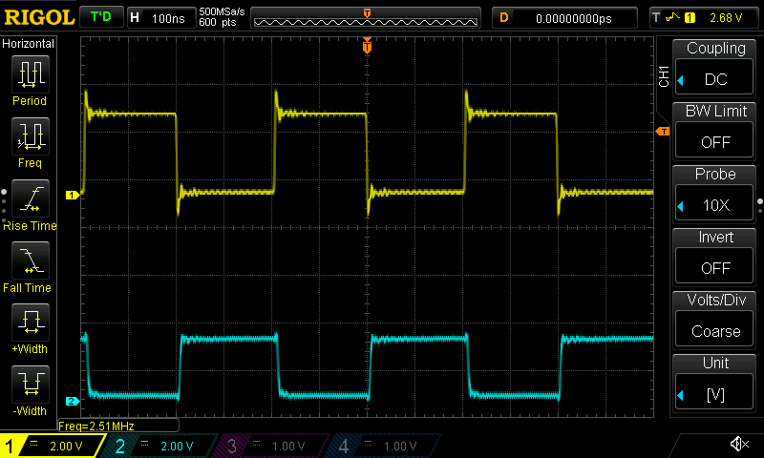

3MHz @ 5V

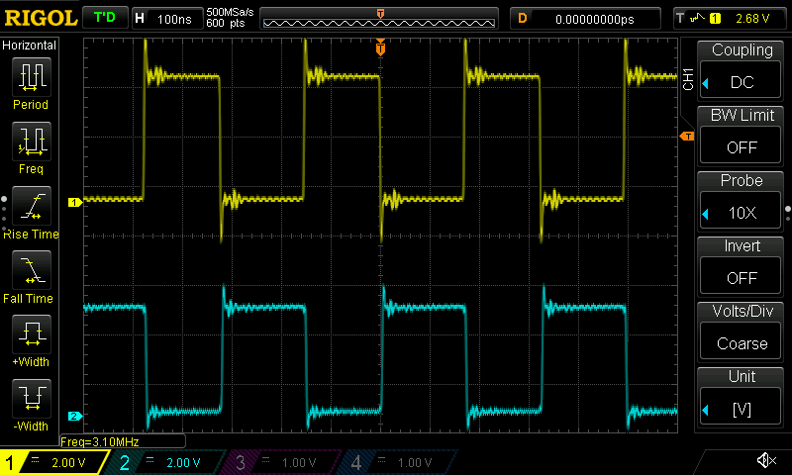

3MHz @ 3.3V

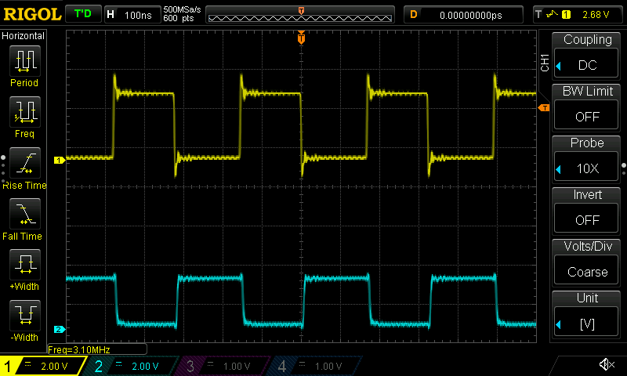

3.5MHz @ 5V

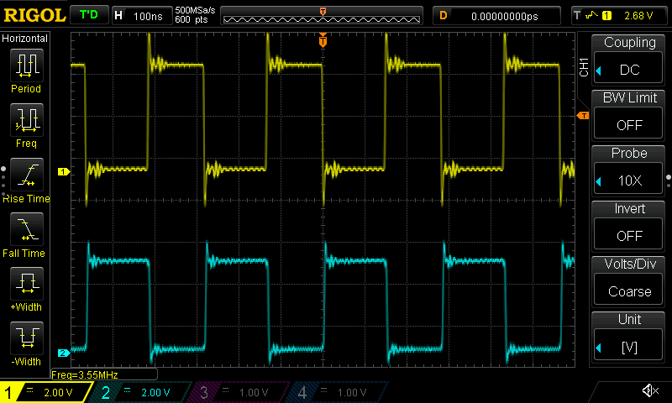

3.5MHz @ 3.3V

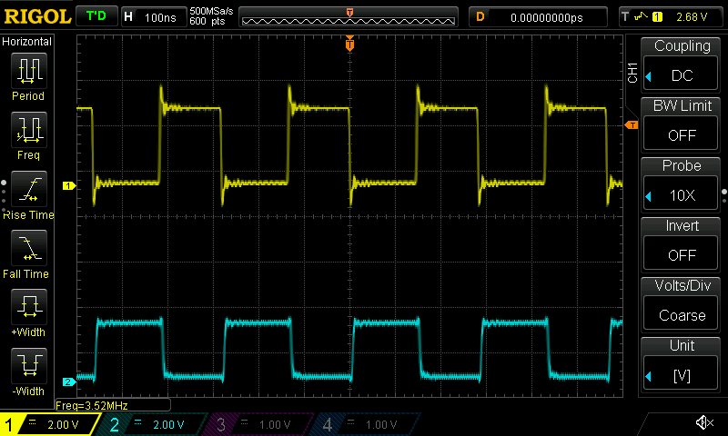

**Summary**

Atlas device works very well and in first tests works stable as well