**Power Supply devices TI**

**Possible step-down controller/converter devices from Texas Instruments are:**

* **LM5116-HT (156.14 Euro HT, 5.22 Euro Low Temp)**
* **TPS40200-HT (78.27 Euro HT, 3.45 Euro Low Temp)**
* **TPS62110-HT (85.85 Euro HT, 3.95 Low Temp)**

**Every one of this devices have different topology, design and working configuration.**

**LM5116-HT**

Features:

* Emulated Peak Current Mode
* Wide Operating Range Up to 80 V
* Low IQ Shutdown (< 10 μA)
* Drives Standard or Logic Level MOSFETs
* Robust 3.5-A Peak Gate Drive
* Free-Run or Synchronous Operation to 1 MHz
* Optional Diode Emulation Mode
* Programmable Output from 1.215 V to 80 V
* Precision 1.5% Voltage Reference
* Programmable Current Limit
* Programmable Soft-Start
* Programmable Line Under-Voltage Lockout
* Automatic Switch to External Bias Supply

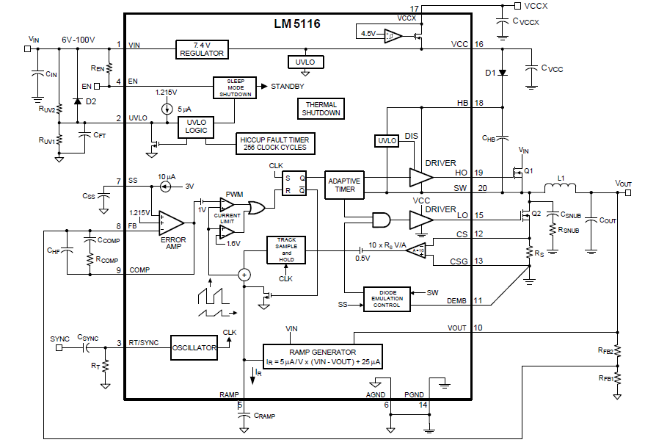

Operating description

The LM5116 high voltage switching regulator features all of the functions necessary to implement an efficient high voltage buck regulator using a minimum of external components.

This easy to use regulator integrates highside and low-side MOSFET drivers capable of supplying peak currents of 2 A.

The regulator control method is based on current mode control utilizing an emulated current ramp.

Emulated peak current mode control provides inherent line feed-forward, cycle by cycle current limiting and ease of loop compensation.

The use of an emulated control ramp reduces noise sensitivity of the pulse-width modulation circuit, allowing reliable processing

of the very small duty cycles necessary in high input voltage applications.

The operating frequency is user programmable from 50 kHz to 1 MHz. An oscillator/synchronization pin allows the operating frequency to be set by a single resistor or synchronized to an external clock.

Fault protection features include current limiting, thermal shutdown and remote shutdown capability.

An under-voltage lockout input allows regulator shutdown when the input voltage is below a user selected threshold, and an enable function will put the regulator into an extremely low current shutdown via the enable input.

**TPS40200-HT**

Features:

* Input Voltage Range 5.5 V to 52 V
* Output Voltage (700 mV to 87% VIN)
* 200-mA Internal P-Channel FET Driver
* Voltage Feed-Forward Compensation
* Undervoltage Lockout
* Programmable Fixed-Frequency (35 kHz to 500 kHz) Operation
* Programmable Short-Circuit Protection
* Hiccup Overcurrent Fault Recovery
* Programmable Closed-Loop Soft Start
* 700mV 1% Reference Voltage
* External Synchronization

Operating description

The TPS40200 is a flexible nonsynchronous controller with a built-in 200-mA driver for P-channel FETs.

The circuit operates with inputs up to 52 V, with a power-saving feature that turns off driver current once the external

FET has been fully turned on.

This feature extends the flexibility of the device, allowing it to operate with an input voltage up to 52 V, without dissipating excessive power.

The circuit operates with voltage-mode feedback and has feed-forward input-voltage compensation that responds instantly to input-voltage change.

The integral 700- mV reference is trimmed to 2%, providing the means to accurately control low voltages.

Clock frequency, soft start, and overcurrent limit each are easily programmed by a single, external component.

The part has undervoltage lockout, and can be easily synchronized to other controllers or a system clock to satisfy sequencing

and/or noise-reduction requirements.

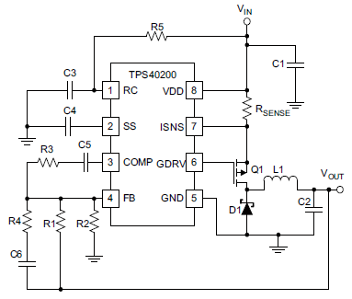

**TPS62110-HT**

Features:

* High-Efficiency Synchronous Step-Down Converter With up to 95% Efficiency
* 3.1-V to 17-V Operating Input Voltage Range
* Adjustable Output Voltage Range From 1.2 V to 16 V
* Synchronizable to External Clock Signal up to 1.4 MHz
* Up to 1.5-A Output Peak Current
* 32-μA Quiescent Current (Typ)
* High Efficiency Over a Wide Load Current Range Due to PFM/PWM Operation Mode
* 100% Maximum Duty Cycle for Lowest dropout
* Overtemperature and Overcurrent Protected
* Available in 16-Pin (PWP) QFP Package

Operating description

The TPS62110 is a synchronous PWM converter with integrated N-channel and P-channel power MOSFET

switches.

Synchronous rectification is used to increase efficiency and to reduce external component count.

To achieve highest efficiency over a wide load current range, the converter enters a power-saving, pulse-frequency

modulation (PFM) mode at light load currents.

Operating frequency is typically 1 MHz, allowing the use of small inductor and capacitor values.

The device can be synchronized to an external clock signal in the range of 0.8 MHz to 1.4 MHz.

For low noise operation, the converter can be operated in PWM-only mode. In the shutdown mode, the current consumption is reduced to less than 2 μA.

The TPS62110 is available in the 16-pin (PWP) QFP package, and operates over a free-air temperature range of –55°C to 175°C.

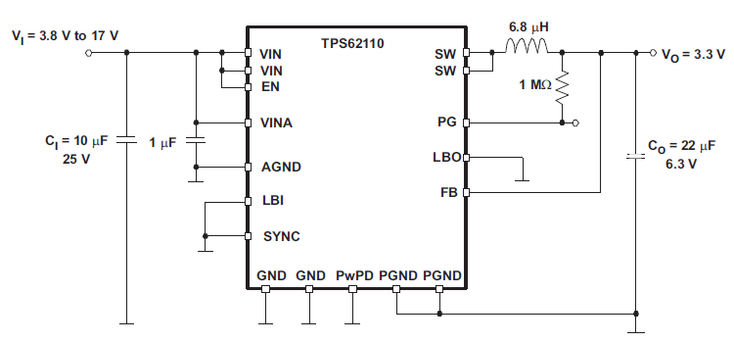

**Conclusions**

**LM5116-HT:**

1. Wide supply voltage (up to 80V)
2. Flexible current output depends on power-FETs
3. Complex circuitry / external parts

**TPS40200-HT:**

1. Wide supply voltage (up to 52V)
2. Simple circuitry
3. Easy to use

**TPS62110-HT:**

1. Supply voltage up to 17V only
2. High integrated device (power-FETs inside)
3. Easy to use
4. Only 1.5A peak current