STech E-commerce Web App

Vision Document

Version 1.0

Revision History

| **Date** | **Version** | **Description** | **Author** |
| --- | --- | --- | --- |
| 28/10/2023 | 1.0 | Initial version of project to explain main functions of project. | Đoàn Mạnh Tân, Lê Quang Thọ |
| 12/11/2023 | 1.1 | Modification in Product Features | Đoàn Mạnh Tân |
|  |  |  |  |
|  |  |  |  |

Table of Contents

**1. Introduction 4**

1.1 Purpose 4

1.2 Scope 4

1.3 References 4

**2. Positioning 4**

2.1 Business Opportunity 4

2.2 Problem Statement 4

2.3 Product Position Statement 4

**3. Stakeholder and User Descriptions 5**

3.1 Stakeholder Summary 5

3.2 User Summary 5

3.3 User Environment 6

3.4 Summary of Key Stakeholder or User Needs 6

3.5 Alternatives and Competition 6

**4. Product Overview 6**

4.1 Product Perspective 6

4.2 Assumptions and Dependencies 7

**5. Product Features 7**

5.1 Logging and Registering 7

5.2 View and search for products 7

5.3 Cart 7

5.4 Payment 8

5.5 Rate and comment 8

5.6 Admin dashboard 8

5.7 Employee dashboard 8

5.8 Chat 8

**6. Non-Functional Requirements 8**

Vision (Small Project)

# Introduction

## Purpose

**The purpose of this document is to define the high-level requirements of the STech e-commerce web app in terms of the needs of the end users.**

## Scope

This Vision Document applies to the STech e-commerce web app , which will be developed by Group 16.

The STech e-commerce web app aims to facilitate Business units in expanding their customer base along with improving the overall convenience of the purchasing experience for customers.

## References

* Applicable references from lecturers:
* Software processes
* Project Management
* Requirements Engineering
* System Modeling
* Architectural design
* OODesign
* User interface
* AgileDevelopment
* [1 - VisionDoc.pdf (utdallas.edu)](https://personal.utdallas.edu/~chung/RE/Presentations10F/Team-hope/1%20-%20VisionDoc.pdf)

# Positioning

## Business Opportunity

This project will assist the businesses in expanding their customer base and market reach, as well as reducing cost. Additionally, it aims to make the customer’s use of products and services more convenient than ever.

Traditionally, customers had to physically visit the location of business to experience their products and services. With the help of the project, they can purchase services and products from the comfort of their own homes.

## Problem Statement

| The problem of | Traditional transaction with limited market reach and poor customer experience. |
| --- | --- |
| affects | Businesses and customers |
| the impact of which is | Businesses market reach is limited and customer experiences are poor as of geographical distance. |
| a successful solution would be | Broaden customer base and market reach of businesses, customers can purchase products and services right from home. |

## Product Position Statement

| For | Businesses (clothes shop, gadgets shop, …), customers around the world |
| --- | --- |
| Who | are running their businesses and want to expand their customer base, are interested in services that a business provides |
| The (product name) | Is a web app |
| That | Enables online transactions between businesses and customers |
| Unlike | Traditional trading convention |
| Our product | Provides user interface for customers to view products and services from businesses and online transactions including payment and shipment, connection between customers and businesses as such support will be received from businesses through online chat. Business owners can keep track of their economic situation such as monthly profit, product management and much more. |

# Stakeholder and User Descriptions

This section describes the users of STech ecommerce web app. There are 3 types of users: Business owner, Business employees and customers.

## Stakeholder Summary

| **Name** | **Description** | **Responsibilities** |
| --- | --- | --- |
| Supervisor | Nguyễn Thị Minh Tuyền  Mai Anh Tuấn | Consult the team in the development progress. |
| Development team | Group 16 | Monitors project progress. Keep track of any systematic problems and handle them. |
| Admin | Business owner | Manage products and services catalog, list of employees; Keep track of their business profit (monthly, yearly, …) |
| Employee | Who works as an employee in the business | Keeps track of the orders status; Provide customer support through online chat. |
| Customer | Who are interested in the services of the business | View and search for products; Add/remove products in their cart; Perform online payment; Choose shipping options; Rate and comment about products; Chat with employees for support; Create account to receive more features and support from the business. |

## User Summary

| **Name** | **Description** | **Responsibilities** | **Stakeholder** |
| --- | --- | --- | --- |
| Admin | Business owner | Manage products and services catalog, list of employees; Keeps track of business profit | Self-represented |
| Employee | Who works as an employee in the business | Keeps track of the orders status; Provide customer support through online chat. | Self-represented |
| Customer | Who are interested in the services of the business | View and search for products; Add/remove products in their cart; Perform online payment; Choose shipping options; Rate and comment about products; Chat with employees for support; Create account. | Self-represented |

## User Environment

The STech e-commerce web app can be accessed through the internet.

The users are able to connect to the internet through gadgets (PC, Laptop, Mobile) to use the app.

## Summary of Key Stakeholder or User Needs

| **Need** | **Priority** | **Concerns** | **Current Solution** | **Proposed Solutions** | |
| --- | --- | --- | --- | --- | --- |
| Easy to use | High | Employees are able to operate the system after 5 hours of training.  Customers can purchase products in 5 minutes. | Looking for UI designs that satisfy most people. | |  |
| Flexible | High | The Website can run on multiple device sizes. | Applying responsive layout. | |  |

## Alternatives and Competition

# Product Overview

## Product Perspective

The STech E-commerce web app will contain three main components which are the SPA web app (user interface to serve the needs of users), Web API (server that handles requests traffic) and the database (stores data).

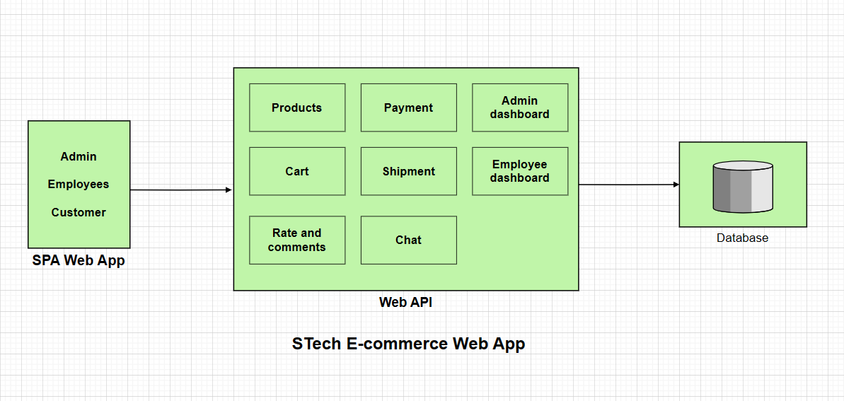

## Assumptions and Dependencies

**The assumptions and dependencies relate to the STech e-commerce web app:**

**Assumptions**:  
 - Platform: S-Tech is accessible via popular web browsers and possibly mobile devices.  
 - Payment: Customers will purchase products/services online, necessitating a secure payment gateway.  
 - User Accounts: Users will create accounts to track orders, manage preferences, and receive updates.

- Inventory Management: S-Tech requires an inventory management system, possibly with integration to third-party suppliers.

- Reviews & Ratings: Products will have review and rating capabilities to enhance the shopping experience and trust.  
- Recommendation System: The platform will utilize data analytics to recommend products based on users' browsing and purchasing behaviors.

**Dependencies**:

- Domain: Acquisition of a suitable domain name (e.g., s-tech.com).  
 - Frontend & Backend Frameworks

- Content: High-quality images and descriptions of products, often from suppliers or created in-house.

# Product Features

## Logging and Registering

Customers can create their account by registering. This process may require their full name, user name, email, password, address, phone number. In terms of admin and employees, certain accounts with pre-created username, password, … will be provided.

## View and search for products

Customers can view the products by categories or price range, choose the order of products base on their price (for example : low to high) or the latest products. They can search for specific products by name and can also choose how many products are displayed on a single page..

## Cart

Customers can add products into their cart if they’re interested. They can remove the products if the ones are no longer wanted. When customers click to view their cart, items in the cart are displayed and they can increase or decrease the amount of the items or completely remove them.

## Payment

After filling their cart, customers can choose process to checkout. They will provide their shipping address (the system may show their default address in advance), contact details and then choose a shipping method with a certain cost. After that, customers will a payment method (credit card or Paypal or Cash on Delivery). With the information provided, the system will verify everything and process the order. Customers will observe the page containing the announcement about their orders (successful or not, delivery time, …)

## Rate and comment

Customers can rate and comment about certain products and services after experiencing them.

## Admin dashboard

Admin can access the dashboard that gives details about product management (admin can add, edit, remove product details, categories), employees list, orders status, economic situation (monthly profit, amount of orders, widely purchased products, …)

## Employee dashboard

Employees can keep track of the orders status. They can update the order status during the process of the orders.

## Chat

Customers can use Messenger live chat (the Messenger icon on the bottom right) to receive support from employees.

## User profile

Customer can view their profile by clicking on the account icon on the top right. Here, they can

view their information (full name, email, phone, …), their orders and comments.

# Non-Functional Requirements

**6.1 Performance**

- Response Time: Product searches, page navigation, and other requests should receive responses within a specified time, e.g., 500 ms.

- Scalability: The system should handle a surge in users during sales or promotional events, e.g., up to 10,000 concurrent users.

**6.2 Availability & Reliability**

- Uptime: The web app should have an uptime of 99.9%.

- Failover: Maintenance announcement.

**6.3 Usability**

- Responsive Design: It should be accessible and usable across various devices and screen sizes, from mobiles to desktops.

- User-Friendly: Intuitive navigation, clear call-to-action buttons, easy checkout process, etc.

**6.4 Security:**

* Authentication and Authorization: Define how user identity is verified and how access permissions are managed.
* Data Encryption: Specify the encryption standards for sensitive data during transmission and storage.
* Session Management: Define how user sessions are managed and secured.

**6.5 Monitoring and Reporting:**

* Logging: Define the level of detail for logs and monitoring data.
* Performance Monitoring: Specify tools and procedures for monitoring system performance.
* Reporting: Define the reporting requirements for system metrics and user activities.

**6.6 Support and Maintenance:**

* Support Response Time: Specify the expected response time for addressing support requests.
* Software Updates: Define procedures for releasing and updating the software.

**6.7 Compatibility:**

* Cross-Browser Compatibility: Ensure the application works seamlessly across major web browsers (e.g., Chrome, Firefox, Safari, Edge).
* Device Compatibility: Specify compatibility requirements for various devices (desktops, tablets, smartphones).

**6.8 Social Integration:**

* Social Media Integration: Specify requirements for integrating with social media platforms.
* Sharing and Social Engagement: Define features that encourage user engagement and sharing.