

INSTITUTO TECNOLÓGICO DE CHIHUAHUA II

Autor: José Sebastian López Ibarra

Docente: Rubén Alonso Hernández Chávez

05 / 11 / 2022

EDD – 09 – ISC

Índex

Introduction 1

Objectives 2

Development 3

Introduction to Quantum Computing 3

What is quantum? 3

What is a qubit? 3

How does quantum computing work? 4

Timeline 5

Main Features 6

Quantum Algorithms 7

Quantum computer uses and application areas 8

Quantum simulation 8

Cryptography 8

Optimization 9

Search 9

Benefits to Quantum Computing 9

Google Claims a Quantum Breakthrough That Could Change Computing 10

Conclusions 11

Recomendations 12

References 13

Index of Figures

Ilustration 1. Superposition 3

Ilustration 2. Example of Computing Work 4

Ilustration 3. Quantum Algorithm 7

Ilustration 4. Quantum Simulation 8

Ilustration 5. Criptography 8

Ilustration 6. Search Problems 9

Ilustration 7. Analysis of Big Data with Quantum Computing 10

# Introduction

Within the different areas of computing we find quantum computing, which allows realize different mechanisms and algorithms to solve various and complex problems. Throughout the document we will talk a little about its definition, what it can be used for and its efficiency.

# Objectives

* Learn the definition of quantum science in the area of computing,
* Expand our knowledge about our career with the knowledge prior to it.

# Development

## Introduction to Quantum Computing

Quantum computers harness the unique behavior of quantum physics—such as superposition, entanglement, and quantum interference—and apply it to computing. This introduces new concepts to traditional programming methods.

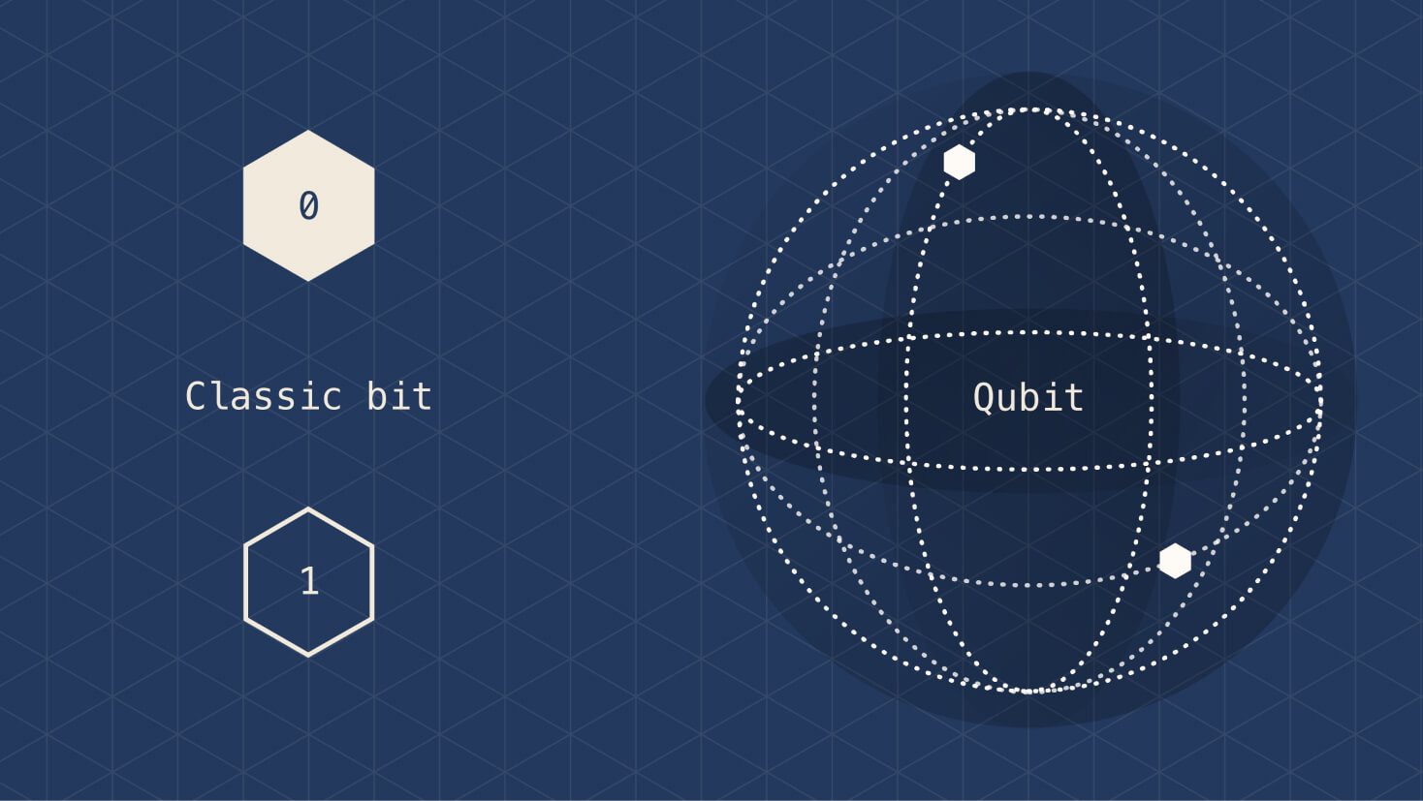

Ilustration 1. Superposition

### What is quantum?

The quantum in "quantum computing" refers to the quantum mechanics that the system uses to calculate outputs. In physics, a quantum is the smallest possible discrete unit of any physical property. It usually refers to properties of atomic or subatomic particles, such as electrons, neutrinos, and photons.

### What is a qubit?

A qubit is the basic unit of information in quantum computing. Qubits play a similar role in quantum computing as bits play in classical computing, but they behave very differently. Classical bits are binary and can hold only a position of 0 or 1, but qubits can hold a superposition of all possible states.

## How does quantum computing work?

A quantum computer has three primary parts:

1. An area that houses the qubits
2. A method for transferring signals to the qubits
3. A classical computer to run a program and send instructions

For some methods of qubit storage, the unit that houses the qubits is kept at a temperature just above absolute zero to maximize their coherence and reduce interference. Other types of qubit housing use a vacuum chamber to help minimize vibrations and stabilize the qubits.

Signals can be sent to the qubits using a variety of methods, including microwaves, laser, and voltage. (What is Quantum Computing, s. f.)

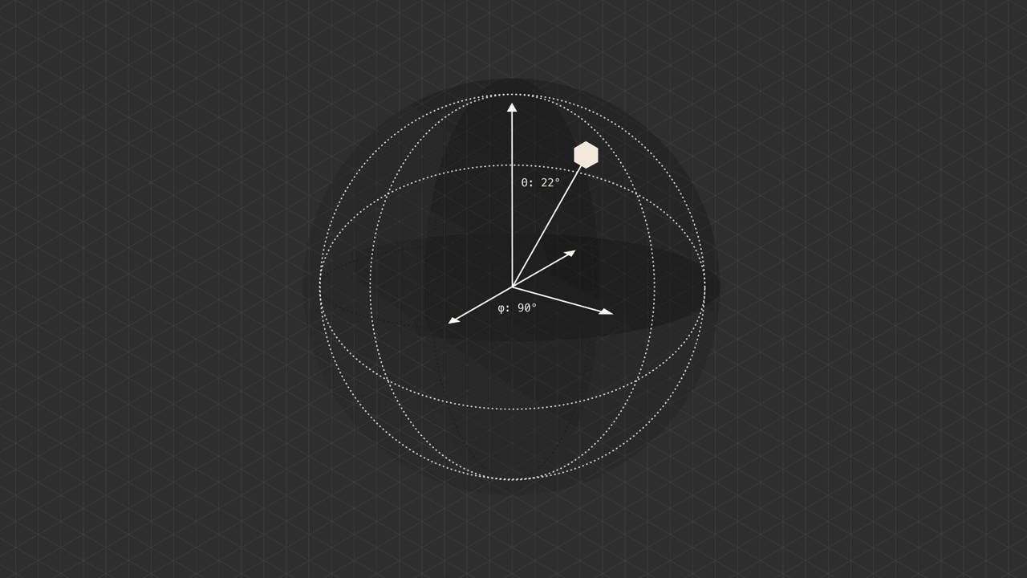

Ilustration 2. Example of Computing Work

## Timeline

Google AI, in partnership with the U.S. National Aeronautics and Space Administration (NASA), claimed to have performed a quantum computation that was infeasible on any classical computer, but whether this claim was or is still valid is a topic of active research.

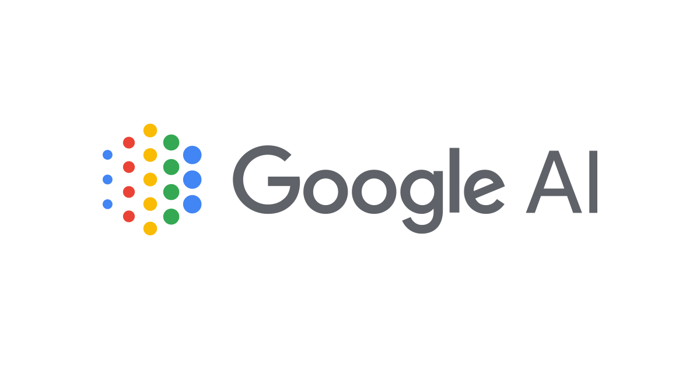

**2019**

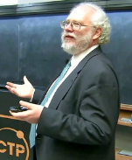

Developed a quantum algorithm for finding the prime factors of an integer with the potential to decrypt RSA-encrypted communications.



**1994**

**Peter Shor**

Analysis states that "investment dollars are pouring in, and quantum-computing start-ups are proliferating". They go on to note that "While quantum computing promises to help businesses solve problems that are beyond the reach and speed of conventional high-performance computers, use cases are largely experimental and hypothetical at this early stage." (Wikipedia contributors, 2022)



**20219**



Suggested that a quantum computer had the potential to simulate things a classical computer could not feasibly do.

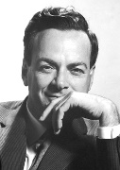

**Richard Feynam**

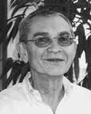

**Yuri Manin**

**1982**



2020 (Present 2022)

Created the first two-qubit quantum computer that could perform computations. Despite ongoing experimental progress since the late 1990s, most researchers believe that "fault-tolerant quantum computing [is] still a rather distant dream."

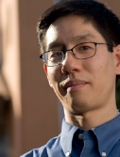

**Richard Feynam**

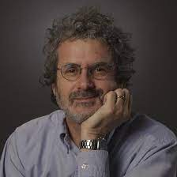

**Yuri Manin**

**1998**



**Mark Kubinec**

Feynman introduced an early version of the quantum circuit notation.

**1986**

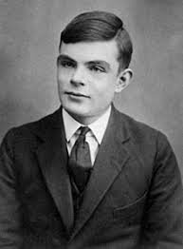

Proposed a quantum mechanical model of the Turing machine.



**1980**

**Paul Benioff**

2000

00

1990

2010

1980

## Main Features

The prevailing model of quantum computation describes the computation in terms of a network of quantum logic gates. This model is a complex linear-algebraic generalization of boolean circuits.

A memory consisting of n bits of information has 2^n possible states. A vector representing all memory states thus has 2^n entries (one for each state). This vector is viewed as a probability vector and represents the fact that the memory is to be found in a particular state. The bits of classical computers are not capable of being in superposition, so one entry must have a value of 1 (i.e. a 100% probability of being in this state) and all other entries would be zero.

In quantum mechanics, probability vectors can be generalized to density operators. The quantum state vector formalism is usually introduced first because it is conceptually simpler, and because it can be used instead of the density matrix formalism for pure states, where the whole quantum system is known. We begin by considering a simple memory consisting of only one quantum bit. When measured, this memory may be found in one of two states: the zero state or the one state. We may represent the state of this memory using Dirac notation so that:

A quantum memory may then be found in any quantum superposition of the two classical states and :

The coefficients and are complex numbers. The state is not itself a probability vector but can be connected with a probability vector via the measurement operation. If the quantum memory is measured to determine whether the state is or (this is known as a computational basis measurement), the zero state would be observed with probability and the one state with probability . The numbers and are called probability amplitudes.

### Quantum Algorithms

Progress in finding quantum algorithms typically focuses on this quantum circuit model, though exceptions like the quantum adiabatic algorithm exist. Quantum algorithms can be roughly categorized by the type of speedup achieved over corresponding classical algorithms.

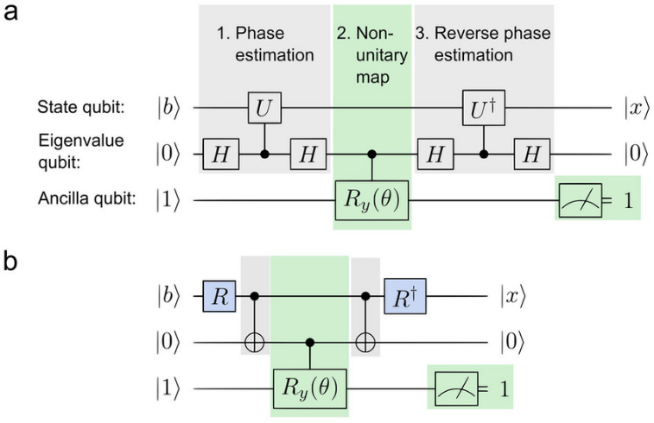Quantum algorithms that offer more than a polynomial speedup over the best-known classical algorithm include Shor's algorithm for factoring and the related quantum algorithms for computing discrete logarithms, solving Pell's equation, and more generally solving the hidden subgroup problem for abelian finite groups. These algorithms depend on the primitive of the quantum Fourier transform. No mathematical proof has been found that shows that an equally fast classical algorithm cannot be discovered, although this is considered unlikely.

Ilustration 3. Quantum Algorithm

Certain oracle problems like Simon's problem and the Bernstein–Vazirani problem do give provable speedups, though this is in the quantum query model, which is a restricted model where lower bounds are much easier to prove and doesn't necessarily translate to speedups for practical problems.

Other problems, including the simulation of quantum physical processes from chemistry and solid-state physics, the approximation of certain Jones polynomials, and the quantum algorithm for linear systems of equations have quantum algorithms appearing to give super-polynomial speedups and are BQP-complete. Because these problems are BQP-complete, an equally fast classical algorithm for them would imply that no quantum algorithm gives a super-polynomial speedup, which is believed to be unlikely. (Wikipedia contributors, 2022)

## Quantum computer uses and application areas

A quantum computer can't do everything faster than a classical computer, but there are a few areas where quantum computers have the potential to make a big impact, which as:

### Quantum simulation

Quantum computers work exceptionally well for modeling other quantum systems because they use quantum phenomena in their computation. This means that they can handle the complexity and ambiguity of systems that would overload classical computers. Examples of quantum systems that we can model include photosynthesis, superconductivity, and complex molecular formations.

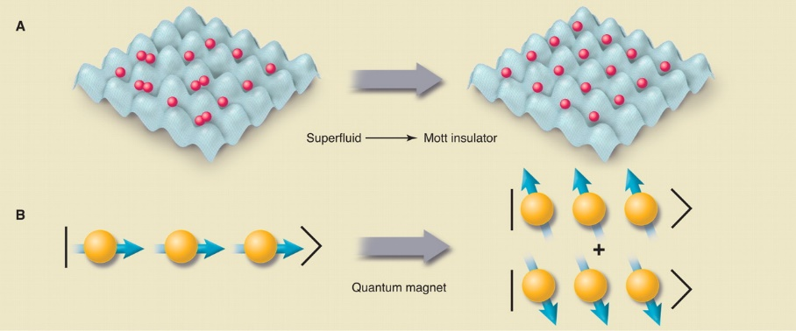

Ilustration 4. Quantum Simulation

### Cryptography

Classical cryptography—such as the Rivest–Shamir–Adleman (RSA) algorithm that’s widely used to secure data transmission—relies on the intractability of problems such as integer factorization or discrete logarithms. Many of these problems can be solved more efficiently using quantum computers.

Ilustration 5. Criptography

### Optimization

Optimization is the process of finding the best solution to a problem given its desired outcome and constraints. In science and industry, critical decisions are made based on factors such as cost, quality, and production time—all of which can be optimized. By running quantum-inspired optimization algorithms on classical computers, we can find solutions that were previously impossible. This helps us find better ways to manage complex systems such as traffic flows, airplane gate assignments, package deliveries, and energy storage.

### Search

A quantum algorithm developed in 1996 dramatically sped up the solution to unstructured data searches, running the search in fewer steps than any classical algorithm could.

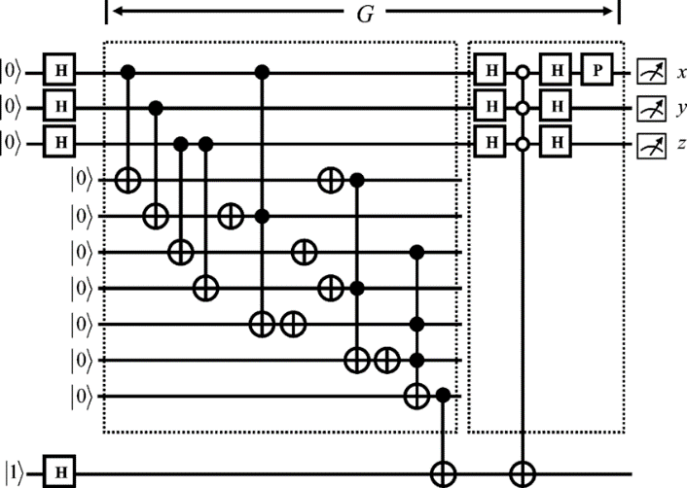

Ilustration 6. Search Problems

## Benefits to Quantum Computing

Used correctly, quantum computers are incredibly fast and effective. They can perform calculations in a few seconds for which today's supercomputers would need decades or even millennia. This fact is also referred to by experts as quantum superiority . For a long time, this was just a theory. In 2019, however, Google's quantum computer protoype was able to perform such a calculation and verify quantum superiority in practice.

Calculations with quantum computers are particularly promising wherever incredibly complex processes with huge amounts of data are to be analyzed or simulated. In addition to digital marketing, the natural science disciplines in particular see great potential here. Quantum computers could contribute to a better and more detailed understanding of the interaction of individual particles, elements and the processes in living cells. But there are also potential 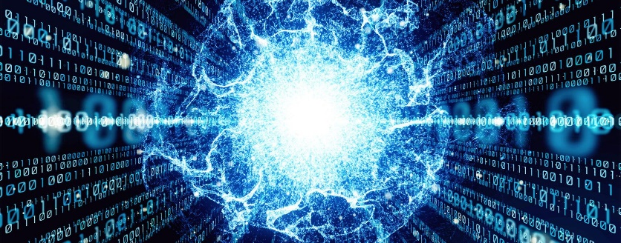applications in medicine.

Ilustration 7. Analysis of Big Data with Quantum Computing

Most of all, researchers hope that quantum computers will take artificial intelligences (AI) a big step forward. These could then safely and reliably take over tasks such as data evaluation or forecasting in the future. (403 Forbidden, s. f.)

## Google Claims a Quantum Breakthrough That Could Change Computing

Google said on Wednesday that it had achieved a long-sought breakthrough called “quantum supremacy,” which could allow new kinds of computers to do calculations at speeds that are inconceivable with today’s technology.

“The original Wright flyer was not a useful airplane,” said Scott Aaronson, a computer scientist at the University of Texas at Austin who reviewed Google’s paper before publication. “But it was designed to prove a point. And it proved the point.”

Article link: <https://www.nytimes.com/2019/10/23/technology/quantum-computing-google.html>

# Conclusions

Over the years we have seen and lived how technology has made great progress and evolution. Every day there are faster and easier ways to solve problems that, without this type of mechanism would take a long time.

Due the different areas of science that exist, it is essential to have control and order within them to have greater efficiency when solving problems. That is why, different mechanisms and algorithms are created to carry out this.

# Recomendations

* Teachers should not assume that we students know everything. We are going to the university for a reason, because we are learning and reviewing the topics previously seen. If possible, repeat things up to three times.

# References

* Wikipedia contributors. (2022, November 5). *Quantum computing*. Wikipedia, The Free Encyclopedia. <https://en.wikipedia.org/w/index.php?title=Quantum_computing&oldid=1120181733>
* What is quantum computing. (n.d.). Microsoft.com. Retrieved November 5, 2022, from <https://azure.microsoft.com/en-us/resources/cloud-computing-dictionary/what-is-quantum-computing/>
* *403 Forbidden*. (s. f.). Recuperado 5 de noviembre de 2022, de <https://www.asioso.com/sr/blog/advantages-and-disadvantages-of-quantum-computing-in-relation-to-digital-marketing-b536>
* *nytimes.com*. (2019, 23 octubre). <https://www.nytimes.com/2019/10/23/technology/quantum-computing-google.html>