# ftd-analyzer

This project is a web application that reads in SEC fail to deliver data and displays it in a graphical format for the user.

Inspired by but not affiliated with: https://wherearetheshares.com

# Table of Contents

1. Use Cases
2. Entity-Relationship Diagram
3. Wireframes

## Use Cases

1. The User wants to view how difficult is is to buy/ sell a certain stock for brokers
2. The user wants to file a lawsuit on a certain broker for failure to deliver
3. The user wants to analyze the times/days for failure to deliver of a certain broker to find any patterns
4. The user is a stock lender and wants to learn about the dangers of lending stocks

## Entity Relationship Diagram

ER Diagram 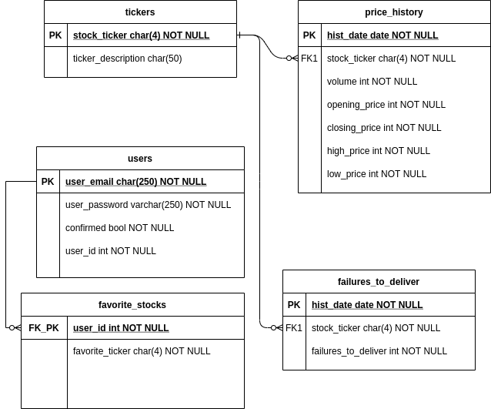

## Wireframes

Homepage 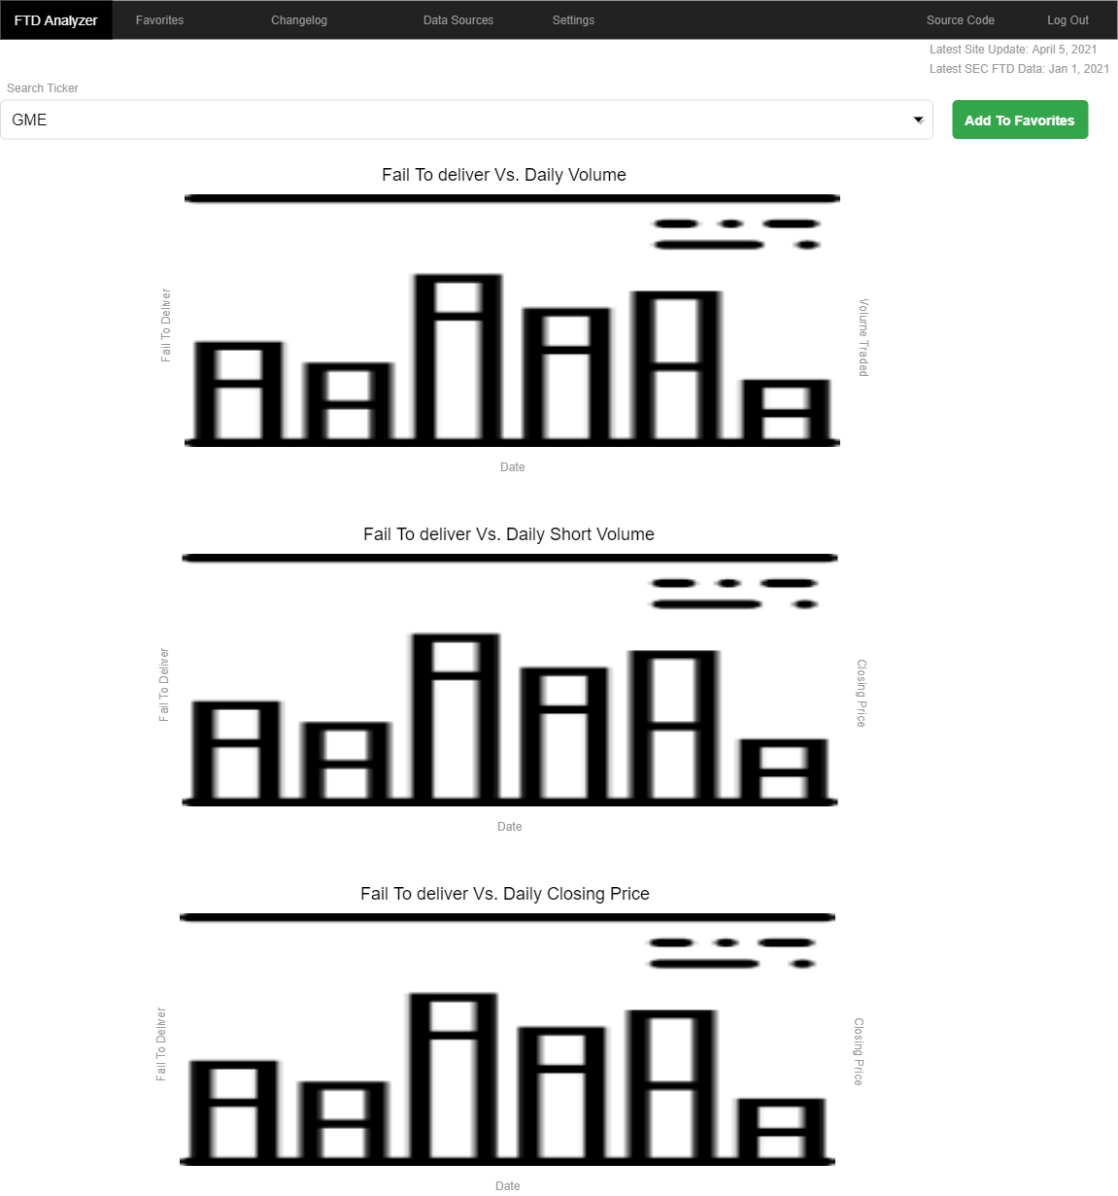

Favorites 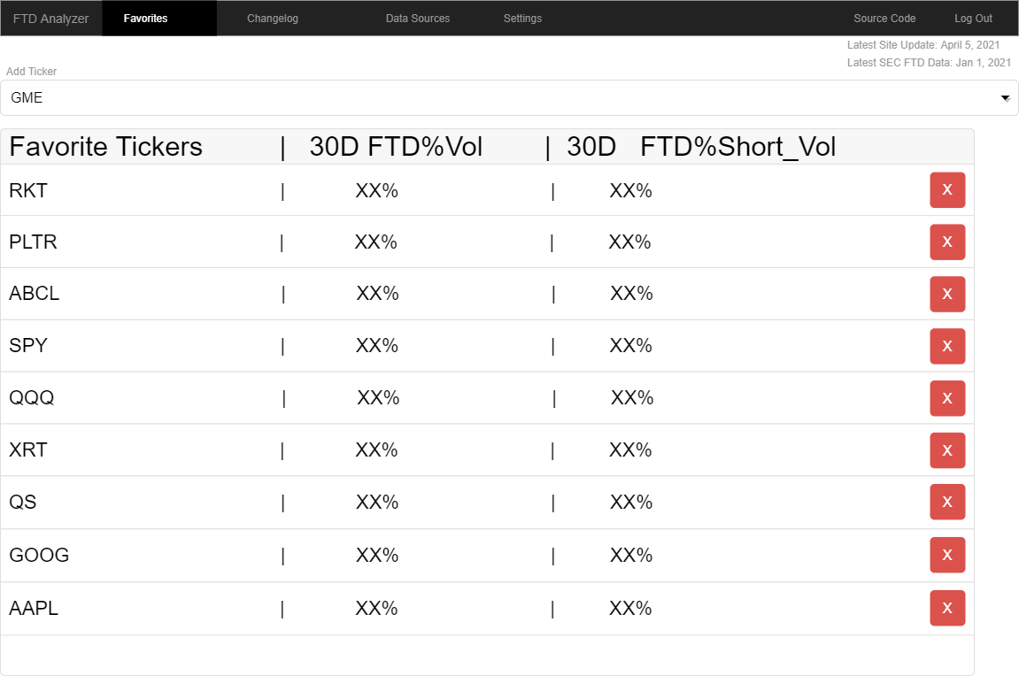

Changelog 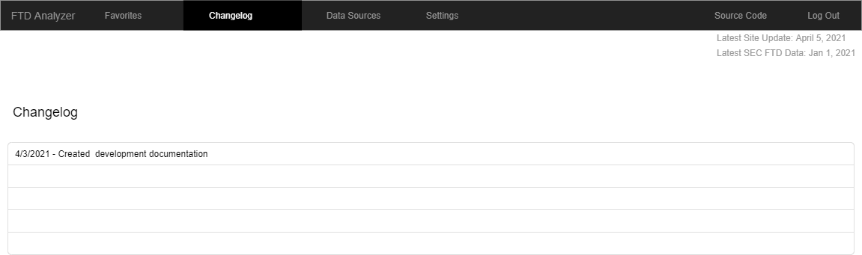

Data Sources & FAQ 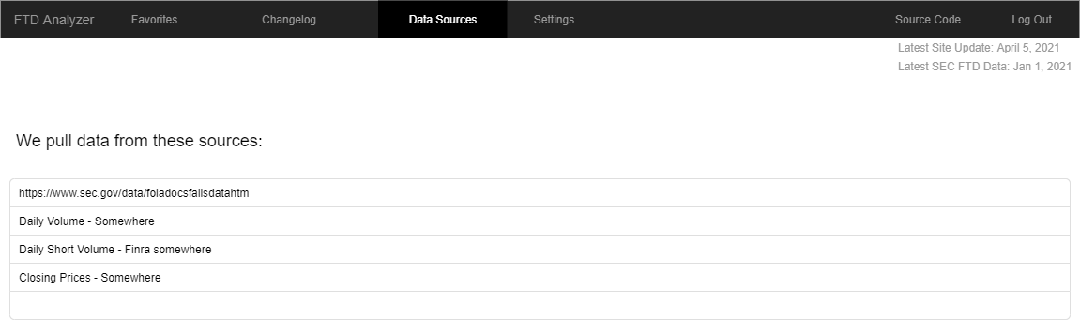

Settings 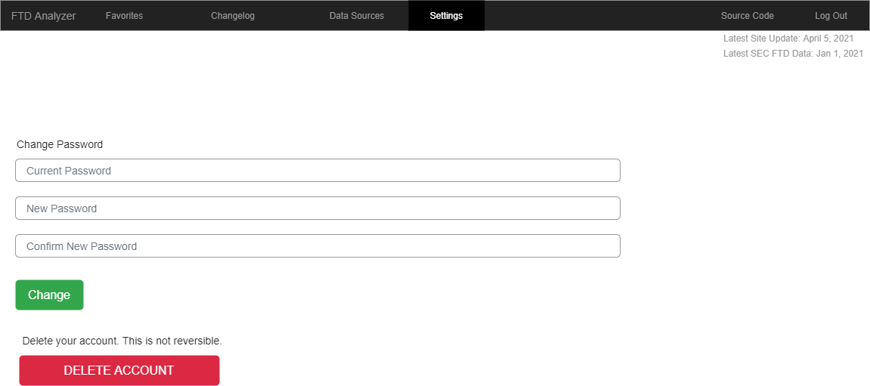

Login Page 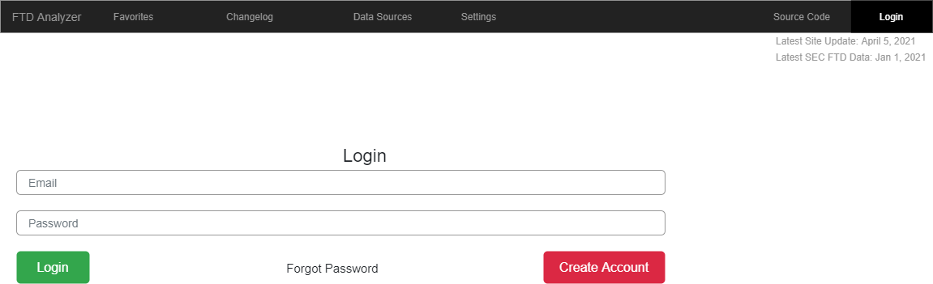

Reset Password 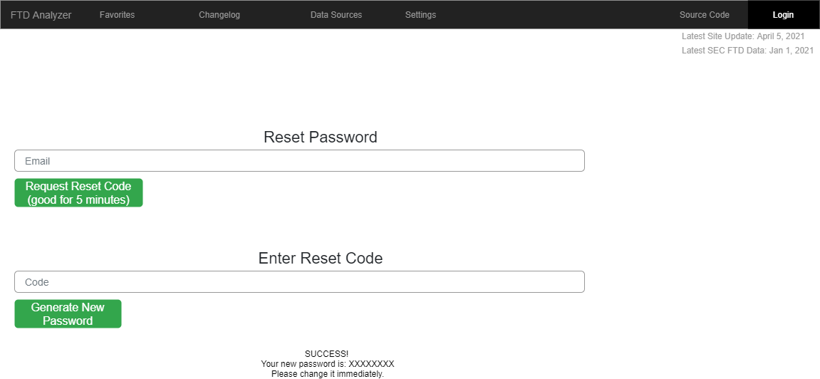

Confirm Account 