CST8412
Assignment 2
Sebastian Sell
041147547

Contents
Introduction 3
Description of UI elements arrangement 4
Purposes of the UI controls 6
Mistakes or incorrect assumptions I had to overcome 7

Introduction

In this document I will be go over the CRUD system I made, specifically on how I decided to use which UI elements and layouts for the CRUD application.
I will also touch on every UI control element and state what their purposes are along with addressing mistakes I made while doing this assignment.
This application was made using Scenebuilder to create the FXML file and then added the controller class in intelji.

Description of UI elements arrangement

To create the CRUD application, I planned to use a layout with a table view in the middle of the screen, a menu bar at the top, and a series of buttons and text fields at the bottom. I used a borderPane layout because by default it provided a good amount of space for its top, center and bottom regions to give a more formatted look.
In the middle region, I used a table view because I believed it was the best element for displaying data in a row-and-column layout similar to many RDBMS. This table view also, by default, provides column labels that state the names of the data on each column to help the user understand what they are looking at.
In the bottom region, I used two HBoxes stacked vertically. The top featured two labels and two text fields, which were for the user to type a name and age. I placed labels. The Hbox on the bottom has four buttons to create, read, update and delete records. I chose Hboxes because I wanted to format the buttons and text fields so they were spaced well across the screen rather than vertically, to avoid a squished GUI and a lot of empty space on the sides.
I chose buttons for the CRUD controls because each button takes minimal space with a name right on the button, and the default button style provides cues that it is a clickable element. I also wanted to implement a UI element that provides a visual cue indicating non-clickability when a certain condition is not met, to enhance the application's user guidance. One example of a button I would not pick over the regular button is the radio button. I thought it would take up space and is typically only looked best when it's organized vertically, which would have squished the GUI, as I stated previously.
On the top region, I picked a menu bar that contains several menu dropdowns that would system-level functions like closing the app. I picked the menu bar element because it looked very similar to a nav bar that is typically seen at the top of computer applications.

Below is an image of the hierarchy of my application in scene builder:
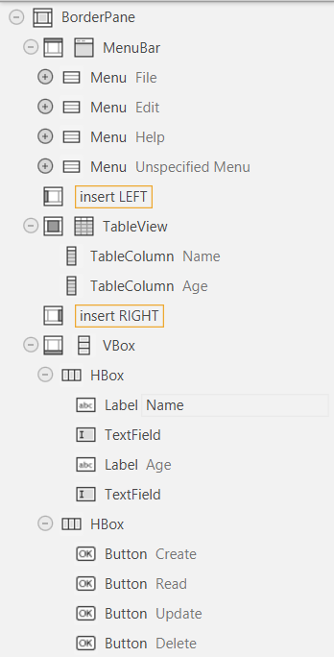

Purposes of the UI controls

At the bottom of the GUI are four buttons that each provide functionality to manipulate the table view. One button is the “Create” button, which adds a record to the program's table view. Another button is the “Read” button that serves as a shortcut to add the values of a selected record into the two text fields so that the user doesn’t have to copy the values manually. The “update” button is used to change the value of an existing record by clicking on a record in the table view and then typing the new values into the text fields before clicking the “Update” button. The “Delete” button deletes a selected record from the user. I set a condition that if the user did not select an item, the read, update, and delete buttons would be unclickable to show the user that the read, delete, or update functions cannot be used until they click an item, which can only occur after using the create button.
The code to define the buttons is located in the Controller class, lines 33-42. And the methods that the buttons call are also located in the same file, from line 67 to line 116.
The binding code for the unclickable effect on the read, update, and delete buttons is in the controller class file, in the initialize method, lines 57-64.
Above the four buttons are two text fields accompanied by two labels, which are implemented to allow the user to type values to either create a new record or update an existing record with those values.
The code for the two text fields is located in the controller class, lines 26-30.
There is a menu bar above the table view that contains various buttons. One button labelled “file” opens a menu dropdown that leads to an “Exit” button, which lets the user close the application if they desire. Near it is another menu button labelled “Help” that would turn into a drop-down menu that shows a button labelled “About”. Clicking this button would create a small pop-up window that would inform the user what the application is. The user can close that window by clicking the “ok” button in the pop-up window.
The methods for those menu buttons are located in the controller class, lines 118-136.

Mistakes or incorrect assumptions I had to overcome

A mistake I made that prevented me from progressing forward was having the border pane and everything else in its regions be inside a pane element. At the beginning of making the FXML file in Scene Builder, I was following the instructions of the early labs to better understand how to get started on making the UI. My assumption was that everything, including the layout elements, had to be in a blank screen element, which would be a regular pane element.
The problem this caused was that it put all the elements, including the entire border pane, at the top left of the pane, and upon running it, it presented mostly a blank screen with all the elements smudged together there. After many attempts at fixing, it through different methods, I found out that using the pane element was not needed, as when I tried having the border pane be the parent, it fit perfectly on the entire screen.

Another mistake I made was clicking on the checkbox for the root construct. The image below shows the exact checkbox in Scene builder.
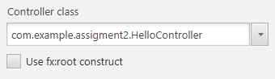
The problem that it caused was making the program run unsuccessfully. The FX:ROOt construct is used to create custom reusable components that are also in the controller class. It requires the controller instance to be passed from the code and not created from the FXML loader. This was not the case with my FXML, so it resulted in an error. Essentially, when that checkbox is clicked, it changes the first line of the FXML code file to <fx:root>, which, upon the code hitting the loader method, determines that the root already exists without stating the object.
After researching the error, I unchecked that checkbox, and it resulted in the program running properly.

