**Installation Instructions:**

1. **Unpack to a folder of your choice**
2. **Go to the Chrome Extensions Menu (See Image below)**
3. **Make sure that the “Developer mode” checkbox is checked**
4. **Click on the “Load unpacked extension…” Button**
5. **Navigate to the folder in which you unpacked the zip file**
6. **Select the “IC” Folder**
7. **Done**

**I also recommend installing an Ad-Blocker (like Adblock) in chrome.   
(Dynamic Ads cause different page DOM’s on page revisits. This can in turn make the tool unable to detect previously annotated regions)**

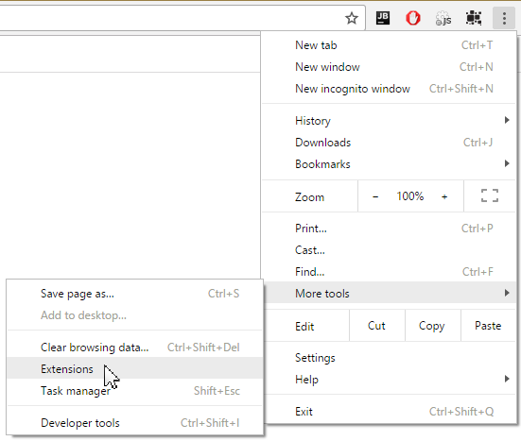

**Extension menu:**

**After installing the tool, you should see the Information Collage extension icon in the browser’s address bar. Clicking it will open up the extensions menu.  
  
This menu enables access to the visualization via the “Visualize!” Button. You can also store previously created collages with the export DB button or load existing collages with the Import DB Button. The Erase DB button wipes the whole database. (After a warning)**

**The checkbox “Enable Annotations” turns annotation features on or off (described in the next section), the checkbox use Collage PDF viewer turns forwarding to the internal pdf editor on and off (does not work in all cases),  
the enable ajax updates checkbox enables or disables ajax request interception and the checkbox Enable DOM selection toggles selection of Dom elements and images (This can cause performance problems on some pages). The tool will remember your settings after you restart it.**

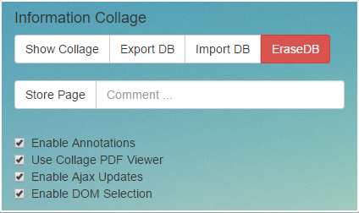

**Annotation:**

**You can use the Information collage tool to annotate Webpages and PDF documents at different levels of granularity.**

* **Complete Pages:   
    
  Click the Store Page Button in the Extensions menu and issue a comment.**
* **Custom areas:**
  1. **Highlight some text you want to store and click the appearing Button.**
  2. **Issue a comment and press save.**
* **Predefined Regions:   
    
  When you hover certain webpage elements (like article HTML tags), a small button with a plus will appear. The button lets you store the complete content of the tag by clicking the button in a similar fashion to the annotation of custom areas.**

**In any case, the tool will store a screenshot of the selection and mark the selected area (except when storing whole pages). When hovering the annotated area later, it will show the comment in a small dialog balloon. The three icons in that balloon let you change the comment, delete the annotation or jump to the location of the selected snippet within the collage (see next section)  
  
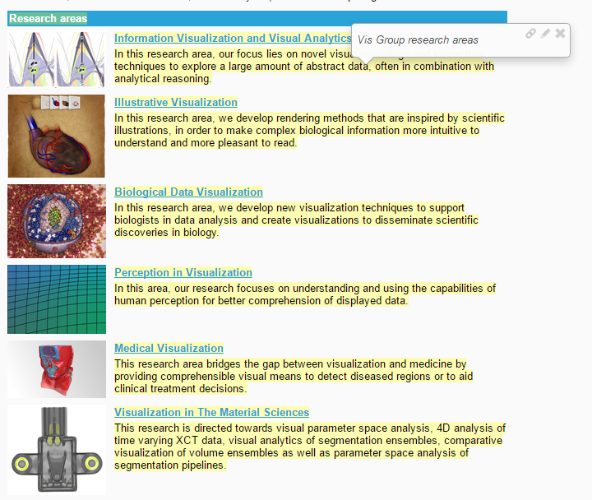  
  
Information Collage Visualization:**

**After clicking the “Visualize!” button in the extension menu the Information Collage visualization will open in a new tab. When opening the Visualization for the first time, you will see an empty grey area.  
On the top left of the screen you will see the visualization’s main menu, which consists of two active buttons.**

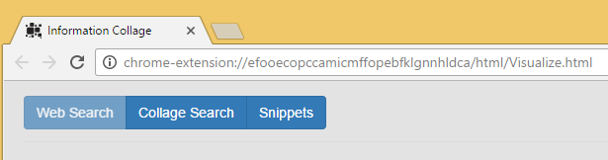

**After clicking the “snippets” button, the annotated snippets will show up in the sidebar in the order their order of capture (Most recent snippets on top). From the sidebar, snippets can moved to the main visualization area by drag and drop. After dragging snippets to the visualization area, you can see the most important keywords of each snippet in a bubble-like visualization. Bubbles of Snippets that are grouped together closely are merged and the bubble keywords are generated from all snippets within the bubble.**

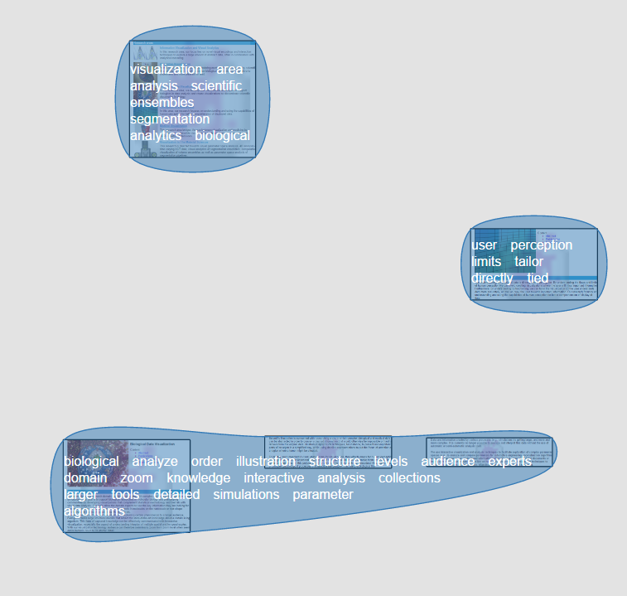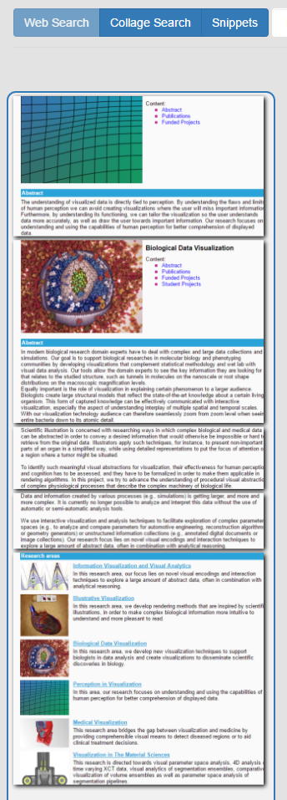   
  
  
  
  
  
  
  
  
**The bubble-grouping algorithm is scale dependent. This allows you to see the keywords of individual snippets at a close zoom level and get an overview of the areas under the bubble at distant zoom levels.**

Close Zoom Distant Zoom

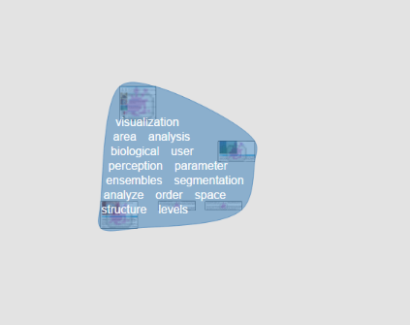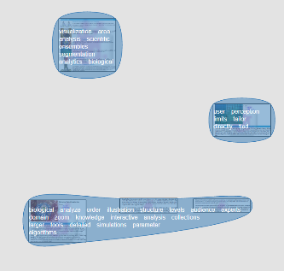

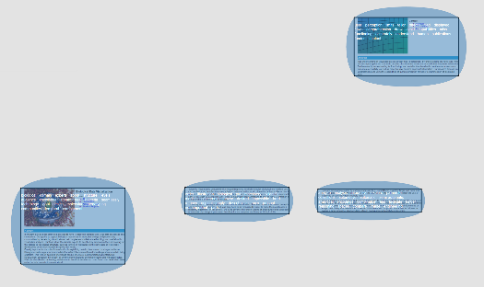

**Cluster/Snippet Similarity:**

**When hovering a cluster or term the mouse, the grouping algorithm will create clusters only from snippets that share terms with the selected cluster or term. To compare clusters with single snippets, select them by a mouse click. Shared terms are then shown in orange, while important terms in each cluster that are not shared will be shown in white.**

**By clicking a snippet or cluster, the selection is fixed. To deselect simply click somewhere in the collage area. To select a cluster an area of the cluster that has no underlying snippets has to be clicked.**

**KWIC (Keyword in Context) – When hovering over a term the visualization will display all sentences in the captured snippet or cluster in which the selected term appears.**

**Context Menus:**

**Several features of the visualization are accessible via context menus. The options that are shown depend on the area that was clicked:**

**Canvas:**

* **Create Note: Create a custom note, with a title and text. Notes are handled similar to webpage snippets.**
* **Create Bubble: Creates an area with a nametag. Snippets can be grouped manually in these areas and are moved together when the bubble is moved.**
* **Toggle cluster visibility: Enables/Disables the cluster visualization.**

**Snippet:**

* **Goto Webpage: Opens the webpage where the snippet was captured.**
* **Show Details: Shows a window with snippet details. (Comment can be changed here)**
* **Copy text: Copy the text contents of the snippet into the copy/paste buffer**
* **Mark/Unmark as important: Marks a snippet as important or unimportant.**
* **Show text: Shows the snippet text.**
* **Delete Snippet: Deletes the snippet + annotation**

**Bubble/Note:**

* **Change or delete color of bubble, create tag and delete notes.**

**Term:**

* **Add to box: Adds the term to the collage search box.**
* **Add to box and start search: Adds the term to the collage search box and starts a collage query.**
* **Add to Web Query: Adds the term to the web query accumulator.**
* **Add to Web Query: Adds the term to the web query accumulator and starts the query in a new tab.**

**Collage Search:**

**To use the keyword based collage search, click the button titled “Collage search” to open the collage search menu, input a term into the search field and hit the search button. If snippets, which contain the given term are found, preview images of those snippets will be displayed in the search result area. Clicking on one of the preview images navigates directly to the snippet in the visualization.  
By clicking on the “Hits” button you can also jump from one search result to the next.   
  
