# 2.1 Database

## 2.1.1 Relational Database

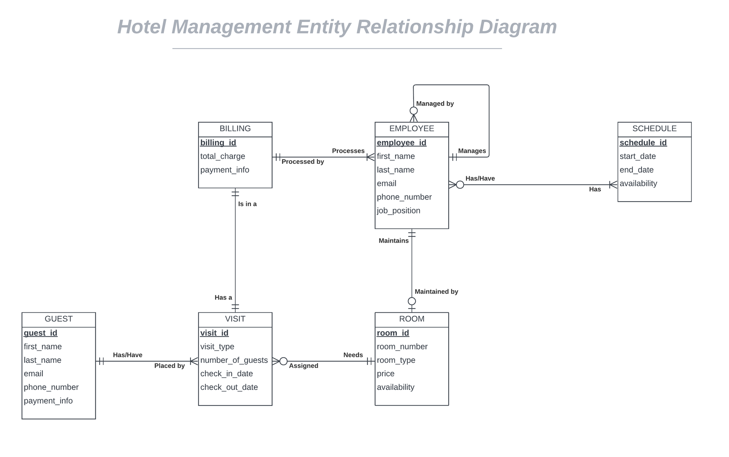

**Figure 2.1.1**

**Relational Database of Hotel Management System**

The figure above shows the relation between the tables in the database of

Hotel Management System.

**2.1.2 Database Schema**

**2.1.2.1 Data Dictionary**

**Figure 2.1.2.1.1**

**Guest Data Dictionary**

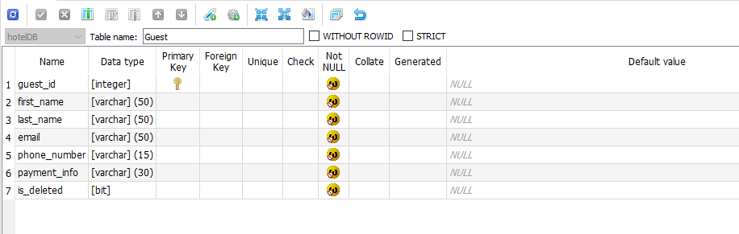

**Figure 2.1.2.1.2**

**Visit Data Dictionary**

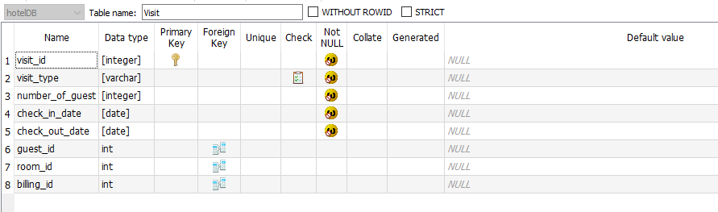

**Figure 2.1.2.1.3**

**Employee Data Dictionary**

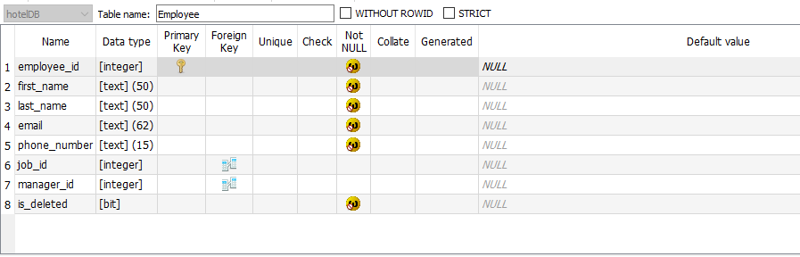

**Figure 2.1.2.1.4**

**Jobs Data Dictionary**

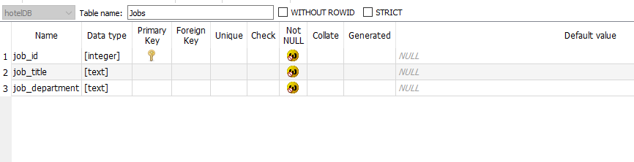

**Figure 2.1.2.1.5**

**Schedule Data Dictionary**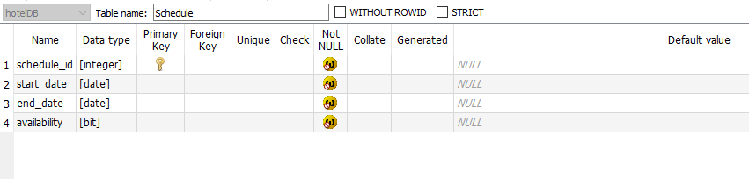

**Figure 2.1.2.1.6**

**Billing Data Dictionary**

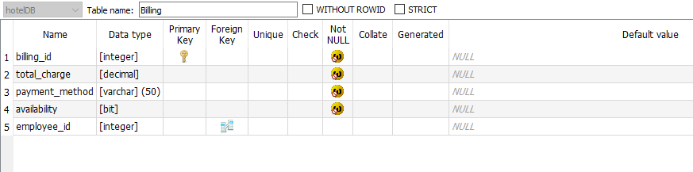

**Figure 2.1.2.1.7**

**Rooms Data Dictionary**

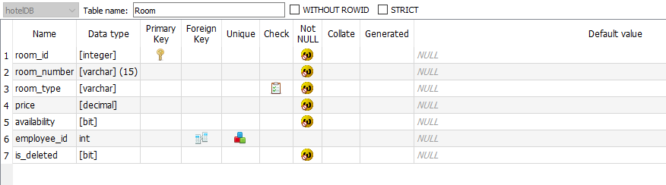

**Figure 2.1.2.1.8**

**Assigned Schedule Data Dictionary**

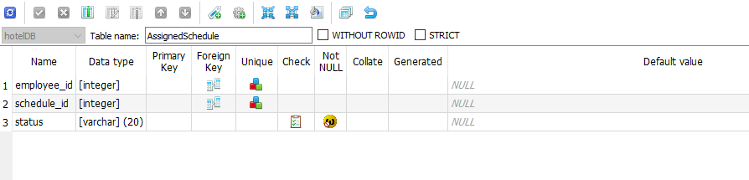

# 2.2 Input Forms

## 2.2.1 Input Inventory

|  |  |
| --- | --- |
| **Form Name** | **Description** |
| Guest, Visit | Entries window that takes the guests information and visit information. |
| Employee | Entries window that takes the employee’s information and assign jobs |
| Room | Entries window that takes rooms information. |
| Schedule | Entries window that takes schedules start and end date |
| Jobs | Entries windows that takes job title and department. |

## 2.2.2 Input Forms Data Dictionary

|  |  |  |  |
| --- | --- | --- | --- |
| **Form and Data** | **Data Type** | **Actions Permitted** | **Allow Nulls** |
| Guest   * First_name * Last_name * Email * Phone_number * Payment_info * Is_deleted | [varchar] (50)  [varchar] (50)  [varchar] (50)  [varchar] (15)  [varchar] (30)  [bit] | ADD, EDIT,  ADD, EDIT,  ADD, EDIT,  ADD, EDIT,  ADD, EDIT,  ADD, EDIT, | Not NULL  Not NULL  Not NULL  Not NULL  Not NULL  Not NULL |
| Visit   * Visit_type * Number_of_guest * Check_in_date * Check_out_date * Guest_id * Room_id * billing_id | [varchar]  [integer]  [date]  [date]  [integer]  [integer]  [integer] | ADD  ADD  ADD, EDIT  ADD, EDIT  ADD  ADD, EDIT  ADD | Not NULL  Not NULL  Not NULL  Not NULL  NULL  NULL  NULL |
| Employee   * First_name * Last_name * Email * Phone_number * Job_id * Manager_id * is_deleted | [varchar] (50)  [varchar] (50)  [varchar] (62)  [varchar] (15)  [integer]  [integer]  [bit] | ADD, EDIT  ADD, EDIT  ADD, EDIT  ADD, EDIT  ADD, EDIT  ADD, EDIT  ADD, EDIT  ADD, EDIT | Not NULL  Not NULL  Not NULL  Not NULL  NULL  NULL  Not NULL |
| Jobs   * Job_title * job_department | [text]  [text] | ADD, DELETE  ADD, DELETE | Not NULL  Not NULL |
| Schedule   * Start_date * End_date * Availability | [date]  [date]  [bit] | ADD, EDIT, DELETE  ADD, EDIT, DELETE  ADD, EDIT, DELETE | Not NULL  Not NULL  Not NULL |
| Billing   * Total_charge * Payment_method * Availability * Employee_id | [decimal]  [varchar] (50)  [bit]  [integer] | ADD,  ADD  ADD  ADD, EDIT  ADD, EDIT | Not NULL  Not NULL  Not NULL  Not NULL  NULL |
| Rooms   * Room_number * Room_type * Price * Availability * Employee_id * Is_deleted | [varchar](15)  [varchar]  [decimal]  [bit]  [integer]  [bit] | ADD, EDIT  ADD, EDIT  ADD, EDIT  ADD, EDIT  ADD, EDIT  ADD, EDIT | Not NULL  Not NULL  Not NULL  Not NULL  NULL  Not NULL |

# 2.3 Screens

## 2.3.1 Screen Navigation Diagram

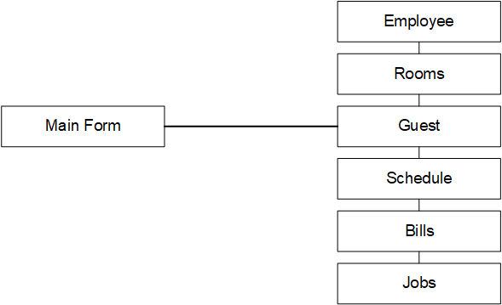

**2.3.2 Screen Description/Layout**

|  |  |
| --- | --- |
| **Screen** | **Description** |
| Employee | Employees at the hotel, with details on their jobs and schedules. |
| Rooms | Details about hotel rooms, such as types, pricing, and occupancy status, are provided. |
| Guest | A customer who stays at the hotel has their personal information and details saved in the system. |
| Schedule | Schedules for personnel shifts |
| Bills | Bills made for guests that detail their charges throughout their stay. |
| Jobs | Jobs details that can be assigned to employees. |