# 1.1 Introduction

The Hotel Management System is a complete platform that improves experiences by streamlining hotel operations. This user-friendly platform aims to transform hotel administration by drawing influence from real-world hotel management systems.

The system efficiently maintains room availability, and pricing. Personalized service is prioritized since the system stores and uses visitor preferences to generate customized offerings, making each guest's stay unique and pleasurable.

The technology checks guest information, issues room, and simplifies payment processes during check-ins.

In addition, the Hotel Management System provides hotel managers with unrivaled efficiency. Accept a future in hotel management where unique visitor experiences are abundant.

# 1.2 System Description

A comprehensive software program designed to streamline and automate various hotel operations, the hotel management system is user-friendly for hotel staff. It manages reservations, room assignments, check-ins, check-outs, employee schedules, and visitor information.

One of the most important aspects of a hotel management system is handling reservations and room availability. The technology gives customers real-time information on hotel availability.

The system retains guest information received during reservations for guest check-ins and payment methods. It then ensures a smooth check-in process by assigning rooms based on availability and number of guests.

The hotel management system generates an itemized statement for customers upon check-out, which includes prices, throughout their stay

The system also manages maintenance tasks. It keeps track of guest profiles, allowing hotel staffs to contact and identify their guest identification smoothly

Moreover, the hotel management system efficiently organizes employee work schedules by recording time-off requests and availability. In addition to increasing overall operational efficiency and customer happiness, this ensures that the staff is available to meet the hotel's and visitors' needs.

# 1.3 System Features

The proposed Hotel Management System has the following features:

**Guest Visit Management:** The system allows guests’ information collected by describing the type of visit, the number of guests, and the check-in and check-out dates. It guarantees that rooms are available and discourages overbooking.

**Check-In and Check-Out:** Having guest information saved during reservations allows for a rapid and secure check-in process. The system generates itemized bills and handles payment processing.

**Employee Scheduling and Task Assignment:** The system handles employee work schedules efficiently, taking into account time-off requests and availability. It allocates duties to employees, such as room upkeep, based on their plans and competence.

**Billing and Payment Handling:** The system produces and organizes billing information for each visit.

# 1.4 System Requirements

The objective and the main purpose of the proposed system are to provide computer-generated data to the store.

## 1.4.1 Hardware Requirements

|  |  |  |
| --- | --- | --- |
| **Hardware** | **Minimum Requirement** | **Recommended Requirement** |
| Processor | 1.6GHz | 2.6 or higher |
| Memory | 2GB | 4GB or higher |
| Hard Drive | 80GB | 128GB or higher |
| Video Card | 1GB | 2GB |

**Table 1.4.1**

**Hardware Requirements**

The above table shows the Hardware requirements of the proposed system. As shown above, minimum specifications exist for better and faster system development. There are recommended hardware specifications.

## 1.4.2 Software Requirements

|  |  |  |
| --- | --- | --- |
| **Hardware** | **Minimum Requirement** | **Use** |
| Operating System | Windows 10 | For the environment or platform to be used. |
| Programming Language | Python | For the development of the system. |
| Database | SQLite3 | For the storage of the records. |

**Table 1.4.2**

**Software Requirements**

The table above shows the software requirements of the proposed system. The purpose of the condition is shown in the "Use" column. Windows 10 platforms are known for their stability and user-friendly interface, but because Microsoft will stop supplying security updates for Windows 7, Windows 10 is recommended. The open-source and free SQLite3 software is recommended.

## 1.4.3 Data Requirements

|  |  |  |
| --- | --- | --- |
|  | **Data** | **Description** |
| Guest | First Name | The first name of the guest who is staying at the hotel or using the services. |
|  | Last Name | The last name of the guest. |
|  | Email | The email address of the guest, which is used for communication and reservation purposes. |
|  | Payment Method | The Guest's payment information could include Cash, Credit, Debit, E-Wallet, Bank, or other payment methods. |
|  | Phone Number | Contact number of the guest, used for communication and reservation confirmation. |
| Employee | First Name | The first name of the employee working at the hotel. |
|  | Last Name | The last name of the employee. |
|  | Email | The email address of the employee, used for official communication within the organization. |
|  | Phone Number | Contact number of the employee, used for work-related communication. |
| Room | Room Number | A name or identifier for each room within the hotel. |
|  | Room Price | The cost or price of the associated room. |
|  | Room Type | The type of room, such as single, double, triple, family, or suite. |

**Table 1.4.3**

**Data Requirements**

The table above shows the information the system needs to generate better and more reliable reports.

## 1.4.4 People Requirement

People are the most important requirements needed in the system. The unified system is very helpful for the user.

|  |  |
| --- | --- |
| **People** | **Description** |
| Hotel System Administrator | The person is responsible for managing the systematic flow of the hotel operations. This person will take documents that relates to the information needed by the application to be inserted. |

**Table 1.4.4**

**People Requirements**

The table above shows the people expected to use the system and those who can help by giving information about the Hotel Management System.

# 1.5 Entity Relationship Diagram

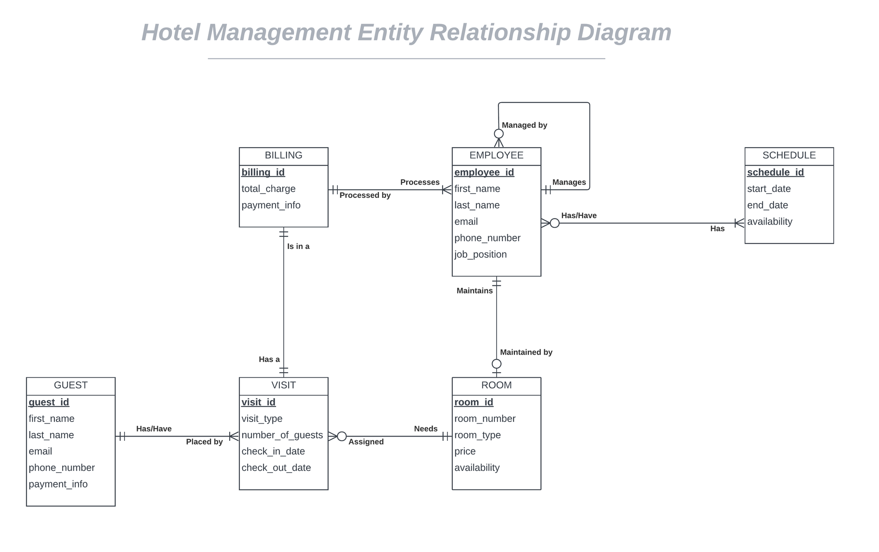

**Figure 1.5**

**Entity Relationship Diagram**

The figure above shows the entity relationship diagram for Hotel Management System

# 1.6 System Composition

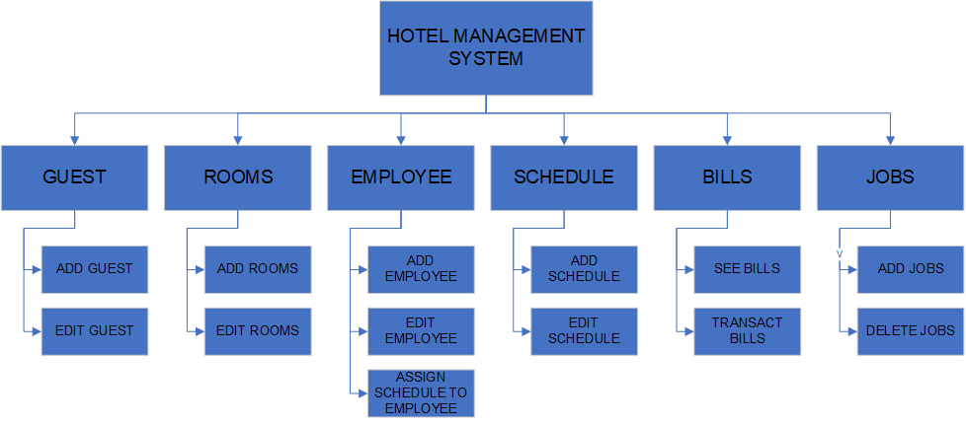

# 1.7 Source Documents

## 1.7.1 Source Documents Inventory

|  |  |
| --- | --- |
| **Forms** | **Description** |
| Guest Form | Gathers guest information for hotel operations and storing, and check-ins process |
| Employee Form | Collects information for employee employment and job assignment |
| Room Form | Collects room information for another room creation. |

**Table 1.7.1**

**Source Document of Hotel Management System**

The table above shows the source documents from which the information needed for the system will come.

## 1.7.2 Source Documents Format

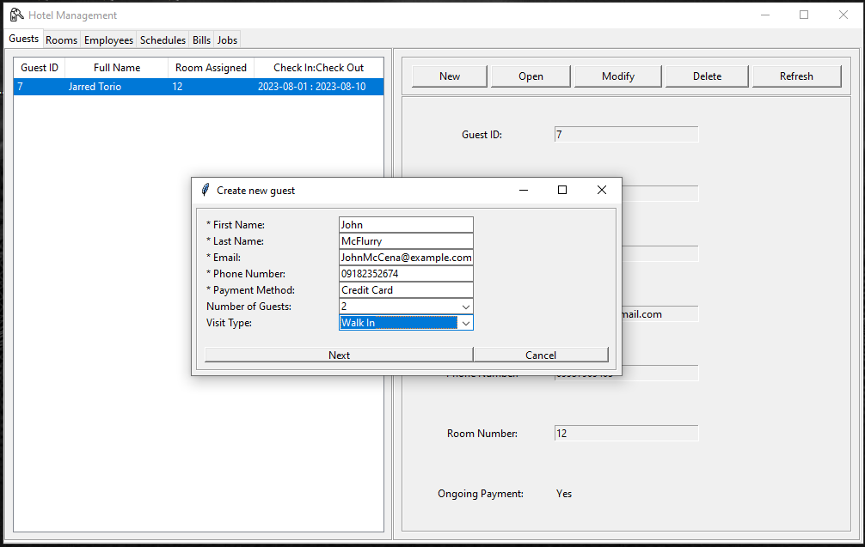

**Figure 1.7.2.1**

**Guest Creation Screen [Basic Information Screen]**

Upon guest creation, a pop window will show up that asks for name, email, phone, number, type of visit, and number of guests.

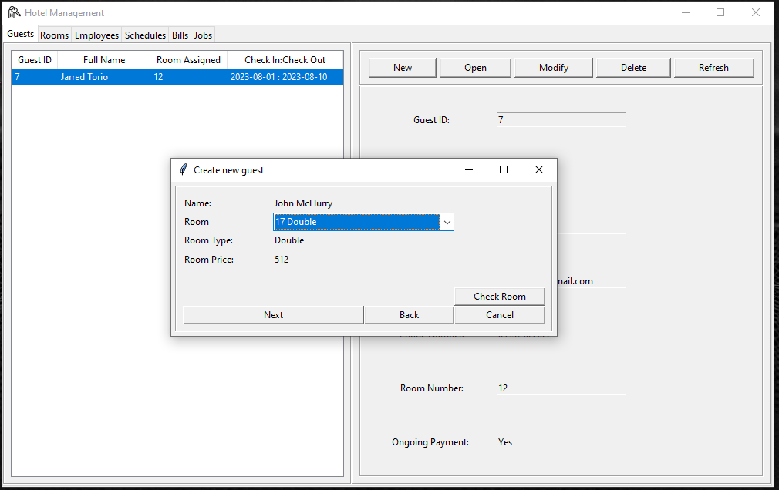

**Figure 1.7.2.2**

**Guest Creation Screen [Room Assignment]**

Upon entering, a new pop window will show to assign rooms

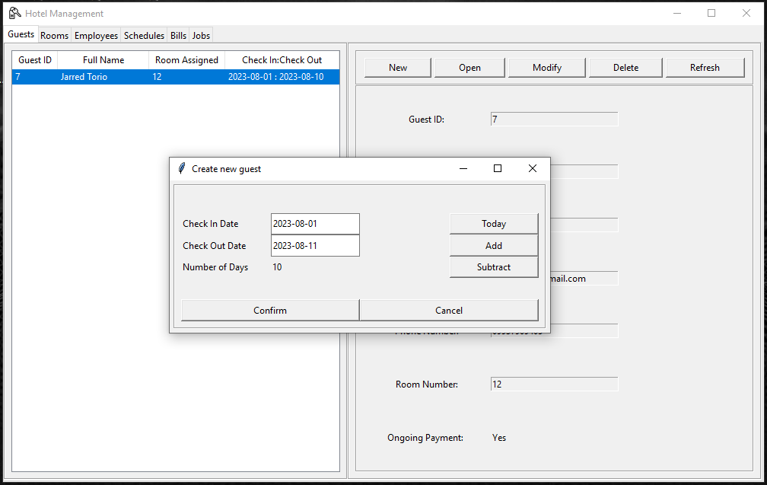

**Figure 1.7.2.3**

**Guest Creation Screen [Check-in, Check-out]**

Next, another pop window will show to assign check-in and check-out dates

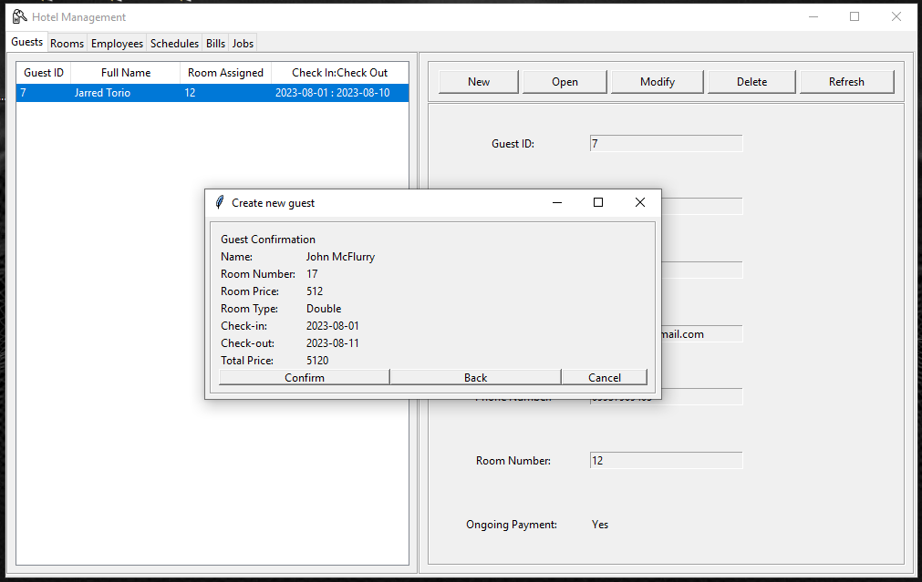

**Figure 1.7.2.4**

**Guest Creation Screen [Information Confirmation]**

Lastly, a guest confirmation screen containing simple information will pop out. Confirming will add the guest

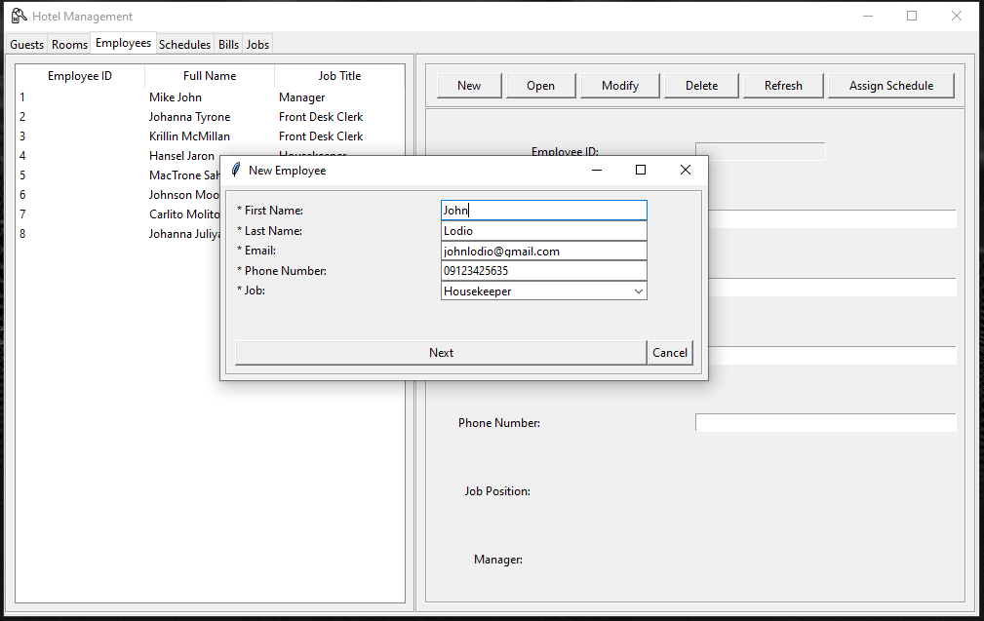

**Figure 1.7.2.5**

**Employee Creation Screen [Basic Information]**

Employee creation, upon entering a pop-up window will ask for basic information of the employee.

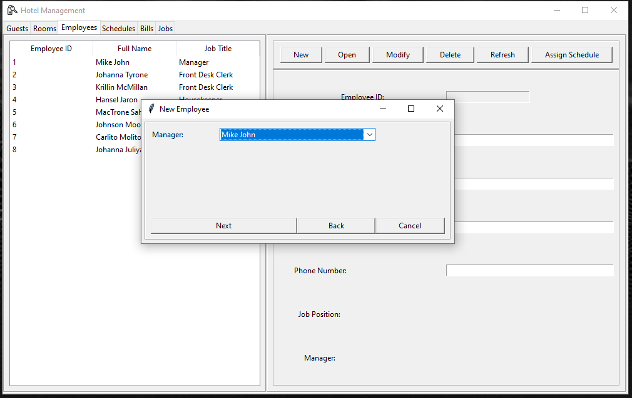

**Figure 1.7.2.6**

**Employee Creation Screen [Manager Assignment]**

Next, after entering basic information, assigning manager is next.

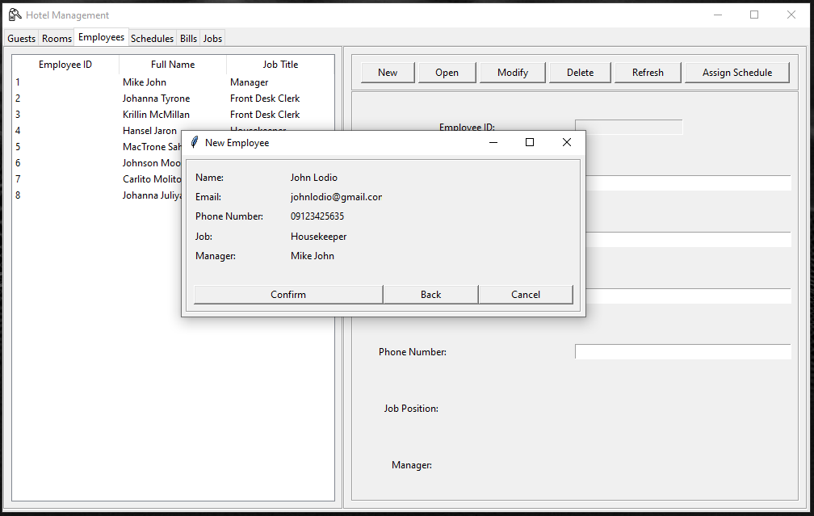

**Figure 1.7.2.7**

**Employee Creation Screen [Information Confirmation]**

Lastly, an employee confirmation screen containing simple information will pop out. Confirming will add the employee.

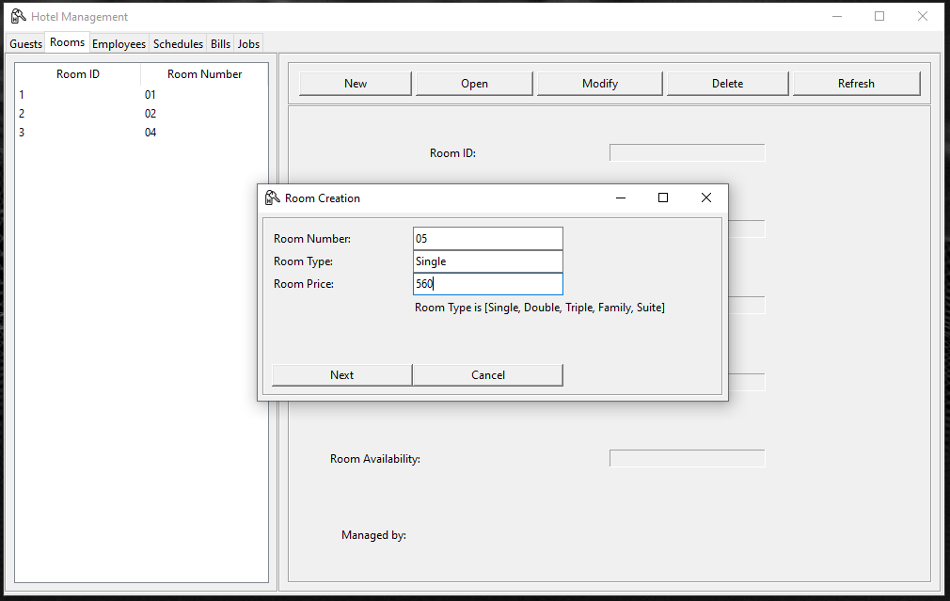

**Figure 1.7.2.8**

**Room Creation Screen [Basic Information]**

The figure above shows a pop-up window if room creation is initiated. Asking for room number, room type, and room price.

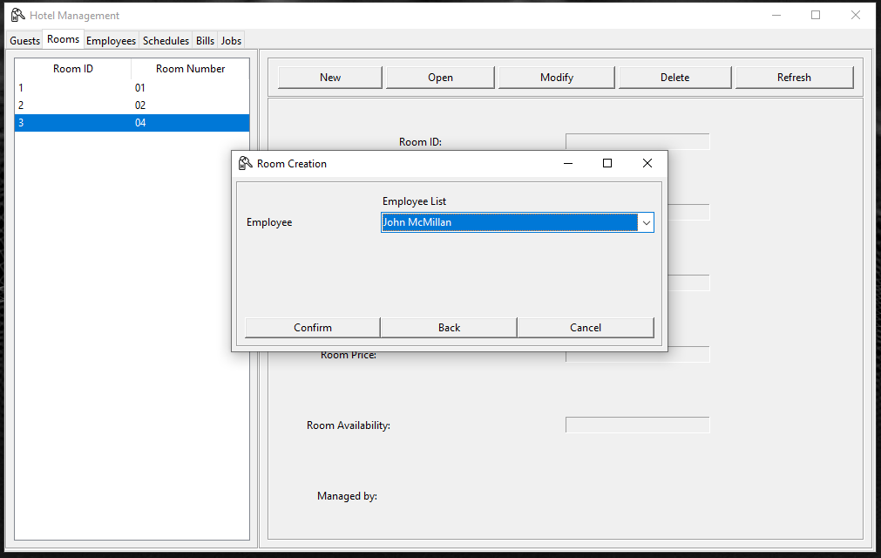

**Figure 1.7.2.8**

**Room Creation Screen [Employee Assignment]**

The figure above shows a pop-up window if room creation is initiated. After entering the basic information, employee assignment window is next to assign an employee to a room. This can be left empty.

# 1.8 Report Form

## 1.8.1 Report Form Inventory

|  |  |
| --- | --- |
| **Form** | **Description** |
| Billing Tab | Shows billing ID, total of bill, and the guest’ payment method, |

# TABLE 1.8.1

**Report Form Table**

# 1.8.2 Report Form Format

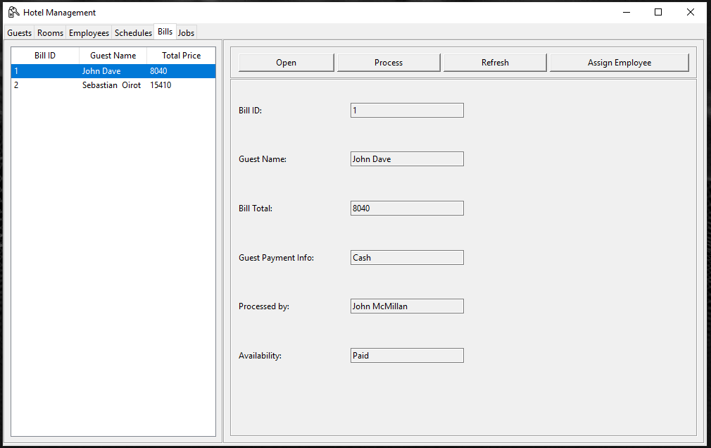

**Figure 1.8.2.1**

**Billing Tab**

The figure above displays the billing form of a checked-in guest.