BAM-2024 FINAL PROJECT REPORT
Group 2 — Healthcare: Global Healthcare & Pharma 2009-2026
Course: Business Inteligencie Tools
Instructor: [ Add instructor name]
Submission date: [ Add date ]
Team members
[ Add team member 1 ]
[ Add team member 2 ]
[ Add team member 3 ]
Juan Sebastián Herrera Sánchez C0965669
[ Add team member 4 ]

Responsibility Matrix
Legend: R = Responsible · A = Accountable · C = Consulted · I = Informed
Task / Deliverable | Person 1 | Sebas | Person 3 | Person 4 | Person 5 | Person 6 | Person 7 | Person 8
Task 1 |  | C
Task 2 |  | I
Cleaning datasets |  | R
Transform data |  | R
Query’s Power BI |  | R
Data model and relationships in Power BI |  | R/A
Three proposed new indicators |  | A
Task 8 |  | C
Task 9 |  | I
Cover page & report formatting |  | C
Presentation slides & delivery |  | I

Summary: Data Cleaning and New Indicators
The "Global Healthcare & Pharma 2010-2026" dataset (Kaggle) contains 5 tables: biotech_funding, clinical_trials, disease_burden, drug_approvals, and pharma_companies_financials. At the null-value and duplicate-row level the dataset is clean, but the diagnostic identified 4 real data-quality issues that affect Power BI modeling and aggregate analysis, all corrected below with reproducible Power Query (M) steps.
File | Rows | Issue detected | Action
biotech_funding.csv | 1208 | 1 record (2009) outside the dataset's stated period (2010-2026) | 'out_of_scope_period' column to exclude from year-over-year trends
clinical_trials.csv / drug_approvals.csv / biotech_funding.csv | — | 7 company-name variants (e.g. "J&J" vs "Johnson & Johnson") prevent correct joins with the financials table | Master standardization table + Merge Queries
drug_approvals.csv | 722 | 10 records with a combined sponsor (e.g. "Pfizer/BioNTech") | 'primary_sponsor' / 'secondary_sponsor' columns + 'is_combo_sponsor' flag
disease_burden.csv | 3310 | 530 rows where the reported global burden is 25-35% lower than the regional sum, across 3 of 20 diseases (COVID-19, HIV/AIDS, Malaria, Maternal disorders) | Recalculation of 'global_dalys_millions_corrected' from the regional detail

Data quality diagnostic (Before)

Company name inconsistency
The same company appears with different spellings depending on the source table, which prevents building reliable one-to-many relationships in the Power BI model (for example, between drug_approvals and pharma_companies_financials). Only true name variants of a single legal entity belong in this standardization map — two independent companies that jointly developed a product are a different situation, handled separately in section 2.2 below.
Raw name | Appears in | Standard name | Why
J&J | biotech_funding, clinical_trials, drug_approvals | Johnson & Johnson | Short name vs. legal name, same company
BMS | biotech_funding, drug_approvals | Bristol-Myers Squibb | Short name vs. legal name, same company
Gilead | biotech_funding, clinical_trials, drug_approvals | Gilead Sciences | Short name vs. legal name, same company
Vertex | biotech_funding, clinical_trials, drug_approvals | Vertex Pharmaceuticals | Short name vs. legal name, same company
Lilly | drug_approvals | Eli Lilly | Short name vs. legal name, same company
Kite | drug_approvals (after splitting combo sponsors, see 2.2) | Gilead Sciences | Kite Pharma has been a Gilead subsidiary since 2017 — not an independent company
Daiichi | drug_approvals (after splitting combo sponsors, see 2.2) | Daiichi Sankyo | Short name vs. legal name used in the financials table
Full table of 7 mappings in company_name_map.csv (attached). Earlier drafts of this table mistakenly included combo strings like "Pfizer/BioNTech" mapped to a single company name, which would have erased the second company. That was corrected — see 2.2.

Combined sponsors in drug_approvals
10 of 722 approvals (1.4%) list two independent companies that co-developed the drug together (e.g. "Pfizer/BioNTech", "Sanofi/Regeneron"). These are genuinely two different, real companies — collapsing them into one name would silently delete one of the two. Instead, the field was split into two columns, primary_sponsor_std and secondary_sponsor_std, so both companies stay identifiable, plus an is_combo_sponsor flag to mark these rows for KPI logic. The one exception is Kite/Gilead: Kite Pharma is a Gilead subsidiary, not an independent partner, so both sides correctly resolve to "Gilead Sciences".
Raw sponsor_company | primary_sponsor_std | secondary_sponsor_std
AbbVie/J&J | AbbVie | Johnson & Johnson
Bayer/J&J | Bayer | Johnson & Johnson
BMS/Pfizer | Bristol-Myers Squibb | Pfizer
Biogen/Eisai | Biogen | Eisai
Daiichi/AstraZeneca | Daiichi Sankyo | AstraZeneca
Kite/Gilead | Gilead Sciences | Gilead Sciences (subsidiary)
Pfizer/BioNTech | Pfizer | BioNTech
Sanofi/Regeneron | Sanofi | Regeneron
Vertex/CRISPR | Vertex Pharmaceuticals | CRISPR Therapeutics
KPI2 (R&D efficiency) counts each approval only once, under primary_sponsor_std, to avoid double-counting across two companies' R&D budgets. This also fixed a bug: earlier this map incorrectly tried to standardize the combo strings themselves (e.g. "Kite/Gilead" → "Gilead Sciences"), which never matched anything because primary_sponsor is split off before the lookup runs — so Kite's and Daiichi's approvals were silently failing to join to the financials table. That is fixed by mapping the split-off short names ("Kite", "Daiichi") directly, as shown in 2.1.

Record outside the dataset period
Deal_id D0001 (Pfizer-Wyeth, USD 68bn) is dated 2009-03-09, one year before the stated period (2010-2026). It is a real merger used as a historical anchor, so it is kept but flagged with out_of_scope_period = 1 to exclude it from annual trend charts.

Inconsistency in global disease burden (disease_burden)
For 17 of 20 diseases, the reported global burden (global_dalys_millions) matches the sum of the 10 regions within a rounding margin (<5%). However, for 3 diseases — HIV/AIDS, Malaria, and Maternal disorders — the reported global figure is systematically 25-35% lower than the regional sum, across all 17 years of the dataset. This indicates a scaling/loading error in those 3 categories, not random noise.
Year | Disease | Reported global (before) | Corrected global (after) | Gap
2010 | HIV/AIDS | 65 | 83.5 | 28.5%
2011 | HIV/AIDS | 62 | 78.5 | 26.6%
2012 | HIV/AIDS | 59 | 72.9 | 23.6%
2013 | HIV/AIDS | 56 | 74.5 | 33%
2014 | HIV/AIDS | 53 | 68.1 | 28.5%
2015 | HIV/AIDS | 50 | 66.6 | 33.2%
2016 | HIV/AIDS | 47.2 | 61.9 | 31.1%
2017 | HIV/AIDS | 44.5 | 57 | 28.1%
Correction method: global_dalys_millions_corrected was recalculated as the rounded sum of the 10 regions per year/disease — validated against the 17 "healthy" diseases (average global/regional ratio = 0.999, standard deviation = 1.5%).

Power Query (M) code — ready for the Advanced Editor
Instructions: in Excel or Power BI, use Get Data > Text/CSV for each file, then open Transform Data > Advanced Editor and replace the generated code with the code below (adjust the path in File.Contents to the actual CSV location). Create the company_name_map query first — the other queries reference it via Merge Queries.
Locale note: every ChangedType step below passes "en-US" as the third argument to Table.TransformColumnTypes. This is required because the CSV files use a period as the decimal separator (e.g. 68.0). If Power Query is running under a non-English regional setting (e.g. Spanish), omitting this argument makes it parse decimal numbers using the system locale instead of the file's own format, and every value in the affected numeric columns shows as "Error".

Reference query: company_name_map
Only true single-company name variants go in this table. Two-company co-development strings ("X/Y") are NOT standardized here — see 3.4, where drug_approvals splits them into primary_sponsor and secondary_sponsor first, and only the resulting short names (e.g. "Kite", "Daiichi") are looked up against this map.
let
Source = #table(
{"raw_name", "standard_name"},
{
{"J&J", "Johnson & Johnson"},
{"BMS", "Bristol-Myers Squibb"},
{"Gilead", "Gilead Sciences"},
{"Vertex", "Vertex Pharmaceuticals"},
{"Lilly", "Eli Lilly"},
{"Kite", "Gilead Sciences"},
{"Daiichi", "Daiichi Sankyo"}
}
)
in
Source

company_name_map

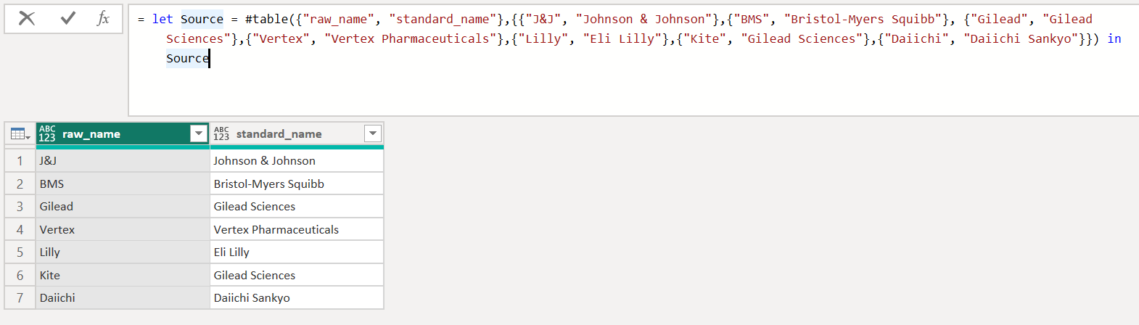

biotech_funding
let
Source = Csv.Document(File.Contents("C:\path\biotech_funding.csv"),[Delimiter=",", Columns=10, Encoding=65001, QuoteStyle=QuoteStyle.None]),
PromotedHeaders = Table.PromoteHeaders(Source, [PromoteAllScalars=true]),
ChangedType = Table.TransformColumnTypes(PromotedHeaders,{
{"deal_id", type text}, {"date", type date}, {"year", Int64.Type}, {"deal_type", type text},
{"acquirer_or_investors", type text}, {"target_or_company", type text}, {"value_usd_bn", type number},
{"description", type text}, {"is_megadeal", Int64.Type}, {"is_real_headline", Int64.Type}}, "en-US"),
MergedWithMap = Table.NestedJoin(ChangedType, {"acquirer_or_investors"}, company_name_map, {"raw_name"}, "map", JoinKind.LeftOuter),
ExpandedMap = Table.ExpandTableColumn(MergedWithMap, "map", {"standard_name"}, {"standard_name"}),
StandardizedName = Table.ReplaceValue(ExpandedMap, each [standard_name], each if [standard_name] = null then [acquirer_or_investors] else [standard_name], Replacer.ReplaceValue, {"standard_name"}),
RenamedStd = Table.RenameColumns(StandardizedName, {{"standard_name", "acquirer_or_investors_std"}}),
AddedOutOfScope = Table.AddColumn(RenamedStd, "out_of_scope_period", each if [year] < 2010 then 1 else 0, Int64.Type)
in
AddedOutOfScope
Before
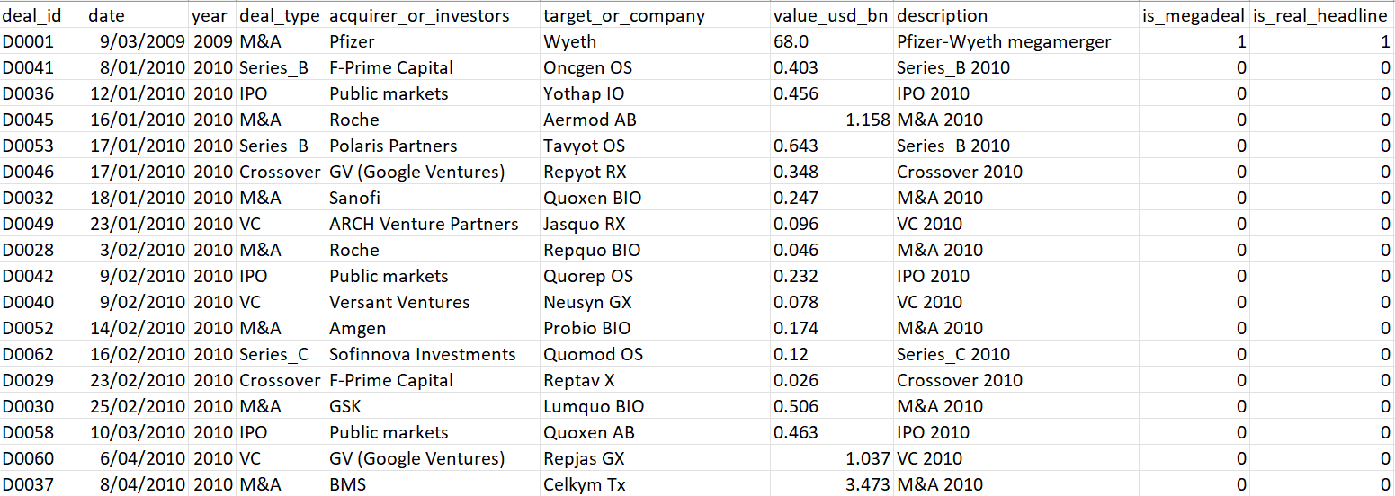
After
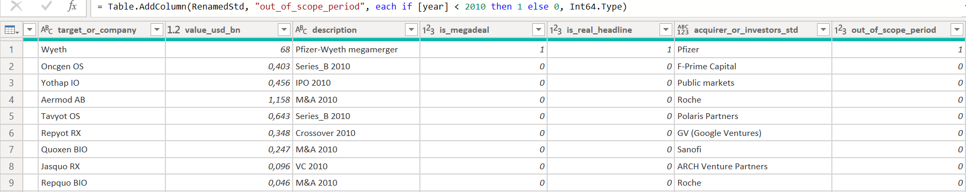

clinical_trials
let
Source = Csv.Document(File.Contents("C:\path\clinical_trials.csv"),[Delimiter=",", Columns=12, Encoding=65001]),
PromotedHeaders = Table.PromoteHeaders(Source, [PromoteAllScalars=true]),
ChangedType = Table.TransformColumnTypes(PromotedHeaders,{
{"trial_id", type text}, {"completion_date", type date}, {"year", Int64.Type}, {"sponsor", type text},
{"therapy_area", type text}, {"phase", type text}, {"enrollment_n", Int64.Type}, {"duration_months", Int64.Type},
{"outcome", type text}, {"is_success", Int64.Type}, {"is_failure", Int64.Type}, {"estimated_stock_impact_pct", type number}}, "en-US"),
MergedWithMap = Table.NestedJoin(ChangedType, {"sponsor"}, company_name_map, {"raw_name"}, "map", JoinKind.LeftOuter),
ExpandedMap = Table.ExpandTableColumn(MergedWithMap, "map", {"standard_name"}, {"standard_name"}),
StandardizedSponsor = Table.ReplaceValue(ExpandedMap, each [standard_name], each if [standard_name] = null then [sponsor] else [standard_name], Replacer.ReplaceValue, {"standard_name"}),
RenamedStd = Table.RenameColumns(StandardizedSponsor, {{"standard_name", "sponsor_std"}})
in
RenamedStd
Before
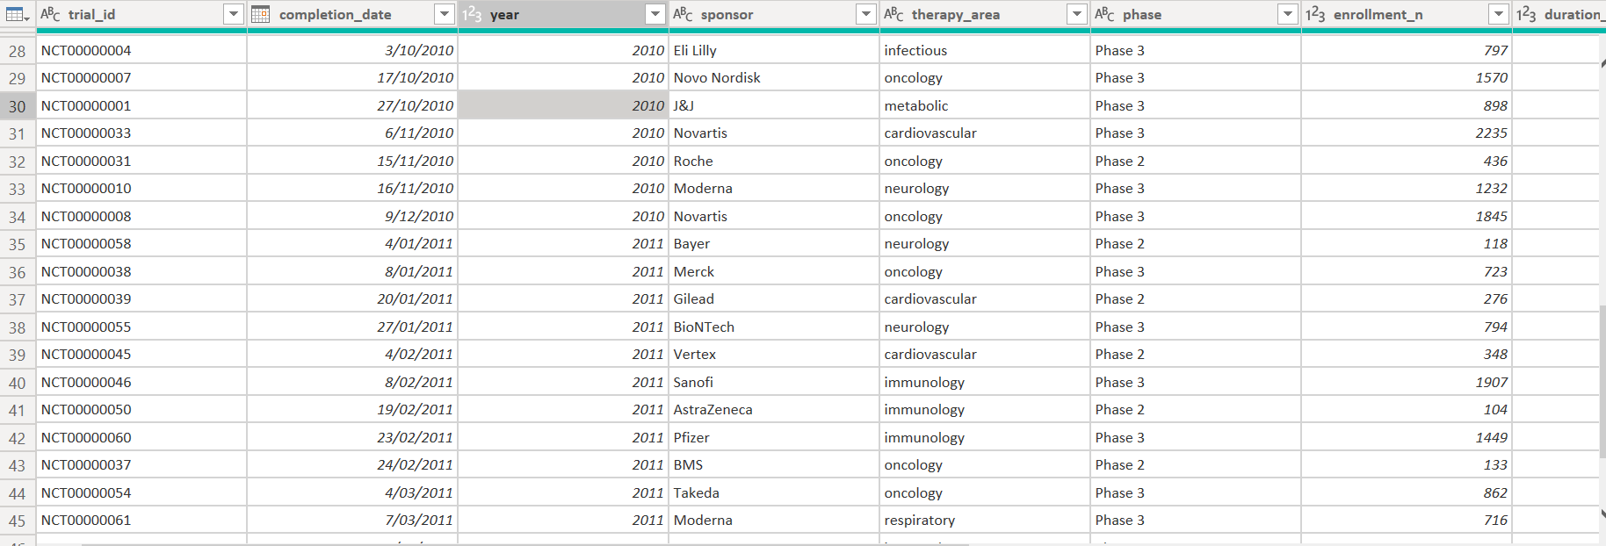
After
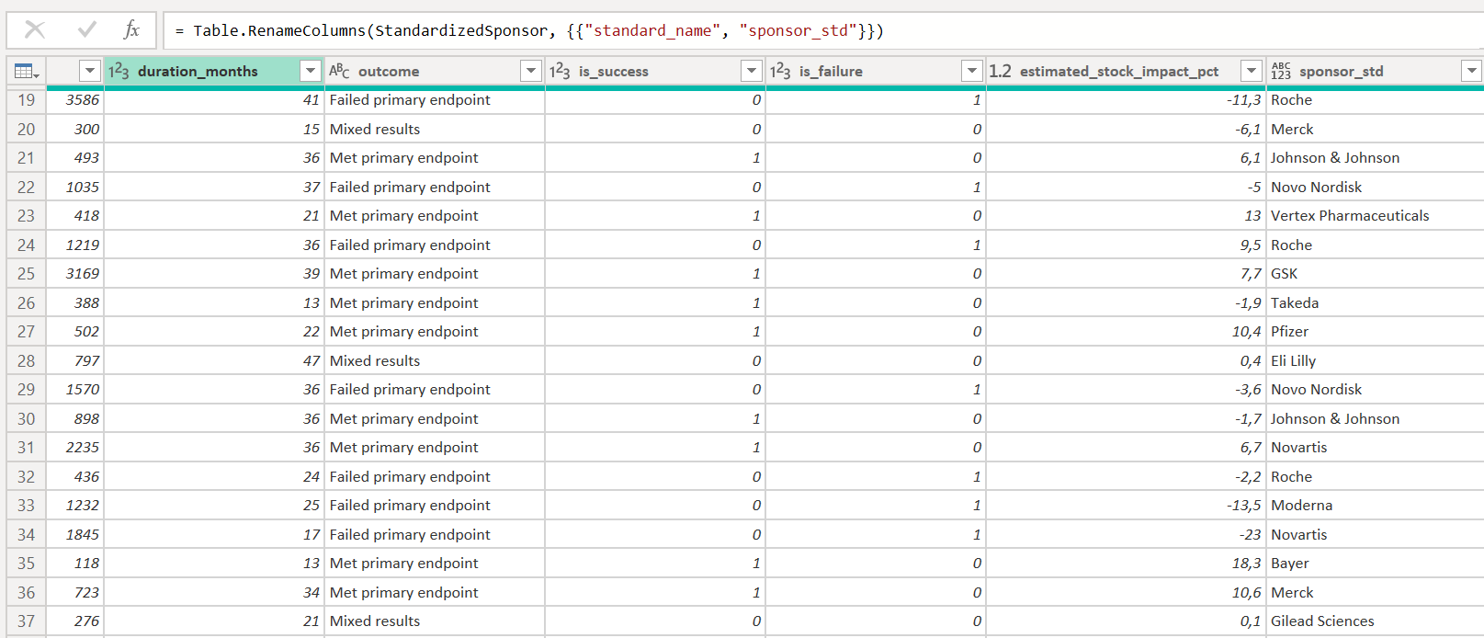

drug_approvals
let
Source = Csv.Document(File.Contents("C:\path\drug_approvals.csv"),[Delimiter=",", Columns=12, Encoding=65001]),
PromotedHeaders = Table.PromoteHeaders(Source, [PromoteAllScalars=true]),
ChangedType = Table.TransformColumnTypes(PromotedHeaders,{
{"approval_id", type text}, {"approval_date", type date}, {"year", Int64.Type}, {"drug_name", type text},
{"sponsor_company", type text}, {"drug_type", type text}, {"therapy_area", type text},
{"peak_sales_usd_bn_est", type number}, {"is_blockbuster", Int64.Type}, {"is_mega_blockbuster", Int64.Type},
{"description", type text}, {"is_real_headline", Int64.Type}}, "en-US"),
AddedComboFlag = Table.AddColumn(ChangedType, "is_combo_sponsor", each if Text.Contains([sponsor_company], "/") then 1 else 0, Int64.Type),
AddedPrimarySponsor = Table.AddColumn(AddedComboFlag, "primary_sponsor", each Text.BeforeDelimiter([sponsor_company], "/"), type text),
AddedSecondarySponsor = Table.AddColumn(AddedPrimarySponsor, "secondary_sponsor", each if [is_combo_sponsor] = 1 then Text.AfterDelimiter([sponsor_company], "/") else null, type text),
MergedWithMap = Table.NestedJoin(AddedSecondarySponsor, {"primary_sponsor"}, company_name_map, {"raw_name"}, "map", JoinKind.LeftOuter),
ExpandedMap = Table.ExpandTableColumn(MergedWithMap, "map", {"standard_name"}, {"standard_name"}),
StandardizedPrimary = Table.ReplaceValue(ExpandedMap, each [standard_name], each if [standard_name] = null then [primary_sponsor] else [standard_name], Replacer.ReplaceValue, {"standard_name"}),
RenamedStd = Table.RenameColumns(StandardizedPrimary, {{"standard_name", "primary_sponsor_std"}})
in
RenamedStd
Before
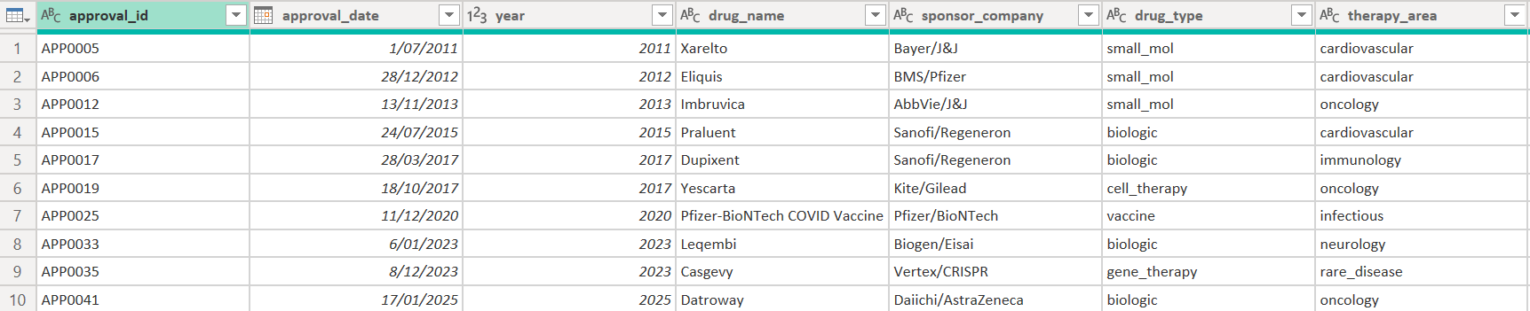
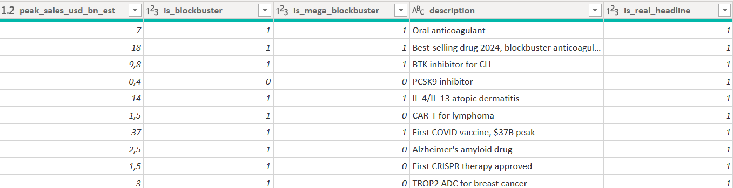
After
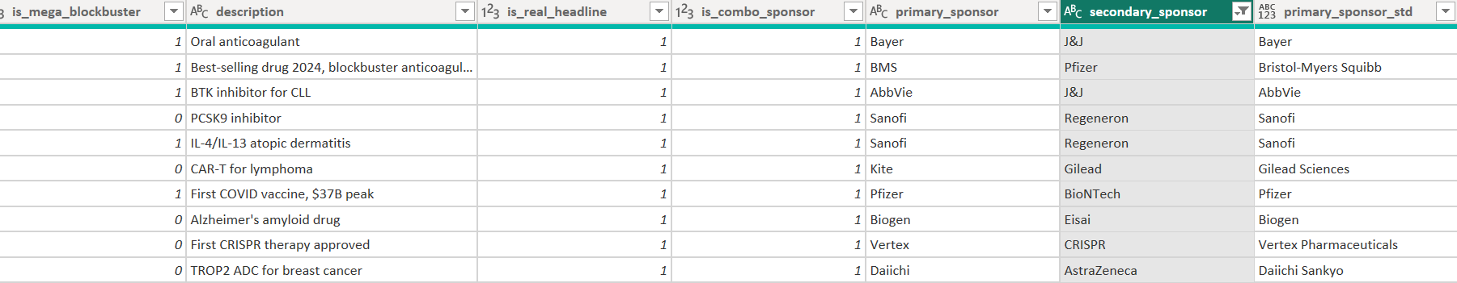

disease_burden
let
Source = Csv.Document(File.Contents("C:\path\disease_burden.csv"),[Delimiter=",", Columns=5, Encoding=65001]),
PromotedHeaders = Table.PromoteHeaders(Source, [PromoteAllScalars=true]),
ChangedType = Table.TransformColumnTypes(PromotedHeaders,{
{"year", Int64.Type}, {"region", type text}, {"disease", type text},
{"dalys_millions", type number}, {"global_dalys_millions", type number}}, "en-US"),
GroupedRecalc = Table.Group(ChangedType, {"year", "disease"}, {
{"global_dalys_millions_corrected", each Number.Round(List.Sum([dalys_millions]), 1), type number}}),
MergedRecalc = Table.NestedJoin(ChangedType, {"year", "disease"}, GroupedRecalc, {"year", "disease"}, "recalc", JoinKind.LeftOuter),
ExpandedRecalc = Table.ExpandTableColumn(MergedRecalc, "recalc", {"global_dalys_millions_corrected"}, {"global_dalys_millions_corrected"}),
AddedGapPct = Table.AddColumn(ExpandedRecalc, "gap_pct", each Number.Round((([global_dalys_millions_corrected] - [global_dalys_millions]) / [global_dalys_millions]) * 100, 1), type number),
AddedFlag = Table.AddColumn(AddedGapPct, "global_dalys_flag", each if Number.Abs([gap_pct]) > 5 then 1 else 0, Int64.Type)
in
AddedFlag
Before
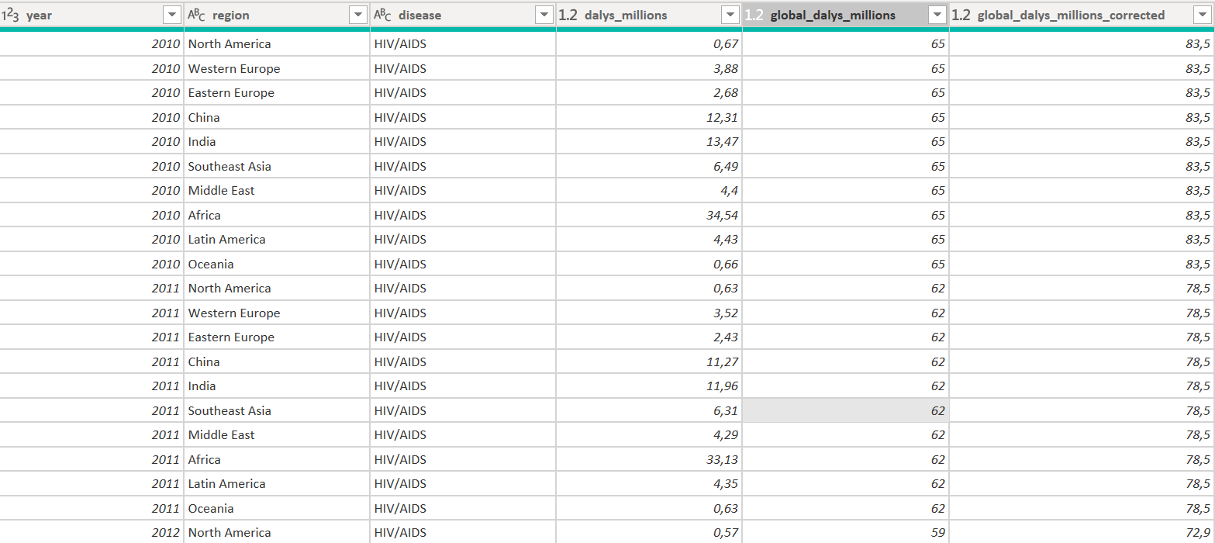
After
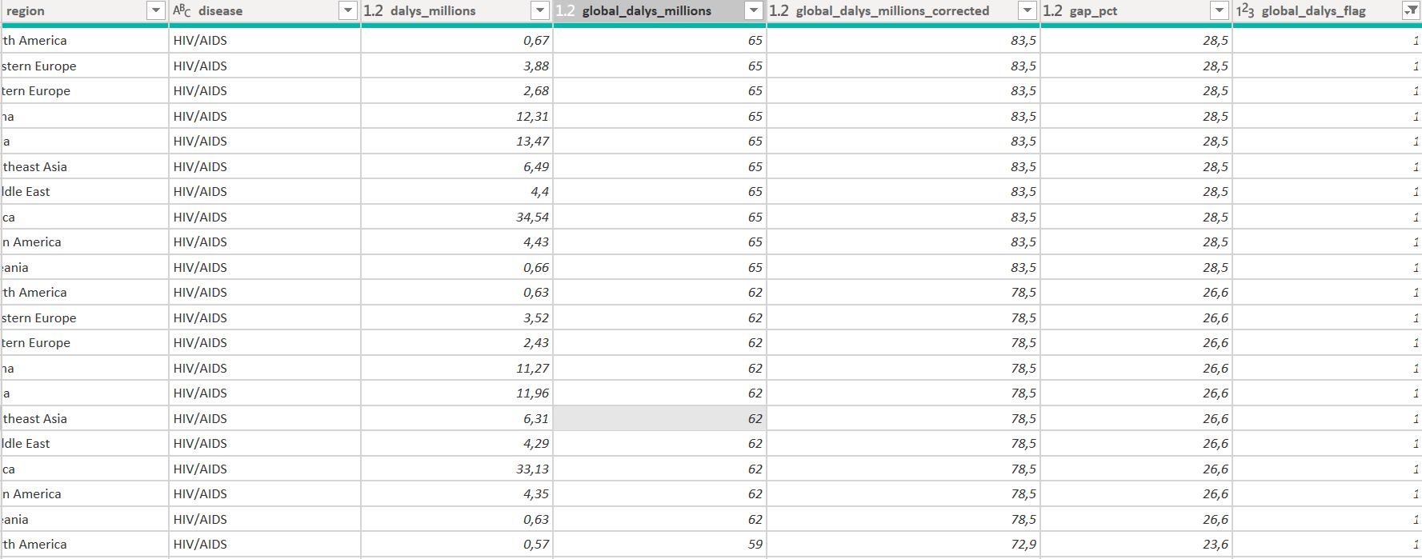

pharma_companies_financials
let
Source = Csv.Document(File.Contents("C:\path\pharma_companies_financials.csv"),[Delimiter=",", Columns=10, Encoding=65001]),
PromotedHeaders = Table.PromoteHeaders(Source, [PromoteAllScalars=true]),
ChangedType = Table.TransformColumnTypes(PromotedHeaders,{
{"year", Int64.Type}, {"company_name", type text}, {"ticker", type text}, {"country_iso3", type text},
{"segment", type text}, {"revenue_usd_bn", type number}, {"operating_margin_pct", type number},
{"operating_income_usd_bn", type number}, {"rd_spend_usd_bn", type number}, {"pipeline_size_est", Int64.Type}}, "en-US"),
TrimmedNames = Table.TransformColumns(ChangedType, {{"company_name", Text.Trim, type text}})
in
TrimmedNames
Before
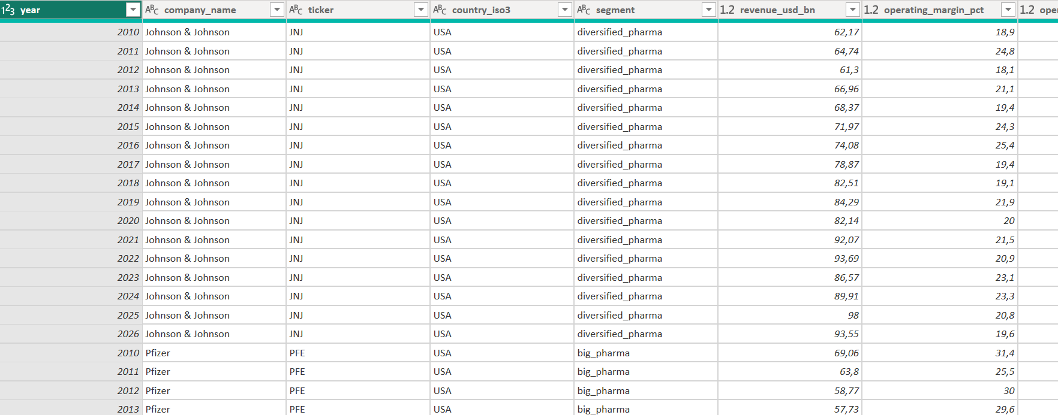
After


4. Data model and relationships in Power BI
With company names already standardized (the *_std columns), relating the three fact tables directly to pharma_companies_financials creates a modeling problem found while building this in Power BI: that table has one row per company PER YEAR (30 companies x 17 years), so company_name is not unique there. Power BI flags any relationship built directly on it as "many-to-many", which produces unreliable filtering in visuals. The fix below adds one small dimension table and avoids this entirely.

4.1 Build a Companies dimension
Create a new query that references pharma_companies_financials, keeps only the company-level columns, and removes the year-level duplicates, producing exactly one row per company (30 rows).
let
Source = pharma_companies_financials,
RemovedOtherColumns = Table.SelectColumns(Source, {"company_name", "ticker", "country_iso3", "segment"}),
RemovedDuplicates = Table.Distinct(RemovedOtherColumns, {"company_name"})
in
RemovedDuplicates
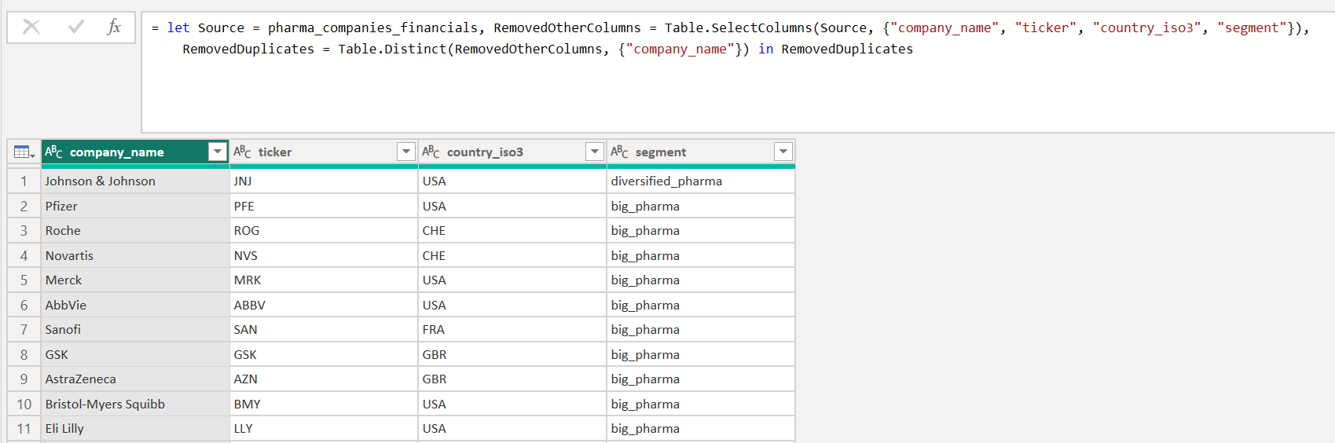
Then we build these 4 relationships (all many-to-one, pointing INTO Companies):
From the table - column | To table - column | Match
biotech_funding [acquirer_or_investors_std] | Companies [company_name] | 16% of rows (190/1208) — most acquirers here are VC/PE investors, not among the 30 companies in the financials table. Expected, not an error
clinical_trials [sponsor_std] | Companies [company_name] | 100% of rows (599/599)
drug_approvals [primary_sponsor_std] | Companies [company_name] | 63% of rows (455/722) — remaining sponsors are smaller biotechs outside the financials table.
pharma_companies_financials [company_name] | Companies [company_name] | 100% of rows (489/489)

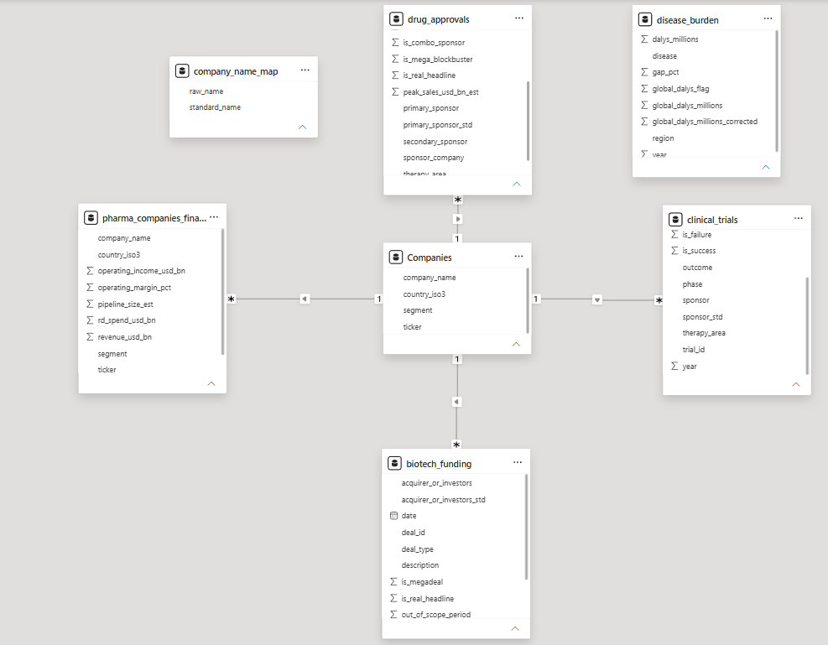

4.2 Year dimension
We Create a one-column Year table covering 2009-2026, not 2010-2026, the historical Pfizer-Wyeth deal (D0001, flagged out_of_scope_period = 1) is dated 2009 and would otherwise never match any year filter. Relate Year[year] to the [year] column in all 5 data tables, each many-to-one.
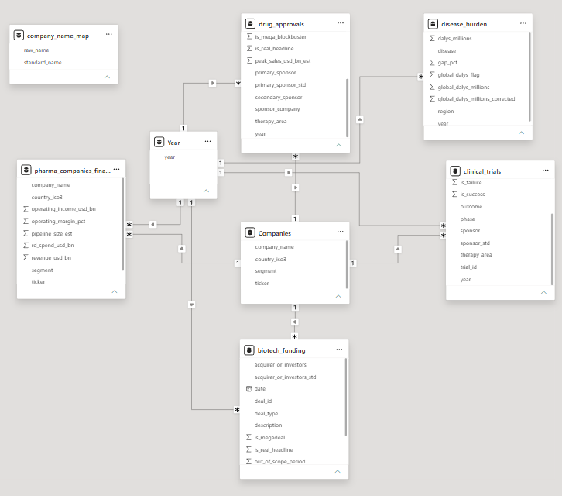

4.3 Therapy-area bridge for Indicator 3
The most direct approach — a 20-row bridge listing every disease with its therapy_area, related straight to drug_approvals[therapy_area] — creates the same many-to-many problem as 4.1: several diseases share one therapy area (e.g. both "Cardiovascular disease" and "Stroke" map to cardiovascular), so therapy_area repeats and isn't unique in that bridge. The corrected design uses a small dimension of only the 8 distinct therapy areas, and pushes the disease-to-area mapping onto disease_burden itself as an added column, so both fact tables relate to the same small dimension instead of to each other.
AddedTherapyArea = Table.AddColumn(AddedFlag, "therapy_area", each
if List.Contains({"Cardiovascular disease","Stroke"}, [disease]) then "cardiovascular"
else if [disease] = "Cancer" then "oncology"
else if [disease] = "Diabetes" then "metabolic"
else if List.Contains({"Chronic respiratory","Lower respiratory infections"}, [disease]) then "respiratory"
else if List.Contains({"Mental disorders","Self-harm"}, [disease]) then "psychiatry"
else if List.Contains({"Alzheimer's & dementias","Neurological disorders"}, [disease]) then "neurology"
else if List.Contains({"HIV/AIDS","Tuberculosis","Malaria","COVID-19"}, [disease]) then "infectious"
else if List.Contains({"Diarrheal diseases","Liver disease"}, [disease]) then "gastrointestinal"
else null, type text)
in
AddedTherapyArea

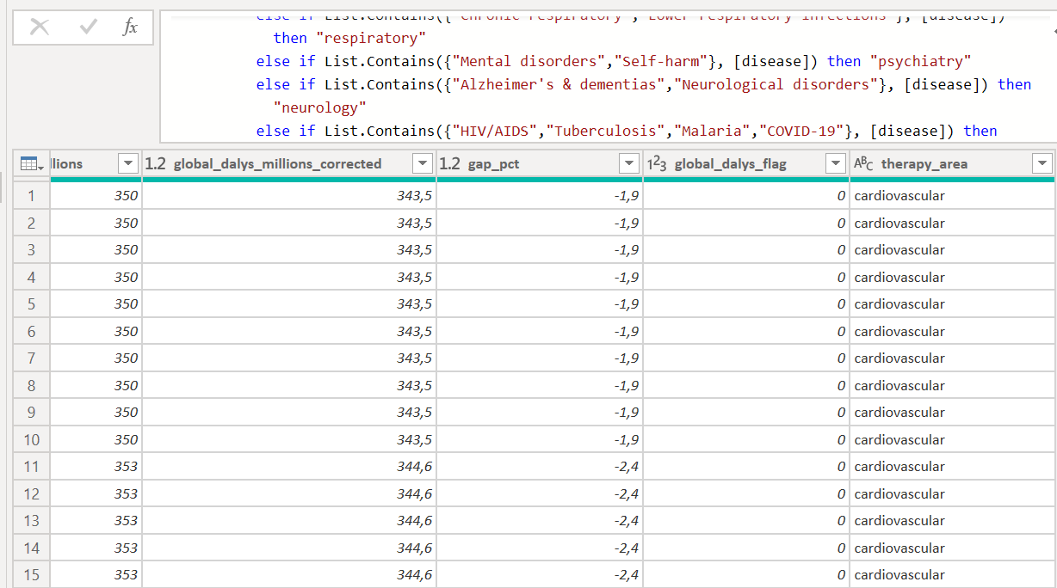

Relate disease_burden[therapy_area] to TherapyArea[therapy_area] (many-to-one), and drug_approvals[therapy_area] to TherapyArea[therapy_area] (many-to-one). Both fact tables now share a correctly-shaped common dimension instead of connecting to each other directly.
Coverage note: drug_approvals also contains 4 therapy areas with no disease_burden equivalent (dermatology, immunology, ophthalmology, rare_disease). Those rows simply won't match anything in TherapyArea and are excluded from Indicator 3 — consistent with the coverage note already in section 5.3.
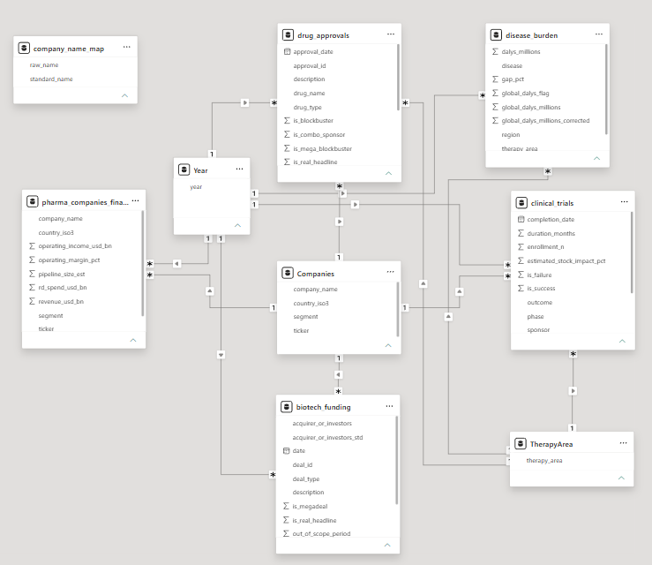

Three proposed new indicators

Indicator 1 — Clinical Trial Success Rate (%)
Management question: in which therapy areas is a Phase 2/3 trial most likely to meet its primary endpoint? Relevant for R&D portfolio allocation decisions.
Formula: % of trials with is_success = 1 out of total completed trials, by therapy area / sponsor / year.
// Calculated column in Power Query (clinical_trials)
// AddedFlag = Table.AddColumn(RenamedStd, "is_success_flag", each [is_success], Int64.Type)

// DAX measure in Power BI
Trial Success Rate % =
DIVIDE(
CALCULATE(COUNTROWS(ClinicalTrials), ClinicalTrials[is_success] = 1),
COUNTROWS(ClinicalTrials)
) * 100
Therapy area | Trials | Successes | Success rate
cardiovascular | 67 | 54 | 80.6%
respiratory | 23 | 18 | 78.3%
infectious | 59 | 44 | 74.6%
gastrointestinal | 23 | 15 | 65.2%
metabolic | 47 | 29 | 61.7%
rare_disease | 47 | 26 | 55.3%
immunology | 74 | 39 | 52.7%
psychiatry | 17 | 7 | 41.2%
oncology | 180 | 63 | 35%
neurology | 62 | 17 | 27.4%
Finding: cardiovascular (80.6%) and respiratory (78.3%) have the highest success rates; oncology (35.0%) and neurology (27.4%) the lowest, despite concentrating the largest number of trials — implying higher R&D risk in those areas.

Indicator 2 — R&D Efficiency (Approvals per $1B invested)
Management question: which companies convert R&D spend into FDA approvals most efficiently? Useful for benchmarking R&D productivity across competitors.
Formula: number of approvals (primary_sponsor_std) ÷ cumulative R&D spend (rd_spend_usd_bn) for that company, joining drug_approvals with pharma_companies_financials on the standardized company name.
// DAX measure in Power BI (requires relationship DrugApprovals[primary_sponsor_std] -> PharmaFinancials[company_name])
Approvals per $B RD =
DIVIDE(
CALCULATE(COUNTROWS(DrugApprovals)),
SUM(PharmaFinancials[rd_spend_usd_bn])
)
Company | Approvals (2010-26) | Cumulative R&D (USD bn) | Approvals / USD bn
Vertex Pharmaceuticals | 28 | 21.4 | 1.305
Regeneron | 24 | 31.9 | 0.752
Novo Nordisk | 30 | 71.8 | 0.418
Amgen | 31 | 104.3 | 0.297
Eli Lilly | 25 | 92.6 | 0.27
Bristol-Myers Squibb | 26 | 96.4 | 0.27
Takeda | 18 | 69.8 | 0.258
GSK | 23 | 89.7 | 0.256
Gilead Sciences | 26 | 103.7 | 0.251
AstraZeneca | 26 | 106.8 | 0.243
Finding: Vertex Pharmaceuticals (1.31) and Regeneron (0.75) are notably more efficient at converting R&D into approvals than large diversified pharma companies (Amgen, Gilead Sciences, AstraZeneca ≈0.24-0.30), consistent with more focused R&D models. Note: Gilead Sciences' figure includes the approvals originally logged under "Kite" — see 2.1/2.2 — without that fix its approval count, and therefore its efficiency ranking, would have been understated.

Indicator 3 — Unmet Need Index
Management question: is drug-approval investment by therapy area proportional to the actual disease burden (DALYs)? Identifies underserved investment opportunity areas.
Formula: sum of corrected global DALYs (2010-2026) for the diseases mapped to a therapy area ÷ number of approvals in that therapy area.
// DAX measure in Power BI (requires TherapyArea dimension + disease_burden[therapy_area] from 4.3)
Unmet Need Index =
VAR BurdenSinDuplicar =
SUMX(
SUMMARIZE(disease_burden, disease_burden[year], disease_burden[disease], "burden", MAX(disease_burden[global_dalys_millions_corrected])),
[burden]
)
RETURN
DIVIDE(BurdenSinDuplicar, CALCULATE(COUNTROWS(drug_approvals)))
Therapy area | DALY burden (millions, cumulative) | Approvals | Unmet need index
gastrointestinal | 1904 | 10 | 190.4
cardiovascular | 9029.4 | 50 | 180.6
psychiatry | 3503.2 | 20 | 175.2
respiratory | 3362.4 | 20 | 168.1
infectious | 3348.9 | 57 | 58.8
neurology | 4859 | 94 | 51.7
metabolic | 1300.9 | 39 | 33.4
oncology | 4225.7 | 276 | 15.3
Coverage note: Kidney disease, Maternal disorders, Neonatal disorders, and Road injuries have no equivalent therapy area in drug_approvals and are excluded from the index — a dataset taxonomy limitation, not a data error. Finding: gastrointestinal (190.4) and cardiovascular (180.6) show the highest disease burden per recorded approval, suggesting an imbalance between medical need and regulatory activity in those areas compared to oncology (15.3, the most "served").

7. Analysis Report — Visualizations & Dashboards (10-page report)
[ Pending — this is the separate 10-page PDF report required by item 3 of the assignment: management-relevant findings and questions the data can answer, with visualizations/dashboards where useful. To be added by the group, drawing on the cleaned data and 3 indicators documented above. ]

8. Dashboard Screenshots (minimum 5 visualizations)
[ Pending — insert here the Power BI Desktop screenshots for item 6 of the assignment: at least 5 dashboard visualizations, with the Power BI Desktop timestamp visible in the screenshot, telling the narrative of the analysis. ]

Data source
Global Healthcare & Pharma 2010-2026 — Kaggle (Sergio Nefedov). https://www.kaggle.com/datasets/sergionefedov/global-healthcare-and-pharma-2010-2026

