Full Project NEB Summary
charming_asp0eps8_w2c0p5_linear_R-P
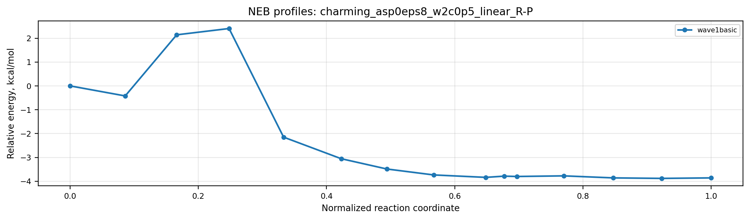
Metric | wave1basic
Converged | 1.000
Steps | 105.000
Cycles | 105.000
Final Ea | 2.407
Peak bead | 3.000
Final fmax | 0.049
P - R | -3.857
Spline Ea | 2.947

charming_histone2_w2c0p5_linear_R-P
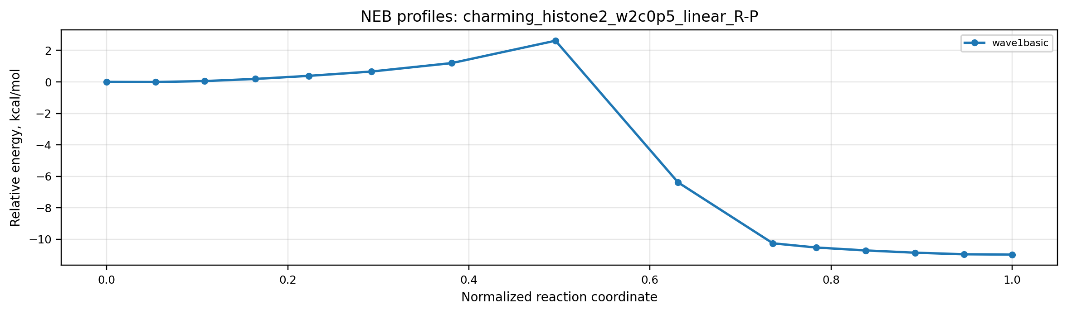
Metric | wave1basic
Converged | 1.000
Steps | 176.000
Cycles | 176.000
Final Ea | 2.618
Peak bead | 7.000
Final fmax | 0.047
P - R | -10.976
Spline Ea | 2.912

charming_cocaF_stage2_ip_w2c0p5_linear_int3-prod
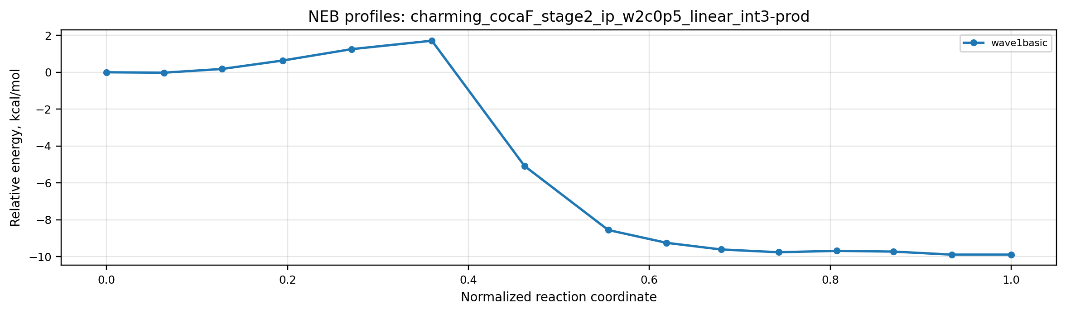
Metric | wave1basic
Converged | 1.000
Steps | 238.000
Cycles | 238.000
Final Ea | 1.711
Peak bead | 5.000
Final fmax | 0.035
P - R | -9.886
Spline Ea | 2.108

charming_halo0_w2c0p5_linear_R-P
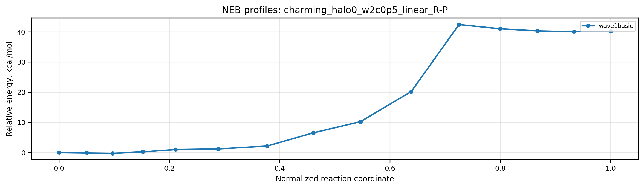
Metric | wave1basic
Converged | 1.000
Steps | 157.000
Cycles | 157.000
Final Ea | 42.463
Peak bead | 10.000
Final fmax | 0.048
P - R | 40.212
Spline Ea | 43.730

