# About ‘BibEl’

The tool is conceived with the goal to catalogue and exploit extensive bibliographic material, originally in the framework of ‘AEGIS’ research grant between ISAE-SUPAERO and SAFRAN Group (2016-2021). Along with keeping track of the ever increasing number of bibliographical entries, the current version of the program is also dedicated to creating an extensive database of meta-data which in the long run might prove useful to endeavours such as:

* Collecting various bibliographic entries that conform to different criteria,
* Synthesising personal notes, comments and quotes from the bibliographic entries conforming to the desired criteria (e.g. themes, authors, time frame…),
* Exchanging files between different parties,
* Eliminating redundancies in the user libraries.

The long term goal is to create a framework for comprehensive state of the art analysis and synthesis, to be able to dynamically outline research histories on given themes, or by different people and/or entities, mutually compare them along a timeline, and much more. The current version of bibliography storage and referencing tool, in itself equivalent to available tools like e.g. [Mendeley](https://www.mendeley.com/), is the foundation for this future endeavour.

The important details for users as well as the program development roadmap are presented in the following sections.

## Version History and Contributors

*Version 0.0, April 2020, Sébastien Andreu (dev.), Aleksandar Joksimovic (superv.)*

* *Basic layout of the menu defined, and the main functions are enabled.*
* *Most of the implemented functionalities work correctly, but there is more to be finalised, e.g.:*
  + *Extraction works properly only when we extract files, but not metadata.*
  + *File filtering in the “Use library” is not sufficiently robust.*
  + *Author management in “Add files” has some quirks to be corrected.*
  + *No document types are implemented yet (e.g. book, conference article) in “Add files”, so technically this version of the program is still useless in practice.*
  + *Other minor quirks that do not impair the use of the program.*

----

*Version 1.0, June 2020, Sébastien Andreu (dev.), Aleksandar Joksimović (superv.)*

* *Submenu layouts finalised for a first working version.*
  + *All the different types of entries (articles, reports, notes, etc.) and their characteristic meta-data enabled and tested for addition into database.*
  + *File filtering robustness verified for the 4 available filters (title, date, document type, theme).*
  + *There still exists a minor problem when a dummy file has to be created as a new entry, it creates problems with filtering and extraction afterwards, so care should be exercised when an entry without an input file is created.*
  + *Robust exportation enabled for bibliographic files, raw meta-data and meta-data in BibTeX format.*

## Main Menu

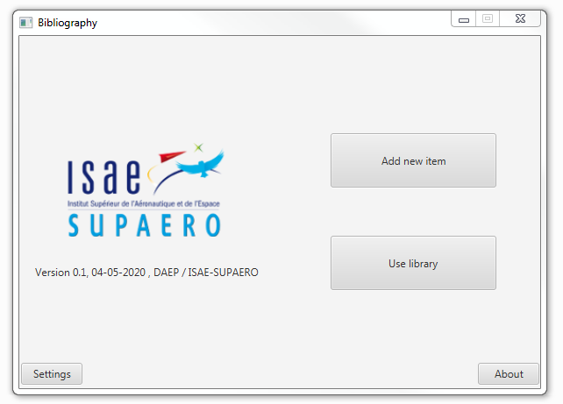

**Main menu and options.**

The main menu is available to the user at the program launch. The menu provides access to the two main modules of the tool:

1. **Add new item**: dedicated to creation of new bibliographic entry (files and their metadata) in the common bibliography database.
2. **Use library**: dedicated to browsing the library (files), editing the existing entries (files and/or their metadata), and retrieving one or multiple entries (files and/or their metadata) for further use, according to criteria selected by the user (e.g. theme, date, etc.).

Moreover, the following two are available:

1. **About**: brief overview of the purpose and functionalities of the program.
2. **Settings**: an additional option that allows the user to specify the address for the database.

# Add New Item

The purpose of this module is to create new entries in the bibliography database, which contain files and the various ‘meta-data’ about the entry, as defined by the user. The interface provides access to the entirety of meta-data information to be entered by the user. The exact structure of this information will depend on the type of document that is entered in the database (book, conference article, lecture notes, etc.).

In the current version of the tool, certain meta-data are common for all the document types: *Title*, *Date*, *Authors*, *Themes*, *Document Type*, *Confidentiality*, *Read*, *Comments*, *Keywords*, *Notes*, *Quotes*. These meta-data are obligatory; otherwise the entry will not be accepted in the database. The rest of the meta-data will vary according to the selected document type. More details on each meta-datum are provided below.

Once all the meta-data of interest are written in the dedicated fields, the entry is added to the database by clicking on the “Save” command at the bottom of the menu; it is possible to subsequently edit the entries in the “Use Library” menu. When an entry is saved, a copy of the selected file is created in the dedicated folder; the associated meta-data are stored in separate .db and .json files. These three units constitute what we refer to as ‘the database”. The database files are by default stored in the same folder where the tool executable is situated. The folder that contains the bibliographic files can be moved by the user to a different address, by modifying it in “Settings” option of the main menu.

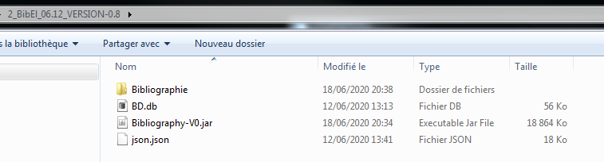

**Database in the working folder.**

When creating the new entry, the original title of the file will be replaced by a generic “label”, in this version (i.e. prone to change if deemed useful) defined as “[1].[2]_[3]_[4]_[5]”, with:

1. First letter of the first author name,
2. Surname,
3. First letters of the first theme of the document,
4. Three letters of the publication month,
5. Publication year.

Example:

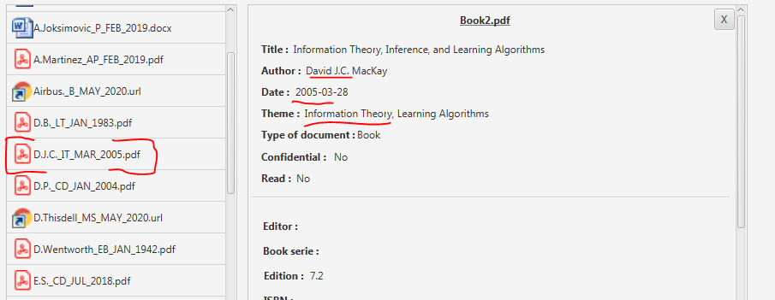

**File label and meta-data used to generate it.**

It is the intention that this label be used in various other databases (in the sizing tools, etc.) for keeping track of the origin of the data used, or later on for easier cross-referencing between different database entries themselves.

Once a new entry is added to the database, the menu is cleared for further use.

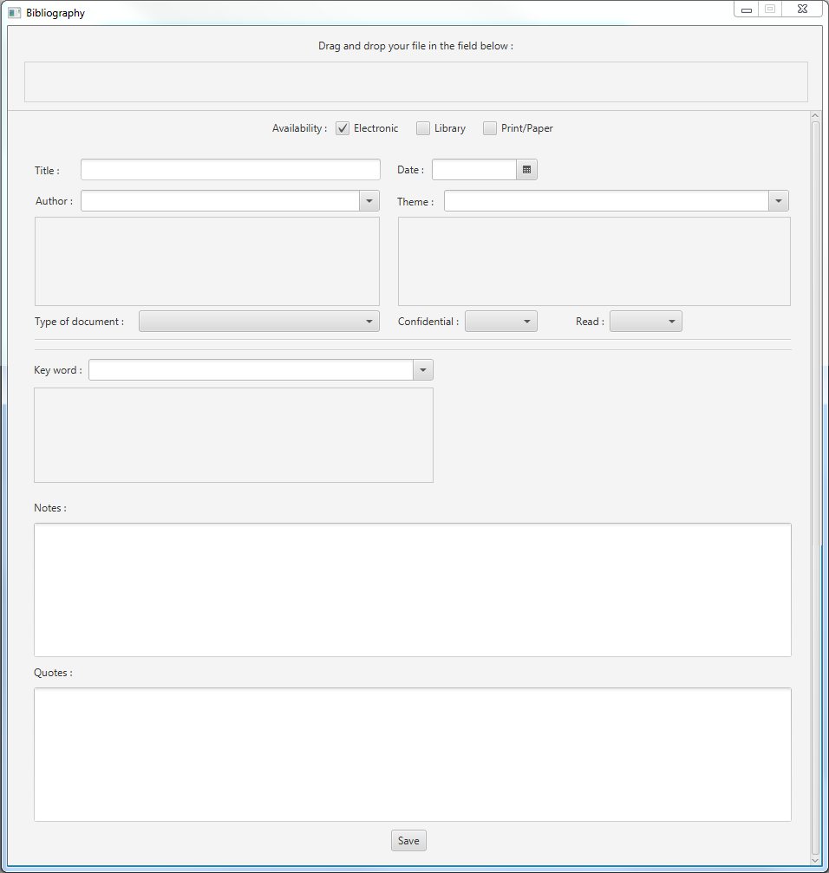

**“Add New Item” interface.**

Drag/drop file:

The tool can be used in parallel while reading a document of interest. The first step to create a new entry is to drag and drop the file into the box. While in all probability the majority of the files will be .pdf – any file is accepted by the tool (.docx, .xlsx, .pptx, .url, etc.).

Availability:

The user can select whether the given entry is available only in electronic form (‘Electronic’), or if it is available elsewhere, i.e. in the institute library (‘Library’) or if the user holds a personal copy of the given item (‘Print/Paper’).

If the user is creating an entry based on a physical item, i.e. for which a file is not available, the idea is that a dummy empty file is created by the tool to serve as placeholder and container for the metadata until an appropriate file can be added at a later point. This functionality is not yet implemented, and such entries should not be created by the user until this is corrected.

‘Availability’ meta-data is not available as a filter in “Use Library” in the current version of the tool.

Title:

Title of the document being added to the database.

In the current version of the tool, it is possible to filter the documents according to the title.

Date:

Publication date of the document at hand. If the complete date is unknown, insert 1st of January of the publication year; publication year is important for exporting citation information in “Use Library”.

In the current version of the tool, it is possible to filter the documents according to the date range.

Authors:

Authors of the document. Each author is remembered in the database, i.e. every name, once added, will be auto-filled each time it appears again.

In the current version of the tool, there is no distinction between name and surname; it is therefore advised to add name(s) firstly, followed by the surnames, to avoid errors when extracting the meta-data for citations (further details in “Use Library”).

Themes:

Theme(s) relevant to the document being added. This should cover broad scopes such as ‘propulsion’, ‘design’, ‘mathematics’ and such; for more detailed labels, use “Keywords”.

As for the authors above, the themes are saved in the database for repeated use.

Confidentiality:

A simple “yes/no” mark to enable protection of confidential bibliographic entries from being exported.

In the current version of the tool, the confidentiality filter is not implemented in “Use Library” module.

Read:

A simple “yes/no” mark to allow the user to keep track on whether the document at hand was read in its totality or not.

Comment:

Comments by the reader, on anything that concerns the document itself.

Notes:

Notes on contents of the document.

Quotes:

Interesting and/or relevant quotes extracted from the document.

Document Type:

The current version of the tool covers the most of typical document types we encounter in research. In the current version of the tool it is possible to filter the database according to the document type.

The following types are available (along with their relevant meta-data), most of them being self-explanatory:

* **‘AEGIS Report’**: theme report written by the contributors to AEGIS (2016-2021).
  + Roadmap track: One of the four AEGIS roadmap tracks, to which this report belongs.
  + Roadmap theme: AEGIS theme within the above roadmap track.
* **‘Book Chapter’**: chapter of a textbook, dedicated to a certain topic.
  + Editor: book editor, if applicable.
  + Book series: series to which the book belongs, if applicable.
  + Edition: edition number, if applicable.
  + ISBN: ISBN code of the book of the book to which the chapter belongs.
  + Publisher: publisher of the book at hand.
  + Publisher office: location of the book publisher office.
  + Online reference: if applicable, URL to the book website, for more details.
* **‘Conference Article’**: article presented at a conference.
  + Conference name: title of the conference.
  + Conference organiser: name of the body that organises the conference.
  + Conference place: city/country where the conference takes place.
  + Paper code: code of the conference paper, if applicable.
  + Online reference: URL of the paper, if applicable.
  + Affiliation: affiliation of the article authors; possibility to add several, in case the paper is co-written between several entities. It is intended to correlate the author names and the affiliation, but this is not implemented in the current version of the tool.
* **‘Conference Presentation’**: presentation of a conference article, or a keynote presentation.
  + *The same meta-data as ‘Conference Paper’.*
* **‘Internal Document’**: document created by ISAE-SUPAERO stuff primarily for sharing information internally with the institute staff.
  + Type: presentation, report or notes/minutes of meeting.
* **‘Journal Article’**: article published in a journal.
  + DOI: digital objects identifier of the article.
  + Journal Title: title of the journal where the article is published.
  + Journal Volume: volume of the journal where the article is published.
  + Journal Number: number/issue of the journal where the article is published.
  + Page: start to end pages, separated with a hyphen.
  + Publisher: name of the journal publisher.
  + Online reference: URL of the article, if applicable.
  + Affiliation: see ‘Affiliation’ under ‘Conference Paper’.
* **‘Lecture Notes’**: written lecture notes or course slides.
  + Course title: name of the course to which the notes belong.
  + University: university where the course is/was given.
  + Year: year when the course took place.
  + Online reference: URL where the notes are available, if applicable.
* **‘MSc Thesis’**: master’s thesis.
  + Supervisors: thesis supervisors; in the current version only one can be used.
  + Thesis reference: in case the document has a reference code.
  + Online reference: URL of the thesis, if applicable.
  + Affiliation/University: entities involved in supervision of the thesis. It is intended to correlate the author/supervisor names and the respective affiliations, but this is not implemented in the current version of the tool.
* **‘Newspaper/Magazine Article’**: article from a published/printed newspaper or magazine.
  + Name: name of the newspaper/magazine where the article was published.
  + Number: issue number.
  + Online reference: URL of the article, if applicable.
  + Publisher: name of the publisher of the periodical.
  + Affiliation: if applicable, affiliation of the article author(s) or the institution(s) referenced in the text. It is intended to correlate the author names and the respective affiliations, but this is not implemented in the current version of the tool.
* **‘Online Article’**: article published on an online platform.
  + Access date: date when the article was accessed, i.e. when the meta-data were picked up.
  + Website: URL of the article.
  + Affiliation: if applicable, affiliation of the article author(s) or the institution(s) referenced in the text. It is intended to correlate the author names and the respective affiliations, but this is not implemented in the current version of the tool.
* **‘Patent’**: patent.
  + Patent number: reference number of the patent.
  + Online reference: URL of the patent, e.g. on Google patents.
  + Affiliation: if applicable, affiliation of the patent author(s). It is intended to correlate the author names and the respective affiliations, but this is not implemented in the current version of the tool.
* **‘PhD Thesis’**: doctoral thesis.
  + Supervisors: thesis supervisors; in the current version only one can be used.
  + Online reference: URL of the thesis, if applicable.
  + Affiliation/University: entities involved in supervision of the thesis. It is intended to correlate the author/supervisor names and the respective affiliations, but this is not implemented in the current version of the tool.
* **‘Press Release’**: official press release by an organisation/company/etc.
  + Access date: date when the article was accessed, i.e. when the meta-data were picked up.
  + Online reference: URL of the article.
  + Affiliation: if applicable, affiliation of the article author(s) or the institution(s) referenced in the text. It is intended to correlate the author names and the respective affiliations, but this is not implemented in the current version of the tool.
* **‘Software Manual’**: software user manual.
  + Software name: name of the software in question.
  + Software version: version of the software covered by the manual.
  + Online reference: URL of the manual, if applicable.
  + Affiliation: institutions affiliated to this software (developers, universities, OEM’s), if applicable.
* **‘Standard’**: technical standard issued by an official body.
  + Title: title of the standard.
  + Online reference: URL of the standard, if applicable.
* **‘Student Report’**: project report by ISAE-SUPAERO students.
  + Supervisors: student project supervisors; in the current version only one can be used.
  + Project type: type of the student project (PIR, PIE, Research project, internship, etc.). Since there is a small finite number of the projects (these can change over the next years, of course) these ought to be handled either by means of a drop menu or the same way as authors or themes, but it is not implemented in the current version.
* **‘Technical Report’**: published report or study (notable example: NASA technical reports).
  + Report reference: reference code of the report, if applicable.
  + Online reference: URL of the report, if applicable.
  + Affiliation: institutions affiliated to this report.
* **‘Textbook’**: a published textbook on a given topic. Curriculum writings by professors fall under ‘Lecture Notes’.
  + Editor: book editor, if applicable.
  + Book series: series to which the book belongs, if applicable.
  + Edition: edition number, if applicable.
  + ISBN: ISBN code of the book.
  + Publisher: publisher of the book at hand.
  + Publisher office: location of the book publisher office.
  + Online reference: if applicable, URL to the book website, for more details.

It is intended to enable many more further functionalities in the future. In the first place, to have a possibility to correlate different entries in the database, e.g. a conference article with the corresponding conference presentation, or a PhD thesis during which the article was written (if that is the case), or such. This can be further extended to documents that cite other documents in the database, etc.

# Use Library

This module is dedicated to:

* Filtering the library according to criteria of interest (corresponding to the meta-data),
* Extracting the bibliographic entries corresponding to the filtering criteria for further exploitation (providing bibliography to students, extracting documents to share with collaborators or other),
* Extracting the meta-data of interest, notably personal notes, comments and quotes, along with the associated bibliographic information (for a further use in article writing or other),
* Extracting citation information in different formats, directly useful in article writing (currently only [BibTeX](https://www.economics.utoronto.ca/osborne/latex/BIBTEX.HTM) format is implemented).

The interface is presented in the figure below.

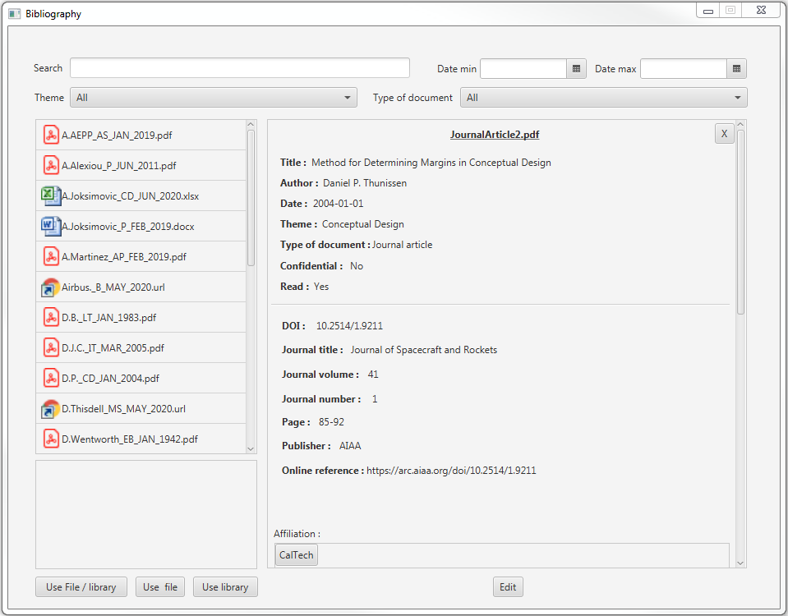

**“Use Library” interface.**

Once the menu is opened, all the files contained in the database are visualised in the window with the file icon and the generic label; the user can browse through these by scrolling manually. Clicking on any entry will open a menu to visualise the meta-data of that entry, on the right hand side of the window. The meta-data can be edited by clicking on the “Edit” button, which brings the user back to the “Add New Item” menu, where the entry can be saved in the database once updated. The idea is to also enable the user to replace the file in the database through this menu, but this functionality has not been implemented in the current version of the tool.

Limited filtering is enabled in the current version of the tool; the final goal is to be able to leverage all the meta-data to filter through the files in the most dynamic way possible. Currently available filters are:

* Search: manually typing either the document title or the label title in this field will filter the documents accordingly.
* Date min/max: possibility to enter the time frame of interest, according to the document publication date.
* Theme: Possibility to filter according to the themes of interest. In the current version of the tool, it is possible to select only one theme at a time.
* Document type: The same as for the ‘Theme’, applied to the ‘Document type’ meta-data.

The filters are not mutually exclusive, i.e. they can be used in combination with each other (e.g. once the database is filtered by theme, the user can select the time frame of interest to narrow the selection further, and so on).

Once the filtering is carried out, the user needs to select the files to be extracted from the database. In the current version of the tool, three options are available:

* Export files & meta-data: Selected bibliography files and their meta-data are exported in a .zip file to an address selected by the user.
* Export files: Only the selected bibliography files will be exported in a .zip file.
* Export meta-data: Only the meta-data of the selected files will be exported in a bundled .txt file, alongside the BibTeX citation in a separate .txt file.

The main idea in the long run is to enable the user to choose which meta-data is to be exported, as well as the format of citations (e.g. format of different journals, conferences, etc.), but it will be further refined in the next versions of the tool. In the current version, all the meta-data that are available are exported. Moreover, a separate file is created which contains an export in BibTeX-friendly format, to facilitate integration of these citations in LaTeX documents.

Once an extraction is completed, the workspace is reset to the initial version so the same operation can be carried out as many times as necessary.