README

# Description

This lab consists of 3 parts, the first part is a noise cancelling application where we will analyse a sum of multiple signals and filter out 1 of them. The second exercise will analyse a heart beat and give us all the computed values from that heartbeat. The last part is a game ( red alert ) that I’ve modified from the original.

YouTube video link: https://youtu.be/Ll9MLjRLWzo

# User guide

# Program 1: noise_canceling.py

In this program we will create a noise cancelling application, the waveform that the code will analyse consists of 3 seperate waves combined into 1. The program will filter out the max frequency and convert the signal back to the time domain.

First we need to create 3 different tones, to do this I used the following site and I downloaded 3 sine waves with a frequency of 100Hz, 200Hz and 500Hz

https://www.wavtones.com/functiongenerator.php

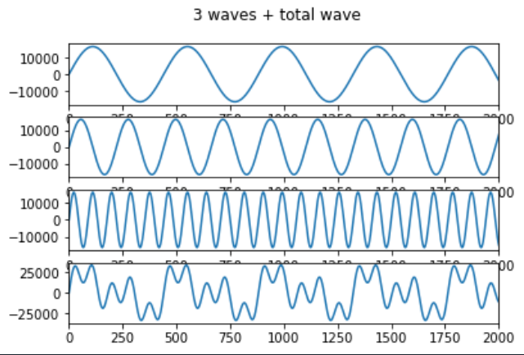After running the program you’ll see the following plots

Figure 1: 3 individual waves + the sum of those 3

As we can see, the 4th signal looks nothing like the first 3 signals, the signals have a frequencie off 100Hz, 200Hz and 500Hz respectively. Now we would like to filter out the 500Hz signal from our 4th signal so we only have the sum of signal 1 + signal 2.

Next the program will plot out a frequency diagram which shows the frequencies that are detected in our main signal.

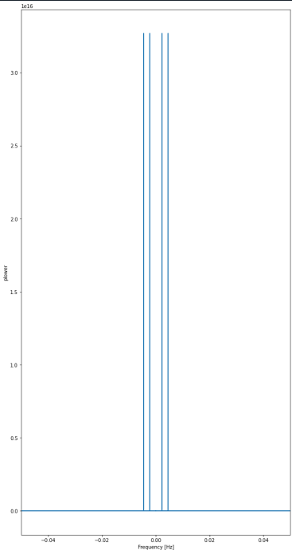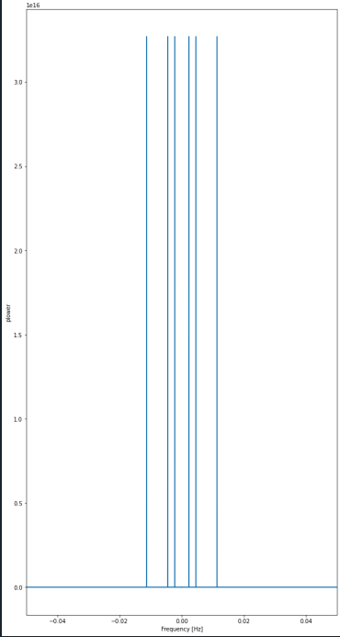

Figure 2: Frequency response diagrams

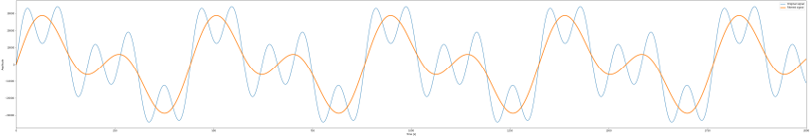The frequency response diagrams shown in Figure 2 are from before and after filtering the signal, on the left figure we see 6 bars that each represent a frequency and on the right we only see 4. This means that the 500Hz signal was successfully filtered out.

Figure 3: Original signal vs filtered signal

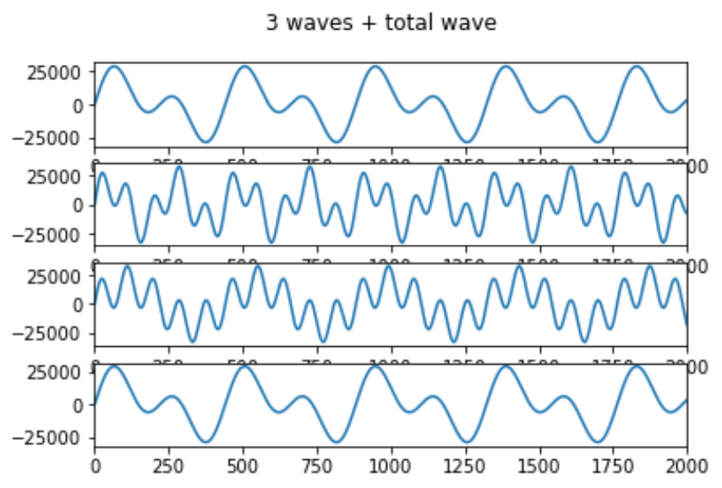The program will plot the original signal and the filtered signal, we can see clearly see that the periode of the orange signal ( filtered signal ) is bigger than the blue signal ( sum of the 3 waves ). This is because we filtered out the 500Hz signal which in terms means that the frequency of the filtered signal will be lower than the original one.

Figure 4: Sum of the waves and the filtered wave

This plot shows the sums of each wave and in the 4th diagram the filtered signal, we notice that the filtered signal is the same as the sum of signal 1 + signal 2 which confirms that the highest frequency signal is successfully filtered out.

# Program 2: Heart Rate Analysis

In this program we will analyse a heartbeate through the use of a wav sound file. Of course our python program can't do anything with just the sound form, that’s why we converted it into a csv data file. The program will analyse the heartbeat and tell us the average beat, ibi, sdnn and many more important values.

After running the program we will see the original heartbeat signal and 2 results, one in the console and one in the plot window.

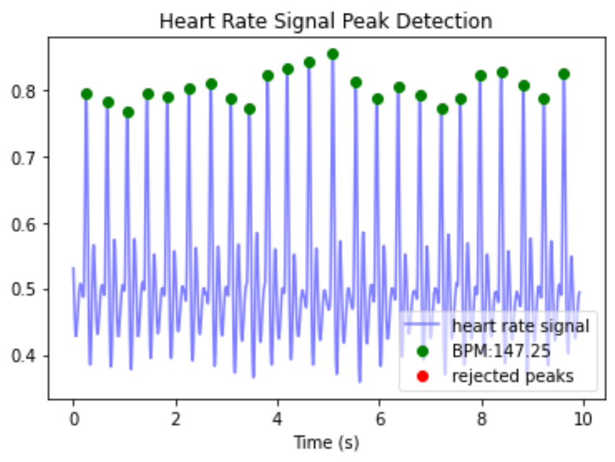Figure 5: Original heartbeat

Figure 5: Analysed heartbeat

Figure 6: console data results

The plot window will analyse the heartbeat and tell us the average bpm and the amount of rejected peaks ( 0 in my case ) but the program calculates and analyses more data from the heartbeat. Those results will be shown in the console window and these are mine.

# Program 3: red.py

# This program will run a game called Red Alert where we have to click the correct image before the image hits the bottom of our screen. I won't go over the basis of the game because you can find all the data on how to do this in the Coding Games in Python book (chapter 6)

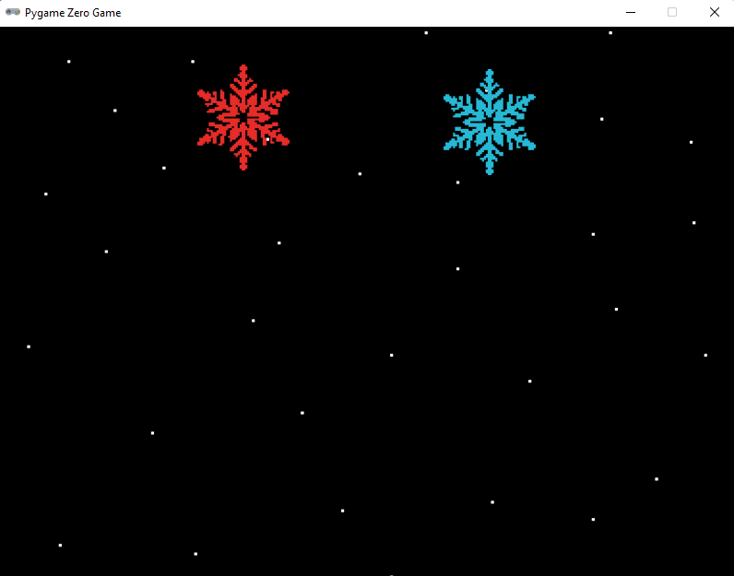

Figure 7: Pygame zero game

After running the program, the following application should pop up. The aim of the game is to click on the red snow flake before it hits the bottom of the screen. Each time you click the red snowflake the game will add another snowflake and reset the snowflakes to the top of the screen. With each time you click the red snowflakes the speed at which they’ll go down will also increase.

The game ends when you click on the wrong star or if you manage to get through all 6 levels ( click the red flake 6 times before it hits the bottom )