Fx plot 1
Fy plot 2
Fz plot 3
Veloxicy plot 4
Longitudinal Slip plot 5
Yaw Rate 6

Fx plot
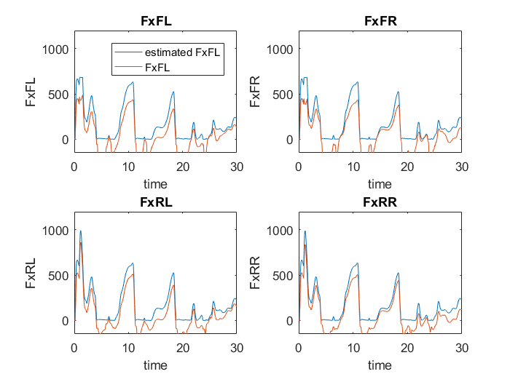

Fy plot
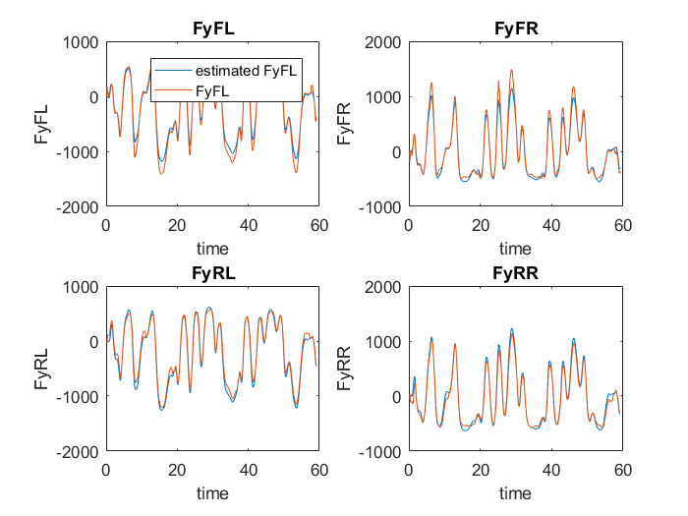

Fz plot
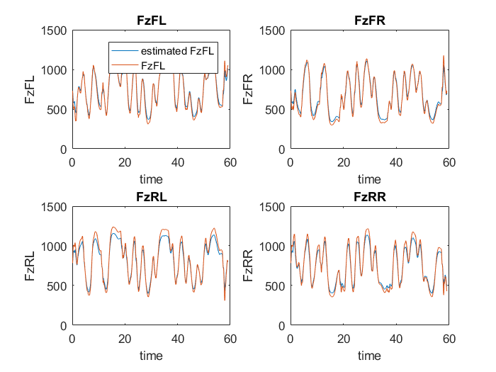

Veloxicy plot
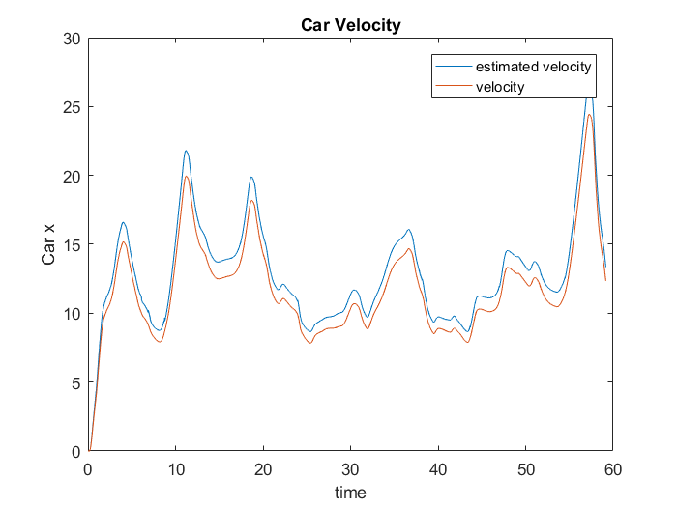

Longitudinal Slip plot
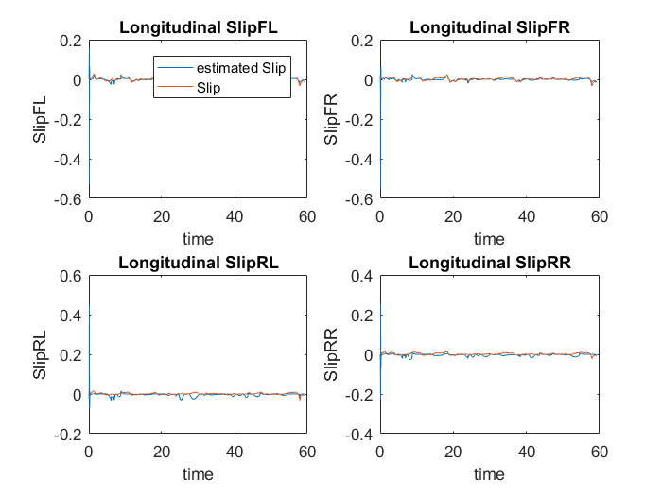

Yaw Rate
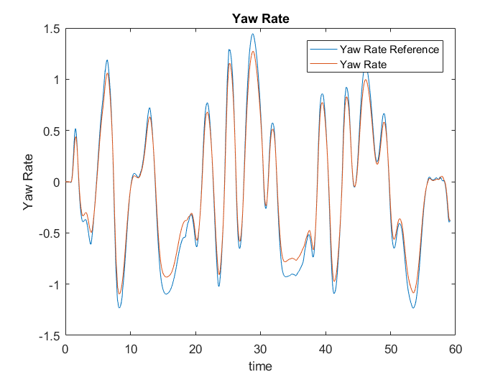
Published with MATLAB® R2016a

