This document describes the high level functions used to control the aircraft in the MatrixPilot software. It focuses on the quadricopter control part, which is coposed of three main functions :

* motor control, which stabilizes the airframe around target yaw, pitch and roll angles
* the altitude control, which stabilizes the airframe around a target altitude of a target vertical velocity
* the x-y positioning control, which stabilizes the airframe arund a target x-y coordinate

**Requirements**

1. Motor control

Motors are controlled by pairs of PID controllers.

* 1. Around the pitch and roll axis :

commanded_roll = pwManual[AILERON] * commanded_tilt_gain

with commanded_tilt_gain = sin(max_tilt) / 1000

Idem for pitch.

Then the vector [commanded_roll, commanded_pitch, RMAX] is normalized to RMAX.

Finally, the following PID control is used :

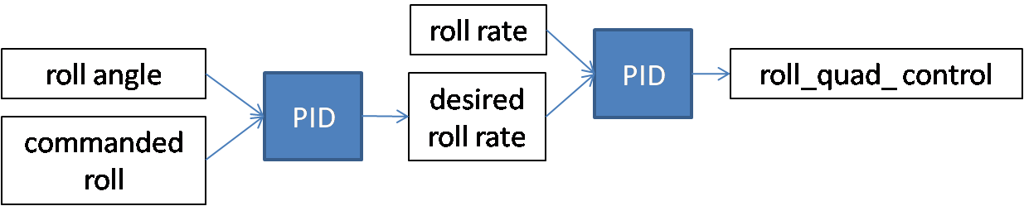

Where roll_angle = rmat[6]

Idem for the pitch axis, where pitch angle = -rmat[7]

* 1. Around the yaw axis :

Example :

Considering only the proportional gains, commanded_roll = 0 and roll_rate = 0:

Desired_roll_rate = roll_angle * (-kp)

roll_quad_control = - Desired_roll_rate * (-rate_kp) = kp * rate_kp * roll_angle

1. Altitude control

When plane altitude is equal to target altitude, considering no integral term and that thresholds are not reached, the throttle should be :

throttle = throttle_offset + 2 * AircraftMass / (100 * MaxThrust) * zkp * vzkp * acczkp * (target_altitude – plane_altitude)

with throttle_offset = 2*SERVORANGE*AircraftMass / (100 * MaxThrust)

**Resources**

Direction cosine matrix :

<rmat.pdf>

PID controllers :

