**Cell InSight 2.26**

This ImageJ macro is a tool to annotate an image stack with point markers. It is compatible with both multi-dimensional images (ImageJ C+T+Z hyperstack) and ImageJ virtual stack. This version has been tested under Fiji-lifeline June 2014.

The first time you use the macro you need to copy the file “GetString.ijm” to Fiji “macros” folder (located in Fiji installation folder).

To open the macro just drag “CellInsight_vx_x.ijm” to Fiji bar, a new window will pop up (the macro editor). Open the image you want to annotate and then hit “Run” in the macro editor. Alternatively you can use Plugins > Macros > Run… and select the file. If more than one image is opened the macro will ask you to select the image to annotate before proceeding.

**First steps**

Upon initialization the macro opens a new window called the **Dashboard**. It is the main interface where most information is gathered, and from which most features can be accessed (buttons from the bottom row). For comfort of use and if your screen size allows it is highly recommended to move the Dashboard so that it does not overlap with the image.

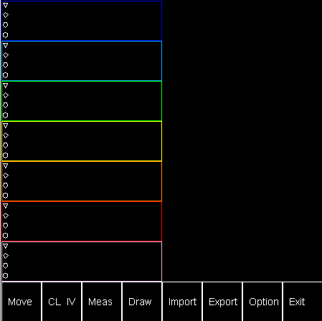

Dashboard

By default the Dashboard is configured with 7 **groups** (7 colors), each holding 4 **subgroups** (geometrical shapes). To start annotating the image you first need to select a subgroup by left clicking on the corresponding row (not on the geometrical shape but on the same row, and within the colored boxes). You will first be asked to input a name for this subgroup: Enter a string in the dialog box (at least two characters) and click “OK”. The currently **selected subgroup** appears inside a white box, it is the subgroup that will be used to insert new markers in the image. At any time you can **rename a subgroup** by first selecting it, and then clicking inside its white box.

*Important note:*

*You should never click “Cancel” in any dialog box, this would exit the macro and you would lose your annotations (if not exported yet)! This is unfortunate but it is a fixed behavior of IJ macros.*

To **insert a marker** in the image just **double left click** in any position. The point will appear with the shape and color of the current subgroup. The **subgroup counter** (right side) is incremented at each new point entry. Time and z slice are recorded too: If you move the z slider the markers will be scaled according to their distance to the current z slice; they will also be dimmed out if they are not in the current frame but still sufficiently close to it.

*Note:* ***The depth of view*** *and* ***frame span*** *can be adjusted from the “Option” panel.*

**Basic functionalities**

* To **delete a point**,or several points you first need to select them: This can be achieved by clicking existing point(s) (close to center). To delete the point(s) hit and release “Alt” while an image is active.
* To **move a point** (or several points) to another subgroup, select them, select the destination subgroup in the Dashboard (it should be highlighted with a white box) and then click “Move”.
* To select **all the points from a subgroup** it is handy to use “IV”: It inverts the selection for all the points belonging to the currently selected subgroup. It is also possible to clear the selection with “CL”.
* When you select a subgroup holding at least one marker a white reference box appear around one of the recorded markers. To cycle through all the recorded markers of the current subgroup hit “Space” to move forward and “Shift” to move backward with one of the images selected. Note that this does not select the markers but only reference their position. The size of the reference box can be adjusted from “Option”.
* If the image starts to get crowded you can **hide/show a subgroup**: A subgroup can be toggled by clicking on the geometrical shapes on the left of its name. This does not only hide the subgroup but also prevent selecting its markers from the images or creating new markers in this subgroup.
* To generate an image stack holding the markers (**map**) hit “Draw”. This is useful to visualize the location of the markers in external software. Only the markers from visible subgroups are drawn.
* You can **save the current project** by clicking “Export”. This saves a text table to a file with extension “.xls” and same name as the image. The file is saved in the folder of the image.If the file already exists it is first backed up to a “.bck” file with same name.
* To **restore a past project** click the “Import” button. The macro checks for a file with name according to the image and stored in its folder. If it cannot find it you will be asked to pick it from the file browser.

**Orthogonal view**

If the image quality is poor (labeling, resolution…) or when the objects are highly clustered it can be difficult to confidently mark individual objects. To understand the spatial context of an object it is useful to rely on the **orthogonal view**. This image can be displayed by clicking on “Option” and ticking “Orthogonal view”. After clicking “OK” another dialog box will pop up, click “OK” again to **generate** the orthogonal view.

*Note: Depending on the size of the image you might want to pre-compute the orthogonal view beforehand and open it at this stage (instead of computing it). The orthogonal view is scaled to show YZ square pixels, for large YZ pixel size ratios (typical in conventional microscopy) this image can hence be fairly large and require a long time to compute. Pre-computing the orthogonal view is also the only way to open it as virtual stack.*

The window of the orthogonal view is automatically aligned to the image window. A **yellow line** in each image window indicates the orthogonal slice that is currently displayed in the other image.

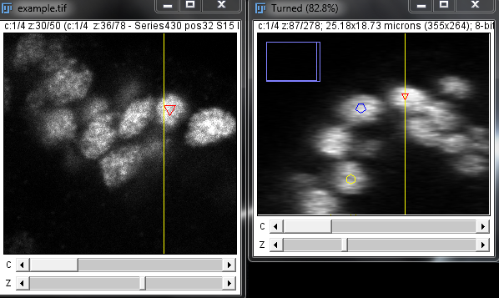

It is possible to mark a point in the orthogonal view. The first click in any image is synchronized to the other image: The yellow line, z-slice and frame are updated accordingly. This is the default behavior and can be disabled by un-ticking respectively Autosync slice and Autosync frame in “Option”. The yellow line will however always be updated as it corresponds to the current z-slice of the other image.

**Intensity measurements**

The macro can **measure the average local intensity** **in all channels** around the recorded markers. To do so hit “Meas”. The numerical results are displayed within a results table that can be exported as a tab separated text file. Small **thumbnails** are also displayed in the Dashboard (to the right of each subgroup).

Each column of these thumbnails corresponds to a marker in the corresponding subgroup and each row to a channel. The width and height of the thumbnails can be adjusted from “Option”. The average intensity is color coded with the same color code as the groups (16 colors from black to white). This is useful to detect outlier objects having a significantly different average intensity pattern in the different channels. The size of the square box used to perform the intensity measurements can be adjusted from “Option”.

**Number of groups and subgroups**

If the **number of groups and subgroups** is too small for your application you can increase the default values. The number of subgroups can be increased by changing the value of the variable ***NSubGp*** in the first section of the code of the macro. Recommended values are in the range 3 to 8. The number of groups can be increased by using a multi-page dash board. This can be defined by changing the value of the variable ***NPages*** from 1 to the desired number of pages.

*Note: There is virtually no limit to the number of pages but you should keep this number as small as required by your application to optimize performance). When importing a project make sure that you use at least as many multi-pages as was used while exporting the project. On the contrary only the first page(s) will be loaded (a warning will be issued).Ideally you should use exactly the same number of pages.*

**Automatic Z pointing**

Holding “Ctrl” while clicking on an image the first click triggers a search through the first neighbor z slices aiming to maximize the average local intensity around this point. This can be useful to pick the center z slice of a bright object by clicking loosely inside.

**Options**

**Depth of view:** See-through maximum number of z slices (slice).

**Frames view:** Number of frames before and after current frame displayed in overlay (frame).

**Measurement box size:** Size of the box to compute average intensity around each point (pix).

**Measurement thumbnails width:** Width of the measurement thumbnails (pix).

**Measurement thumbnails height:** Height of the measurement thumbnails (pix).

**Selection maximum distance:** An existing point will be selected by a click up to this distance away (pix).

**Marker size:** Size of the markers when in viewing slice (pix).

**Reference box size:** Size of the white reference box to show recorded points (pix).

**Intensity optimization box size:** Size of the box used to find locally brightest slice (pix).

**Intensity optimization max. depth:** Exploration mid-range to find locally brightest slice (slice).

**Only draw subgroups CM:** Only the center of mass of each visible subgroup is drawn.

**3D render:** Display markers map in 3D viewer.

**Show thumbnails:** Show measurement thumbnails.

**Orthogonal view:** Generate/open orthogonal view.

**Increment frame on new point:** Automatically increment the frame slider when entering a new point.

**Synchronize frame:** Synchronize frame sliders in orthogonal view.

**Synchronize slice:** Synchronize z slice slider in orthogonal view.

**Show labels:** Show marks label (First two letters of subgroup names).

**Sort subgroups z-order:** Re-order all the points by ascending z slice (only applied once).

**Sort subgroups t-order:** Re-order all the points by ascending frame (only applied once).

Most option default values can be set by changing the values of the variables in the second section of the macro. This can be useful if you do not want to tweak these values to your liking each time you launch the macro.

**Advanced configuration**

Some shortcuts can come handy when using this macro. Four of them are defined in the file Shortcuts.ijm. To enable them just install the macro from Plugins > Macros > Install. F1/F2 are set to toggle the overlay (markers and lines) while F5/F6 are used to move the z slider of the active image.