**MosaicExplorerJ Documentation (v1.2)**

This ImageJ script is designed to interactively explore, align and stitch multidimensional microscopy tiled scans. It is specifically designed for lightsheet microscopy datasets and supports dual light sheet illumination sides (left/right) and dual detection sides (front camera/bottom camera). The tiles should be stored either as subfolders of 16-bit 2D TIFF images or as 16-bit 3D TIFF files with predictable naming (see Appendix **File Naming**). The script should work with any version of ImageJ, but it has only be extensively tested with Fiji Life-Line 2014 June 02 version, available here: <https://imagej.net/Fiji/Downloads>

**Opening a scan**

1. Drag and drop the macro to ImageJ and press ***Run*** from the macro editor window
2. Select the **ROOT** **folder** of the scan
3. Set the size of the tiles (default: 2048 x 2048 pix)
4. Set the side margins of the mosaic (default: 512 pix)
5. Set channel names (should match the channel identifier strings in file names)
6. Dual Side: mosaics from left and right illumination side are displayed simultaneously
7. Dual Camera: navigate the images from both cameras
8. Color mode: convert images from 16-bit to RGB (visualization only, recommended).

Past mosaic adjustment settings can be loaded if present (automatically detected).

**Control Panel**

Press ***Alt*** to open the ***Control Panel*** (**Figure 1**). From this panel you can set Z slice (***ZPos***), channel, camera, illumination side and adjust the display saturation intensity. Each time, press ***OK*** to refresh the display. The current Z slice can also be adjusted outside the panel by pressing ***Shift*** while hovering over the upper left most visible tile. The current Z slice is updated by increments of ***ZStep*** (use ***Space*** to scroll through all possible steps). As reference, the current Z slice is displayed in the title of the ***Board*** window.

From this panel, it is also possible to switch between grayscale and color modes or only display one of the two sides of a dual side scan (useful while adjusting the mosaic). Further options are covered in the following sections.

Note: It is not recommended to close the ***Board*** window manually (or press ***Cancel*** from any dialog box) since this would cause the script to stop without saving the current settings. To exit cleanly, open the ***Control Panel***, tick ***Exit*** and click ***OK.*** You can save the current settings for further exploration (file ***ScanStitch.csv*** saved in **ROOT folder**).

**Adjusting the XY positions of the tiles in the grid** (no tile Z correction)

The following parameters control the XY adjustment of the mosaic:

***OvlX*** (%): Fractional overlap between horizontally adjacent tiles

**OvlY** (%): Fractional overlap between vertically adjacent tiles

***XCor***: Horizontal shift (pix) between tile rows (compensate camera / stage tilt)

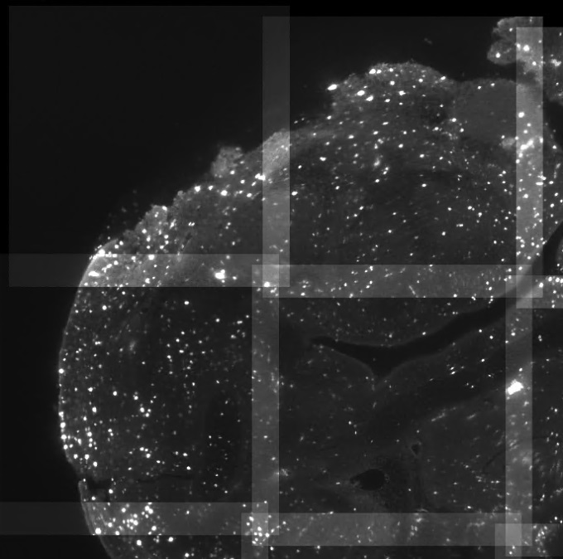***YCor***: Vertical shift (pix) between tile columns (compensate camera / stage tilt)

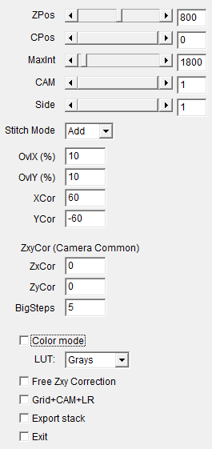

**Figure 1**. The Board window (Left) displaying the mosaic (here with additive tile blending), and the ***Control Panel*** (Right) used to navigate the dataset and adjust the mosaic.

These settings can be adjusted manually, or more simply by following this procedure:

1. Exit the ***Control panel*** (press ***OK***)
2. Draw a line (right to left) between matching features of horizontally adjacent tiles (**Figure 2, top right**)
3. Press ***Alt*** to open the ***Control Panel***
4. Tick the option ***Register OvlX & YCorr --> OvlY & XCorr***
5. Click ***OK***.

The mosaic is adjusted by assuming identical horizontal and vertical fractional overlap. If the stitching is not accurate, it can be refined by drawing a vertical line (bottom to top) between matching features in vertically adjacent tiles and this time ticking ***Register OvlY & XCor only*** (**Figure 2, bottom left**). This last step is actually the only step to perform for single column mosaics (including dual side scans with one column per side).

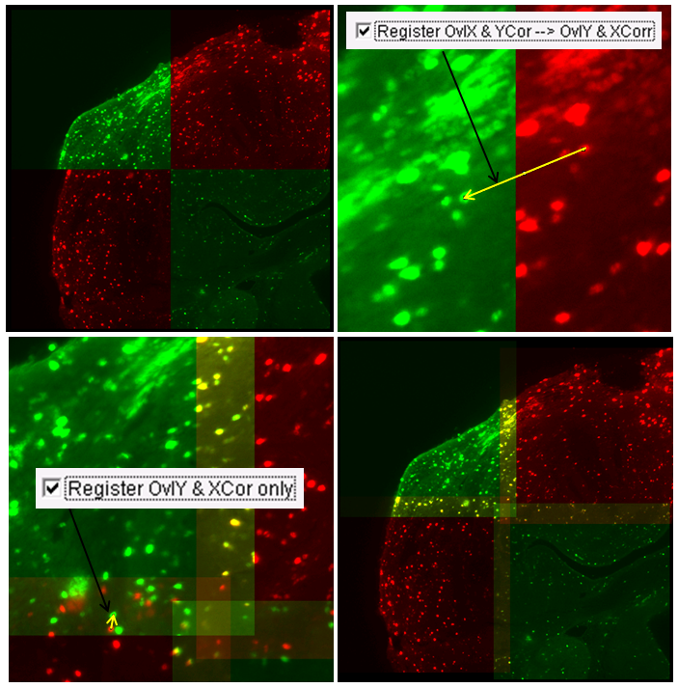

**Figure 2**. Procedure to adjust the mosaic assuming that matching features are apparent in adjacent tiles. **Top Left**: Initial mosaic (no overlap). **Top Right**: Joining two matching features with ImageJ line tool (yellow arrow) and registering horizontally adjacent tiles. **Bottom Left**: The tiles are properly aligned horizontally but there is still a vertical mismatch which is registered by drawing another line (yellow arrow) this time joining vertically adjacent tiles. **Bottom Right**: Aligned mosaic with matching features merging to yellow in all overlap regions.

**Adjusting the Z positions of the tiles in the grid**

If no matching features are visible in the overlap regions (e.g. due to lightsheet tilt), the tiles can be offset axially (Z dimension). Two types of correction are available:

1. Linear correction (default): a constant Z offset is applied between all adjacent columns (***ZxCor***) and adjacent rows (***ZyCor***)
2. Free correction: the Z offsets can be freely adjusted manually.

It is possible to switch between these two modes from the ***Control Panel***.

For linear correction, it is recommended to use the top left tile as reference and gradually tweak ***ZxCor*** from the tile to the right, until some matching features are apparent in the overlap region. Then ***ZyCor*** can be adjusted, this time by considering the tile below. The adjustment of the Z offsets can be performed by typing values in the Panel or by following the procedure described below for free correction.

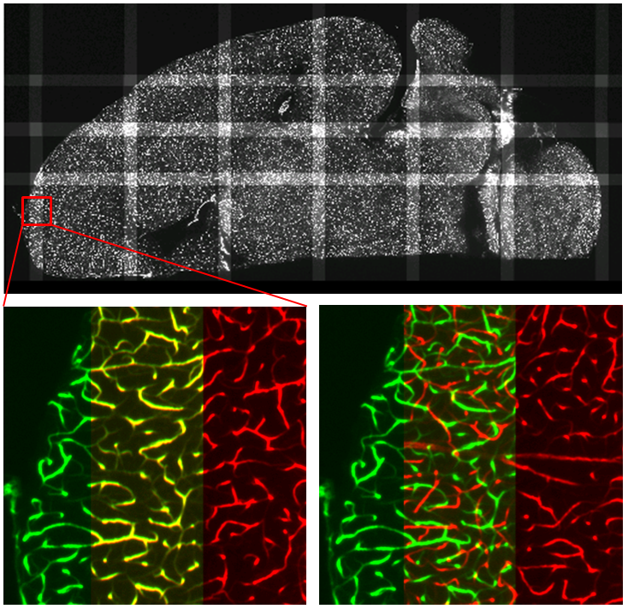

**Figure 3. Top** A slice from a large mosaic (90° rotated to the left for convenience). **Bottom left**: Zoomed inset, color mode enabled so that features from adjacent tiles merge to yellow. **Bottom right**: without Z correction: no matching features apparent in the region of overlap.

For free correction, the Z offsets of the tiles (***ZxyCor***) can be adjusted independently by pressing ***Shift*** while the mouse is located on the tile to adjust. The offsets are incremented by ***ZStep*** and only the tile above (or to the left) is displayed as reference while adjusting (to speed up the display). Exit adjustment mode by pressing ***Alt***.

The offsets of the tiles below and to the right of the tile currently adjusted are also updated accordingly so that, when only the tiles from the first row/column are adjusted, the correction is always guaranteed to be XY separable. Separable shifts are expected for lightsheet tilt and reproducible axial wobble of the motors moving the sample.

As a last resource, the inner tiles can also be adjusted (or the offsets can even be edited manually from the ***Control Window***), but the correction is then not guaranteed to be separable.

**Note**: The Z offset of the tile being adjusted (or ***ZxCor*** and ***ZyCor*** when not in free correction mode) is displayed in the title of the ***Board*** window.

**Exporting image stack** (single camera)

Stitched images from a mosaic can be exported by following these steps:

1. Open the ***Control Panel*** and set ***Stitch Mode*** to ***Maximum*** (maximum intensity), ***Copy*** (last tile overwrites previous), or ***Ramp*** (linear intensity weighting in overlap region)
2. Tick ***Export stack to folder*** and click ***OK***
3. Set the X/Y bounds of the mosaic tiles to export (default: all tiles)
4. Set the first and last Z slice to export (default: all Z slices)
5. Tick ***Perform operation*** (un-tick to cancel exportation) and click ***OK***
6. Select an empty folder where to export the images.

**Notes**:

* By default, only the current channel is exported but it is possible to export all channels at once by ticking the corresponding option.
* When selecting ***Convert to 8-bit***, images are converted with a fixed range set by the current intensity saturation.
* If the exported images are improperly cropped, disable cropping or increase the side margins (initial dialog box).

**Dual illumination side**

The mosaics acquired from both illumination sides can be visualized and stitched together. For this, **Dual Side** must beticked when opening the scan. Dual side scans must have the same number of tiles on both sides. To align the whole mosaic, both left and right mosaics have first to be adjusted independently. For this, it is convenient to un-tick ***Dual side mode*** from the ***Control Panel***.

To align the mosaics from both sides, draw a line between matching features (from right to left) in the overlap region, open the ***Grid+CAM+LR Panel*** from the ***Control Panel*** and tick ***Register RL***. If no matching features are apparent in the overlap region, a Z offset can be applied to all the tiles from the right mosaic (***ZRLCor*** from ***Control Panel***).

For best results, it is possible to compensate intensity imbalance between both sides by adjusting ***MaxInt*** (***Control Panel***) to different values for both sides (use slider from Panel to select the sides). In this case, the intensity from the right side is scaled by a multiplicative factor set to the ratio between both ***MaxInt*** values. Whereas ***MaxInt*** is a display only adjustment for single side scan, the intensity correction factor is applied upon exportation for dual side scans.

When using ***Ramp*** blending in dual side scan with only one column per side, use ***OvlX*** to adjust the slope of the ramp (typically set to ***OvlY*** if the overlap from side to side is equal to the vertical overlap).

**Note**: A perfect alignment of the mosaics from both illumination sides can only be achieved if the lightsheets from both illumination sides are collinear.

**Camera registration at union Z slice**

For Dual Camera scans, ***Dual Camera*** should be ticked from the initial dialog box and the mosaics should first be adjusted independently for both cameras before registering the cameras at the union Z slice. For this last operation:

1. Navigate to the Z slice where you want to switch camera
2. Disable color mode and set the view to the first camera
3. Enter camera options by ticking ***Grid+CAM+LR*** from the Panel
4. Tick ***Start CAM2 registration*** (and click ***OK***)
5. Draw exactly two points (ImageJ multi-point) referencing two pairs of matching features in both ***CAM1*** and ***CAM2*** windows
6. Tick ***Register CAM2 Tilt and Scaling*** (and click ***OK***)
7. Draw a single point referencing a matching feature in both camera windows
8. Open ***Grid+CAM+LR Panel***, tick ***Register CAM2 XY Position***(and click ***OK***).

Both cameras are overlaid to check the results visually. Close the camera overlay by ticking ***Close CAM1*** from ***Grid+CAM+LR*** (and clicking ***OK***). It is possible to check the current camera alignment at any time by ticking ***Overlay CAM1*** (while the view is set to first camera and color mode is disabled).

**Exporting image stack** (dual camera)

Once the mosaics from both cameras have been adjusted and registered at the union Z slice, the procedure to export a Dual Camera dataset is similar than before but with***Auto CAM switch*** ticked from the Exportation Panel.

Use the field ***CAM union Z slice*** to set the camera switch slice (for best results it should be the same slice you used to register both cameras). To set the order of the cameras use ***CAM 2 low Z, CAM1 high Z*** tick box. The default behaviour is that ***CAM2*** feeds Z slices <= Z union slice.

**Appendix - File Naming**

1. **Images stored as series of 16-bit 2D TIFF images**

The images should be stored in independent subfolders for each X/Y tile position, illumination side, and channel. The default subfolders naming is detailed below:

* Strings to encode X/Y positions, illumination sides and channel are respectively --X, --Y, --RL and --C followed by an index (2 digits)
* The names of the images in the subfolders should hold the same fields as the subfolders. The default string to encode Z slice is --Z followed by an index (4 digits)
* Images from both cameras should be stored in the same subfolder and the camera side is encoded in filename by the string “CAM1” or “CAM2”.

All these strings (and the number of digits for the indices) can be configured in the script. It is possible to use long names to encode the channels in the filenames, for instance “C00--L05” for channel “C00”. These long names can be configured when opening a scan.

**Sample subfolders hierarchy**

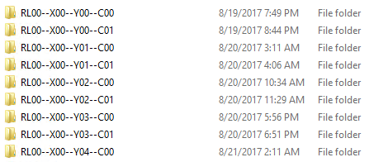

**Sample image filenames (first subfolder)**

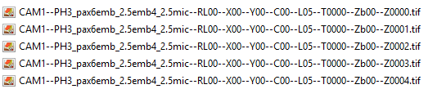

1. **Images stored as 3D multi-tiff files**

No subfolder should be present in the root folder and the 3D TIFF tiles should be named by following the same convention than the subfolders from previous section.

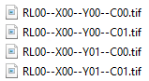

The images should appear by order of Z slices in the file, images from camera 1 first, followed by images from ***CAM2***.