Projecting the popularity of the main

political parties in Germany

Sebastijan Dominis

1. System description and the area of use

This project simulates the future popularity of the main six political parties in Germany, namely CDU, SPD, AfD, the Greens, FDP, and the Left, and it does so by using the Monte Carlo simulation. It was written in R programming language, using R Studio. To be more specific, it simulates what the popularity of each of the mentioned political parties may be over the next three months, on a month-to-month basis. The application area mainly revolves around political analysis. As a part of the project, data regarding GDP, inflation, immigration, and global temperatures was also gathered, in order to make the potential interpretation of the results a bit easier, although the actual interpretation will be left up to the experts. Therefore, this project does not make any specific interpretations, but simply gathers the data and makes a simulation of the near future.

2. Type of simulation and applied simulation language

A few variations of the Monte Carlo simulation were used, due to the fact that different distributions were needed. The code was written in R programming language, due to the simplicity of creating graphs in it, and more importantly, the ease of doing the analysis itself. Readr package was utilized to read the data, and fitdistrplus was used to determine the appropriate distribution for each of the political parties’ popularity.

3. Description of the collected data

The collected data includes the following variables:

1. Party name: Name of the political party.

2. Date: Date of data recording.

3. Popularity: Percentage support for the political party.

4. Immigration: Number of immigrants in the recorded period.

5. Inflation: Percentage of YoY inflation.

6. GDP: Quarterly nominal Gross Domestic Product (although flawed GDP data was initially removed and later added for 2022-2023 period).

7. Temperature: Average global temperature for the recorded period

The data regarding the party names, and their popularity over time was gathered from Politico, and it only includes the largest six political parties in Germany. The data regarding GDP, inflation, and immigration was gathered from Destatis. Finally, the data regarding the global temperatures comes from Our World in Data.

4. Conceptual model

In order to prepare the model, we need to understand what data we need. Monte Carlo simulation takes some past data over a given period of time, and uses it to project future data. Given that this model aims to project future party popularity, past party popularity is needed to make the simulation possible. In addition to that, it is important to be mindful of the amount of data that comes in, and the amount of data we want to simulate. The more past data we have, and the shorter the future period we aim to simulate is, the better our results are going to be. Therefore, the data regarding the past 36 months (3 years) is gathered, with the intent of simulating the next 3 months. Only the monthly averages are taken, since gathering daily data would be extremely time-consuming, inefficient, and mostly useless. Politico is chosen as the source of data, since it gathers various relevant polls, and makes an average of them. It is a popular website, and deemed trustworthy. Since only past party popularity is going to have an impact on the Monte Carlo simulation, it is the only data needed to make the project. However, since the main goal of this project is to create a model that can be used for political analysis, some of the main factors that are deemed relevant in the realm of politics can be considered as well. Various global events cannot be put in numbers, but GDP, inflation, immigration, and temperature surely can. These factors, while not impacting our simulation, are considered to be relevant to the project, and the data about them will therefore be gathered and displayed as well.

5. Computer model creation

As previously suggested, the model is implemented in R programming language, using past party popularity data. Functions for Monte Carlo simulations with Weibull, uniform, and gamma distributions are defined to project party popularity over the next three months. These distributions were chosen by using the fitdistrplus package to analyze past popularity data, and see which distribution fits it the best. The data regarding the popularity of CDU most closely resembled the Weibull distribution, the Left was closest to gamma distribution, while the rest of the parties came the closest to the uniform distribution. Therefore, three Monte Carlo functions were created to fulfill these needs. The one using the uniform distribution was run four times, and the other two were run one time each.

6. Description of the simulation, interpretation of results, and recommendation for the system

As mentioned a few times earlier, the Monte Carlo simulation was used six times in total – once for each of the political parties, in order to roughly simulate their popularity over the next three months. Given that the aim of this project was to set the ground for some political analysis, a graph portraying the past data regarding party popularity is displayed first, in order to proved some context. Once again, the data only includes the main six parties.

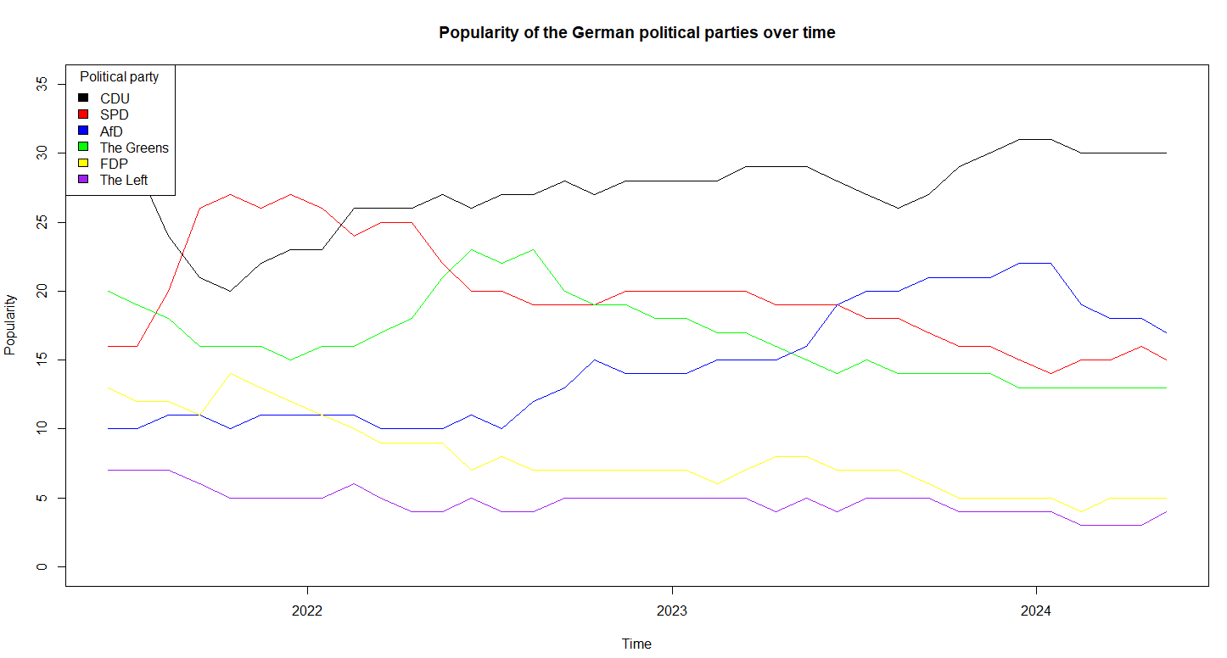

The results of the Monte Carlo simulation will be displayed in the following order:

1. CDU

2. SPD

3. The Greens

4. The Left

5. FDP

6. AfD

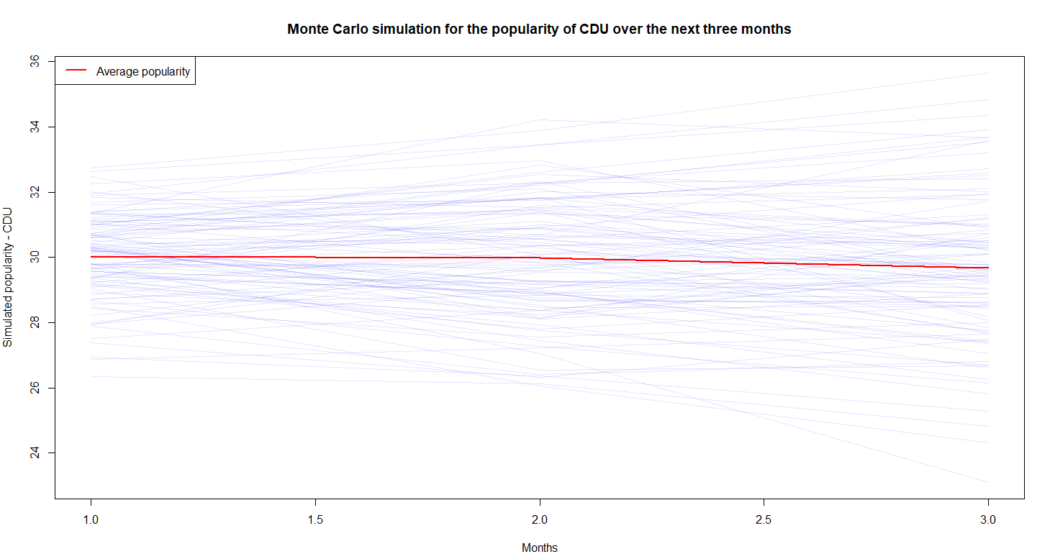

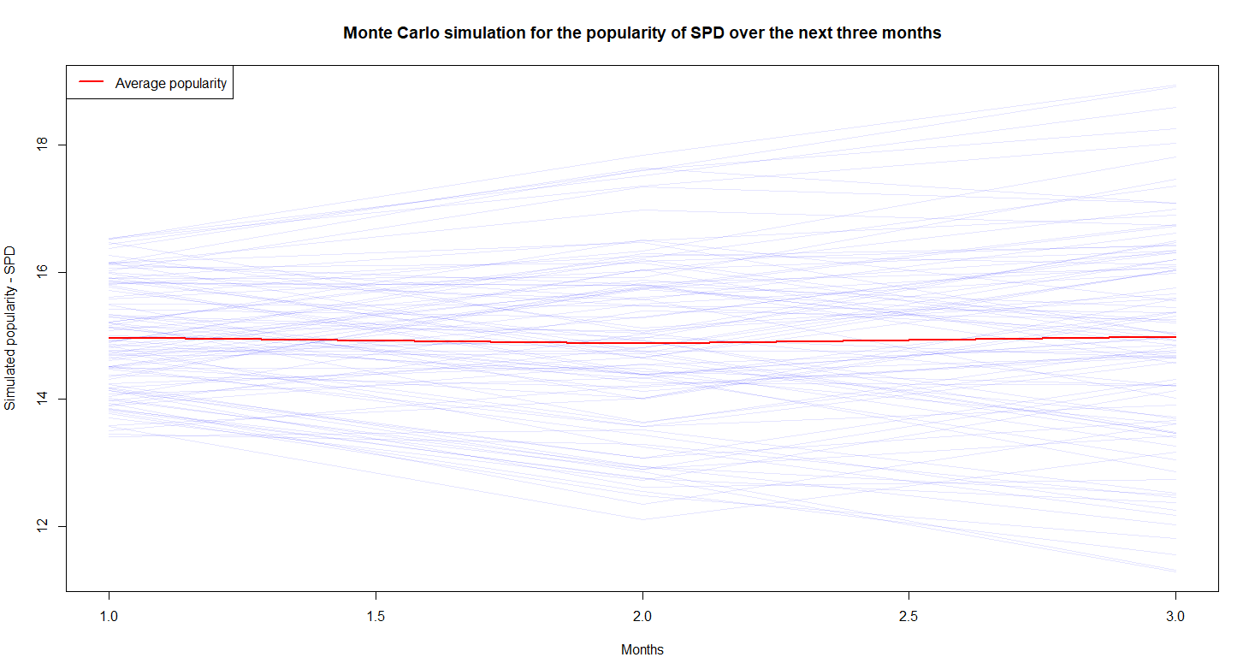

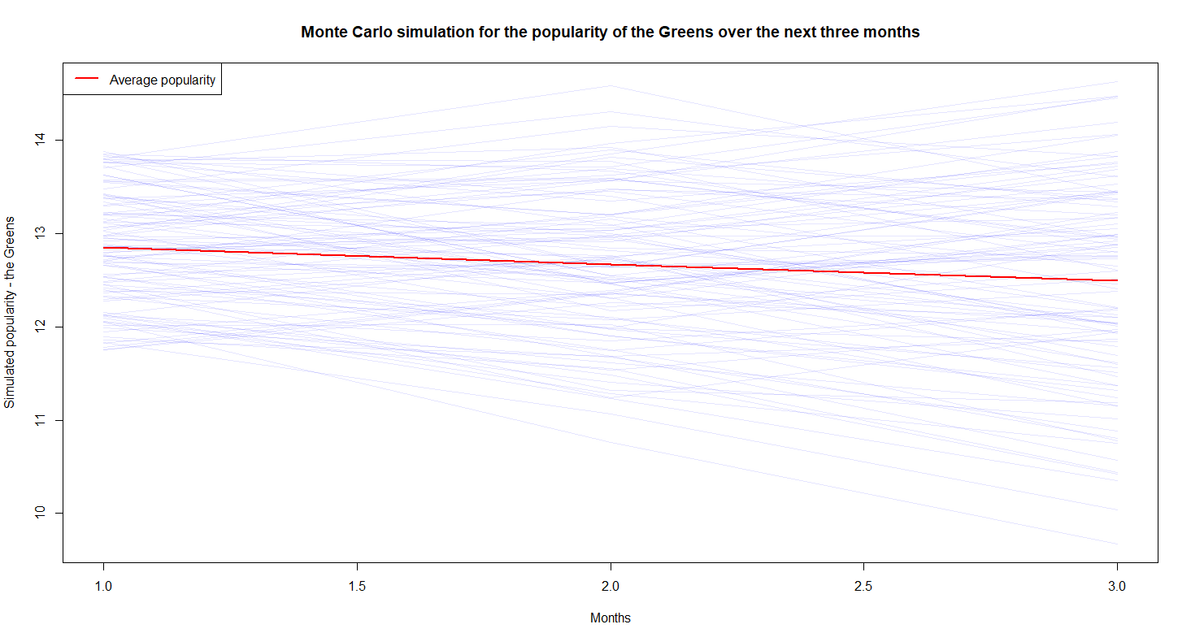

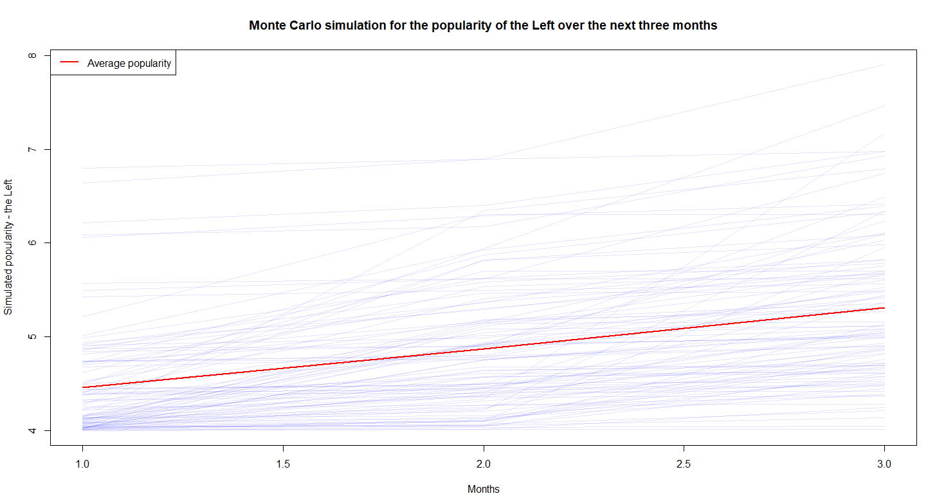

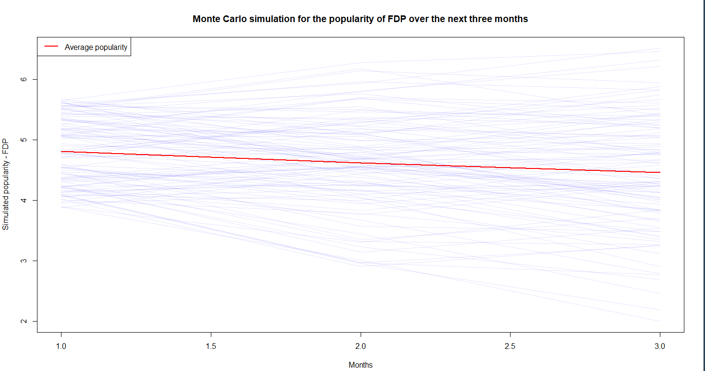

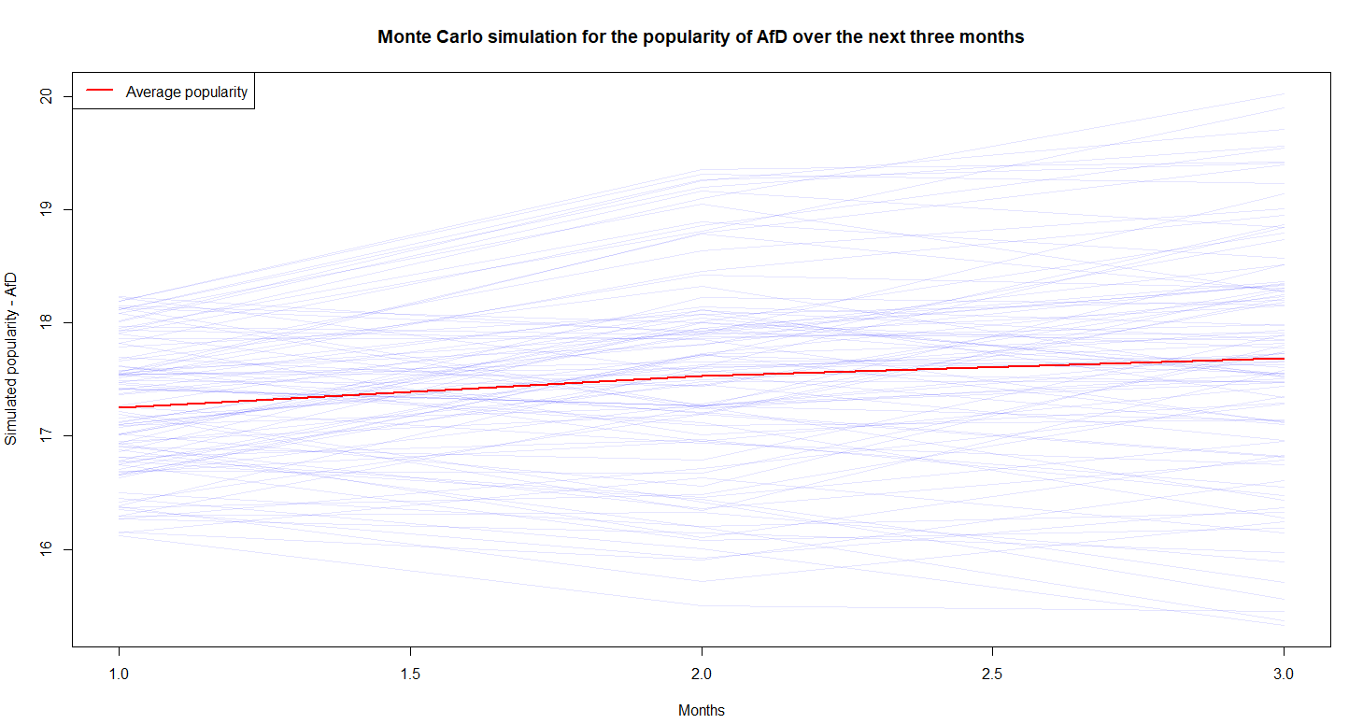

Based on the simulations, the popularity of CDU will likely experience a mild decline. SPD will most likely stagnate. The Greens’ popularity will likley drop, while the Left is likely to experience a surge in popularity. FDP will likely lose some popularity, while AfD will gain some.

As previously mentioned, some data regarding GDP, inflation, immigration, and the global temperatures was also gathered, as it may provide some context, and will therefore be shown here as well. No simulation was performed on it, so it will not be interpreted, but only serves the purpose of providing some more possibly relevant information.

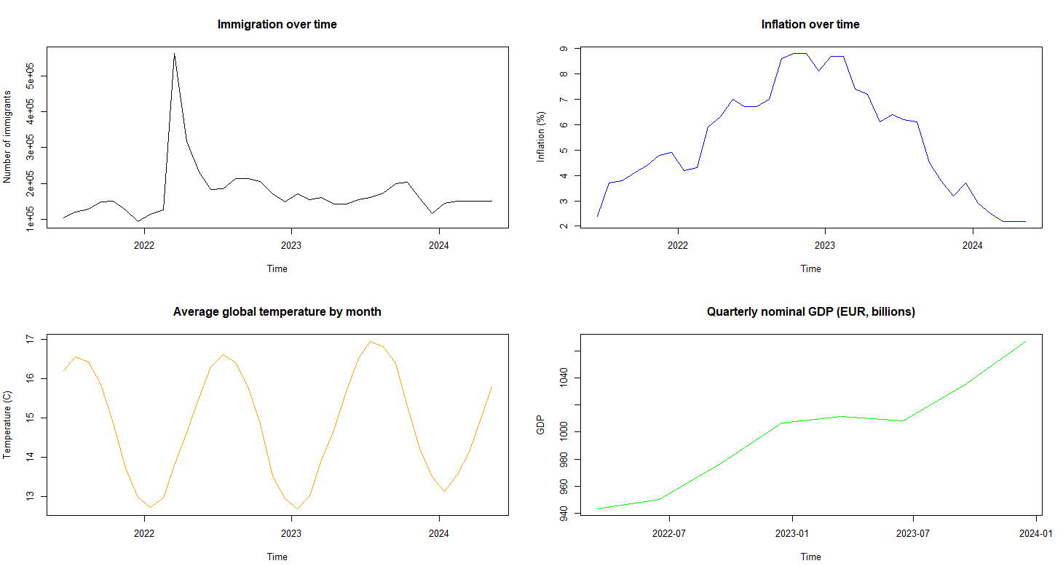

Experts in the field can now take the results of the simulations performed in this project, take a look at the additional information provided, and make a more professional political analysis.

7. List of references

Politico, 2024. Politico. [online] Available at: https://www.politico.com [Accessed 31 May 2024].

Statistisches Bundesamt (Destatis), 2024. Destatis. [online] Available at: https://www.destatis.de [Accessed 31 May 2024].

Our World in Data, 2024. Our World in Data. [online] Available at: https://ourworldindata.org [Accessed 31 May 2024].

Wickham, H. and Grolemund, G., 2016. R for Data Science. O'Reilly Media.

Delignette-Muller, M.L. and Dutang, C., 2015. fitdistrplus: An R Package for Fitting Distributions. Journal of Statistical Software.

Grolemund, G. and Wickham, H., 2017. R for Data Science: Import, Tidy, Transform, Visualize, and Model Data. O'Reilly Media.

Kabacoff, R.I., 2015. R in Action: Data Analysis and Graphics with R. 2nd ed. Manning Publications.