*[Name] :R. Abinaya*

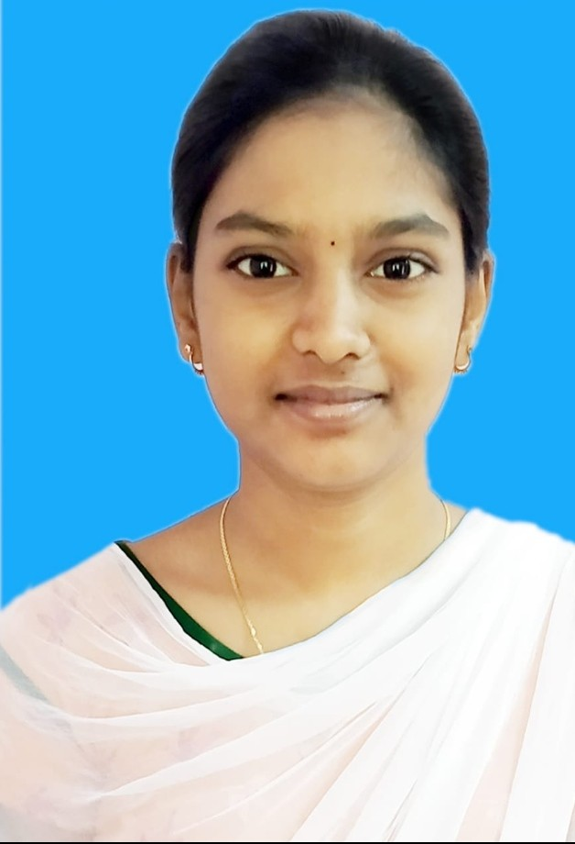

*[address]: 1/128, Thanavayal.*

# *CARREER OBJECTIVE :*

*My goal is to become associated with a* company where I can utilize my skills and gain further experience while enhancing the company’s productivity and reputation.

# *EDUCATIONAL QUALIFICATION :*

* ***Alagappa govt.arts college,Karaikudi.***
  + ***2021***
  + ***Pursuing B.sc.Computer Science.***
* ***St. Mary's Girl's Hr. Sec. School. Devakottai.***
  + ***2020***
  + ***HSLC – 90.82%***
* ***St. Mary's Girl's Hr. Sec. School.***
  + ***2018***
  + ***SSLC – 93.66%***

# *PROGRAMMING LANGUAGES KNOWN :*

* ***C***
* ***C++***
* ***JAVA***
* ***Python***

# *STRENGTH/AREA OF EXPERIENCE :*

* ***Positive thinking and active quick learner.***
* ***Planning and scheduling.***
* ***Skilled problem solver.***
* ***Good leadership and supervision quality.***
* ***Presence of mind.***
* ***Ability to built up relationship rapidly and set up trust.***

# *LANGUAGES KNOWN :*

* ***Tamil***
* ***English***

# *PERSONAL DETAILS :*

|  |  |
| --- | --- |
| ***NAME*** | ***R. Abinaya*** |
| ***DAUGHTER OF/SON OF*** | ***L. Ramanathan*** |
| ***GENDER*** | ***Female*** |
| ***DATE OF BIRTH*** | ***15.06.2004*** |
| ***NATIONALITY*** | ***INDIAN*** |
| ***EMAIL ID*** | [***rabinaya1564@gmail.com***](mailto:rabinaya1564@gmail.com) |
| ***MOBILE NUMBER*** | ***7695804050*** |

***HOBBIES :***

* ***Reading Books***
* ***Listening Music***

*DECLARATION*

*I hereby declare that the above mentioned statement is correct and true to* the best of my knowledge and belief.

*DATE : 27.04.2023*

*R. Abinaya*