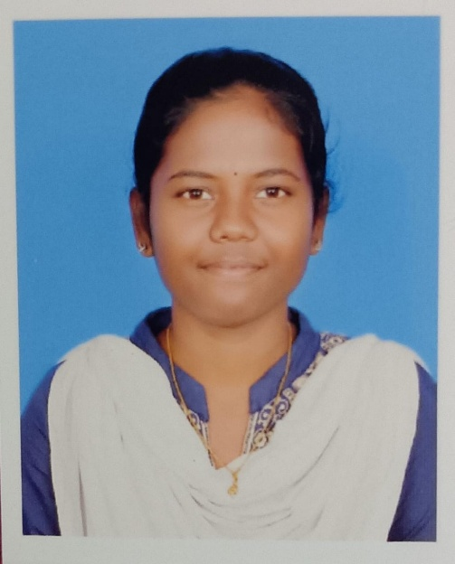

SHRUTIKA.S

1/637(3D) iyurullithachankanmai, kalaiyarkovil, sivagangai(Dt).

CARREER OBJECTIVE:

My goal is to become associated with a company where I can utilize my skills and gain further experience while enhancing the company’s productivity and reputation.

EDUCATIONAL QUALIFICATION:

* Alagappagovt.artscollege,Karaikudi.
  + 2021
  + Pursuing B.sc.Computer Science.
* Holy spirit matriculation higher secondary school,kalaiyarkoil.
  + 2020
  + HSLC – 88.33%
* Holy spirit matriculation higher secondary school,kalaiyarkoil.
  + 2018
  + SSLC – 81.04%

PROGRAMMING LANGUAGES KNOWN:

* C
* C++
* JAVA

STRENGTH/AREA OF EXPERIENCE:

* Positive thinking and active quick learner.
* Planning and scheduling.
* Skilled problem solver.
* Good leadership and supervision quality.
* Presence of mind.
* Ability to built up relationship rapidly and set up trust.

LANGUAGES KNOWN:

* Tamil
* English

PERSONAL DETAILS:

|  |  |
| --- | --- |
| NAME | SHRUTIKA.S |
| DAUGHTER OF/SON OF | SEKAR.V |
| GENDER (M/F) | FE MALE |
| DATE OF BIRTH | 15.09.2003 |
| NATIONALITY | INDIAN |
| EMAIL ID | sekarshrutika@gmail.com |
| MOBILE NUMBER | 7639667486 |

HOBBIES :

* Reading Books
* Drawing
* Listening Music
* watching mobile

DECLARATION

I hereby declare that the above mentioned statement is correct and true to the best of my knowledge and belief.

DATE : 15.10.2023SHRUTIKA.S