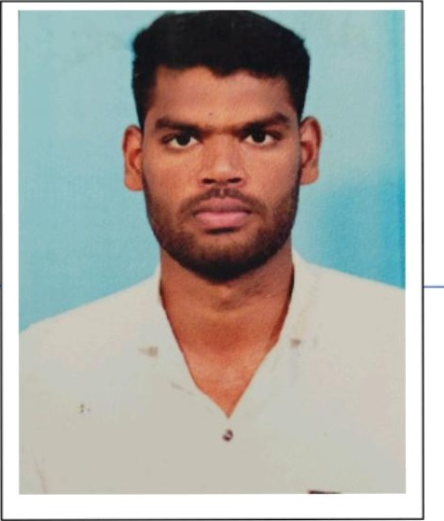fName] J.selva ganapathy

*{addressj34,subaramaniyaburam 8th Street,south extn Karaikudi*

# CARREER OBJECTIVE:

My goal is to become associated with a company where I can utilize my skills and gain fuuher experience while enhancing the company’s productivity and reputation.

# EDUCATIONAL @UALIFICA TION:

X• Alagappa gow.aNs coIIege,Karaikudi.

* *2021*
* *Pursuing B.sc.Computer Science.*
* - *sri kalaivani Matric Higher Secandory SchooI,KALLAL.*
  + *2020*
  + *HSLC - 90.82&*
* *- ~~-~~ sri kalivani Matric Higher Secandory SchooI,KALLAL.*
  + *2018*
* *SS1C* — 9:2.d68

# PROGRAMMING LANGUAGES KNOWN:

& JAVA

4 Python

*STRENGTH/AREA OF EXPERIENCE.*

*4 Positive thinking and* acrive *quick learner.*

*4 Planning and scheduling.*

*a Skilled problem solver.*

*X Good leadership and supervision quality.*

### 4 Presence otmind.

*4 Ability* to *built up relationship rapidly and set up trust.*

*LANGUAGES KNOWN:*

•• Tamil

*•• English*

*PERSONAL DETAILS.*

*NAME*

*DAUGHTER OF/SON OF GENDER (M/F)*

*DATE OF BIRTH NATIONALITY EMAIL ID MOBILE NUMBER*

## HOBBIES.

*X Reading Books*

*+ Listening Music*

*d.seIra ganapathy deevanandham MALE*

25.06.2002

INDIAN

[rjselvaganapathy'@gmaiI.com](mailto:rjselvaganapathy%27@gmaiI.com) 8072375639

DECLARATION

I hereby'declare that the above mentioned statement is correct and true to the best of my knowledge and belief.

*DATE: 27.04.2023 J.selava ganapathj‹*