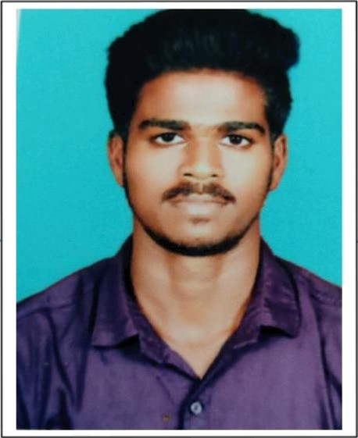{Name] K.krishnan Kalakkanmoi,KaIakkanmoi(po),Nadarajaburam(Yia), Sivangangai,63055i5i

*CARREER OBJECTIVE.’*

Mj/ goal is to become associated with a company' where I can utilize my'skills and gain funher experience while enhancing the company's productivity and reputation.

## EDUCA TIONAL QUALIFICA TION:

+ Alagappa gow.aNs coIIege,Karaikudi.

* *2021*
* *Pursuing B.sc.Computer Science.*

Britto Higher Secandory SchooI,KALLAL.

### 2020

* *HSLC - 7B.8&*

8r/fto *Higher Secandory SchooI,KALLAL.*

*- 20 J8*

* *SSLC — 84. SO4*

## PROGRAMMING LANGUAGES KNOWN:

4 JA VA

e Python

# STRENGTH/AREA OF EXPERIENCE:

*4 Positive thinking and active quick learner.*

### 4 Planning and scheduling.

*4 Skilledproblem solver.*

4 Good *leadership and* svperv/sion *quality.*

*4 Presence of mind.*

*4 Abilify to built up relationship rapidly and set up trust.*

# LANGUAGES KNOWN:

w’ Tamil

*w’ English*

*PERSONAL DETAILS:*

|  |  |
| --- | --- |
| *NAME* | *K Krishnan* |
| *DAUGHTER 0F/S0N OF* | *M Kalailingam* |
| *GENDER(M7F)* | *MALE* |
| *DATE OF BIRTH* | *1 I. 10.2003* |
| *NATIONALITY* | *INDIAN* |
| *EMAIL ID* | [*krishnakrishna22320@gmaiI.com*](mailto:krishnakrishna22320@gmaiI.com) |
| *MOBILE NUMBER* | *9360908813* |

# HOBBIES:

### J' Reading Books

M Listening Music

DECLARATION

### I herebj/ declare that the above mentioned statement is correct and true to the best of my knowledge and belief.

*DATE.° 27.04.2023 K.Krishnan*