- A company’s market share in a specific region is 20%. A research has been done in order to find out if the recent promotion sales and marketing had a positive impact on the company’s market share. According to this research 250 people were chosen randomly and among those 60 of them said that they buy the company’s product. Would you be able to conclude that the promotion sales and advertisement had a positive impact on the company’s market share?
- It is known that at least 25% of the workers have a problem in attendance to work. Recently some regulations were applied and in order to see the effectiveness of the new regulations 115 workers were chosen randomly and it is observed that 15 workers still have a problem with attendance. Do you believe that the new regulations on attendance were effective?
- A new teaching technique is applied in a class where the success ratio is at most 25%. In order to test the effectiveness of the new teaching technique 108 students were chosen randomly. How many of the students should be found succesful to be able to say that at a 5% significance level this new teaching technique is effective in increasing the success of the students?
- 200 pieces, among those that were produced by female workers, were chosen randomly and 250 pieces, among those that were produced by male workers, were chosen randomly. It is found that 10 pieces from the 200 and 15 pieces from the 250 were defective. According to this, at a 5% significance level, is it possible to say that there is a difference between the defective ratios of female and male workers’ productions?
- Here is an example from youtube: http://www.youtube.com/watch?v=V2GYyh9c3ww
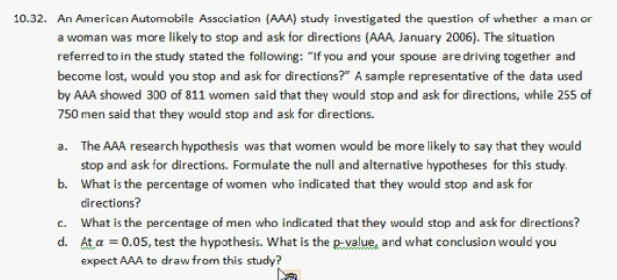
- If you like you can use R package for anything such as : http://www.r-tutor.com/elementary-statistics/hypothesis-testing/two-tailed-test-population-proportion

