|  |  |  |  |  |  |  |  |  |  |  |  |
| --- | --- | --- | --- | --- | --- | --- | --- | --- | --- | --- | --- |
|  |  |  |  |  |  |  |  |  |  |  |  |
| **Aylar/Yıllar** | **1999** | **2000** | **2001** | **2002** | **2003** | **2004** | **2005** | **2006** | **2007** | **2008** | **Mevsim İndeksi** |
| **Ocak** | 4.80 | 4.90 | 2.50 | 5.30 | 2.60 | 0.70 | 0.87 | 0.75 | 1.00 | 0.80 | 111.52 |
| **Şubat** | 3.20 | 3.70 | 1.80 | 1.80 | 2.30 | 0.60 | 0.34 | 0.22 | 0.43 | 1.29 | 74.75 |
| **Mart** | 4.10 | 2.90 | 6.10 | 1.20 | 3.10 | 0.90 | 0.40 | 0.27 | 0.92 | 0.96 | 100.85 |
| **Nisan** | 4.90 | 2.30 | 10.30 | 2.10 | 2.10 | 0.60 | 1.08 | 1.34 | 1.21 | 1.68 | 139.86 |
| **Mayıs** | 2.90 | 2.20 | 5.10 | 0.60 | 1.60 | 0.40 | 1.08 | 1.88 | 0.50 | 1.49 | 101.91 |
| **Haziran** | 3.30 | 0.70 | 3.10 | 0.60 | -0.20 | -0.10 | 0.46 | 0.34 | -0.24 | -0.36 | 12.31 |
| **Temmuz** | 3.80 | 2.20 | 2.40 | 1.40 | -0.40 | 0.20 | -0.14 | 0.85 | -0.73 | 0.58 | 42.64 |
| **Ağustos** | 4.20 | 2.20 | 2.90 | 2.20 | 0.20 | 0.60 | 1.03 | -0.44 | 0.02 | -0.24 | 65.35 |
| **Eylül** | 6.00 | 3.10 | 5.90 | 3.50 | 1.90 | 0.90 | 1.38 | 1.29 | 1.03 | 0.45 | 148.66 |
| **Ekim** | 6.30 | 3.10 | 6.10 | 3.30 | 1.40 | 2.20 | 1.91 | 1.27 | 1.81 | 2.60 | 176.43 |
| **Kasım** | 4.20 | 3.70 | 4.20 | 2.90 | 1.60 | 1.50 | 1.23 | 1.29 | 1.95 | 0.83 | 153.90 |
| **Aralık** | 5.90 | 2.50 | 3.20 | 1.60 | 0.90 | 0.40 | 0.43 | 0.23 | 0.22 | -0.41 | 71.83 |

1. **TREND COMPONENT**

In SPSS : ANALYZE > REGRESSION > CURVE ESTIMATION

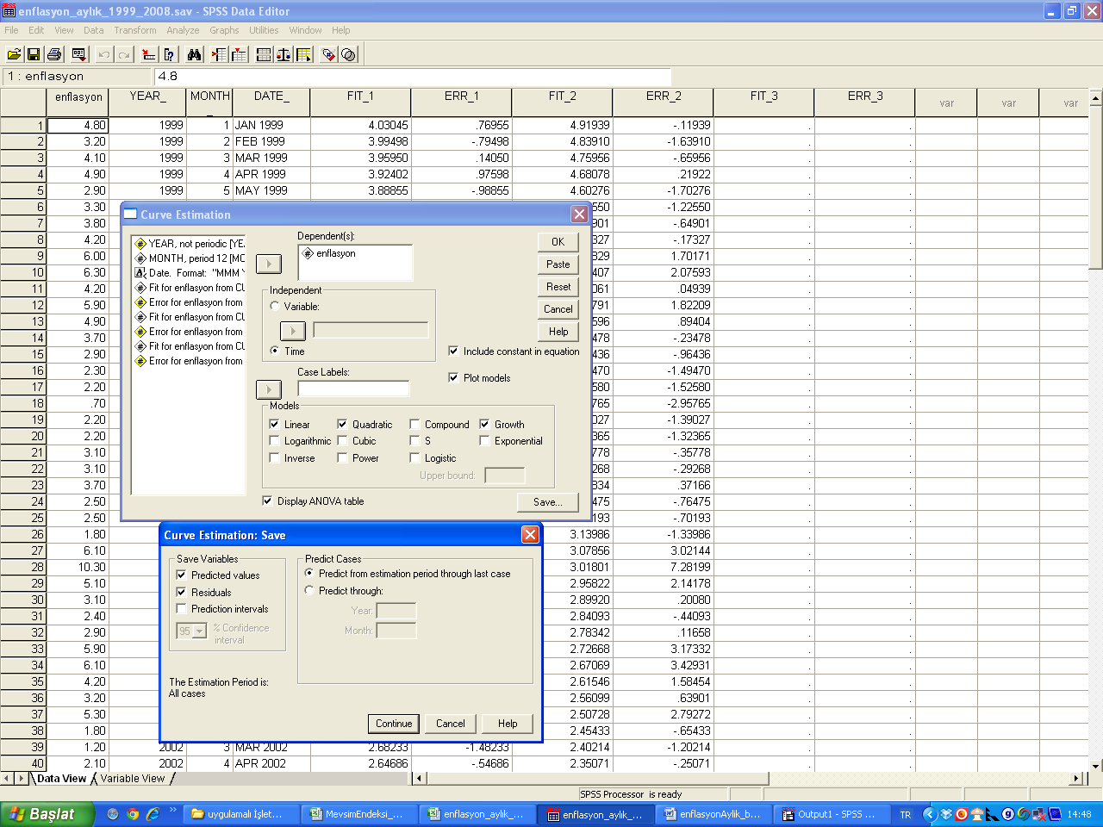

* 1. **Linear**

**Model Summary**

|  |  |  |  |
| --- | --- | --- | --- |
| R | R Square | Adjusted R Square | Std. Error of the Estimate |
| .670 | .449 | .445 | 1.341 |

**ANOVA**

|  |  |  |  |  |  |
| --- | --- | --- | --- | --- | --- |
|  | Sum of Squares | df | Mean Square | F | Sig. |
| Regression | 173.203 | 1 | 173.203 | 96.294 | .000 |
| **Residual** | **212.244** | 118 | 1.799 |  |  |
| Total | 385.446 | 119 |  |  |  |

**Coefficients**

|  |  |  |  |  |  |
| --- | --- | --- | --- | --- | --- |
|  | Unstandardized Coefficients | | Standardized Coefficients | t | Sig. |
| B | Std. Error | Beta |
| Case Sequence | -.035 | .004 | -.670 | -9.813 | .000 |
| (Constant) | 4.046 | .246 |  | 16.420 | .000 |

* 1. **Quadratic**

**Model Summary**

|  |  |  |  |
| --- | --- | --- | --- |
| R | R Square | Adjusted R Square | Std. Error of the Estimate |
| .710 | .504 | .496 | 1.278 |

**ANOVA**

|  |  |  |  |  |  |
| --- | --- | --- | --- | --- | --- |
|  | Sum of Squares | df | Mean Square | F | Sig. |
| Regression | 194.345 | 2 | 97.172 | 59.493 | .000 |
| **Residual** | **191.102** | 117 | 1.633 |  |  |
| Total | 385.446 | 119 |  |  |  |

**Coefficients**

|  |  |  |  |  |  |
| --- | --- | --- | --- | --- | --- |
|  | Unstandardized Coefficients | | Standardized Coefficients | t | Sig. |
| B | Std. Error | Beta |
| Case Sequence | -.082 | .014 | -1.585 | -6.039 | .000 |
| Case Sequence ** 2 | .000391 | .000 | .944 | 3.598 | .000 |
| (Constant) | 5.008 | .356 |  | 14.072 | .000 |

* 1. **Growth**

**Model Summary**

|  |  |  |  |
| --- | --- | --- | --- |
| R | R Square | Adjusted R Square | Std. Error of the Estimate |
| .559 | .313 | .307 | 1.381 |

**ANOVA**

|  |  |  |  |  |  |
| --- | --- | --- | --- | --- | --- |
|  | Sum of Squares | df | Mean Square | F | Sig. |
| Regression | 102.532 | 1 | 102.532 | 53.748 | .000 |
| Residual | 225.101 | 118 | 1.908 |  |  |
| Total | 327.633 | 119 |  |  |  |

**Coefficients**

|  |  |  |  |  |  |
| --- | --- | --- | --- | --- | --- |
|  | Unstandardized Coefficients | | Standardized Coefficients | t | Sig. |
| B | Std. Error | Beta |
| Case Sequence | -.027 | .004 | -.559 | -7.331 | .000 |
| (Constant) | 1.573 | .254 |  | 6.200 | .000 |

The dependent variable is ln(enflasyon).

**Descriptive Statistics**

|  |  |  |
| --- | --- | --- |
|  | N | Sum |
| **errsqgrowth** | **120** | **233.22** |
| Valid N (listwise) | 120 |  |



1. **SEASONALITY COMPONENT**

**IN SPSS : ANALYZE > TIME SERIES > SEASONAL DECOMPOSITION**

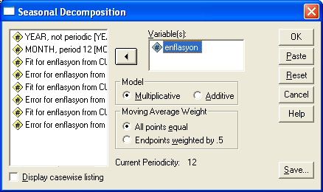



1. **CYCLICAL COMPONENT**

For yearly data: $Y_{t}=TCI$ (Trend*Cyclical*Irregular)

$$CI\%=\frac{Y_{t}}{T}*100$$

For seasonal (monthly / quarterly) data: $Y_{t}=TSCI$ (Trend*Seasonal*Cyclical*Irregular)

$$CI\%=\frac{Y_{t}}{TM}*100$$