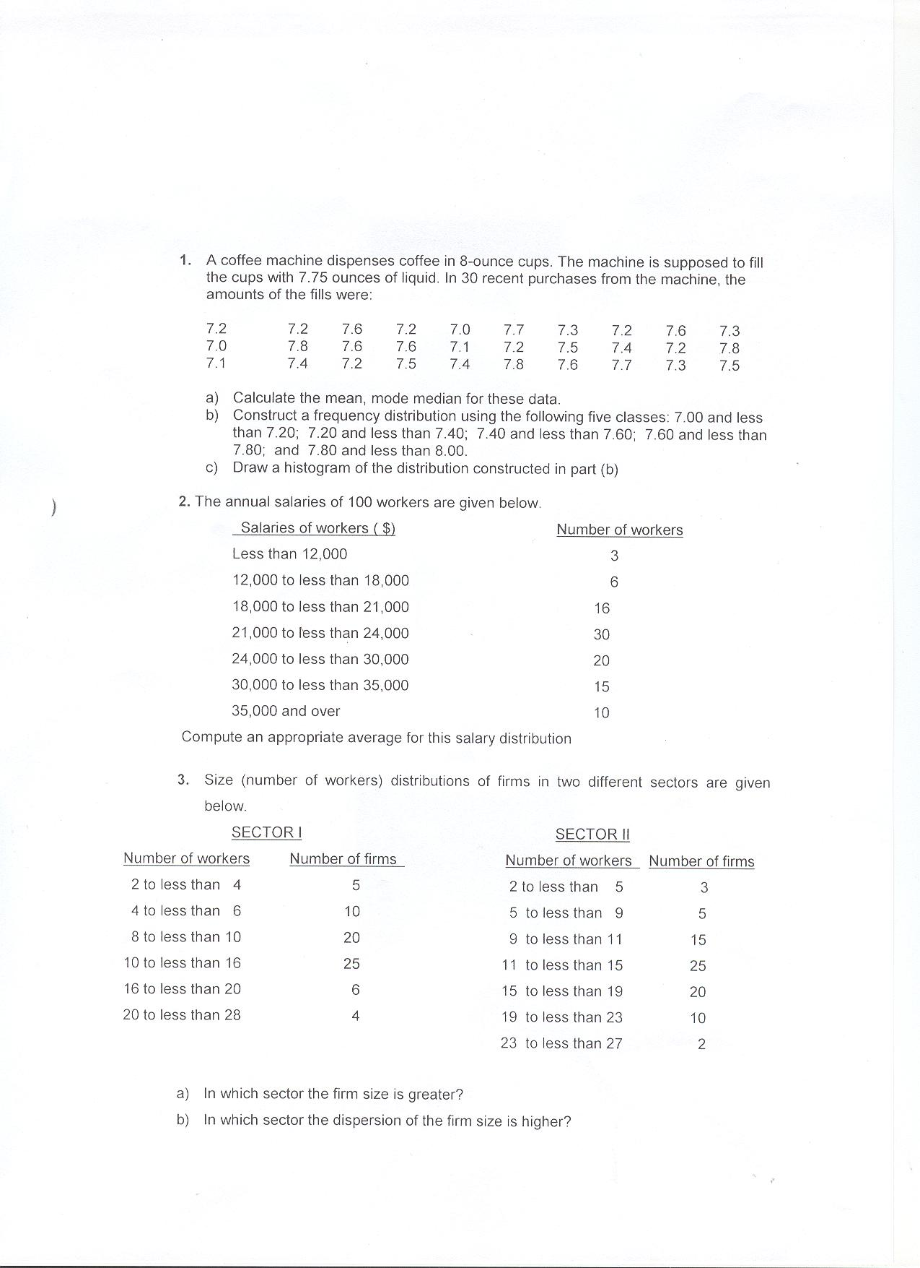

4. A group of 13 students is studying in Istanbul, Turkey, for five weeks. As part of their study of the local economy, they each purchased an Oriental rug and arranged for its shipment back to the US. The shipping time, in days, for each rug was as follows:

|  |  |  |  |  |  |  |
| --- | --- | --- | --- | --- | --- | --- |
| 31 | 31 | 42 | 39 | 42 | 43 | 34 |
| 30 | 28 | 36 | 37 | 35 | 40 |  |

Find the average shipping time.

5. A professor teaches 2 large sections of introductory marketing and randomly selects a sample of test scores from both sections. Compare the 2 sections using appropriate statistics.

|  |  |  |  |  |  |
| --- | --- | --- | --- | --- | --- |
| Section 1 | 50 | 60 | 70 | 80 | 90 |
| Section 2 | 72 | 68 | 70 | 74 | 66 |