Predicting Arrhythmia Based on ECG

Introduction:

In this project, we propose a method based on AI for the classification of heartbeats which can accurately classify five different arrhythmias in accordance with the AAMI EC57 standard.
As recommended by the Association for the Advancement of Medical Instrumentation (AAMI), all beats were classified as beats originating in the sinus mode (N), supraventricular ectopic beats (S beats), ventricular ectopic beats (V beats), fusion beats (F), or unclassifiable beats (Q). S and V refers to extra, abnormal heartbeats that begin in one of the heart's two lower chambers.

N: Normal Beats.
S: Supraventricular ectopic beats (S beats or SVEB): Supraventricular tachycardia, where the electrical signals come from the wrong area.

V: Ventricular tachycardia, where there are abnormal electrical signals in the lower chambers of the heart.

F: A fusion beat occurs when electrical impulses from different sources act upon the same region of the heart at the same time.

Q: Unknowns or Unclassified Beats.

Procedure:
We trained our model and then let it work on test data that were not used to train it.
We evaluated the confusion matrix on heartbeats that were not used in the network training phase. Note that the dataset is being augmented to reach a balance in the number of beats in each category. As it can be seen from confusion matrix and accuracy (precision, recall & f1 score), the model is able to make accurate predictions and distinguish different classes.

Result Analysis: Here, we will use the data from MIT-BIH Arrhythmia Dataset and analyze the accuracy by plotting and then calculating the precision, recall, f1 score and confusion matrix.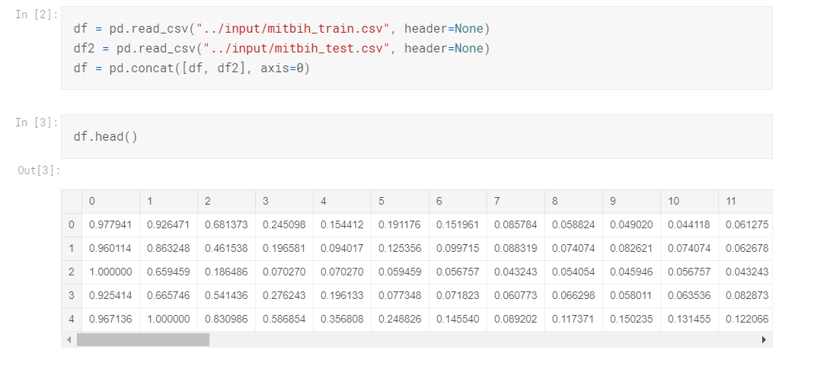
First, we create the dataframe from the MIT-BIH Arrhythmia Dataset csv file. Then we plot it with 5 category, N, S, V, F, Q.
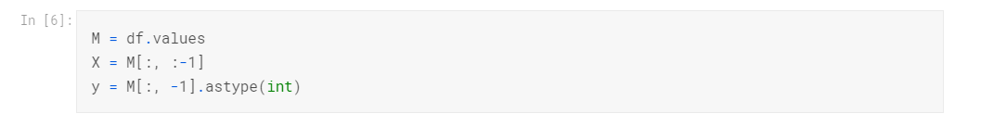
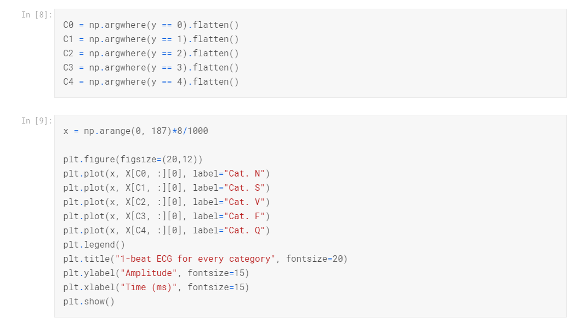
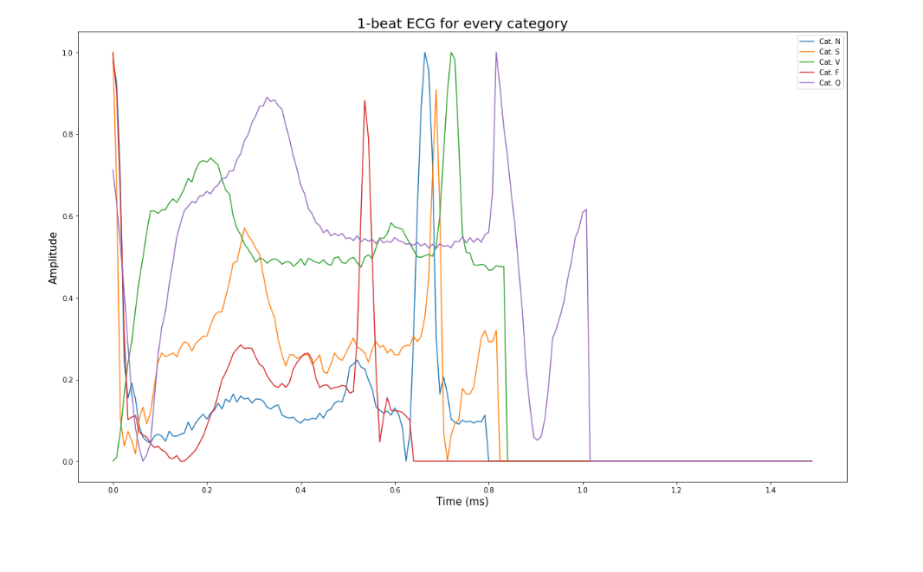
At this moment, the model must be trained, to train properly the model, we have to augment all data to the same level. For a first try, we will just augment the smallest class to the same level as class 1. With that we will be able to have a test set of around 5x800 observations.
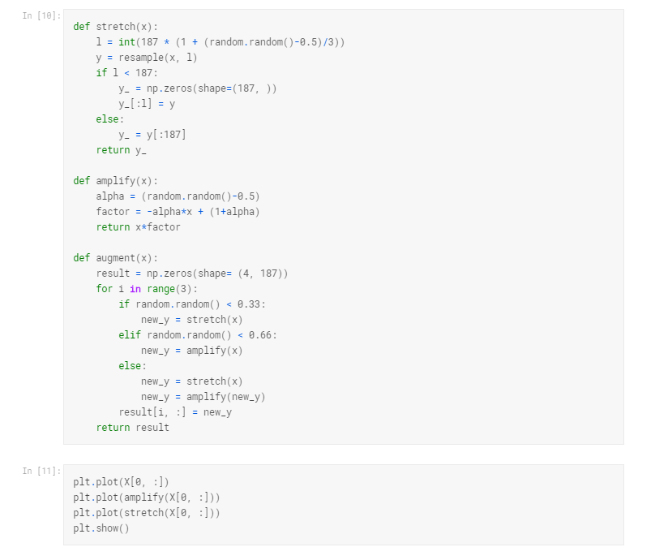
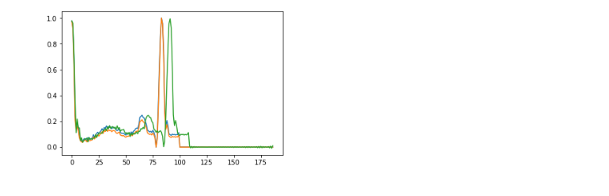
Now after we train the model and predict it, we will discuss the Accuracy by Precision, recall, f1 score & confusion matrix.

Confusion Matrix: A confusion matrix is a summary of prediction results on a classification problem. The number of correct and incorrect predictions are summarized with count values and broken down by each class. It shows the ways in which your classification model is confused when it makes predictions. It gives us insight not only into the errors being made by a classifier but more importantly the types of errors that are being made. In confusion Matrix each row represents the instances of an actual class and each column represents the instances of a predicted class.
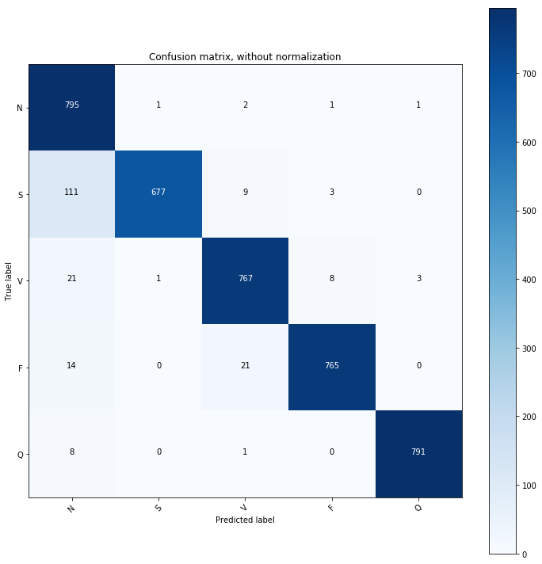
Here, the N class is making 795 correct predictions and 5 incorrect predictions out of 800 signals. S class is making 677 correct predictions 123 incorrect prediction out of 800 signals. Same goes for the rest of the classes.

Precision and Recall : Precision-Recall is a useful measure of success of prediction when the classes are very imbalanced. In information retrieval, precision is a measure of result relevancy, while recall is a measure of how many truly relevant results are returned. To get the value of precision we divide the total number of correctly classified positive observations by the total number of predicted positive observations. On the other hand, recall can be defined as the ratio of the total number of correctly classified positive examples divide to the all observations in actual class.
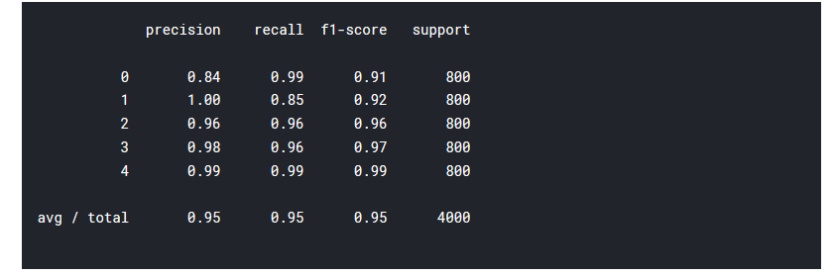
Here 0,1,2,3,4 indicates the classes N, S,V,F and Q. The precision of N is 0.84. The calculation is =795/(795+111+21+14+8)
=0.84.
For S, the precision is= 677/(667+1+1)
=1.00
For V, the precision is= 767/(767+2+9+21+1)
=0.96
For F, the precision is= 767/(767+2+9+21+1)
=0.96
For Q, the precision is= 791/(791+1+3)
=0.99
High precision relates to the low false positive rate.
The recall of N is 0.99. The calculation is= 795/800
= 0.99
For S, the recall is= 677/800
= 0.85
For V, the recall is= 767/800
= 0.96
For F, the recall is= 765/800
= 0.96
For Q, the recall is= 791/800
= 0.99

High precision relates to the low false positive rate. A low recall indicates many False Negatives. But our recall is around 0.9, which is above 0.5, so it’s great.

F1 score:
To measure the F1 score we have the follow this equation:
F1 score = 2*(Recall * Precision) / (Recall + Precision)
For N class it is = (2*0.84*0.99) / (0.84+0.99)
=0.91
The rest F1 score of the remaining classes are done in the same way.

