Figure 2
Model-Adjusted Effort Ratings Across Trials by Condition
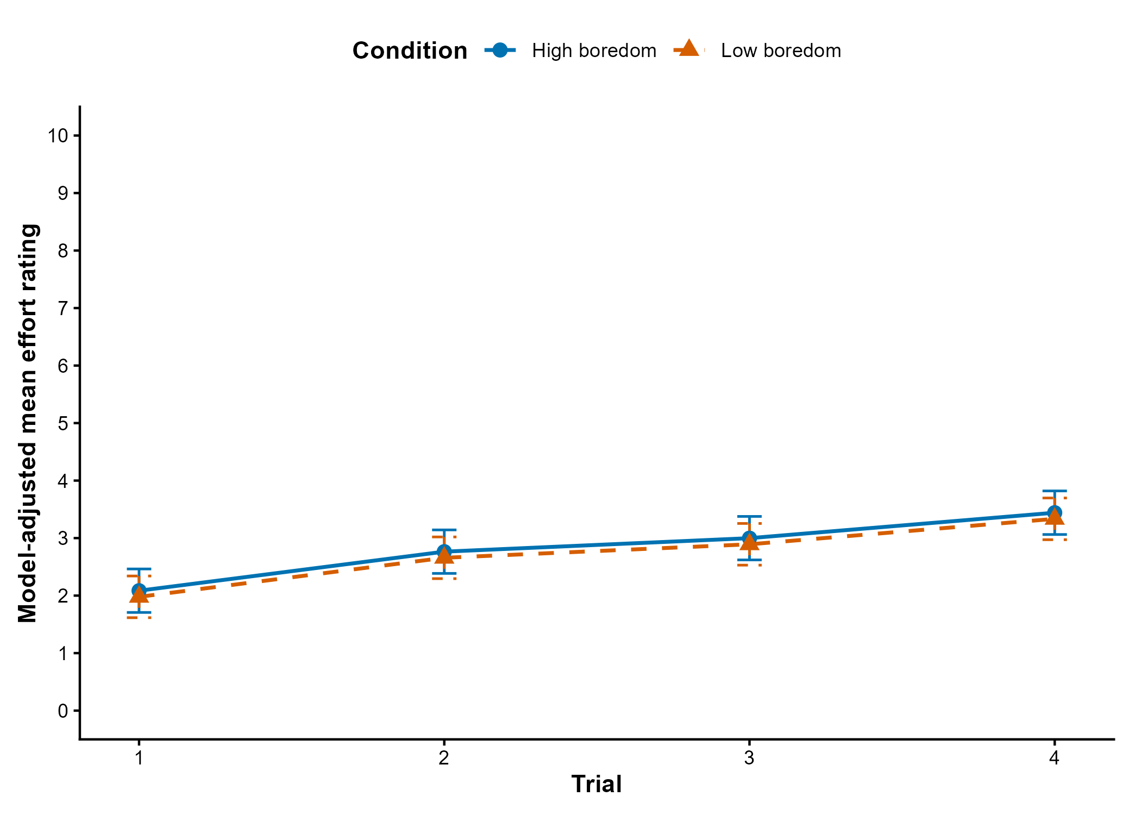
Note. Points represent estimated marginal means from the baseline-adjusted random-slope model. Error bars represent 95% confidence intervals. Estimates are adjusted for baseline effort and trial order.

