Easing Effort through Distraction – Can listening to engaging podcast reduce perceived effort during spontaneous sway measurements?

Sebastian Kappes

Department of Sport Science, University of Konstanz

Project Seminar 1: Balance and Boredom

Dr. Lorenz Assländer; Dr. Maik Bieleke

September 15, 2026

Content
Easing Effort through Distraction – Can listening to engaging podcast reduce perceived effort during spontaneous sway measurements? 1
Introduction 3
Methods 4
Study design 4
Participants and ethics 5
Materials and measures 6
Experimental setup 6
Podcast stimuli 6
Questionnaire and attention measures 7
Procedure 8
Data management and analysis 8
Results 11
Descriptive Data 11
Effort Ratings 11
Discussion 14
Limitations 15
Conclusion 15
Sources 16

Introduction
Effort influences whether people choose to engage in demanding activities. For example, people tend to assign lower value to rewards that require greater cognitive effort (Westbrook et al., 2013). Perceived effort, however, does not necessarily correspond directly to objective task demands. Although instruments such as the Rating of Perceived Exertion provide standardized and reasonably reliable assessments, they measure the subjective experience of exertion rather than exertion itself (Borg, 1982).
Perceived effort can also be influenced by task-irrelevant stimuli. Music, for example, can direct attention away from physical sensations and reduce perceived exertion during physical activity (Terry et al., 2020). Evidence is less consistent for cognitively demanding tasks, in which auditory stimulation may compete for limited attentional resources and impair performance. Moreover, mental effort has no directly observable equivalent to physical measures such as force or power output. Its assessment therefore commonly combines subjective ratings, performance measures, and physiological indicators, which do not always correspond closely (Charles & Nixon, 2019; Longo et al., 2022).
Compared with music, little is known about how listening to podcasts affects perceived effort during simple motor tasks. Podcasts combine auditory stimulation with meaningful spoken content, and the listener’s engagement may therefore influence both distraction and effort perception. However, research has rarely examined whether different levels of engagement with spoken audio alter perceived effort.
The present study intends to use the feature of podcasts, being able to engage listeners less or more depending on content, to investigate whether perceived effort during a static balance task depends on engagement with a concurrent audio stimulation. Participants completed one measurement block while listening to an engaging, self-selected podcast and another while listening to a podcast expected to be less engaging. In accordance with previous research on impacts of music, we hypothesized that participants would report lower perceived effort while listening to the engaging podcast.

Methods

Study design
The study used a two-condition within-subjects crossover design to examine perceived effort during quiet standing under conditions intended to produce lower and higher boredom. Data were collected by master's students from the Department of Sport Science at the University of Konstanz, under faculty supervision, between May and July 2024 and during the corresponding period in 2026. Each participant attended one session and completed two blocks: a low-boredom (LB) condition involving a self-selected, potentially engaging podcast and a high-boredom (HB) condition involving a standardized monotonous podcast. Each block contained four trials. Order was counterbalanced across participants by alternating between LB-HB and HB-LB sequences.
The primary outcome was perceived effort reported on a 0-10 scale under the independent variable of the high or low boredom podcast condition. The wider protocol also measured postural sway, pain, attention to the podcast, and researcher-observed body movements.

Participants and ethics
Participants were recruited through flyers and direct approaches on the University of Konstanz campus and through a video posted on the Department of Sport Science's Instagram account. Eligibility required the ability to stand independently for five to ten minutes. Exclusion criteria were acute orthopedic injury; neurological, vestibular, muscular, endocrine, or mineral-metabolism disorders relevant to balance or safety; dizziness, balance difficulties, or recurrent circulatory problems during prolonged standing; previous severe concussion or spinal surgery; epilepsy; dementia; or a cardiac pacemaker, defibrillator, or cochlear implant. Mean age was M = 23.51 years, mean height and weight of participants was M = 176.59cm and M = 75.05kg (Table 1).
Table 1
Descriptive Sample Data
Statistic | Age (years) | Height (cm) | Weight (kg)
mean | 23.51 | 176.59 | 75.05
sd | 2.46 | 9.21 | 11.67
min | 20.00 | 157.00 | 51.00
max | 33.00 | 192.00 | 104.00
range | 13.00 | 35.00 | 53.00
skew | 1.39 | -0.29 | 0.17
kurtosis | 3.49 | -0.82 | -0.43
missing | 0.00 | 4.00 | 0.00
Note. SD = standard deviation. Skewness and kurtosis are reported as distribution diagnostics.

Participants received study information, provided informed consent, and could withdraw at any time without giving a reason. Data were recorded under a pseudo-anonymous participant code. Participants were not initially informed of the intended boredom manipulation because this knowledge could have influenced their responses and behaviour; they were debriefed after completing the experiment. The study was approved by ethics committee upon initial implementation in 2024.

Materials and measures

Experimental setup
Testing took place in an approximately 4 × 4 m laboratory at the Human Performance Research Centre (HPRC), University of Konstanz. Four VR base stations were positioned in the room's corners at a height of approximately 2.30 m. Participants wore a [manufacturer/model] VR headset and [number/model] motion sensors attached at standardized positions on both wrists, between shoulder blades and above the tailbone. The virtual environment, presented using Steam VR Room software with the measurement protocol running through Anaropia software, showed a stationary animated gray-and-white checkered wall. Hardware specifications, sampling parameters, calibration procedures, and software settings are available through study repository upon request to the authors.
PsychoPy was run on a separate computer and synchronized with the VR recording through matching timestamps. A researcher used it to record visible non-postural movements as head, arm, leg, or other movements. LimeSurvey was used to collect participant information, questionnaire responses, trial-level ratings like effort, and attention-check counts.

Podcast stimuli
In the LB condition, participants selected one of three German-language podcasts. The 2024 options concerned true crime, friendship, and the 2024 European Football Championship. In 2026, the time-sensitive European championship episode was replaced with a football-related episode about Zinedine Zidane; the other options remained unchanged in2026. In the HB condition, participants were shown three ambiguously worded options to approximate the experience of choice in the LB condition, but all selections led to the same episode of Einschlafen mit Wiki. In this episode, a German Wikipedia article on stairs is read in a deliberately monotonous manner.
All excerpts had the same duration and were cut at standardized timestamps. Prerecorded instructions at trial breaks and prompted participants to report ratings of effort, boredom, and pain. Audio was presented through the VR headset and volume was tested with each participant to feel comfortable. Complete stimulus details are available via supplementary material in the repository.

Questionnaire and attention measures
The survey contained German-language items assessing trait boredom with the Short Boredom Proneness Scale (SBPS; Struk et al., 2017) and state boredom with the Multidimensional State Boredom Scale (MSBS; Fahlman et al., 2013). Wording followed the validated German translation by Zerr et al. (2024).
After each trial, participants rated effort, boredom, and pain from 0 to 10. Perceived effort was the primary outcome; boredom indicated whether the conditions produced the intended difference. Higher levels of in the HB condition in this project were confirmed in a relating study (Pecher, 2026). To monitor attention to the audio, participants pressed a mechanical counter whenever a specified keyword occurred. Keywords were Treppe in the HB condition and Rudi/Rudolf, Fußball, or Freundschaft/Freundschaften for the respective LB podcasts. A researcher recorded the number after each trial and reset the count after each condition. This count was treated as an attention-check, not as a direct measure of boredom.

Procedure
Before each session, equipment was sanitized and calibrated. After consent and safety screening, age, height, and body mass were recorded and a pseudonymous code assigned. Participants received standardized instructions, were fitted with the VR equipment and motion sensors, and selected a podcast.
At least two researchers conducted each session. One operated the VR and PsychoPy systems; another recorded questionnaire responses and counter values in LimeSurvey and remained near the participant for safety.
Participants completed four 210-s standing trials per condition and were instructed to stand as still as possible while facing the virtual wall and listening to the podcast. Each trial was followed by a 35-s break, during which effort, boredom, and pain were rated and participants could move their legs. The blocks were separated by an approximately 10-min break containing an additional questionnaire. After the second block, participants completed the remaining questionnaire measures and were debriefed about the boredom manipulation and podcast choice.

Data management and analysis
Questionnaire, observational, and motion-tracking data were linked using participant codes and synchronised timestamps. Identifying information was stored separately from the research data, with access restricted to authorized researchers at the HPRC in Konstanz in accordance with data protection regulations.
Complete analysis and data management can be replicated by following the scripts in accordance with their specific workflow.ME files from the repository.
The primary analysis compared perceived-effort ratings between the LB and HB conditions while accounting for repeated observations within participants.
Raw balance, PsychoPy, and LimeSurvey files were retained unchanged, and all processing was performed on working copies. PsychoPy files collected in 2024 and 2026 were combined and assigned standardized filenames containing participant code, measurement block, and condition. Participant codes were standardized across sources, including replacement of German umlauts with their corresponding ASCII characters. Duplicate, incomplete, or technically failed files were excluded only following review and were documented in workflow and audit files.
PsychoPy movement events were extracted separately for head, arm, leg, and other movements. Events occurring less than 0.01 s after the beginning of a trial were treated as probable carry-over clicks and excluded. Movement counts were aggregated for each trial and condition.
LimeSurvey exports from 2024 and 2026 differed in language and column structure and were therefore mapped to standardized variable names. Researcher names were removed before processing. Demographic information, condition order, trial-level ratings, attention-counter values, Short Boredom Proneness Scale items, and Multidimensional State Boredom Scale items were extracted. Invalid values and values explicitly representing missing data were coded as missing. Scale items and available sum and mean scores were retained. Balance data provided the authoritative participant list and the authoritative height and body-mass values. Implausible height entries identified during data checking were replaced with missing values and documented.
The processed datasets were merged using the standardized participant codes. Separate analysis-ready files were retained for balance, PsychoPy, and LimeSurvey data. A combined participant-level master file and a condition-level file containing one HB and one LB row per participant were created. Participants without retained balance data were not included in the combined master file. All matching decisions, exclusions, corrections, and missing-data cases were recorded in audit files and processing workflows -available in the repository.
Descriptive statistics for effort were calculated separately for the HB and LB conditions at baseline and after each of the four trials. These included means, standard deviations, observed ranges, valid sample sizes, and missing values. Missing effort ratings were not included.
The primary analysis used a linear mixed-effects model because each participant completed both conditions and provided repeated ratings across four trials. Trial-level effort ratings from 0 to 10 were predicted by condition, trial, trial order, and centered condition-specific baseline effort. Participant-specific random intercepts and condition slopes accounted for differences in overall effort and in responses to the experimental conditions. The model included 323 observations from 41 participants. Model convergence, singularity, residual distributions, and residual variance were examined before interpretation. No observations were removed as statistical outliers.
The primary condition effect was reported using the unstandardized regression coefficient, standard error, 95% confidence interval, test statistic, degrees of freedom, and two-sided p value with α = .05. A condition-by-trial interaction was examined as a secondary analysis, and trial-specific comparisons were adjusted using Holm’s method. An unadjusted random-intercept model was retained as a sensitivity analysis. Cohort year and individual LB podcast choice were not included as predictors because the primary analysis concerned the average within-participant HB–LB contrast; possible differences associated with year or podcast choice were outside the primary research question.

Results

Descriptive Data
Mean Effort Ratings with standard deviation, range, missing values in both conditions at baseline and in each trial are depicted in Table 2.
Table 2
Descriptive Statistics for Effort Ratings by Condition and Timepoint
Timepoint | HB M (SD) | HB Range | HB n | HB Missing | LB M (SD) | LB Range | LB n | LB Missing
Baseline | 1.07 (1.23) | 0–5 | 41 | 0 | 0.85 (1.33) | 0–5 | 40 | 1
Trial 1 | 2.10 (1.55) | 0–7 | 41 | 0 | 1.98 (1.76) | 0–6 | 40 | 1
Trial 2 | 2.90 (1.74) | 0–8 | 41 | 0 | 2.52 (1.50) | 0–7 | 40 | 1
Trial 3 | 3.07 (1.65) | 0–6 | 41 | 0 | 2.83 (1.48) | 0–7 | 40 | 1
Trial 4 | 3.52 (1.63) | 0–6 | 40 | 1 | 3.23 (1.61) | 0–7 | 40 | 1

Effort Ratings
Figure 1 below shows the trajectory of effort ratings from baseline over all four trials for both conditions.
Figure 1
Trajectory of effort ratings
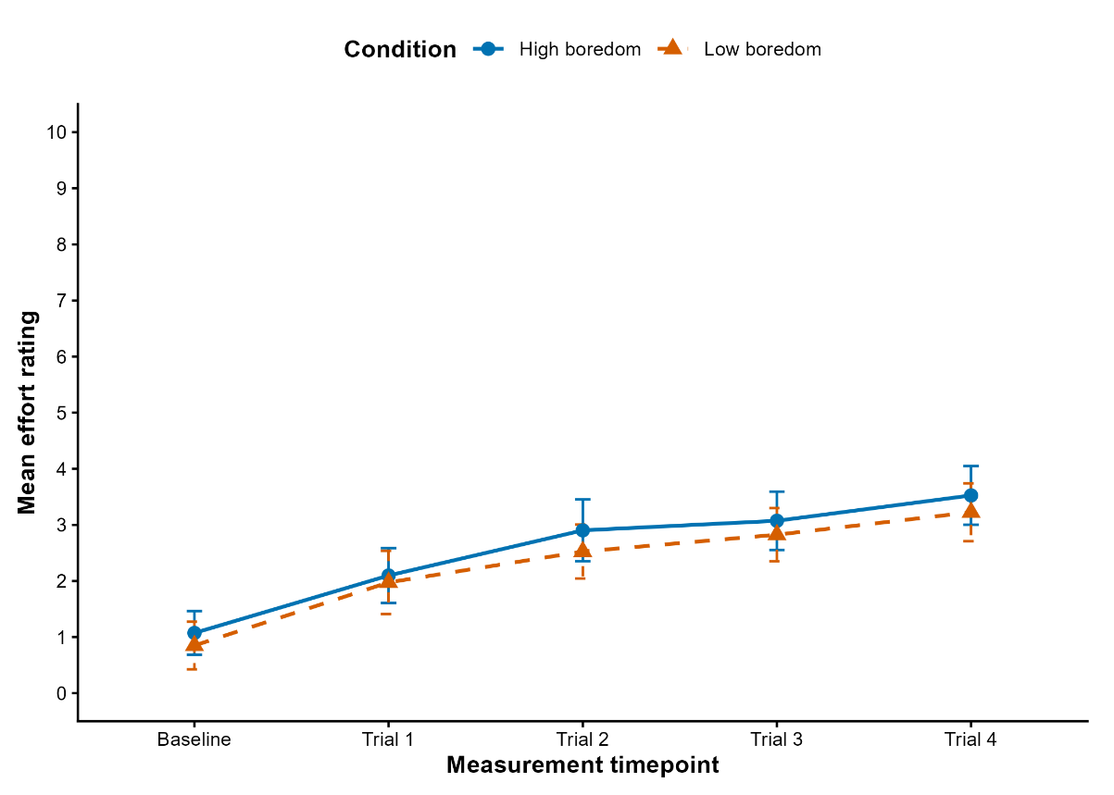

A linear mixed-effects model was used to examine whether effort ratings differed between the high-boredom and low-boredom conditions while accounting for repeated measurements, trial, trial order, and baseline effort. Model-adjusted effort was slightly lower in the low-boredom condition (M=2.72), (SE=0.17), 95% CI [2.38, 3.05]) than in the high-boredom condition (M=2.82), (SE=0.17), 95% CI [2.47, 3.17] (Table 3). The development of adjusted effort ratings across the four trials is displayed in Figure 1.

Table 3
Condition | Estimated M | SE | 95% CI
High boredom | 2.82 | 0.17 | [2.47, 3.17]
Low boredom | 2.72 | 0.17 | [2.38, 3.05]
Model-Adjusted Mean Effort Ratings by Condition

However, the estimated difference between conditions was small and not statistically significant, (B=-0.11), (SE=0.15), 95% CI [−0.42, 0.21], (t(34.57)=-0.69), (p=.492), (Table 4). Thus, the primary analysis did not support the hypothesis that effort would be lower in the low-boredom condition. An unadjusted sensitivity model indicated a small significant difference, (B=-0.22), (p=.027) (Table 4), suggesting that the result was sensitive to model specification.

Table 4
Overall Low-Boredom Minus High-Boredom Effort Contrast
Model | Contrast | Estimate | SE | 95% CI | df | t | p
Primary: baseline-adjusted random slope | LB - HB | -0.11 | 0.15 | [-0.42, 0.21] | 34.6 | -0.69 | 0.492
Sensitivity: unadjusted random intercept | LB - HB | -0.22 | 0.10 | [-0.41, -0.02] | 278.5 | -2.22 | 0.027

Discussion
Studies investigating the effects of engagement in an altering stimulus, like listening music, can reduce the perceived effort of the simultaneously conducted primary task, have shown that listening to music can reduce perceived effort (Terry et al., 2020). Our measurement aimed at investigating the role which level of engagement in the altering stimulus plays on the perceived effort. Expecting initially, that a more engaging stimulus would reduce perceived effort more than a less engaging or even boring stimulus. Our analysis showed small descriptive differences in perceived effort ratings between the high- and low-boredom conditions (Table 1 and Figure 1). However, robust statistical testing using a linear mixed model approach, revealed those differences to only be descriptive. The testing did not show significant differences in effort rating between conditions across the trials. This refutes our hypothesis.
One very plausible reason for this might be that both conditions are not engaging enough to distract from the perceived effort during the balance task. Which is why future studies in this topic should perhaps add another control condition with self-chosen music.
Outside stimuli during tasks, while being able to reduce effort, have also shown to reduce performance in primary tasks (Haapakangas et al., 2020), perhaps making task completion harder. Considering this more engaging outside stimuli might be as distracting from effort but also enhance effort by making task completion harder. This might counter the diversion from effort effect we hypothesized. This research also shows that whether distraction strategies work, is also reliant on the type of primary task conducted. So, this procedure might work for some tasks while it does not for others. However, this requires further investigation.

Limitations
It is important to keep in mind, that this study had its limitations. Conducting testing in two different years with a different set of researchers should results in some workflows being different, potentially impacting measurements.
Measuring during the summer led to high temperatures occurring in the laboratory room, potentially increasing effort and affecting other ratings.

Conclusion
This study and its data leads us to conclude, that diversion from a task by listening to podcasts does not necessarily reduce the effort perceived in said task. However, studies have shown that this can be done by other stimuli, so we assume that the type of stimuli one experiences during the task change how this impacts perceived effort. So, it is possible, that more tailored diversion stimuli might help reduce perceived effort further.

Sources
Borg, G. A. (1982). Psychophysical bases of perceived exertion. Medicine and Science in Sports and Exercise, 14(5), 377–381.
Charles, R. L., & Nixon, J. (2019). Measuring mental workload using physiological measures: A systematic review. Applied Ergonomics, 74, 221–232. https://doi.org/10.1016/j.apergo.2018.08.028
Fahlman, S. A., Mercer-Lynn, K. B., Flora, D. B., & Eastwood, J. D. (2013). Development and validation of the multidimensional state boredom scale. Assessment, 20(1), 68–85. https://doi.org/10.1177/1073191111421303
Haapakangas, A., Hongisto, V., & Liebl, A. (2020). The relation between the intelligibility of irrelevant speech and cognitive performance—A revised model based on laboratory studies. Indoor Air, 30(6), 1130–1146. https://doi.org/10.1111/ina.12726
Longo, L., Wickens, C. D., Hancock, G., & Hancock, P. A. (2022). Human Mental Workload: A Survey and a Novel Inclusive Definition. Frontiers in Psychology, 13, 883321. https://doi.org/10.3389/fpsyg.2022.883321
Pecher, K. (2026). Standing Still, Feeling Bored The Role of Podcasts in the Development of State Boredom.
Struk, A., Carriere, J., Cheyne, J., & Danckert, J. (2017). A Short Boredom Proneness Scale. Assessment, 24, 346–359. https://doi.org/10.1177/1073191115609996
Terry, P. C., Karageorghis, C. I., Curran, M. L., Martin, O. V., & Parsons-Smith, R. L. (2020). Effects of music in exercise and sport: A meta-analytic review. Psychological Bulletin, 146(2), 91–117. https://doi.org/10.1037/bul0000216
Westbrook, A., Kester, D., & Braver, T. S. (2013). What Is the Subjective Cost of Cognitive Effort? Load, Trait, and Aging Effects Revealed by Economic Preference. PLoS ONE, 8(7), e68210. https://doi.org/10.1371/journal.pone.0068210
Zerr, K., Seiler, J. P.-H., Rumpel, S., & Tüscher, O. (2024). Validation of a German version of the Boredom Proneness Scale and the Multidimensional State Boredom Scale. Scientific Reports, 14(1), 2905. https://doi.org/10.1038/s41598-024-53236-4

