MITRE ATT&CK Threat Detection Report
Environment: WIN11-TARGET (Windows 11 Pro VM)
Tools Used: Splunk Enterprise 10.4, Sysmon v15 (Olaf Hartong config)
Date: June 2026
Author: Michael Isiuwa

Executive Summary
This report documents the simulation and detection of a three-stage attack chain using the MITRE ATT&CK framework. The objective was to emulate realistic adversary behaviour across three distinct tactics - Execution, Persistence, and Defense Evasion and demonstrate detection capability using Splunk Enterprise and Sysmon on a controlled Windows 11 lab environment.
Each technique was manually simulated, captured in Sysmon logs, detected via targeted Splunk queries, and mapped to its corresponding MITRE ATT&CK technique ID. Detection rules were created in Splunk to provide ongoing alerting capability beyond the initial simulation.
The attack chain simulated represents a realistic post-compromise scenario: an attacker executes malicious PowerShell commands after gaining initial access, establishes persistence via a scheduled task, then attempts to evade detection by masquerading a malicious executable as a legitimate Windows process.

Attack Chain Overview
Stage | Technique | MITRE ID | Tactic
1 | PowerShell Execution | T1059.001 | Execution
2 | Scheduled Task Creation | T1053.005 | Persistence
3 | Masquerading | T1036.005 | Defense Evasion

Environment & Tools
Lab Architecture
The simulation was conducted in an isolated virtual machine environment using Oracle VirtualBox. No external networks or production systems were involved. All attack activity was contained within the virtual machine.
Component | Details
Host OS | Windows 11 (main PC)
Virtual Machine | Windows 11 Pro — WIN11-TARGET
Hypervisor | Oracle VirtualBox 7.x
RAM Allocated | 6 GB
Disk Allocated | 80 GB

Security Tools
Sysmon v15 (System Monitor)
Microsoft Sysinternals tool deployed on WIN11-TARGET to provide enhanced Windows event logging. Configured using the Olaf Hartong sysmon-modular configuration — the most widely adopted community Sysmon config, tuned to detect MITRE ATT&CK techniques and automatically tag events with technique IDs. Sysmon captured process creation, file creation, registry modification, and network events throughout the simulation.
Splunk Enterprise 10.4
Industry-leading SIEM platform used to ingest, search, and alert on Sysmon logs. Configured to monitor the Microsoft-Windows-Sysmon/Operational event log channel. All detections were performed using SPL (Search Processing Language) queries. Three scheduled alert rules were created — one per technique — to provide ongoing detection capability.

Technique 1: PowerShell Execution — T1059.001
Field | Details
Technique | PowerShell Execution
MITRE ID | T1059.001
Tactic | Execution
Severity | High

Description
PowerShell is a powerful scripting environment built into every Windows system. Attackers abuse it to execute malicious commands, download payloads, and interact with the operating system while blending in with legitimate administrative activity. The use of the -ExecutionPolicy Bypass flag is a well-known attacker technique to override Windows script execution restrictions.
Attack Simulation
The following PowerShell command was executed on WIN11-TARGET to simulate post-compromise reconnaissance activity:
powershell -ExecutionPolicy Bypass -NoProfile -Command "Get-Process; Get-LocalUser; whoami"
This command specifies running processes, lists local user accounts, and confirms the current user context - standard attacker behaviour immediately after gaining access to a system.
Detection
Sysmon EventID 1 (Process Creation) captured the execution and automatically mapped it to MITRE T1059.001. The following Splunk query was used to detect the activity:
index=main source="WinEventLog:Microsoft-Windows-Sysmon/Operational" "ExecutionPolicy" "Bypass"
Splunk returned 6 events confirming detection of the simulated attack. Key fields observed in the logs:
Field | Value
Image | C:\Windows\System32\WindowsPowerShell\v1.0\powershell.exe
CommandLine | powershell.exe -ExecutionPolicy Bypass -NoProfile
ParentImage | C:\Windows\System32\cmd.exe
User | WIN11-TARGET\analyst
MITRE Tag | technique_id=T1059.001, technique_name=PowerShell

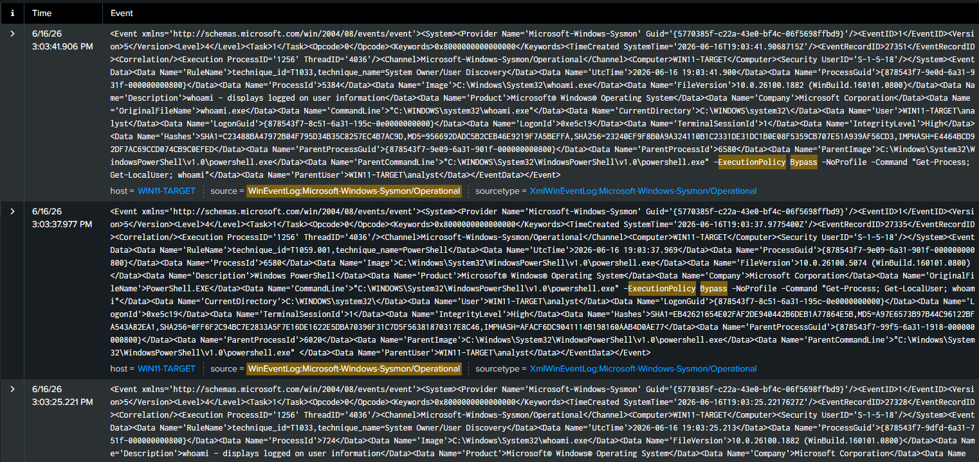
Figure 1: Splunk detection of T1059.001 — 6 events returned showing ExecutionPolicy Bypass in CommandLine field
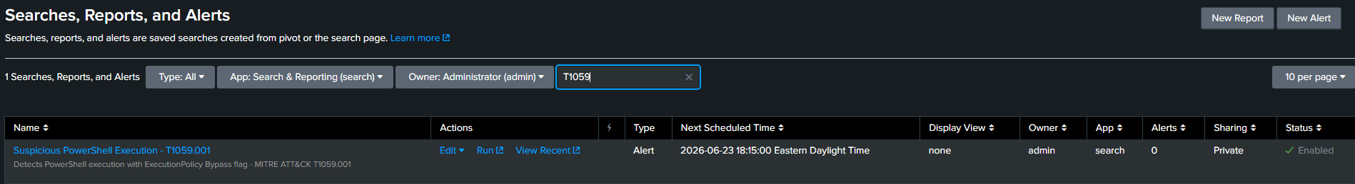
Alert screenshot: Figure 2: Splunk alert rule "Suspicious PowerShell Execution - T1059.001" configured to run hourly

Detection Rule
A scheduled Splunk alert was created titled "Suspicious PowerShell Execution - T1059.001" configured to run hourly and trigger when results exceed zero.
Recommended Mitigation
- Restrict PowerShell execution policy via Group Policy to AllSigned or RemoteSigned
- Enable PowerShell Script Block Logging (Event ID 4104) for deeper visibility
- Alert on any use of -ExecutionPolicy Bypass in production environments
- Deploy Constrained Language Mode to limit PowerShell capabilities for standard users
Technique 2: Scheduled Task Creation — T1053.005
Field | Details
Technique | Scheduled Task/Job
MITRE ID | T1053.005
Tactic | Persistence
Severity | High

Description
Scheduled tasks are a native Windows feature that attackers abuse to maintain persistence on a compromised system. By creating a task that executes malicious code at system startup or user logon, an attacker ensures their access survives reboots and user logoffs. Attackers commonly use task names that mimic legitimate Windows maintenance tasks to avoid detection.
Attack Simulation
The following command was executed to create a persistence mechanism on WIN11-TARGET:
schtasks /create /tn "WindowsUpdateCheck" /tr "powershell.exe -WindowStyle Hidden -Command 'whoami'" /sc onlogon /ru System
The task was named WindowsUpdateCheck to blend in with legitimate Windows update activity. It was configured to run as SYSTEM at every user logon, executing a hidden PowerShell command.
Detection
Sysmon captured the attack across three event types simultaneously:
Sysmon Event | ID | What It Captured
Process Creation | EventID 1 | schtasks.exe spawned by PowerShell
Registry Modification | EventID 13 | Task written to TaskCache registry key
File Creation | EventID 11 | Task file created in C:\Windows\System32\Tasks\
The following Splunk query was used to detect the activity:
index=main source="WinEventLog:Microsoft-Windows-Sysmon/Operational" "WindowsUpdateCheck"
Key fields observed in EventID 1:
Field |  | Value
Image | C:\Windows\System32\schtasks.exe
CommandLine | schtasks.exe /create /tn WindowsUpdateCheck
ParentImage | C:\Windows\System32\WindowsPowerShell\v1.0\powershell.exe
User | WIN11-TARGET\analyst
MITRE Tag | technique_id=T1053.005, technique_name=Scheduled Task/Job

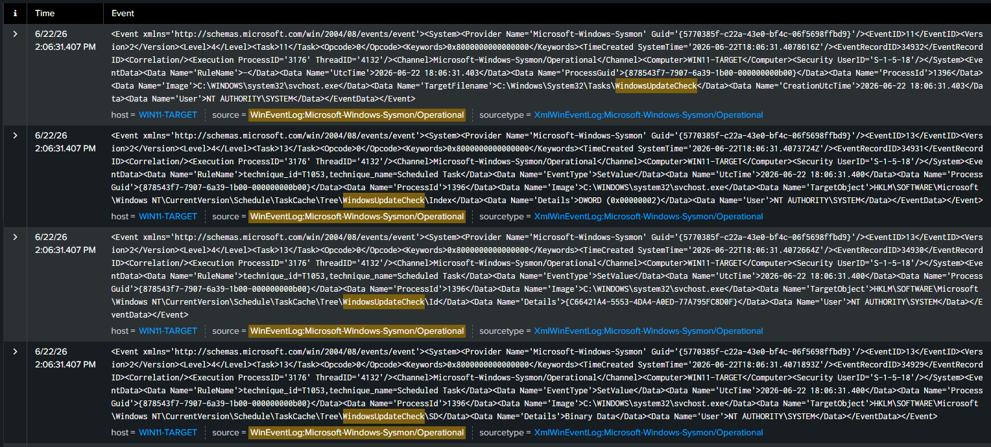
Detection screenshot: Figure 3: Splunk detection of T1053.005 — events showing schtasks.exe spawned by PowerShell creating WindowsUpdateCheck persistence task
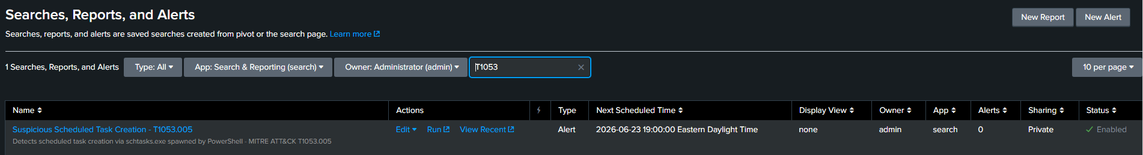
Alert screenshot: Figure 4: Splunk alert rule "Suspicious Scheduled Task Creation - T1053.005" configured to run hourly
Recommended Mitigation
- Monitor scheduled task creation events (Windows Event ID 4698) in production
- Alert on any scheduled task created to run as SYSTEM by a non-administrative process
- Regularly audit scheduled tasks using schtasks /query to identify unauthorized entries
- Restrict task creation permissions for standard user accounts via Group Policy
Technique 3: Masquerading — T1036.005
Field | Details
Technique | Masquerade Task or Service
MITRE ID | T1036.005
Tactic | Defense Evasion
Severity | High

Description
Masquerading is a defense evasion technique where attackers rename malicious files to mimic legitimate Windows processes, making it harder for analysts and security tools to identify malicious activity. A common approach is naming a malicious executable svchost.exe — one of the most frequently running Windows processes — and executing it from a non-standard location.
Attack Simulation
The following commands were executed to simulate masquerading on WIN11-TARGET:
Copy-Item "C:\Windows\System32\WindowsPowerShell\v1.0\powershell.exe" -Destination "C:\Users\analyst\AppData\Local\Temp\svchost.exe"

Start-Process "C:\Users\analyst\AppData\Local\Temp\svchost.exe" -ArgumentList "-WindowStyle Hidden -Command whoami"
PowerShell was copied to the Temp folder and renamed svchost.exe, then executed from that non-standard location — mimicking how real attackers disguise malicious payloads.
Detection
The key detection indicator is path anomaly — legitimate svchost.exe exclusively runs from C:\Windows\System32\. Any instance running from another location is immediately suspicious. Sysmon captured 179 events including:
Sysmon Event | ID | What It Captured
File Creation | EventID 11 | svchost.exe written to Temp folder
Process Creation | EventID 1 | svchost.exe executing from Temp
Process Termination | EventID 5 | Fake svchost process ended
Process Access | EventID 10 | DLL injection attempt detected (T1055.001)

The following Splunk query was used to detect the activity:
index=main source="WinEventLog:Microsoft-Windows-Sysmon/Operational" "svchost.exe" "Temp"

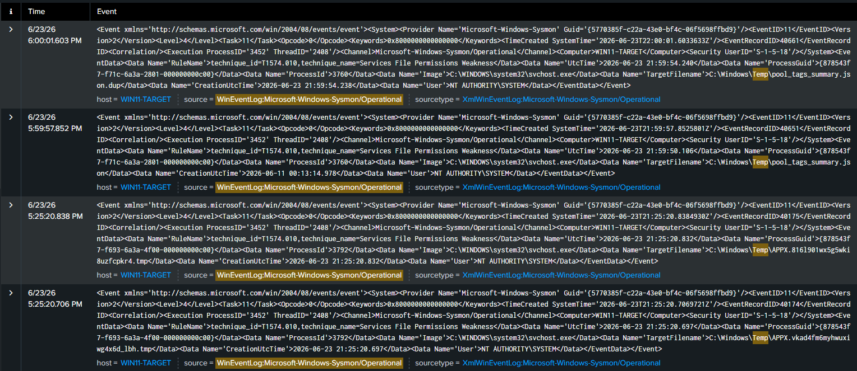
Detection screenshot: Figure 5: Splunk detection of T1036.005 — 179 events showing svchost.exe executing from Temp folder, mapped to T1036.005 and T1055.001

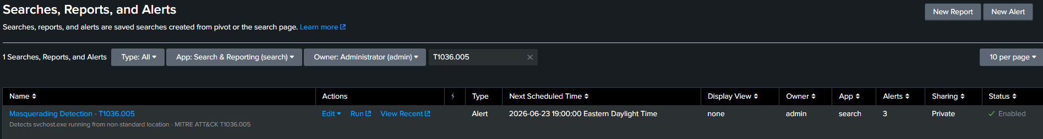
Alert screenshot: Figure 6: Splunk alert rule "Masquerading Detection - T1036.005" configured to run hourly

Notable Finding: Sysmon also automatically detected a secondary technique — T1055.001 (Dynamic-link Library Injection) — triggered by the masquerading process attempting to access legitimate Windows processes. This demonstrates how a single attacker action can generate detections across multiple MITRE techniques simultaneously.
Recommended Mitigation
- Implement process path validation rules — alert on any known Windows system process running outside its expected directory
- Deploy application whitelisting to prevent execution of unauthorized binaries from user-writable locations such as Temp folders
- Block script execution from AppData and Temp directories via Software Restriction Policies or AppLocker
- Monitor for process names that match known Windows binaries but run from unexpected paths

Conclusion
This simulation demonstrates end-to-end detection capability across three MITRE ATT&CK tactics using an isolated Windows 11 lab environment. All three techniques were successfully simulated, detected via Sysmon logs ingested into Splunk, and mapped to their corresponding MITRE ATT&CK technique IDs. Scheduled detection rules were deployed to provide ongoing alerting capability.
The exercise highlights several key findings relevant to real-world security operations:
A single attacker command can trigger detections across multiple MITRE techniques simultaneously, as demonstrated by the masquerading simulation which also surfaced a DLL injection detection. Sysmon with a professionally tuned configuration provides automatic MITRE ATT&CK tagging, significantly accelerating analyst triage. The parent-child process relationship visible in Sysmon logs is a critical indicator — legitimate Windows processes have predictable parent processes, and anomalies in these relationships are a reliable signal of malicious activity.
Defensive Recommendations Summary
Technique | Priority | Key Control
T1059.001 PowerShell | High | Enforce execution policy, enable script block logging
T1053.005 Scheduled Task | High | Monitor task creation events, audit existing tasks
T1036.005 Masquerading | High | Process path validation, application whitelisting

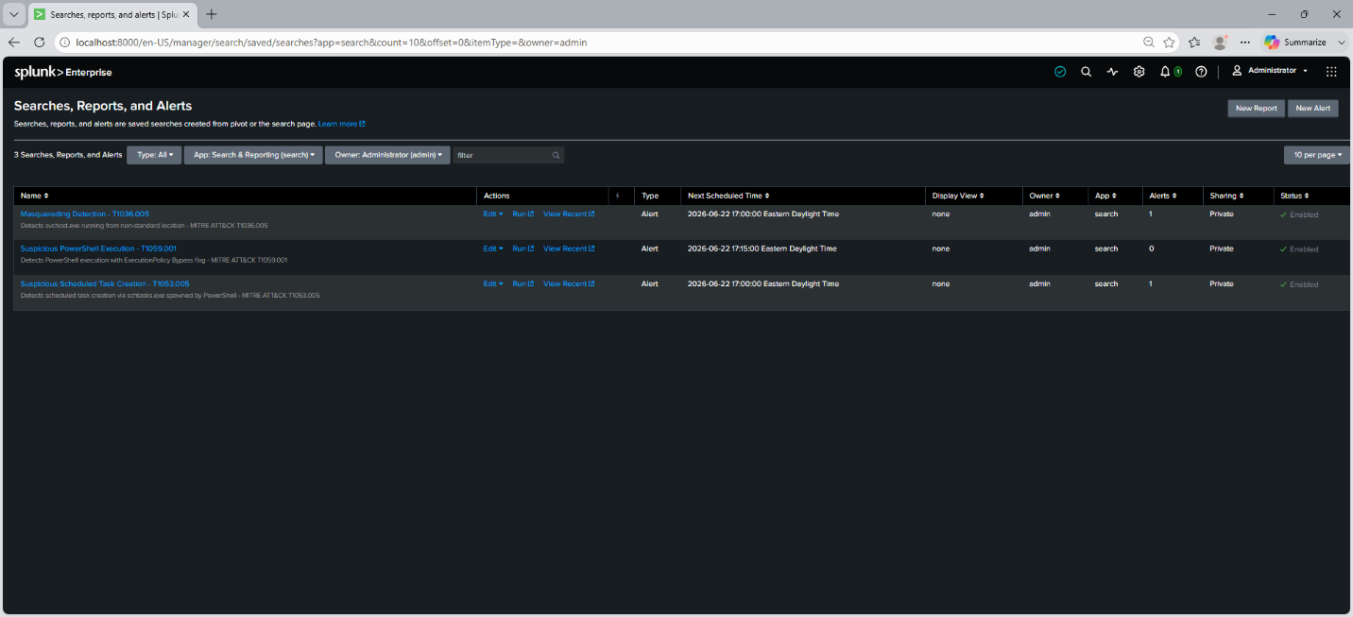
Figure 7: All three MITRE ATT&CK detection rules active in Splunk — T1059.001, T1053.005, and T1036.005

