解压之后是是一张图片，而提示是说使用python来实现。
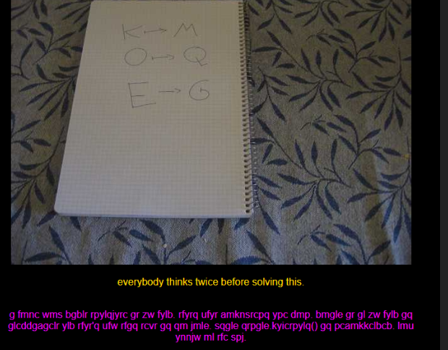
图片中的内容就是一个移位。K 到m 移动了两位
那么就是把下面这段英文都移动两位。那么最后的结果结果：
i hope you didnt translate it by hand.
thats what computers are for. doing it in by hand
is inefficient and that's why this text is so long.
using string.maketrans() is recommended. now apply on the url.
实现的脚本就是
from string import maketrans
in_string = "abcdefghijklmnopqrstuvwxyz"
out_string = "cdefghijklmnopqrstuvwxyzab"
goal = """g fmnc wms bgblr rpylqjyrc gr zw fylb.
rfyrq ufyr amknsrcpq ypc dmp. bmgle gr gl zw fylb
gq glcddgagclr ylb rfyr'q ufw rfgq rcvr gq qm jmle.
sqgle qrpgle.kyicrpylq() gq pcamkkclbcb. lmu ynnjw ml rfc spj."""
trans_string = maketrans(in_string, out_string)
print goal.translate(trans_string)

