This is a fairly robust way to import users and profiles from CSV files. I don’t think it has errors at the moment, but that doesn’t mean there can’t be. Feel free to adjust batch sizing.

This ZIP contains the following directories:
- Data
  - CSV files
    - All fields use double quotes text qualifier, including column headers
- Configs
  - ProfileConfig.json
    - This file maps the CSV text headers to profile types and attributes
    - It supports three kinds of objects
      - Text
        - Includes simple dates, drop downs, radio buttons
      - Profiles
        - Tries to find a specific profile given the profile type specified and then assign it to the attribute specified
      - Users
        - Tries to find a specific user mapping the value in the CSV column to a user object with the parameter specified
    - Example
      - I want to import existing Organizations from a CSV file with three columns, Name, Populations, Sponsor.
      - Using the configuration shown below, each Organization’s Population will be stored in the attribute “managed_types” on the Organization profile.
      - Each Organization’s Sponsor will be stored in the attribute “sponsor” after searching for the user who’s email matches the value in the CSV file.
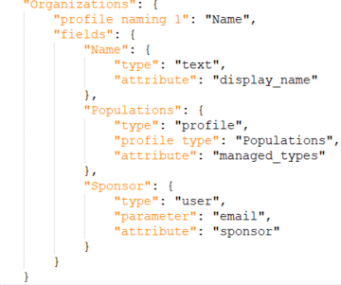
- Logs
  - Minor logging. Could be improved.
- Scripts
  - ImportUsers.rb
    - If any imported profiles include references to users, like Sponsor, then run ImportUsers.rb before running SyncProfiles.rb
    - At a minimum, you will need to change
      - API Token
      - URL
      - CSV filename
  - SyncProfiles.rb
    - This will create new profiles and update existing ones
    - If any imported profiles include references to other profiles, the other profiles will need to be imported first
    - At a minimum, you will need to change
      - API Token
      - URL
      - The order you wish to import the specific profile types
  - Functions.rb
    - You should not need to make changes here, but you might need to if you hit a problem

