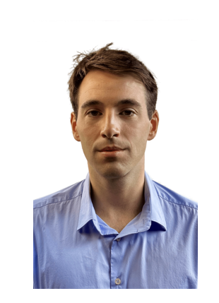
{{ full_name }}

Nationality: {{ nationality }}
Availability: {{ availability }}
Languages: {{ languages }}
Location: {{ location }}

Highlights
{% for h in highlights %}
- {{ h | trim}}
{%- endfor %}

Experience
{% for exp in experience %}
{{ exp.period }} | {{ exp.company }}, {{ exp.location }}
 | {{ exp.title }}

{% if exp.summary %}{{ exp.summary }}{% endif %}
{%- for b in exp.bullets %}
- {{ b | trim}}
{%- endfor %}
{% endfor %}
Education
{% for edu in education %}
{{ edu.period }} | {{ edu.degree }} – {{ edu.school }}
 | {% if edu.specialization %}Specialisation in {{ edu.specialization }}{% endif %}
{% endfor %}
Technical Skills

{%tr for row in skills|batch(4, '') %}
{{ row[0] | trim }} | {{ row[1] | trim }} | {{ row[2] | trim }} | {{ row[3] | trim }}
{%tr endfor %}

Personal Projects
{% for pr in projects %}
- {{ pr | trim}}
{%- endfor %}

Awards
{% for aw in awards %}
{{ aw.year }} | {{ aw.title }}
 | {{ aw.description }}
 | {{ aw.url }}
{% endfor %}
Hobbies

{{ hobbies }}

