*Thank you for participating in our first Houston Robotics & AI Day!*

**Purpose Statement:** (1) increase collaboration of our robotics programs

(2) give our students practice presenting, (3) serve as a mini -recruiting event for Houston Robotics programs.

*2016 organizing team: Aaron Becker, Nathaniel Wiggins, Mark Moll, Lydia Kavraki, Carol Fairchild, Nikolaos Tsekos, Luong Nguyen, Joe Francis, and Tom Harmon*

**Webpage:** <http://bsc.uhcl.edu/index.php?id=58&eventId=28>

**Location:** [2700 Bay Area Blvd, Houston, TX 77058:](https://goo.gl/maps/FqNvk9Pt1Tt)  Bayou Atrium [see attached map]

**Parking:** Please see campus map on last page. Parking is free in the Student lots behind the Bayou building (Orange on the map) or across from the Bayou building (Visitors). Do not park in the faculty lots.

**WiFi Instructions:** UHCL public

**Dress Code:** Summer Business Casual

**Presenter Instructions:** Bring your own laptop and practice connecting to the projector during registration. We will have two projectors ready, so the *i*th presenter connects their computer to the projector while the *(i*-1)th presenter is speaking.

**8:45 -9:15 registrations, Atrium I**

**9:15 -12:15 Talks & Demonstrations, Room TBD:**

9:15-9:20: Welcome to UH-CL & Houston Robotics and AI Day Tom Harman

**Robot Communication, Control, and Planning**

9:20-9:25 “Incremental Task and Motion Planning”, Neil Dantam, [ntd@rice.edu](mailto:ntd@rice.edu), Rice University

9:25-9:30 “Controlling a swarm of robots with just two inputs”, Shiva Shahrokhi, [sshahrokhi2@uh.edu](mailto:sshahrokhi2@uh.edu), The University of Houston

9:30-9:35 “Synergistic Framework for Manipulation Planning “Keliang He, [keliang.h@gmail.com](mailto:keliang.h@gmail.com), Rice University

9:35-9:45 “ROS Networking for Robots using Ad-hoc” Sai Krishna Tirumala [TirumalaS7949@uhcl.edu](mailto:TirumalaS7949@uhcl.edu), and Murali Krishnan Rajakumar, RajakumarM6395@uhcl.edu, UH Clear Lake

9:45-10:00 [time for questions]

***NASA Swarmathon***

10:00-10:15 “*NASA Swarmathon”,* Charles Kendrick KendrickC0625@uhcl.edu, Darshan Patel PatelD3709@uhcl.edu, and Jahan Khoja KhojaJ1902@uhcl.edu, UH Clear Lake

10:15-10:35 “*Social Robots as Windows into ROS Robotic Systems: Demonstration*”, Liz Lundgren Liz@myhitechweb.com, UH CL

10:35-10:40 “The Martian Map”, David Wu, [DavidWu18495@gmail.com](mailto:DavidWu18495@gmail.com), The University of Houston

10:40-10:45 “Swarmathon”, Reyna Ploch [PlochR2541@uhcl.edu](mailto:PlochR2541@uhcl.edu), Bree Siller et al. (UHCL and SJC)

10:45-11:00 [time for questions]

**Robot Motion Planning**

11:00-11:05 “Kinematically Constrained Cartesian Control via Linear Optimization”, Zak Kingston, [zkk1@rice.edu](mailto:zkk1@rice.edu), Rice University

11:05-11:10 “Semi-Autonomous Multicopter in Scientific Research”, An Nguyen, [an.nguyen.vn@ieee.org](mailto:an.nguyen.vn@ieee.org), University of Houston

11:10-11:15 “Time-Optimal Trajectory Generation Problem Subject to Minimum and Maximum Constraints”, Stephen Butler, [sdb10@rice.edu](mailto:sdb10@rice.edu), Rice University

11:15-11:20 “Multi-Tool Manipulation Using Controllable Omnidirectional Magnetic Fields”, Mohamed A. Ghori, [alighori@gmail.com](mailto:alighori@gmail.com), University of Houston

11:20-11:25 “Task and Motion Policy Synthesis for Mobile Manipulation”, Yue Wang, [wy2007121@gmail.com](mailto:wy2007121@gmail.com), Rice University

11:25-11:30 “From Games to Swarms”, Lillian Lin, [lklin@uh.edu](mailto:lklin@uh.edu), University of Houston

11:30-11:40 [time for questions]

**Robotic Applications**

11:40-11:45 “Battery Cooling System“ Altovely Uriostegui, (UH and SJC)

11:45-11:50 “3D Printing”, Kevin Fuentes , SJC

11:50-11:55 “Virtual Reality”, Kevin Fuentes, SJC

12:00-12:05 “Seismic Surveying with Drone-Mounted Geophones”, Srikanth K.V.Sudarshan, Victor Montano  [skvenkatasudarshan@uh.edu](mailto:skvenkatasudarshan@uh.edu) , [victorm.baez@yahoo.com](mailto:victorm.baez@yahoo.com), The University of Houston

12:05-12:10 “Student success”, Reyna Ploch PlochR2541@uhcl.edu, Bree Siller et al. (UHCL and SJC)

**12:15-1:30 lunch in atrium.** A limited number of vegetarian lunches are provided

**1:30-3 pm poster session,** snack food provided, chance to turn in questions for door prizes

**2:30 turn in feedback forms, door prize drawing**

## Poster Session 1:30 – 3 pm [poster number, poster title, presenter name, presenter email, affiliation]

Submit your four poster feedback forms to the posters of your choice for a chance to win a door prize.

1. “Underwater ROV”, Miguel Rosales, RosalesM1720@uhcl.edu, UH Clear Lake
2. “*Social Robots as Windows into ROS Robotic Systems: Demonstration”,* Liz Lundgren, UH Clear Lake
3. “Fast Tracking of MRI Compatible Robots with Computer-Controlled Optically Detunable Markers,” Junmo An, [jan2@uh.edu](mailto:jan2@uh.edu)**,**  University of Houston
4. “Incremental Task and Motion Planning”, Neil Dantam, [ntd@rice.edu](mailto:ntd@rice.edu), Rice University
5. “Kinematically Constrained Cartesian Control via Linear Optimization”, Zak Kingston, zkk1@rice.edu, Rice University
6. “Task and Motion Policy Synthesis for Mobile Manipulation”, Yue Wang, [wy2007121@gmail.com](mailto:wy2007121@gmail.com), Rice University
7. “Synergistic Framework for Manipulation Planning”, Keliang He, [keliang.h@gmail.com](mailto:keliang.h@gmail.com), Rice University
8. “Time-Optimal Trajectory Generation Problem Subject to Minimum and Maximum Constraints”, Stephen Butler, [sdb10@rice.edu](mailto:sdb10@rice.edu), Rice University
9. “Controlling a swarm of robots with just two inputs” Shiva Shahrokhi, [sshahrokhi2@uh.edu](mailto:sshahrokhi2@uh.edu), UH
10. “Path-planning and Neighbor Interactions with Microbot Swarms”, Arun Mahadev and Li Huang, [lhuang21@uh.edu](mailto:lhuang21@uh.edu), UH
11. “Multi-Tool Manipulation Using Controllable Omnidirectional Magnetic Fields”, Mohamed A. Ghori, [alighori@gmail.com](mailto:alighori@gmail.com), UH
12. “The Martian Map”, David Wu, DavidWu18495@gmail.com, UH
13. “From Games to Swarms”, Lillian Lin, [lklin@uh.edu](mailto:lklin@uh.edu), UH
14. “Seismic Surveying with Drone-Mounted Geophones”, Srikanth K.V.Sudarshan, Victor Montano  [skvenkatasudarshan@uh.edu](mailto:skvenkatasudarshan@uh.edu) , [victorm.baez@yahoo.com](mailto:victorm.baez@yahoo.com), UH
15. “3D Printing”, Kevin Fuentes, SJC
16. “Virtual Reality”, Kevin Fuentes, SJC
17. “Swarmathon”, Reyna Ploch PlochR2541@uhcl.edu Bree Siller et al. (UHCL and SJC)
18. “Student success”, Reyna Ploch PlochR2541@uhcl.edu Bree Siller et al. (UHCL and SJC)
19. “Battery Cooling System” Altovely Uriostegui, (UH and SJC)
20. “Semi-Autonomous Multicopter in Scientific Research”, An Nguyen, [an.nguyen.vn@ieee.org](mailto:an.nguyen.vn@ieee.org), The University of Houston

Macintosh HD:Users:ab55:Downloads:Bayou-Map.pdf

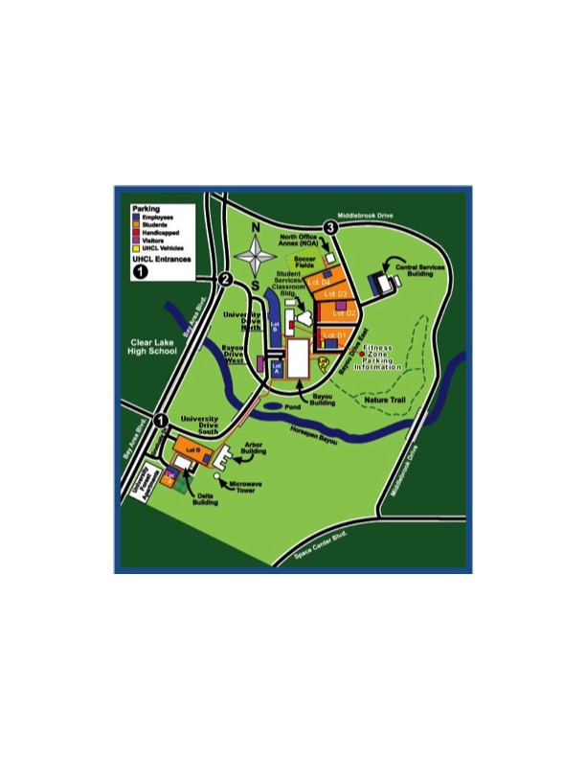Registration and Lunch in Atrium I

Morning Presentations in room _____

Poster session and door prizes in room ______

UHCL Location:

https://goo.gl/maps/FqNvk9Pt1Tt