MONEYMAP FINANCE TRACKER
Laboratory Activity 4.1
Final Project Development: React Environment Initialization and Prototype Translation - Part 1
Field | Entry
Student name(s) | [Replace with student name(s)]
Course / section | [Replace with course and section]
Instructor | [Replace with instructor name]
Submission date | [Replace with submission date]
Repository branch | main
Evidence commit | 73830d9

Project repository
https://github.com/SecretlySpy/TIP_MoneyMap-Finance-Tracker-App
Figma prototype
https://www.figma.com/design/JeEeOG1jZ0B72pA8gf7fMk/MoneyMap---Finance-Tracker?node-id=75-172

Table of Contents
Table of Contents 2
1. Activity and Project Overview 3
2. Intended Learning Outcomes and Scope 3
Selected primary interfaces 3
3. Development Environment and Source Code Access 3
Project stack 3
Environment check 4
4. Comparative Visual Analysis 5
4.1 Dashboard 5
4.2 Add Transaction - Expense 7
4.3 History 8
4.4 Budgets 9
5. Source Code and Component Architecture 10
5.1 Navigation code example 10
How this code runs 10
5.2 Component hierarchy 12
Data and state flow 13
6. Fitts's Law Evaluation 13
Live Figma interaction audit 13
Result 14
7. Donald Norman's Seven Stages of Action 15
Gulf of execution 15
Gulf of evaluation 15
8. Development Status and Impediments 16
Next steps 16
9. AI Tool Usage Disclosure 16
10. Conclusion and Verification Summary 17
Appendix A. Changed-File and Design-Frame Manifest 18
Files updated by this completion task 18
Application and Figma changes 18
Appendix B. Evidence Provenance 19

1. Activity and Project Overview
MoneyMap is an Expo React Native finance tracker that stores data locally. For this activity, we selected Dashboard, Add Transaction - Expense, History, and Budgets. Together, these screens show the main flow of checking finances, recording an expense, reviewing transactions, and monitoring a budget.
We compared the selected Figma frames with the existing source and rendered-app screenshots. The screens and routes were already implemented, so no visual feature or business-logic change was needed. We added explanatory navigation comments and a portable Android Studio launcher. The checks completed for this report were 37 passing Jest suites (232 tests), 18 passing Expo Doctor checks, a successful Android JavaScript export, and a live review of the selected Figma interactions.
The main limitation is device evidence. No Android device or emulator was available, and the active Node version does not match the project baseline. The Android launcher now resolves the project JDK 21 toolchain, but the app screenshots are still labeled as archived September 6 captures instead of current-device proof.

2. Intended Learning Outcomes and Scope
The table below connects each learning outcome to a specific part of the project.
Outcome | Requirement | Evidence in this submission
ILO-01 | Design and implement a foundational, scalable directory structure and client-side routing. | src/navigation, feature screens, components, stores, services, and tests are separated by responsibility; RootNavigator composes stack and tab routes.
ILO-02 | Translate high-fidelity interfaces into functional React components using JSX and styled React Native views. | Four selected frames are mapped to routed screens and reusable components with live store/service integration.
ILO-03 | Evaluate and document progress, successes, critical blockers, and subsequent phases. | The Norman, Fitts, status, and verification sections record what worked, what remains unverified, and what should be tested next.

Selected primary interfaces
Screen | Figma node | Why it was selected
Dashboard | 80:194 | Primary overview and navigation hub; exposes balance, Safe-to-Spend, feature shortcuts, recent activity, and the add-transaction entry point.
Add Transaction - Expense | 84:220 | Captures the central data-entry workflow and demonstrates categories, accounts, numeric input, validation, and persistence.
History | 88:240 | Shows retrieval, search, filtering, transaction grouping, detail navigation, and destructive-action access.
Budgets | 89:266 | Shows budget status, monthly progress, navigation to related bills, and budget creation/editing.

3. Development Environment and Source Code Access

Project stack
Area | Implementation
Runtime | Expo SDK ~54.0.37, React Native 0.81.5, React 19.1.0
Language and UI | JavaScript/JSX with React Native StyleSheet-based components
Routing | React Navigation 7 with a root stack, nested feature stacks, and four bottom tabs
State | Zustand 5 stores for finance data, budgets, goals, settings, and UI state
Persistence | OP-SQLite with SQLCipher-oriented secure storage configuration; offline-first repository layer
Testing | Jest and React Native Testing Library plus static release, security, and regression checks

Environment check
Item | Status | Evidence / implication
Git state | VERIFIED | The report uses main at HEAD 73830d9; the worktree contains the documented activity and launcher changes, and no commit was created.
Node.js | PARTIALLY VERIFIED | v24.16.0 is installed; project guidance recommends Node 22 LTS.
npm | VERIFIED | v11.13.0 is installed and project scripts execute.
Java | VERIFIED FOR LAUNCHER | Global JDK 25 is installed; android:check correctly selected the project JDK 21 toolchain.
Android SDK | VERIFIED | SDK path resolves locally.
Device/emulator | UNVERIFIED | adb listed no connected devices and no local Android Virtual Device was configured.
Android Studio run config | VERIFIED | Three Node-backed Shell Script configurations parse; android:check passed; no user-specific shell path remains.

4. Comparative Visual Analysis
Each comparison places the current Figma frame beside a rendered application capture. The application images are archived screenshots dated September 6, 2026 and cropped from the top to approximately the same phone-viewport aspect ratio. Cropping changes only the visible extent; it does not modify the UI. A fresh screenshot from the current commit remains UNVERIFIED because no device or emulator was available.

4.1 Dashboard
Live Figma - Dashboard (80:194) | Rendered app archive - Dashboard
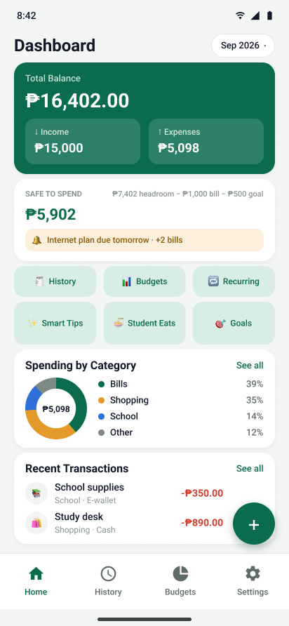 | 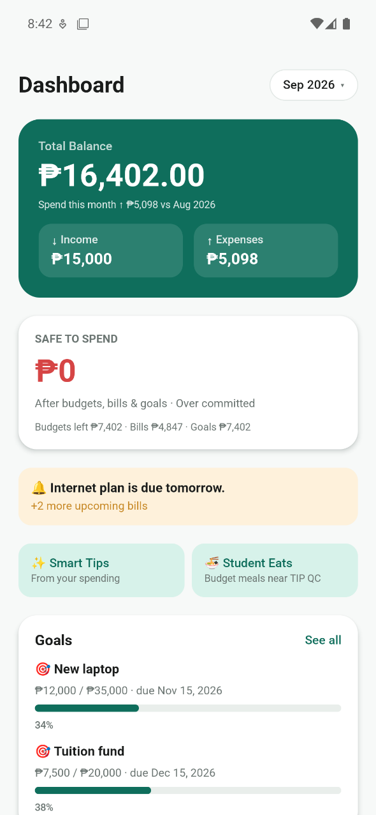

Figure 1. Current design and archived application rendering, aligned to a comparable viewport for review.
- Both versions place the balance and Safe-to-Spend information first, followed by shortcuts, spending information, recent transactions, and the add button.
- The Figma frame is more compact and shows six quick actions. The archived app screen uses a longer scrolling layout.
- DashboardScreen builds the page from MonthChip, SafeToSpendCard, SpendingDonut, TransactionRow, SectionCard, and EmptyState.

4.2 Add Transaction - Expense
Live Figma - Expense Entry (84:220) | Rendered app archive - Expense Entry
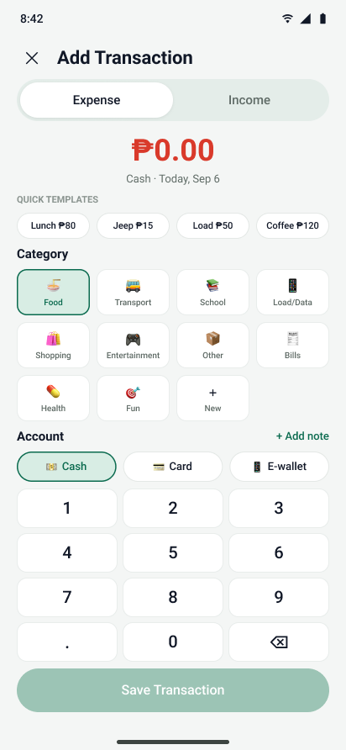 | 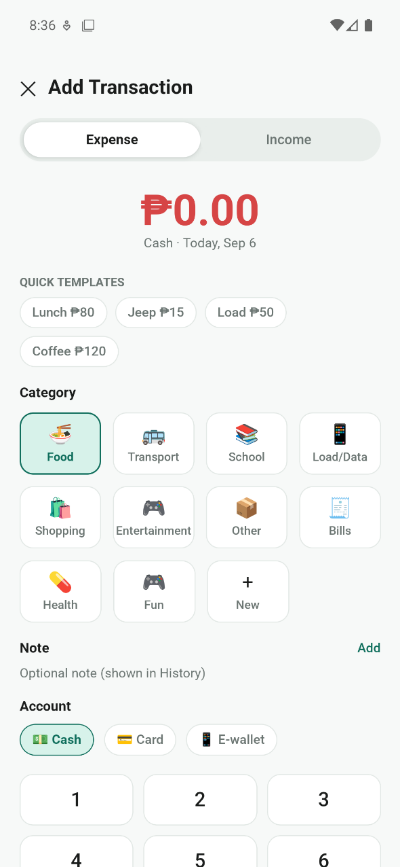

Figure 2. Transaction-entry structure: type switch, amount, templates, categories, account selection, keypad, and primary action.
- Both versions follow the same order: transaction type, amount, templates, category, account, keypad, and Save Transaction.
- The app capture scrolls farther than the Figma frame and gives the note field more vertical space.
- EntryScreen reuses Chip, PrimaryButton, ScreenContainer, and TextPromptModal, then sends the completed values to the finance store.

4.3 History
Live Figma - History (88:240) | Rendered app archive - History
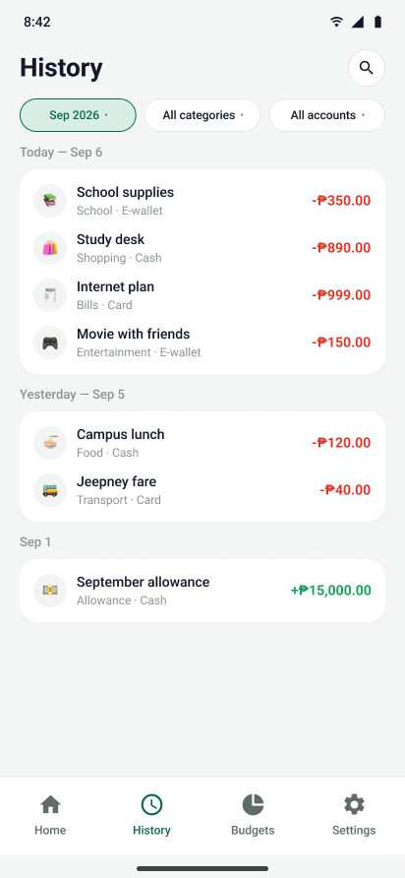 | 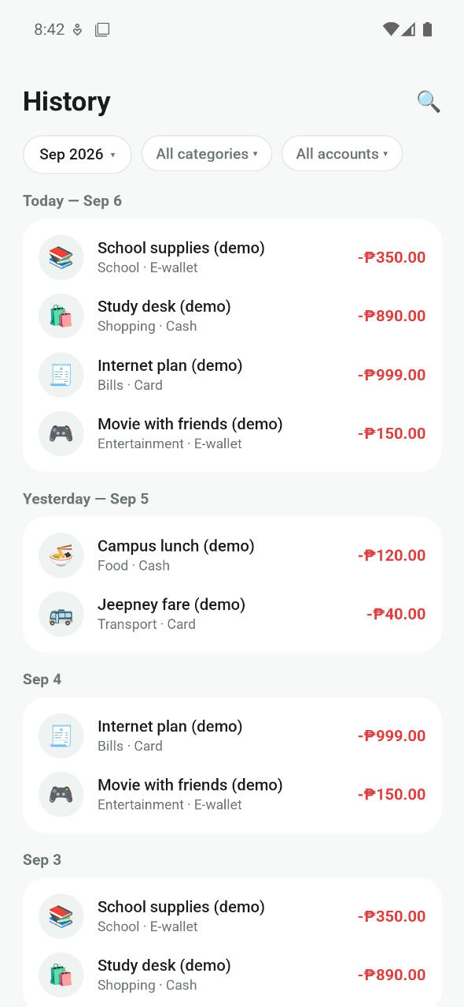

Figure 3. Ledger review with search/filter controls, grouped transactions, and bottom navigation.
- Both versions use a month selector, search, filter chips, grouped dates, signed amounts, and the bottom navigation.
- The Figma frame shows a shorter sample. The original archived capture continues through more date groups below the crop.
- HistoryScreen filters the store data and renders each result with TransactionRow; selecting a row opens its detail route.

4.4 Budgets
Live Figma - Budgets (89:266) | Rendered app archive - Budgets
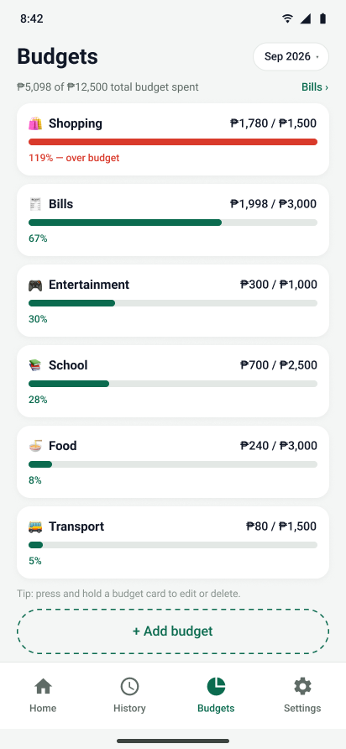 | 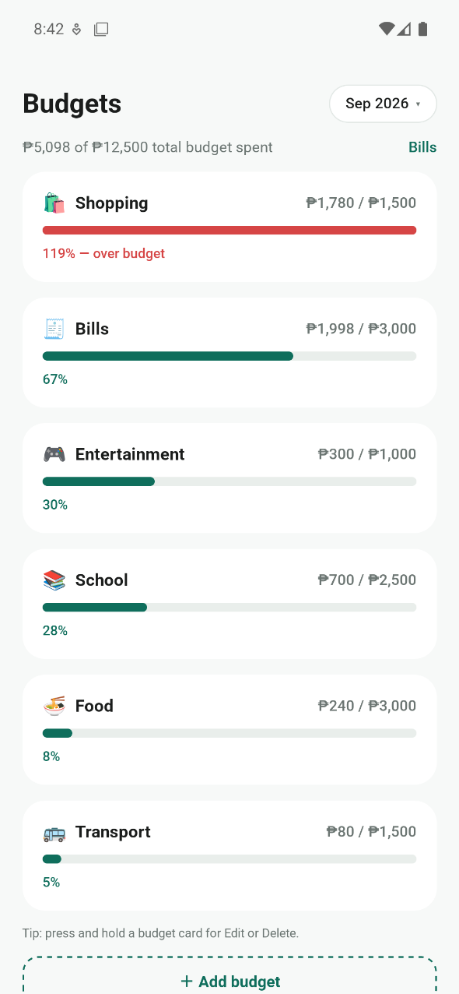

Figure 4. Monthly budget overview, related-bills link, budget cards, add action, and persistent navigation.
- Both versions keep the month control, Bills link, budget progress cards, add-budget action, and bottom navigation in the same order.
- The Figma cards are slightly more compact, while the archived app capture shows a longer visible list.
- BudgetsScreen uses BudgetCard for each item and reuses MonthChip, DashedButton, BottomSheet, EmojiGrid, and TextPromptModal for the workflow.

5. Source Code and Component Architecture

5.1 Navigation code example
The excerpt below comes directly from src/navigation/RootNavigator.jsx. It shows how the selected screens are connected instead of being separate mockups.
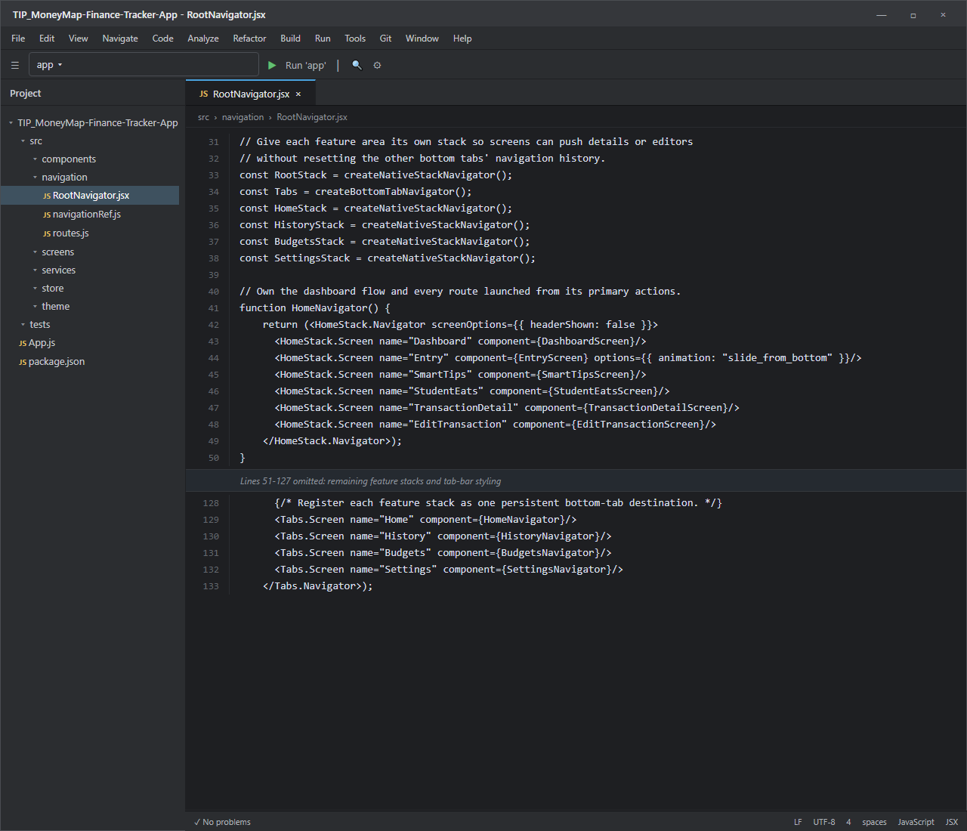
Figure 5. Android Studio-style view of the commented routing excerpt from src/navigation/RootNavigator.jsx (lines 31-50 and 128-133).

How this code runs
1. Lines 31-38 create the root, tab, and feature stacks; the block comment explains why separate stacks preserve each tab's navigation history.
2. Lines 40-50 define HomeNavigator and register the dashboard plus every screen opened from its actions.
3. The omitted middle block applies the same pattern to History, Budgets, and Settings, then derives the tab-bar appearance from the theme and safe area.
4. Lines 128-133 register the four feature stacks as persistent bottom-tab destinations.
5. Selecting a tab loads its nested stack; opening Entry uses the configured slide-up transition and temporarily hides the tab bar.

5.2 Component hierarchy
The selected screens use the same application shell, stores, and shared components.
App.js
`-- DatabaseGate
`-- NavigationContainer
`-- RootNavigator
`-- MainTabs
|-- HomeNavigator
| |-- DashboardScreen
| `-- EntryScreen
|-- HistoryNavigator
| `-- HistoryScreen / HistoryBody
|-- BudgetsNavigator
| `-- BudgetsScreen
`-- SettingsNavigator

Shared data path:
Screen -> Zustand store -> repository/service -> encrypted local SQLite
Screen <- derived selectors / view services <- persisted finance data
Component | Location | Purpose | Reused By
ScreenContainer | src/components/ScreenContainer.jsx | Safe-area, spacing, and scroll layout. | Dashboard, Entry, History, Budgets
MonthChip | src/components/MonthChip.jsx | Shows and changes the active month. | Dashboard, History, Budgets
Chip | src/components/Chip.jsx | Template, category, account, and filter choices. | Entry, History
PrimaryButton / DashedButton | src/components/Buttons.jsx | Primary save and secondary add actions. | Entry, Budgets
SectionCard | src/components/SectionCard.jsx | Shared content-card layout. | Dashboard, History
TransactionRow | src/components/TransactionRow.jsx | Displays one signed transaction row. | Dashboard, History
BudgetCard | src/components/BudgetCard.jsx | Displays budget amount and progress. | Budgets
BottomSheet / TextPromptModal | src/components/BottomSheet.jsx; TextPromptModal.jsx | Collects values for add/edit workflows. | Entry, Budgets

Data and state flow
Dashboard, History, and Budgets read finance data from the Zustand finance store. Entry writes a new transaction through the same store. Calculation helpers such as financeView, money, and safeToSpend prepare display values, while the repository layer persists the records in local encrypted SQLite storage. Shared colors, spacing, typography, and control sizes come from src/theme/tokens.js.

6. Fitts's Law Evaluation
Fitts's Law uses MT = a + b log2(D/W + 1). D is the distance to a target and W is its effective size. We used the principle to check reach, target size, and spacing; we did not calculate a movement time because no user-specific constants or measured starting positions were available.

Live Figma interaction audit
The four selected Figma frames contained 24 interactive nodes and 11 navigation destinations; all destination IDs resolved. Most frequent actions were already large and close to the lower thumb area. A few controls look small in the design, but the React Native version increases the effective target with hitSlop.
Screen / Control | Initial Finding | Fitts's Law Consideration | Action Taken | Final Status
Dashboard: add FAB | 60 px target near lower edge | Large and close to the thumb zone. | No change. | Already compliant
Dashboard: quick actions | 44-61 px high | Short travel between repeated targets. | No change. | Already compliant
Entry: category, keypad, save | 64, 53, and 51 px high | Frequent input targets are large and separated. | No change. | Already compliant
Entry: close button | 36 x 36 px visual target | Visual target is compact. | Kept existing 12 px hitSlop; device check pending. | Minor improvement recommended
Entry/History: chips | About 30-34 px visual height | Spacing and hitSlop increase effective size. | Kept existing Chip hitSlop. | Minor improvement recommended
History: search | 36 px visual target | Small icon, but the app expands its touch area. | Kept existing 8 px hitSlop. | Minor improvement recommended
Dashboard: bill strip | 340 x 32 px | Wide target but shallow vertically. | No change; thumb-test on device. | Minor improvement recommended
Budgets: Bills subheader | 372 x 18 px design layer | Wide but visually thin and less obvious. | No change; device check pending. | Minor improvement recommended
All screens: bottom tabs | 80 px tab bar | Persistent and close to the thumb zone. | No change. | Already compliant

Result
We did not change Figma or application behavior for this activity because the main actions already had suitable effective targets. The compact secondary controls should still be checked with real thumb use. If users miss them, the first adjustment should be a larger touch area rather than a visual redesign.

7. Donald Norman's Seven Stages of Action
We used one real MoneyMap task for the model: recording a campus lunch expense and checking that it appears correctly.
Stage | Student action/thought | Interface support
1. Form the goal | Record the lunch purchase so the available balance and budget remain accurate. | Dashboard exposes the add action and current financial context.
2. Form the intention | Create an expense rather than income. | The transaction type control makes the mode explicit.
3. Specify the action | Choose Expense, Food, Cash; enter the amount; optionally add a note. | Templates, categories, accounts, and a custom keypad reduce recall.
4. Execute the action | Press Save Transaction. | The full-width 51 px primary button provides a clear endpoint.
5. Perceive system state | Observe the screen transition and the new transaction row. | The intended flow returns to a ledger/history context after saving.
6. Interpret system state | Read the negative amount, category, account, and date as a recorded expense. | Semantic amount styling and structured row labels support interpretation.
7. Evaluate outcome | Confirm totals, budget use, and Safe-to-Spend reflect the purchase. | Dashboard aggregates and budget views provide the final feedback loop.

Primary-interface Norman summary
Interface | Goal | Execution | Evaluation
Dashboard | Check the current financial position and choose the next task. | Scan the balance, Safe-to-Spend card, shortcuts, and add button. | Totals and recent activity communicate the current state; current-device rendering is still unverified.
Add Transaction - Expense | Record one expense accurately. | Choose the type, category, and account; enter the amount and note; save. | Validation and the resulting History entry show whether the transaction was accepted.
History | Find and verify a recorded transaction. | Choose a month, search or filter, then open the matching row. | Grouped results and transaction details show whether the query and saved data match the goal.
Budgets | Check monthly spending against a budget. | Choose the month, review progress, open related bills, or use the add action. | Progress and remaining values show the outcome; thumb reach and TalkBack still need device testing.

Gulf of execution
The add button, Expense/Income choice, categories, accounts, keypad, and Save Transaction button make the required steps visible. The remaining concern is the smaller secondary controls, which still need a real-device thumb test.

Gulf of evaluation
After saving, the History row shows the signed amount, category, account, and date. Dashboard and Budgets then show the effect on totals. The code and automated tests support this flow, but its final visual feedback still needs to be checked on a current Android device.

8. Development Status and Impediments
Area | Status | Evidence / Notes | Remaining Issue
Project setup and routing | Verified | Source structure inspected; navigation tests passed. | None for the JavaScript layer.
Four selected interfaces | Partially Verified | Screens exist in Figma and source; archived app captures are included. | Recapture the current commit on Android.
Figma interactions | Verified | 24 interactive nodes; 11 destinations; no missing destination IDs. | Thumb-test compact secondary controls.
Automated tests | Verified | 37/37 suites and 232/232 tests passed. | Does not prove native rendering.
Expo configuration | Verified | Expo Doctor passed 18/18 checks. | None found by Expo Doctor.
Android JavaScript export | Verified | 1,558 modules bundled; Hermes output was 5.83 MB. | Not a native APK/device test.
Native Android run | Blocked | No device or AVD; local Node/JDK differ from the project baseline. | Use Node 22, JDK 21, and an Android device/AVD.
Dependency audit | Open Risk | 25 advisories: 18 moderate and 7 high. | xlsx has no published fix; upgrades need review.
Submission details | Blocked | Identity fields are still placeholders. | Students must complete and review them.
Android Studio launcher | Verified | Cross-platform Node launcher, 3/3 launcher tests, and Windows preflight passed. | Physical macOS/Linux IDE launch still needs host verification.

Next steps
- Use the documented Node 22 and JDK 21 setup, then attach an Android device or configure an AVD.
- Replay the four selected flows and capture fresh screenshots from the current commit.
- Check the compact controls with normal thumb use and TalkBack.
- Replace the cover placeholders, then have the student team review and revise the report before submission.

9. AI Tool Usage Disclosure
I used OpenAI Codex as a coding and documentation assistant. It helped me locate the relevant React files, compare the four selected screens with Figma, add explanatory comments, create the portable Android Studio launcher, run the listed checks, and organize this report. I used its suggestions as a starting point and kept the technical claims tied to the source files and command output recorded here.

Codex did not run the unavailable Android device test and did not invent screenshots, routes, components, or results. I kept those limits marked as UNVERIFIED. Before submission, I still need to complete the identity fields and make sure I can explain every section in my own words.

10. Conclusion and Verification Summary
Based on the source code and local checks, MoneyMap covers the Part 1 implementation and documentation requirements at the JavaScript layer. The four selected interfaces are connected through navigation, reuse React Native components, and use the existing Zustand and local SQLite data flow. The Figma links, Jest tests, Expo Doctor checks, and Android JavaScript export passed.
These results do not confirm Android-device behavior. The remaining work is to run the current commit with the documented native toolchain, capture fresh screenshots, and complete the thumb-reach and accessibility checks.

Appendix A. Changed-File and Design-Frame Manifest

Files updated by this completion task
Path | Change | Purpose
MoneyMap_Laboratory_Activity_4.1_Documentation.docx | Updated | Editable report with comparisons, code screenshot, architecture, usability analysis, status, and disclosure.
scripts/build-lab-activity-4-1-document.ps1 | Updated | Reproducible report builder; it reads source but does not change application behavior.
.idea/runConfigurations/*.xml | Updated | Cross-platform Node-backed actions for Android, Metro, and Jest.
scripts/run-android.mjs | Added | Discovers compatible Android SDK/JDK paths and starts the local Expo CLI.
scripts/run-android.test.mjs | Added | Checks Windows, macOS, and Linux launcher path resolution.
package.json | Updated | Exposes the Android launcher, safe preflight, and launcher test commands.
src/navigation/RootNavigator.jsx | Comments only | Explains navigator factories, feature stacks, tabs, hydration, splash, and lock routing.
README and Project Guidelines | Updated | Setup, troubleshooting, verification, and handover instructions.

Application and Figma changes
- Application source changes: explanatory comments only; navigation behavior is unchanged.
- Figma design changes: none.
- Reason: the selected screens already exist in both Figma and code, and the main actions already have suitable effective targets. The remaining compact-target concerns are documented for device testing.

Node ID | Frame | Task action
80:194 | Dashboard | Read-only review; current screenshot and interaction audit captured.
84:220 | Add Transaction - Expense | Read-only review; current screenshot and interaction audit captured.
88:240 | History | Read-only review; current screenshot and interaction audit captured.
89:266 | Budgets | Read-only review; current screenshot and interaction audit captured.

Appendix B. Evidence Provenance
- Current Figma evidence was retrieved live on October 1, 2026 from page 75:172, MoneyMap - Update 092726.
- Rendered-app images come from docs/screenshots/2026-09-06 and are labeled as archived. The report uses temporary viewport crops; original files remain unchanged.
- Source claims are grounded in package.json, app.json, src/navigation, src/screens, src/components, src/store, src/services, tests, and Project Guidelines.
- The code screenshot is generated from the exact commented RootNavigator.jsx ranges named in its caption.
- Check results in Section 8 were executed during this completion task unless marked archived, partial, or blocked.

