# Assembly of the SecurAir

## Introduction

There are two options for soldering: **With or without headers**. This manual will describe the version with headers. The advantage is that you can quickly swap components by just detaching the components. However, this results in a **bulkier product**. You could leave out the female headers and solder the pins from the male headers directly to the printed circuite board (PCB).

For more information and to download the software you need to flash into the display, please visit: <https://github.com/SecurAir/SecurAir>

## Tools required

Make sure you have soldering equipment (including flux) and a small cutter (to cut the remaining legs at the bottom side of the PCB). Any flux will do, although lead-free is recommended.

## Components

Please make sure you have all components:

* 1 PCB in Secura logo shape
* 1 TTGO (ESP32 board with display)
  + Including 2x 12 pins male headers
  + Including 2x 12 pins female headers (optional)
* 1 CO2 sensor (silver package, don’t damage the black filter!)
  + Including 1x 5 pins male header
  + Including 1x 5 pins female header (optional)
  + Including 1x 4 pins male header
  + Including 1x 4 pins female header (optional)
* 1 Temperature/humidity sensor (white package with four pins)
  + Including 1x 4 pins female header (optional)
* 1 Resistor
* 1 USB-C cable (USB charger not included, any charger will do)

## Soldering

* Fold the legs of the resistor and solder the resistor to the PCB. Cut the remaining legs at the back side of the PCB
* A picture containing text, floor

  Description automatically generatedSolder the female headers to the PCB.
  + 2x 12 pins female headers for the TTGO Display
  + 1x 5 pins and 1x 4 pins for the CO2 sensor
  + 1x 4 pins for the CO2 sensor
* Solder the 2x 12 pins male headers to the TTGO Display.  
  Make sure the black plastic is at the backside and the short  
  pins go through the PCB of the TTGO Display. Solder at the top.

## Assembling

Now everything is soldered, connect all components to the headers at the PCB.

* TTGO Display at the top of the PCB with the USB-C connector on the left
* CO2 sensor below the display, matching the 4 and 5 pin headers
* A picture containing text, floor

  Description automatically generatedTemperature / Humidity sensor with the opening to the right (facing the CO2 sensor)  
  *If the sensor is too loose, bend the legs a bit alternatively forward and backwards or to the side*

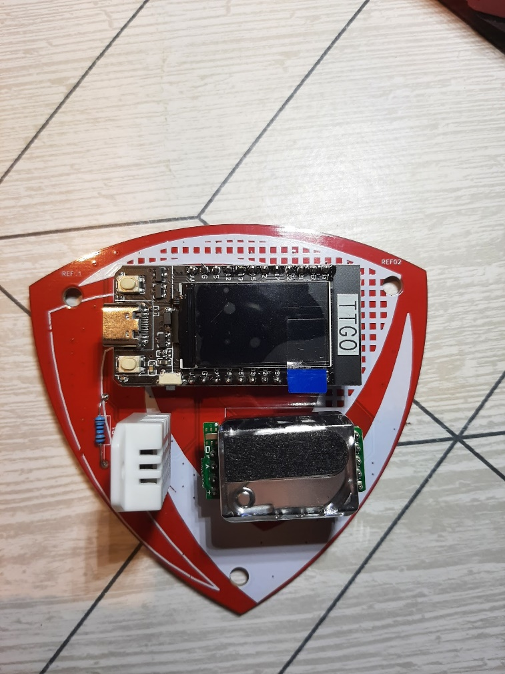

Optional: Bend the Temperature/Humidity sensor backwards (covering the resistor)

