Admin User Manual: BrightView Provision Dashboard

1. Introduction
Welcome to the BrightView Provision Admin Dashboard. This central management console allows administrators to oversee store performance, manage users, track finances, publish announcements, and configure store settings.

2. Getting Started

2.1 Logging In
To access the dashboard, navigate to the Login Page.
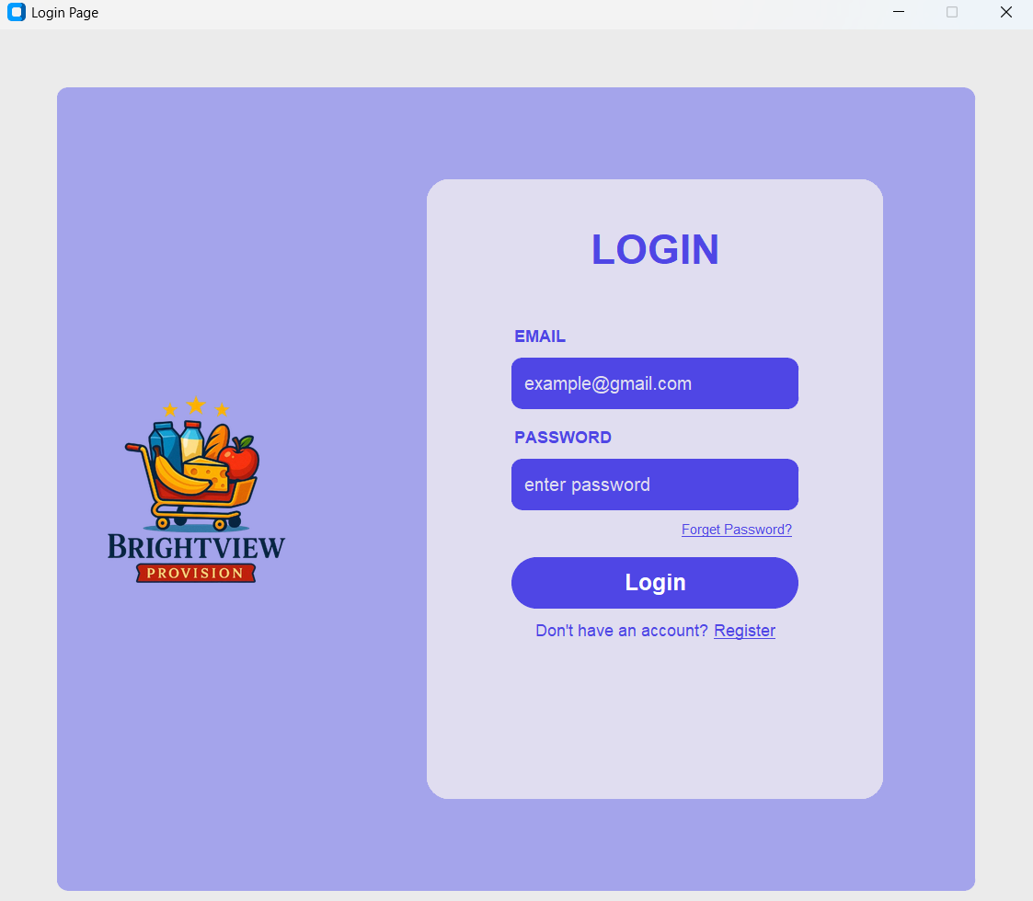
Figure 1: Admin Login Page
- Email: Enter your registered administrator email address (e.g., example@gmail.com).
- Password: Enter your secure password.
- Login: Click the blue Login button to access the system.
  - Note: If you do not have an account, contact admin to make an admin account for you

3. Dashboard Overview (Home)
Upon logging in, you will land on the Home tab. This provides a high-level snapshot of business performance.
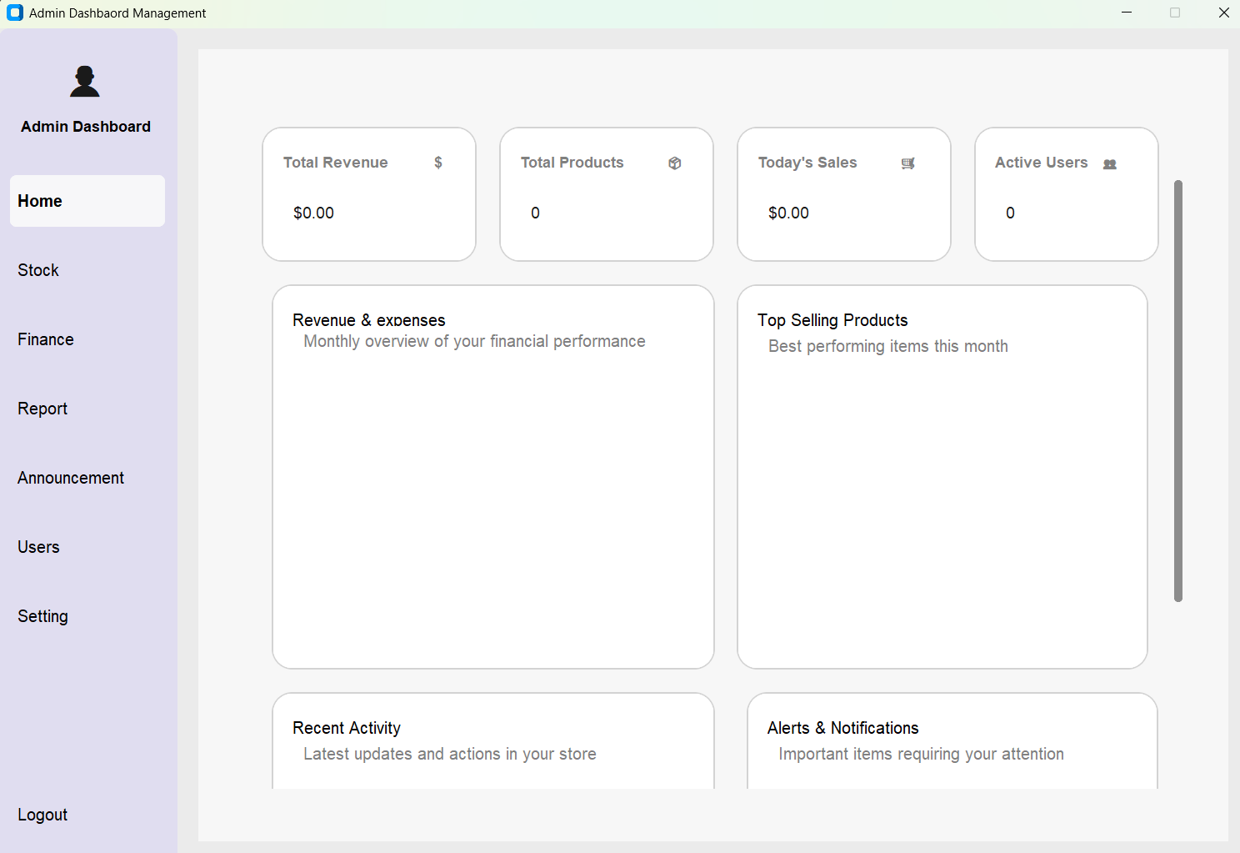
Figure 2: Home Dashboard Overview
- Key Metrics Cards:
  - Total Revenue: Current total earnings.
  - Total Products: Number of items in the inventory.
  - Today's Sales: Sales figures for the current 24-hour period.
  - Active Users: Number of users currently active on the platform.
- Performance Charts:
  - Revenue & Expenses: A monthly overview of financial performance.
  - Top Selling Products: A list of items performing best this month.
- Activity Feeds:
  - Recent Activity: Logs of recent updates and actions in the store.
  - Alerts & Notifications: Important items requiring immediate admin attention.

4. Stock Management

4.1 Dashboard Overview
Navigate to the Stock tab in the sidebar to manage your inventory levels and product details.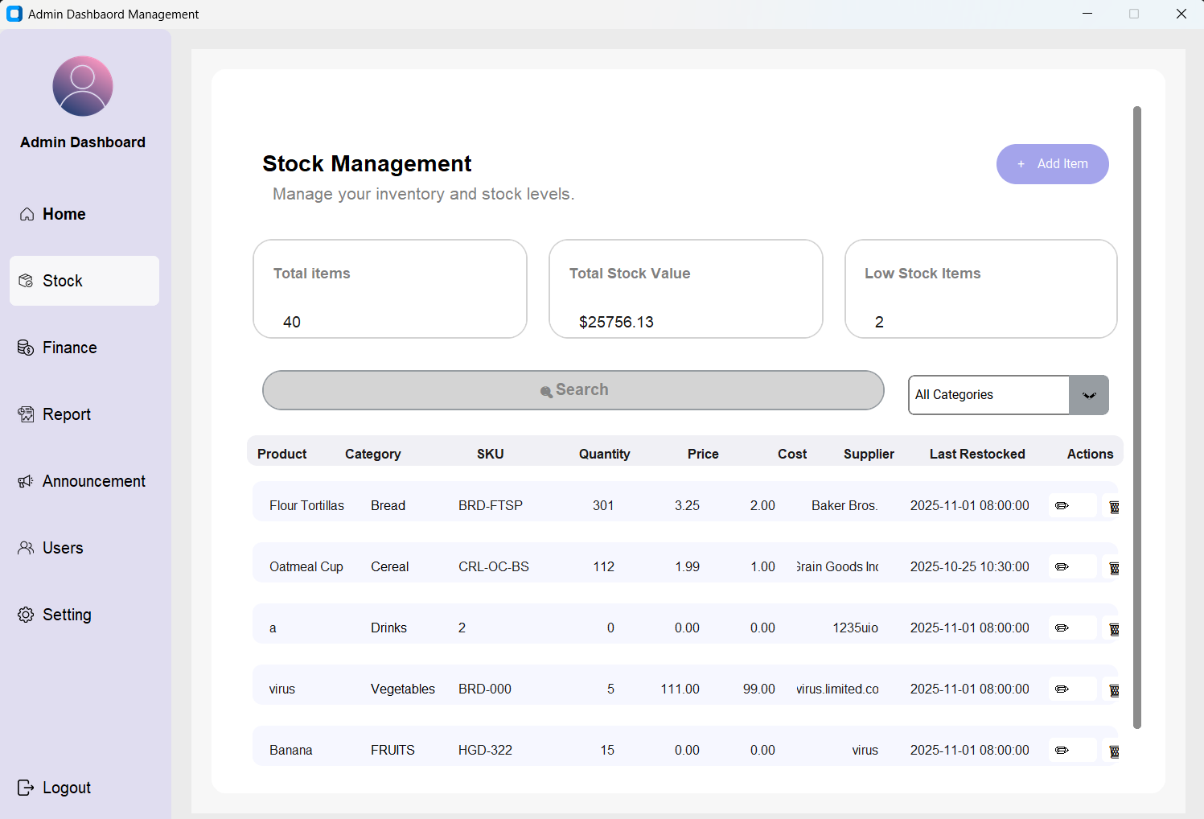
Figure 3: Stock Management Dashboard
- Inventory List: View all products currently in stock.
- Stock Alerts: Identify items that are running low and need restocking.
- Add/Edit Product: Tools to update product details, prices, or quantities.

4.2 Adding a New Item
- Click the + Add Item button in the top right corner.
- A popup window titled Add New Stock Item will appear.
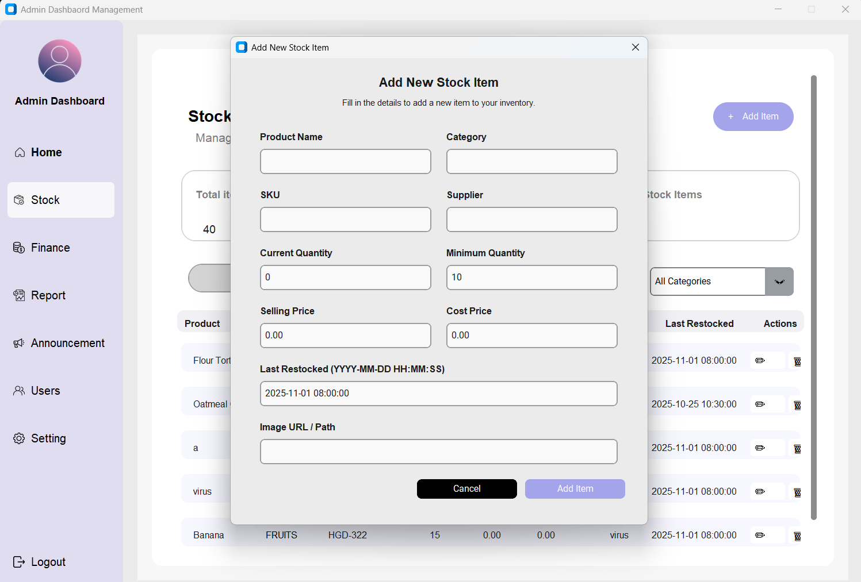
Figure 4: Add new item
- Fill in the following details:
  - Product Name: Enter the name of the product you want to add.
  - Category: Select the correct category that matches the product.
  - SKU: Provide the unique Stock Keeping Unit code.
  - Supplier: Enter the supplier or vendor name.
  - Current Quantity: Specify the number of units currently in stock.
  - Minimum Quantity: Set the minimum level before a low-stock alert is triggered.
  - Selling Price: The price at which the item will be sold.
  - Cost Price: The acquisition or production cost of the item.
  - Last Restocked (YYYY-MM-DD HH:MM: SS): Enter the date and time the product was last restocked.
  - Image URL / Path: Provide a link or file path to the product image.
- Click Add item to save.

5. Finance Management
Navigate to the Finance tab in the sidebar to view detailed financial data.
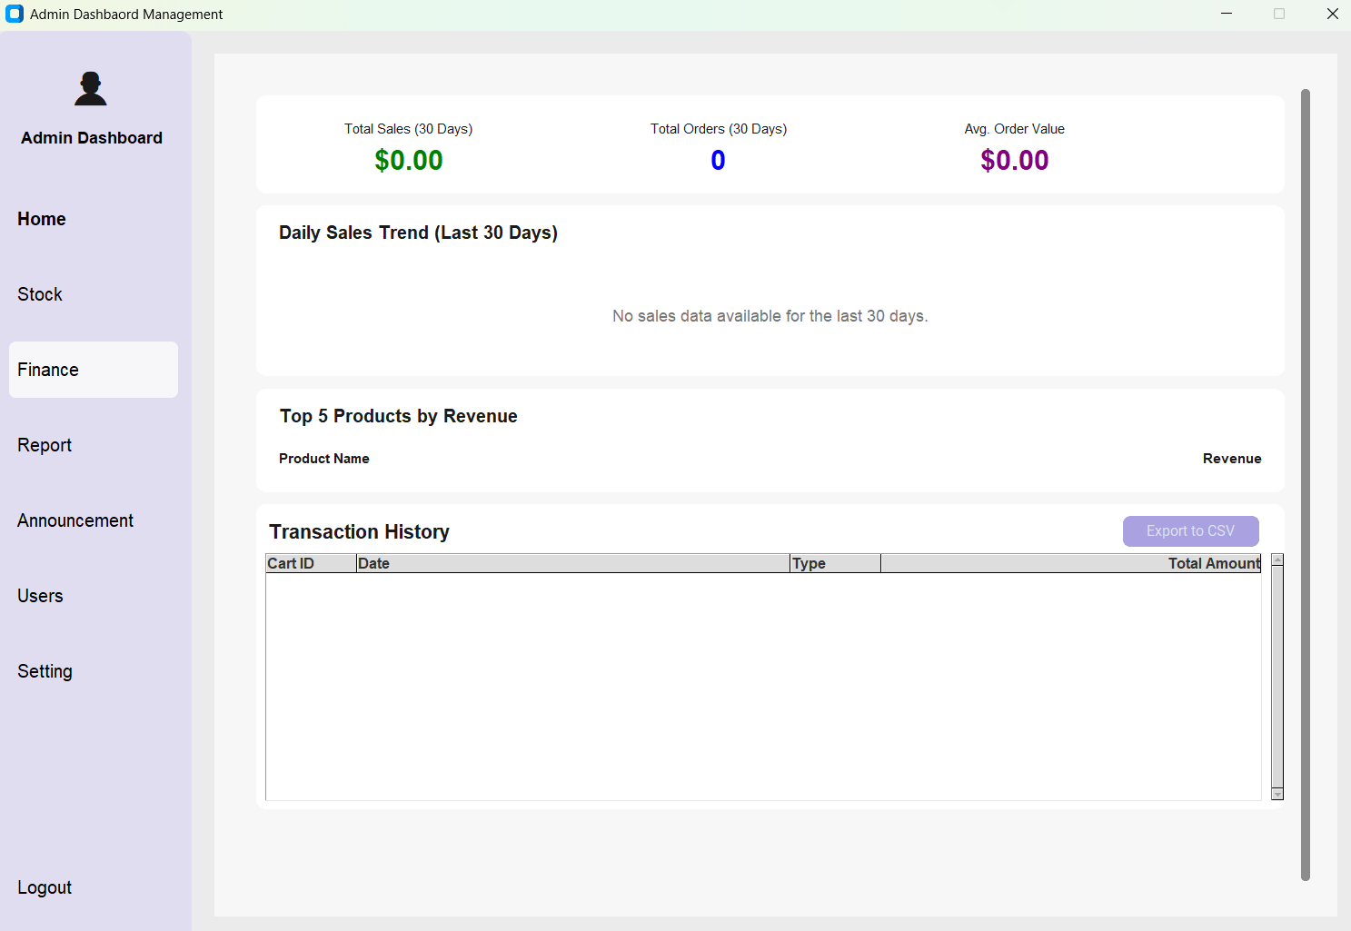
Figure 5: Finance and Transaction History
- Financial Overview: View Total Sales (last 30 days), Total Orders, and Average Order Value (AOV).
- Daily Sales Trend: A visual graph showing sales volume over the last 30 days.
- Top 5 Products: A leaderboard of products generating the most revenue.
- Transaction History: A detailed table listing specific carts, dates, transaction types, and total amounts.
- Exporting Data: Click the purple Export to CSV button to download the transaction history for external accounting.

6. Reports & Analytics
Navigate to the Report tab to analyze long-term trends.

6.1 Sales Analysis
The default view shows the Sales Analysis dashboard.
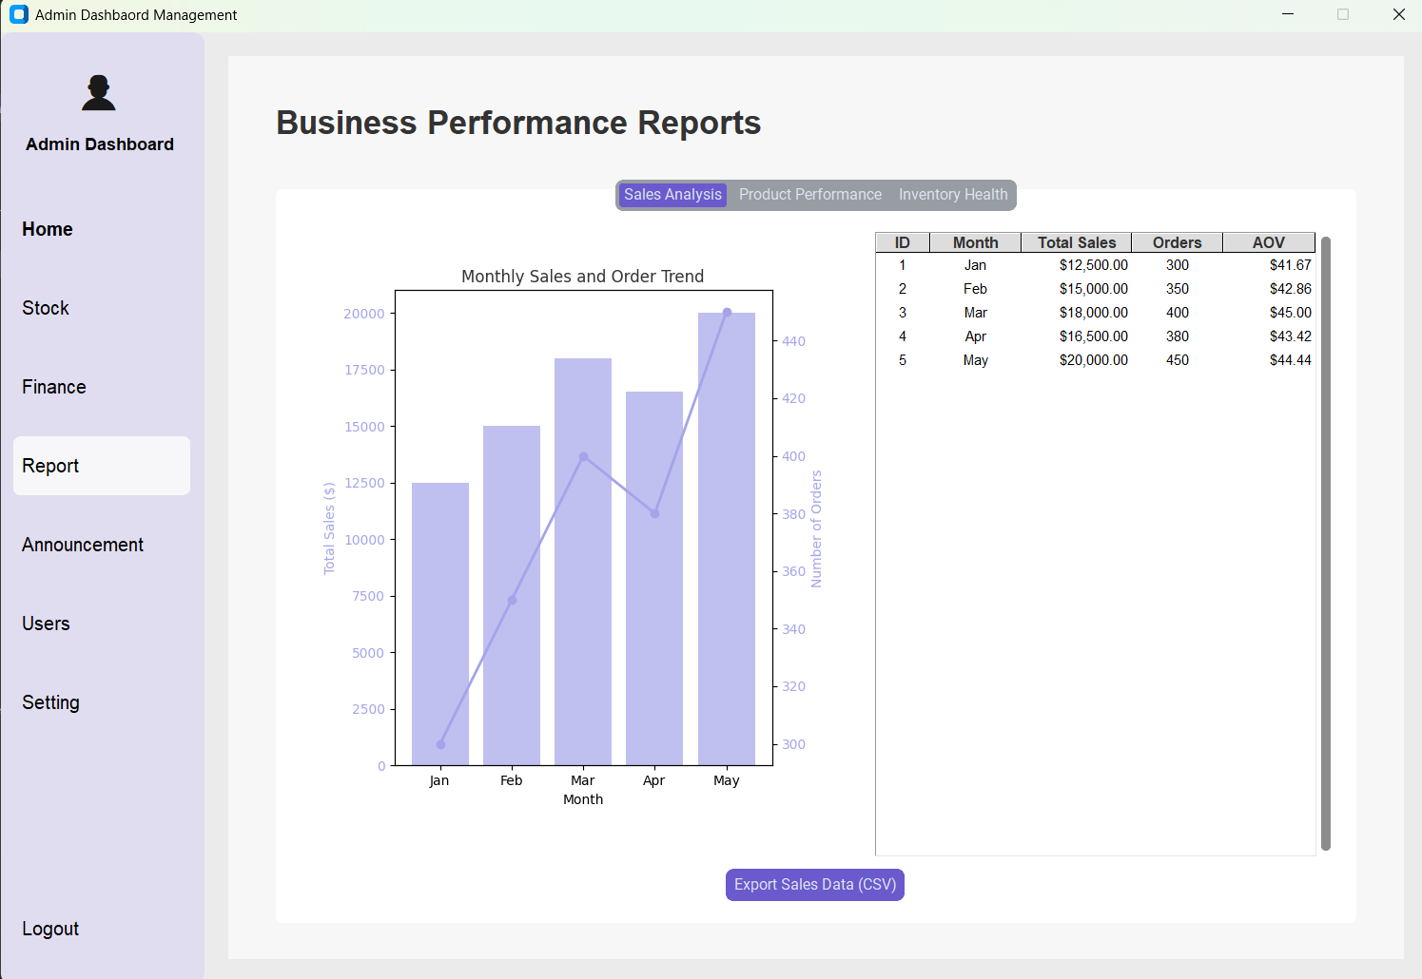Figure 6: Sales Analysis Graph
- Graph: Displays "Monthly Sales and Order Trend" (Bar chart for sales volume, Line chart for number of orders).
- Data Table: Detailed breakdown by Month, Total Sales ($), Total Orders, and AOV.

6.2 Exporting Reports
- Click the Export Sales Data (CSV) button at the bottom of the screen.
- A system dialog will appear. Select the destination folder on your computer.
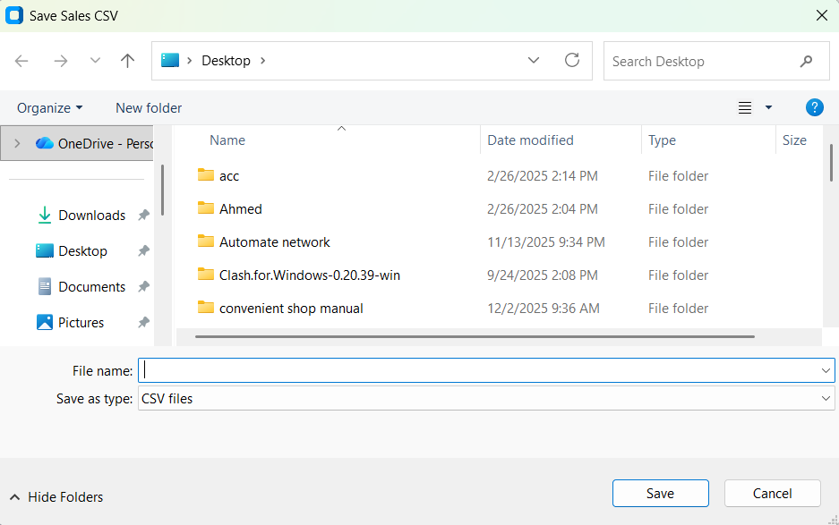
Figure 7: Saving the Exported Report
- Name the file and click Save.
  - Note: You can also switch tabs at the top to view Product Performance and Inventory Health (functionality similar to Sales Analysis).

7. Announcement Management
Navigate to the Announcement tab to manage promotional banners and discount alerts for customers.

7.1 Dashboard Overview
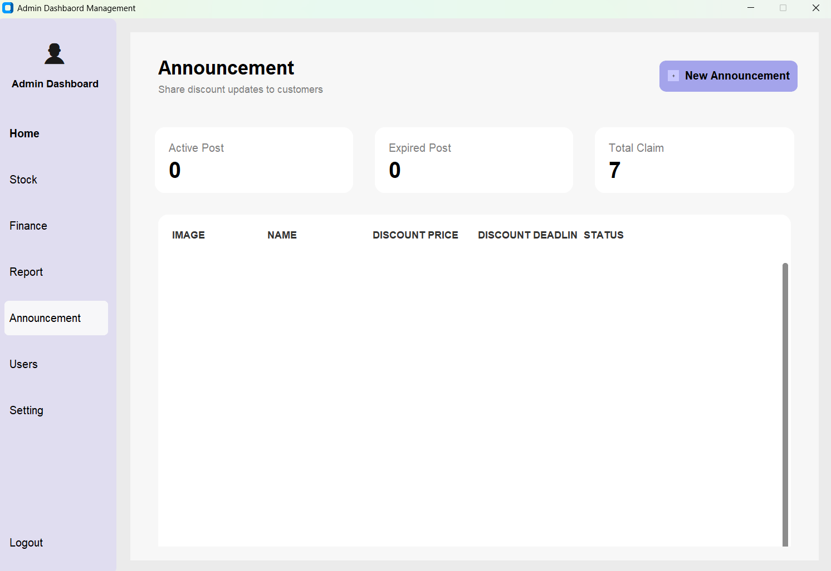Figure 8: Announcement Dashboard
- Active Post: Number of announcements currently visible to customers.
- Expired Post: Number of past announcements.
- Total Claim: How many customers have claimed the offers.

7.2 Adding a New Announcement
- Click the + New Announcement button in the top right corner.
- A popup window titled Add New Discount Announcement will appear.
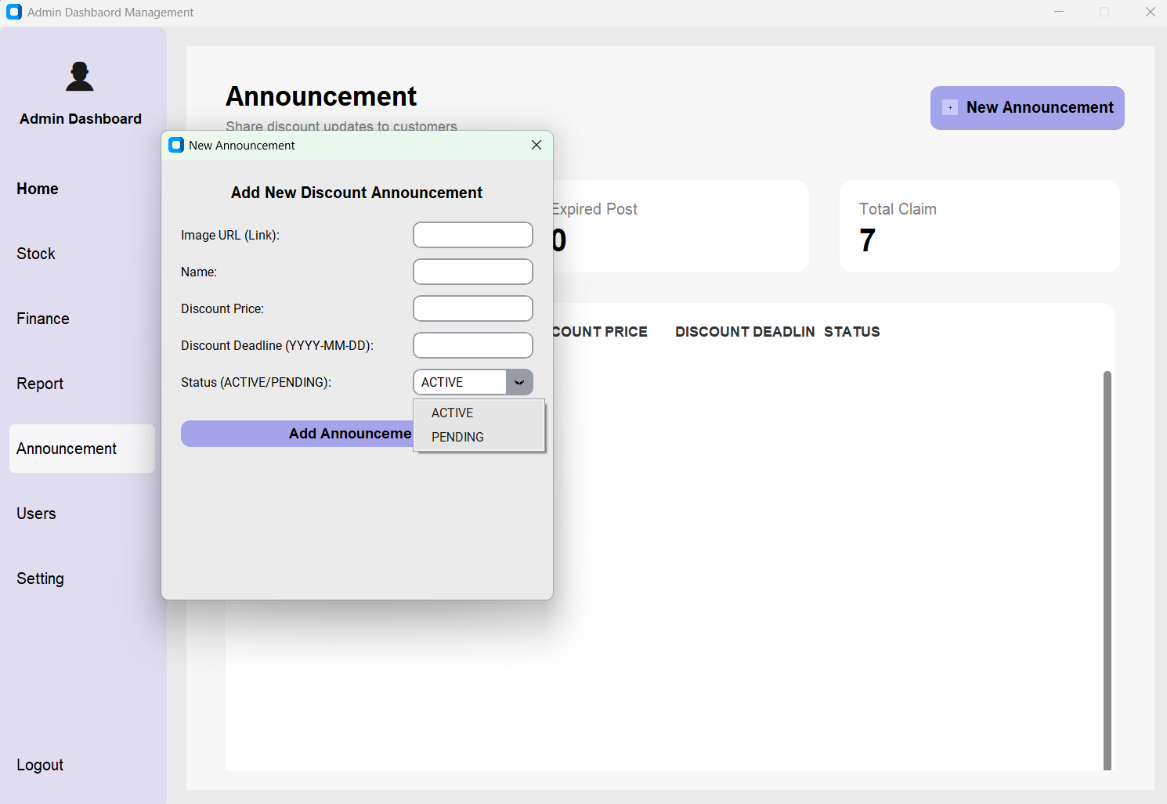
Figure 9: Creating a New Announcement
- Fill in the following details:
  - Image URL (Link): Paste the direct link to the promotional image.
  - Name: Enter the title of the promotion.
  - Discount Price: Enter the value of the discount.
  - Discount Deadline: Enter the expiry date in YYYY-MM-DD format.
  - Status: Select ACTIVE to publish immediately or PENDING to save for later.
- Click Add Announcement to save.

8. User Management
Navigate to the Users tab to manage staff and admin access.

8.1 User Overview
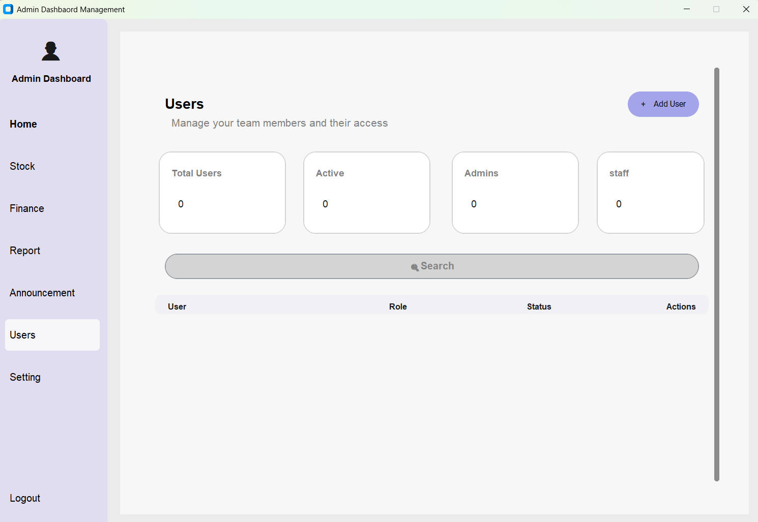Figure 10: User Management Dashboard
- Stats Cards: View counts for Total Users, Active Users, Admins, and Staff.
- User List: A table showing User Name, Role, Status, and Action buttons.
- Search: Use the search bar to find specific users by name or email.

8.2 Adding a New User
- Click the + Add User button in the top right.
- A popup window titled Add New User will appear.
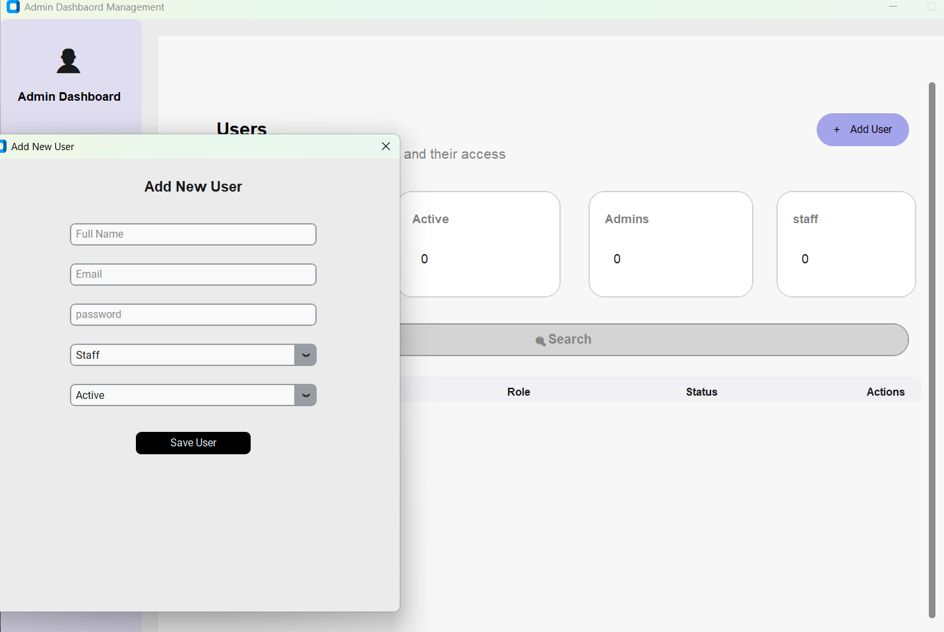Figure 11: Adding a New User
- Fill in the required fields:
  - Full Name: The user's legal name.
  - Email: The user's login email address.
  - Password: Assign a temporary password.
  - Role: Select Staff or Admin from the dropdown.
  - Status: Select Active to grant immediate access.
- Click Save User to create the account.

9. Settings
Navigate to the Setting tab to configure general store information.
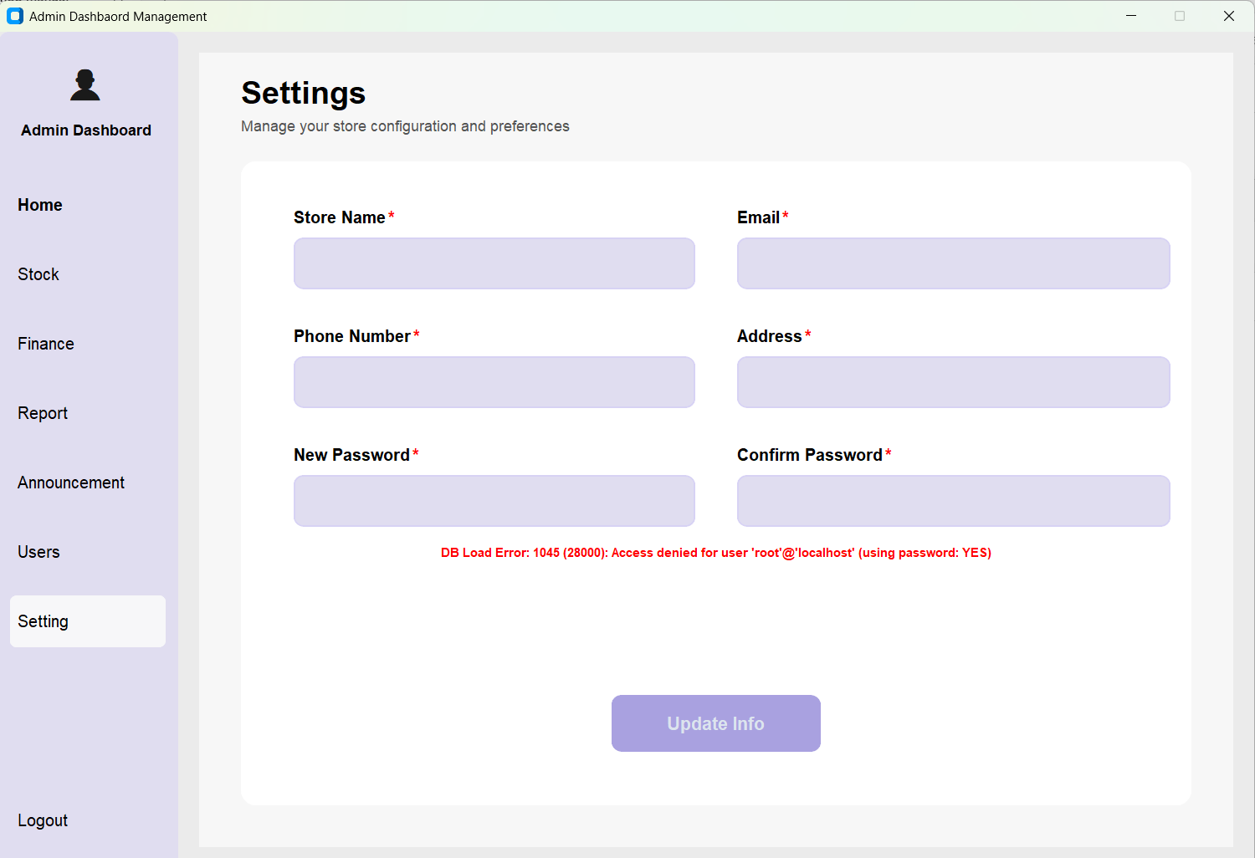Figure 12: General Settings
- Store Information: Update the Store Name, Email, Phone Number, and Physical Address.
- Security: Update the admin password by entering a New Password and confirming it in the Confirm Password box.
- Save Changes: Click Update Info to apply changes.
  - Troubleshooting Note: If you see red error text (e.g., "DB Load Error") after clicking Update Info, please contact the technical support team immediately as this indicates a server connection issue.

