Introduction
BRIGHTVIEW provision app is a convinience store mobile app designed to make your daily life easy as we bring your daily household refreshments at your door-step from your fingertips,.
You can download the mobile app in your phone from playstore for android mobile phones , and appstore for iphones.

Getting Started
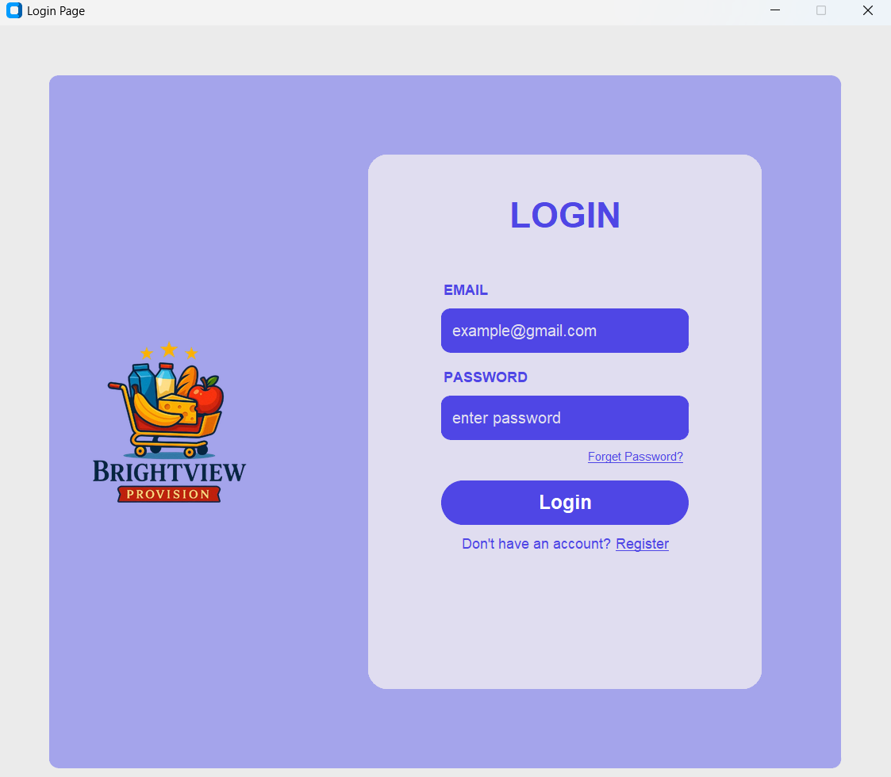

- Upon succesful installation of the mobile app, the very first page shows the login page For current users I.e(lready has a brightview provision mobile app) feed in your email here, use the email you registered before.
-be sure to use the format example@gmail.com

-then enter the password you created


-if both valid :click loginbutton.


-if incorrect password: click forgot password to set up a new one


For a new user,click “ register” button to ccreate a new account


That button leads you to this page,to create a new account for a new user.
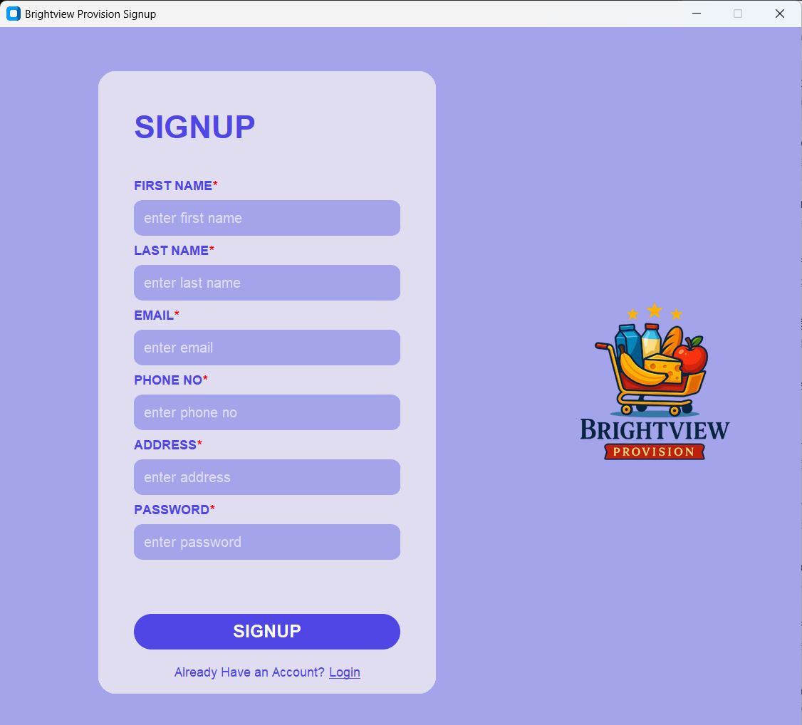
- First fill your first name 
- Then your last name correctly 
- Enter your email correctly, this emil will be used to receive updates and track your goods.
- Fill your phone number, use a correct available phone number. The same number will be used to recover your account upon unforeseen inconviniences.
- Enter your address,this will be your billing and delivery address.
- Create a password ;Adviseably strong password but also easy to remember.
-you can not share this password with anyone else for security reasons
- Upon completion filling the form click signup to finish creatung your account.

After successful account creation, your screen should look like this. This is your home screen!

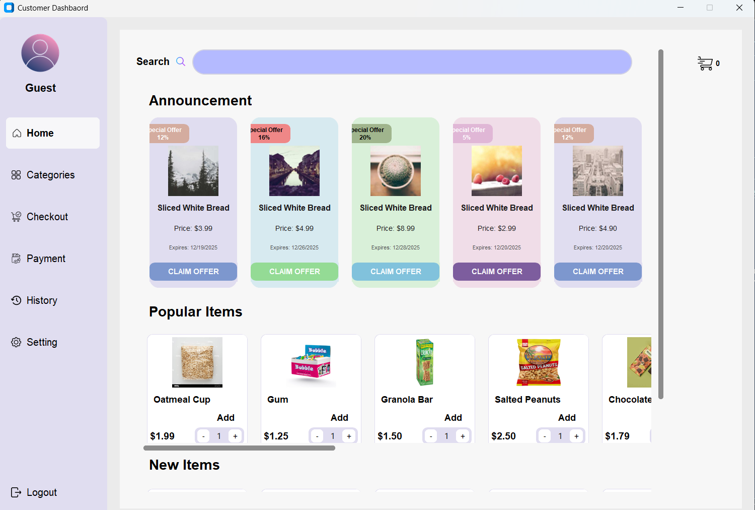
You can scroll up & down to move across pages.

Navigation

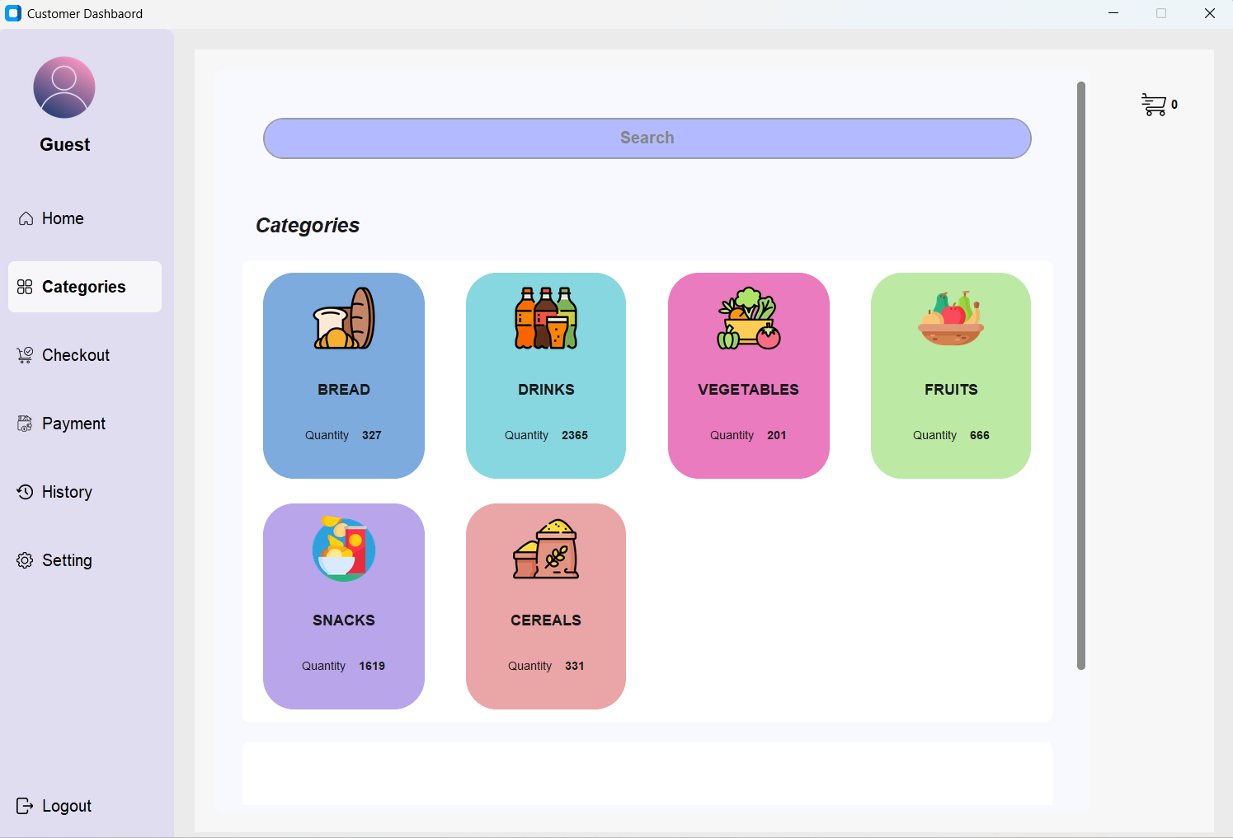
Upon clicking category button ,on your right hand side appears categories of goods you may want to purchase.
And you may click any of the category you want to search available goods. :one category at a time
For example if you want to see our vegetables, you click the vegetable tab as seen below,and the available options will appear

Then scroll through available goods from that category
To order goods
Scroll til you see an item you want , then click it

Select quantinty by either increasing ammounts
Or decreasing if you accidentally added more than you need.
once you’re done selecting your items and youre ready to pay click the checkout button, which leads you to the checkout page

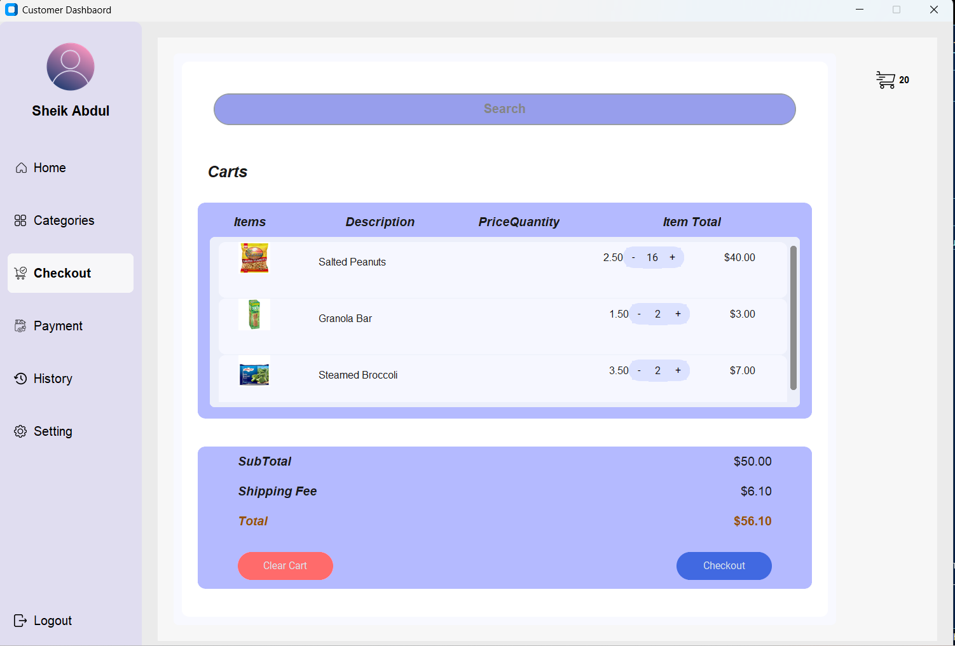
On this page you see all items you added to your cart ,ready for payment and shipping.you can also adjust quantity like on the previous page and confirm your order by clicking the checkout button bottom right corner of your screen

This button leads you to paying for your goods, empties the cart and your goods are readdy to be shipped and delivered to you.


For first time users you will need to fill in your payment information, by clicking the buttton payment button ,which leads you to the payment page for you to set up your card details.

And your screen now looks like this
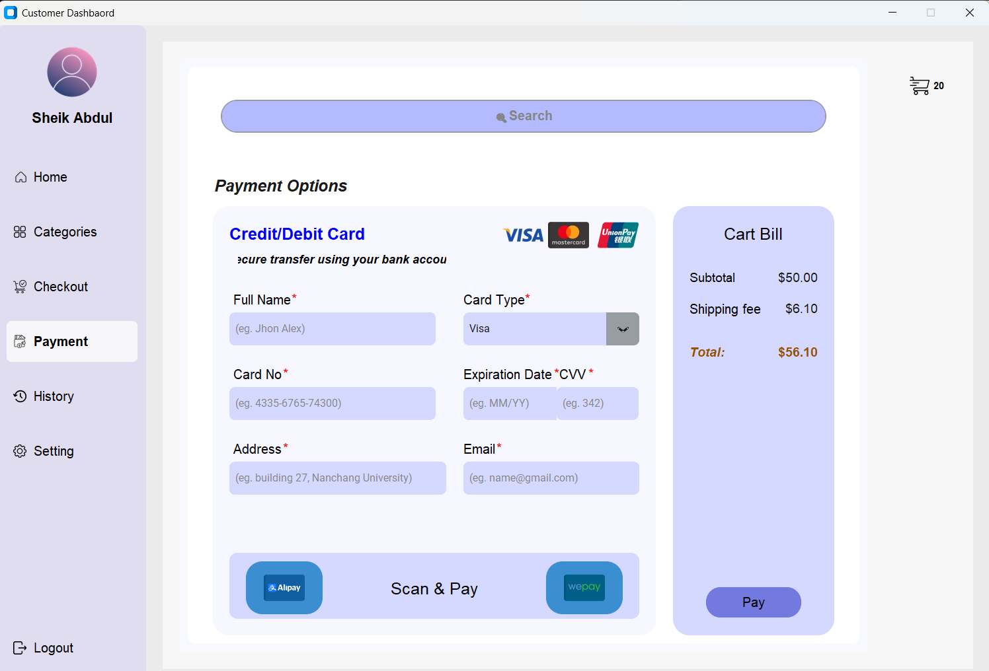
- Our mobile app accepts all credit and debit cards.
- Fill your full name as on your bank card
- Then select your card type(if masters, or visa card)
- Fill your card number
- Then your card’s expiration date using MM/YY format
- Enter your billing address
- Enter your email in the format email@gmail.com
To complete click the pay button.

ORDER HISTORY
- To view your past purchase click here


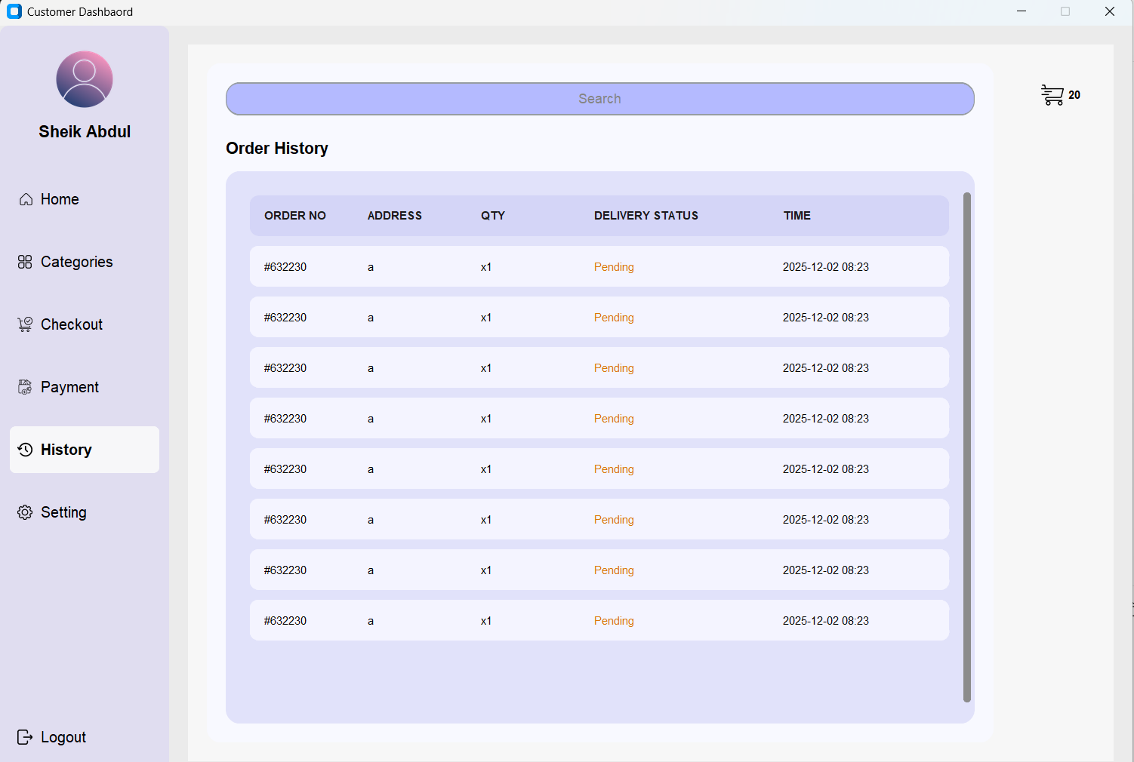

Settings & Options
For more profile settings or update ;

- Enter your first name
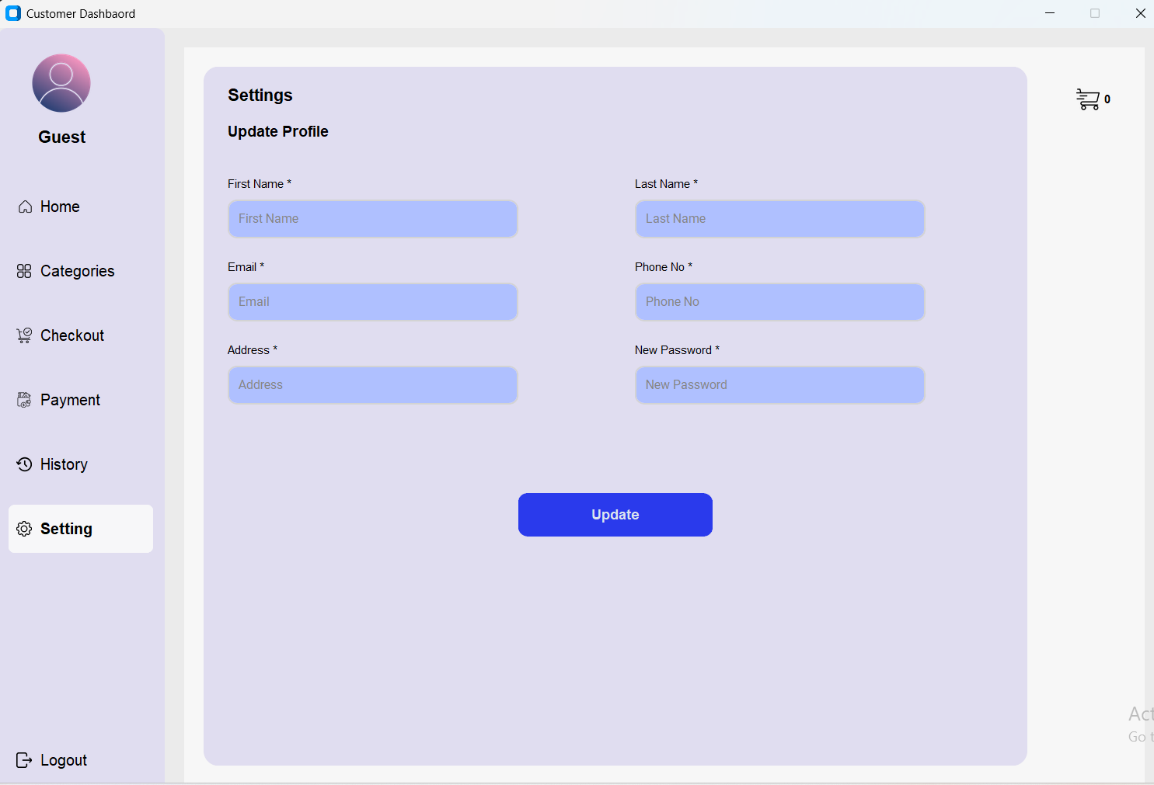

- Then your last name

- Then your email


- Enter youtr phone number
- 
- Enter address


- Enter new password

- To complete; click update


Trouble shooting

Possible errors you may face upon Signing up/ register :

- This error shows up when you try to sign up without filling your first name.
- To solve this error ,enter your first name.This can not be empty
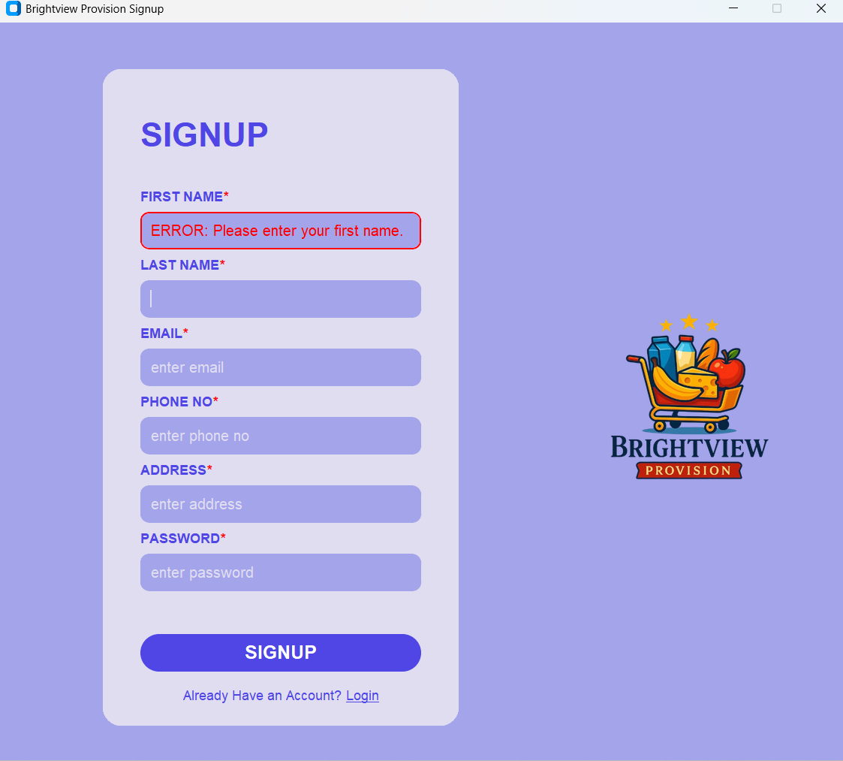

- This error happens when you try to sign up without filling your last name
-To solve this error fill in your last name,this field cannot stay empty

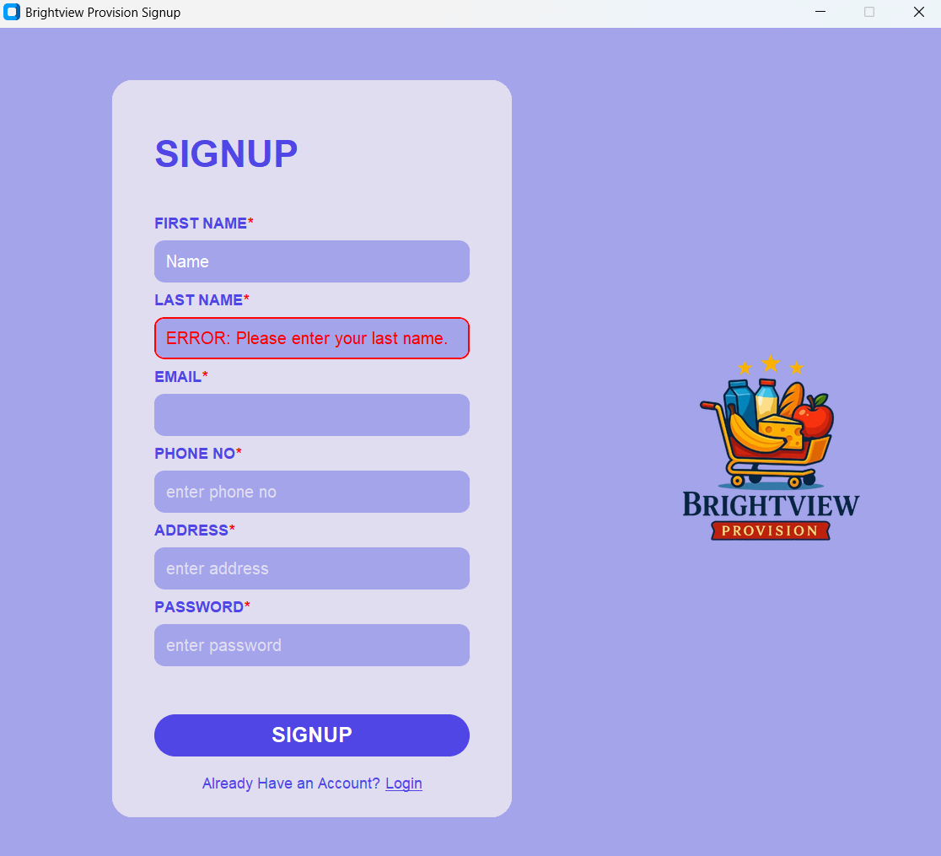

- This error on email field happens when you leave the field empty
-To solve this error fill the field with your valid email
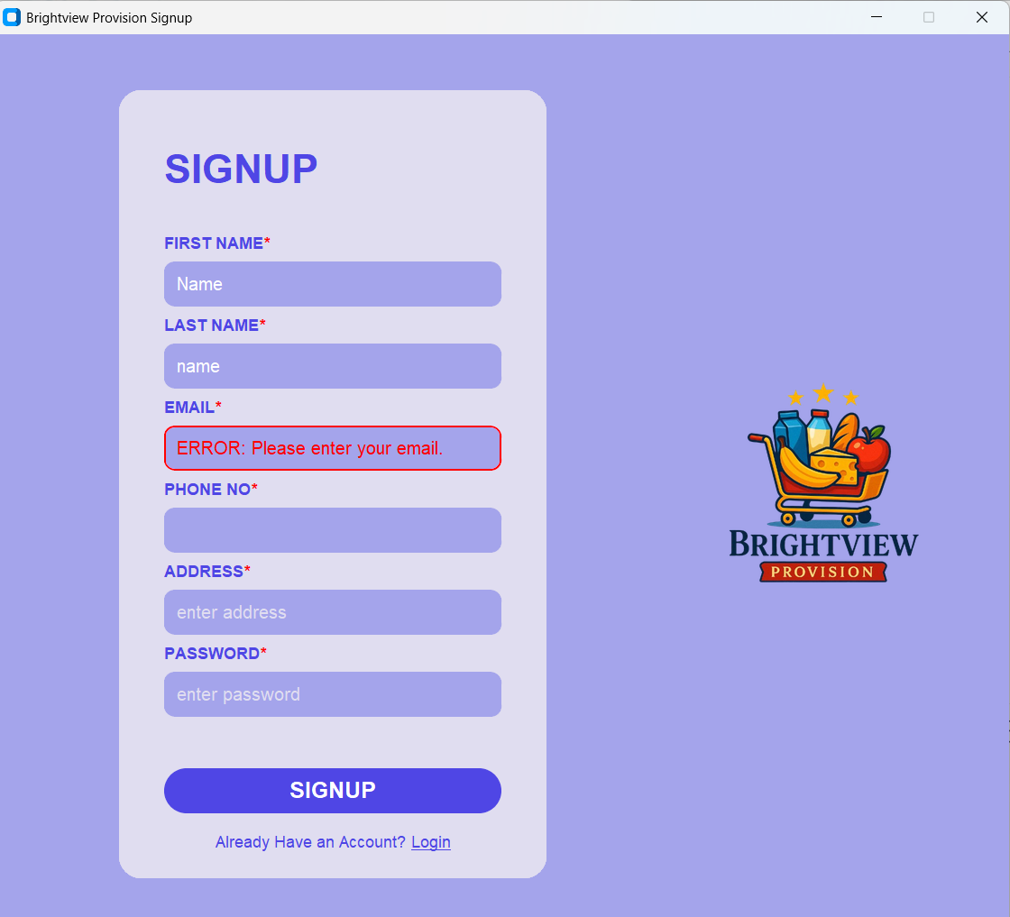
- This error happens when your phone number field is empty
-To solve this error ,enter your phone number correctly.
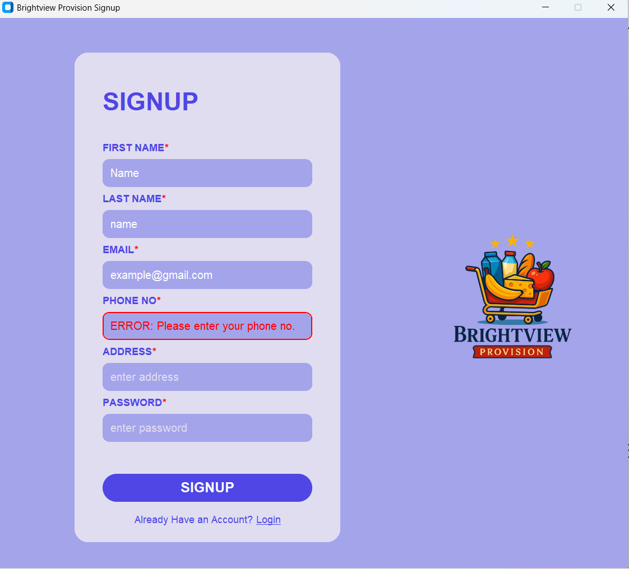

- This error happens when the address field is empty
-To solve this fill your address correctly
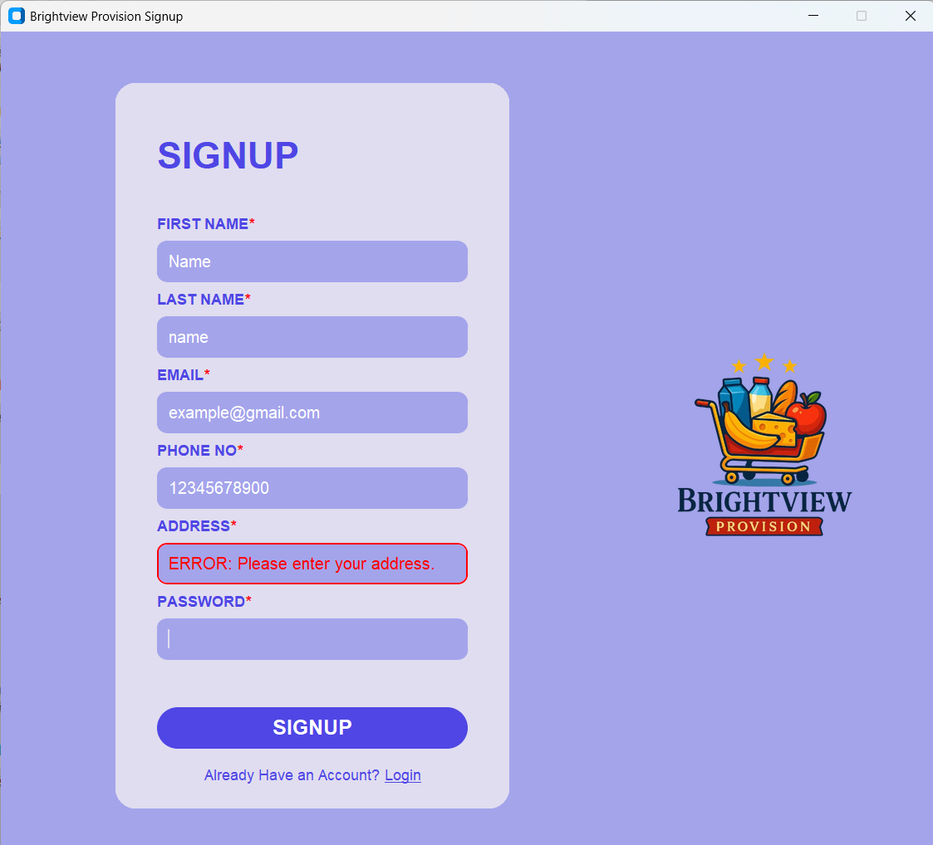

- This error happens when you leave the field empty
-To solve this fill your password so set it up
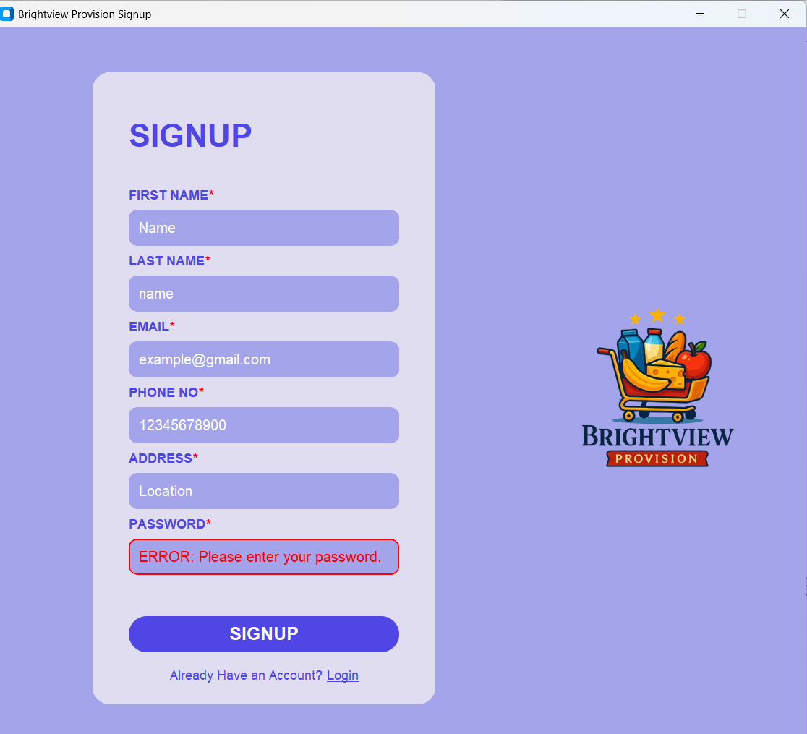

- This error happens when you try to log in before filling in all fields
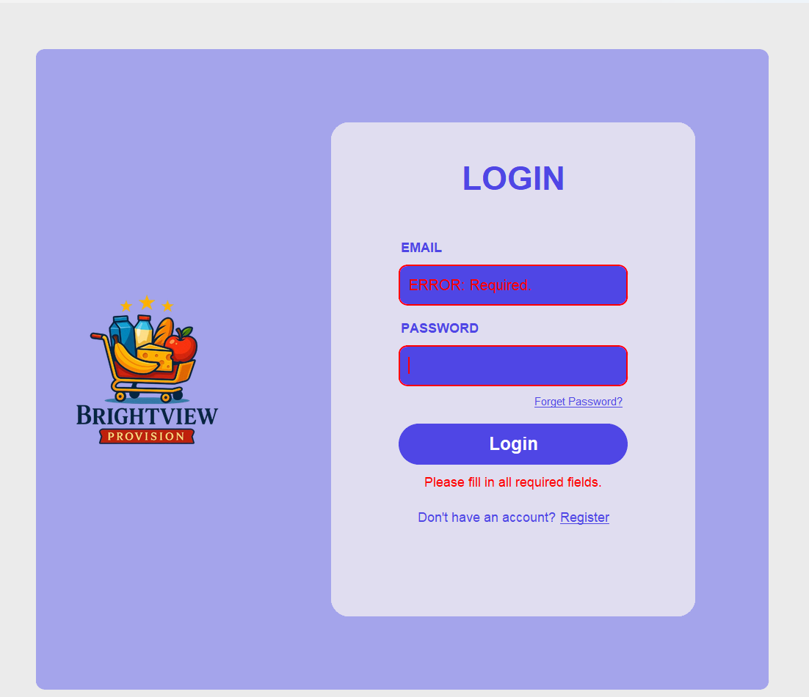

- to solve this error begin filling in all requirements as guided below
- Fill the email part with the same email you used to create an account , to solve such errors


- Then fill in this field with a password you created ,while signing up

-And now you’re all set, you can click the Login button to submit page

Contact / Support
- For further customer support ,please contact
our email brightviewprovisions@info.co.cn
Or call 888 for customer care call.

