
Secure By Design
EDUCATE. EMPOWER. SECURE THE FUTURE.
COURSE 1.1 / COMPANION WORKBOOK

Windows Server
2025
DC01 and DC02
Build the identity foundation
A practical companion for configuring Active Directory on two domain controllers, checking the result, and recording evidence.
MATERIALS EDITION 0.5 / COURSE 1.1
Updated 9 October 2026 · sbd-dc01-dc02
NAME ____________________ / DATE ______________

START HERE / YOUR LEARNING PATH

Table of contents
Understand the services, follow the configuration, and keep evidence of what you observe. Select a title to jump to that page.
What is Active Directory? 3
Why use two domain controllers? 4
What crosses the network? 5
Plan your build 6
Build DC01 7
Add DC02 8
Verify the domain 9
Keep a useful build record 10
Continue the learning path 11
Notices and permissions 12

Use it alongside the course
The interactive companion adds chapter progress, knowledge checks, evidence notes, and a 3D view of the network as it takes shape. The workbook is your readable reference and writing space.
YOUR PACE Read the foundations first if these concepts are new. Return to them whenever a configuration choice needs a clearer explanation.

FOUNDATIONS / UNDERSTAND THE WHY

What is Active Directory?
The shared directory behind domain identities.

A directory for people and computers
Active Directory Domain Services (AD DS) is the Windows Server directory service. It stores objects such as user accounts, computer accounts, and groups, together with their attributes. Administrators use this shared directory to organize identities and manage access consistently.

The domain and the controller
A domain is a logical collection of directory objects, named here sbd.test. A domain controller (DC) is a server running AD DS that stores and serves that directory. DC01 and DC02 are two servers serving the same domain. A forest contains one or more domains; this build starts with one.

Identity, permissions, and policy
Authentication checks who is signing in. Authorization determines what that identity may access. Signing in successfully does not grant access to every resource: the destination service still applies its permissions. Groups make it practical to assign access to roles instead of managing every person separately.

Organization and consistent settings
Organizational units (OUs) organize objects and support delegated administration and Group Policy. Group Policy applies centrally managed settings to users and computers. A global catalog helps find directory objects across a forest; both controllers in this course provide that role.
REMEMBER AD DS stores the directory, and every domain controller serves it. Authentication proves who someone is; authorization decides what they may reach.
THINK IT THROUGH Explain the difference between the sbd.test domain and the SBD-DC01 server.
Microsoft · What is Active Directory Domain Services?
Microsoft · Group Policy and organizational units
Microsoft · Authentication and authorization

FOUNDATIONS / UNDERSTAND THE WHY

Why use two domain controllers?
Keep the directory available when one server is unavailable.

Remove the single-server dependency
With one DC, its outage removes the only live directory service point. With two healthy, reachable controllers, clients can use a surviving DC for supported operations. This also lets you patch or restart one server while the other continues serving requests. Reconnection may take time; uninterrupted service is not guaranteed.

Both controllers do useful work
Both writable DCs can process normal directory changes and authentication requests. Replication shares directory changes between them. They are not a primary server and an idle spare. Certain operations still depend on a single FSMO role holder, so role placement and recovery need their own plan.

Make the redundancy real
Microsoft recommends at least two virtualized DCs per domain on different virtualization hosts. Two VMs on one host share that host as a failure point. Consider shared storage, power, and network dependencies too.

Availability still needs recovery
Replication can spread an accidental deletion or harmful change to both servers. Keep protected backups and test recovery separately. Two is a starting point for this design, not a universal capacity target: additional sites, users, and recovery needs may require more controllers.
REMEMBER Before relying on DC02, verify replication, review shared dependencies, and confirm both controllers pass their health checks.
THINK IT THROUGH If both controllers run on the same physical host, which outage would still stop both services?
 | SEE IT INSIDE THE NETWORK  DC01 is down, step 3: with SBD-DC01 offline, the workstation authenticates with SBD-DC02 instead, so sign-in continues.  securebydesigninc.com/inside-the-network#process=dc-down&step=3

Microsoft · Avoiding single points of failure
Microsoft · Operations master role placement
FOUNDATIONS / UNDERSTAND THE WHY

What crosses the network?
The ports a domain member needs to reach its domain controllers.
Your lab is one flat network, so nothing stands between a client and DC01. In a segmented network, every one of these conversations has to be allowed on purpose. Inside the Network shows them crossing the core switch. The table starts after name resolution, which course 1.2 covers.
PURPOSE | PORT | WHAT IT CARRIES
Authentication | TCP/UDP 88 | Kerberos tickets
Password change | TCP/UDP 464 | Kerberos password changes and resets
Directory | TCP/UDP 389 · TCP 636 | LDAP and LDAPS; UDP 389 carries the domain controller locator ping
Global catalog | TCP 3268 · 3269 | Forest-wide searches; 3269 uses TLS
Group Policy and SYSVOL | TCP 445 | SMB reads of policies and scripts from domain controller shares
RPC services | TCP 135 · 49152–65535 | Endpoint mapper, then the dynamic range for NetLogon, LSA, and SAM
Time | UDP 123 | W32Time; members follow the domain time hierarchy
Administration | TCP 9389 | AD Web Services for PowerShell and Administrative Center, from administration hosts only

REMEMBER Allowing Kerberos isn't enough. Applying Group Policy and reading SYSVOL also need LDAP, SMB, and RPC. In the Inside the Network design, rule F03 permits this directory profile for domain members, with LDAP signing and channel binding required.
THINK IT THROUGH A workstation gets Kerberos tickets, but Group Policy never applies. Which ports would you check first?
 | SEE IT INSIDE THE NETWORK  Sign in, step 4: after it authenticates, the workstation reads directory information and Group Policy from SBD-DC01.  securebydesigninc.com/inside-the-network#process=signin&step=4

Microsoft · Service overview and network port requirements for Windows
Microsoft · Configure a firewall for Active Directory domains and trusts
01 / PREPARE

Plan your build
Build two new domain controllers in one isolated network. The interactive guide contains the detailed steps, verification commands, and chapter evidence fields.

What you will learn
• Configure DC01 and add DC02 to the same domain.
• Inspect service state, replication health, and both controllers' roles.
• Connect configuration choices to security reasoning and evidence.

Before you begin
Use two new Windows Server 2025 Desktop Experience VMs, console access, and approved installation media. Record your starting OS builds. Keep this exercise isolated; sample domain values must match your own environment plan.

Sample configuration
SETTING | SAMPLE VALUE
Domain and NetBIOS | sbd.test / SBD
First controller | SBD-DC01 / 10.0.10.10/24
Second controller | SBD-DC02 / 10.0.10.11/24
DC02 DNS server | 10.0.10.10 (SBD-DC01); course 1.2 sets the final order
Network and time | Isolated subnet / record the internal time source

CM-2 BASELINE Record the intended values and the observed starting configuration. Keep the baseline aligned with changes to the build.

02 / CONFIGURE

Build DC01
WHY THIS MATTERS Create the sample forest and its first domain controller.

Follow the build
1. On DC01, add the Active Directory Domain Services role and its management tools through Server Manager.
2. Promote the server using Add a new forest and sbd.test. Leave DNS server selected (course 1.2 explains it); the first controller is always a global catalog. Choose Windows Server 2025 functional levels and a unique DSRM password.
3. Review the SBD name, paths, and prerequisites. Read any warnings, resolve blocking errors, install, and restart.
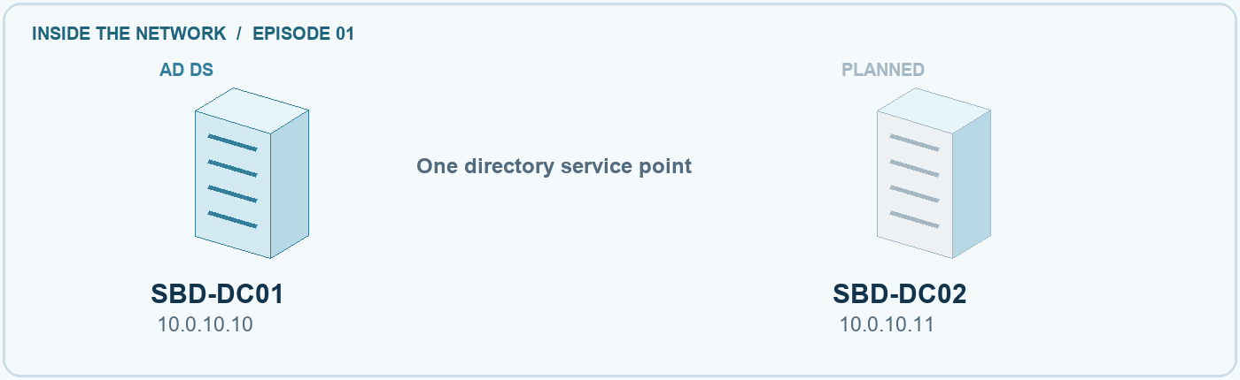
NETWORK STATE DC01 configured; DC02 planned.

Check your result
Get-ADDomain | Select-Object DNSRoot, NetBIOSName
Get-Service NTDS,Netlogon
Get-SmbShare -Name SYSVOL,NETLOGON
Expect the planned domain and running services, with both shares present. Investigate missing results before adding DC02.
CM-6 SETTINGS Record the promotion choices and why they fit the environment. Keep passwords out of evidence.
COMMON MISTAKE Role installation alone does not complete domain-controller promotion.

03 / EXTEND

Add DC02
WHY THIS MATTERS Add another writable controller to the same domain.

Follow the build
1. Point DC02 at DC01 (10.0.10.10) for DNS; course 1.2 explains the DNS design. Check network reachability and clock alignment.
2. Install AD DS, then choose Add a domain controller to an existing domain. Use sbd.test and authorized domain credentials. Leave DNS server and global catalog selected.
3. Review site, replication source, DSRM password, and prerequisites. Install and restart. Leave DC02's DNS setting as it is; course 1.2 sets the final order.
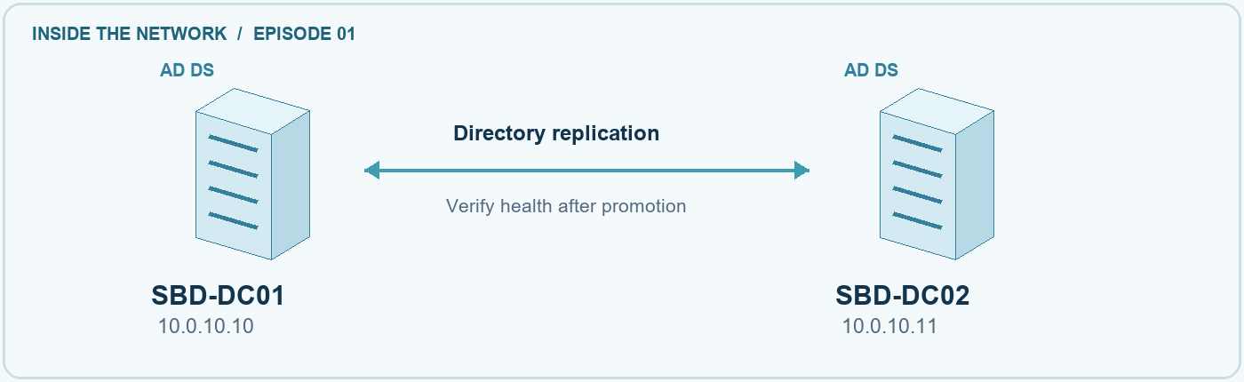
NETWORK STATE Two controllers with a replication relationship.

Check your result
Get-ADDomainController -Filter *
repadmin /replsummary
repadmin /showrepl SBD-DC02
Expect both controllers and successful recent replication. Record any unresolved errors.
CP-9 RECOVERY A second controller supports availability. Backups and tested recovery remain separate work.
COMMON MISTAKE Choose the existing-domain option. A new forest would create a separate directory.

04 / VERIFY

Verify the domain
WHY THIS MATTERS Ask each controller for an observable result.

Follow the build
1. In an elevated PowerShell window on either controller, run DCDiag against SBD-DC01 and then SBD-DC02. Read each test's result, not just the last line.
2. Check replication both ways: the summary, then each controller's inbound partners. Expect recent successful attempts in both directions and no failures.
3. List both controllers' global catalog status and operations master roles; SBD-DC01 holds all five. Confirm SYSVOL and NETLOGON are shared on SBD-DC02 too.
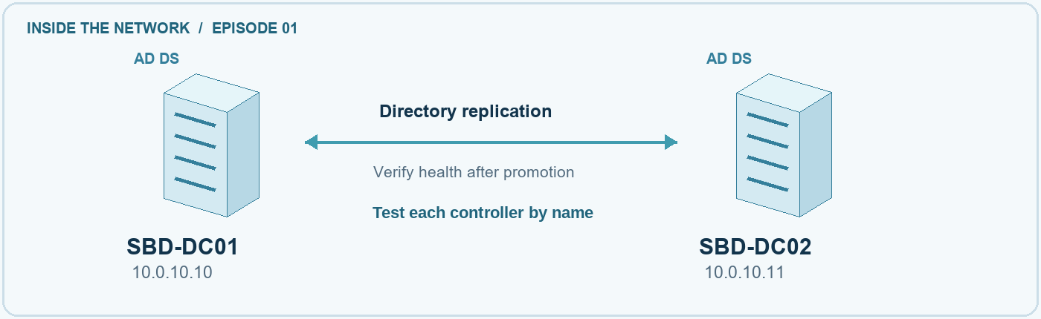
NETWORK STATE Check each controller and confirm replication both ways.

Check your result
dcdiag /s:SBD-DC01
dcdiag /s:SBD-DC02
repadmin /replsummary
repadmin /showrepl *
Get-ADDomainController -Filter * |
Select-Object HostName, IsGlobalCatalog, OperationMasterRoles
Get-SmbShare -Name SYSVOL,NETLOGON -CimSession SBD-DC02
Expect each DCDiag test to pass or have a recorded cause, successful replication both ways, and SYSVOL and NETLOGON on both controllers. A command that ran is not a pass.
IA-2 SIGN-IN Healthy, replicating controllers make domain sign-in possible. These checks do not establish all authentication requirements.
COMMON MISTAKE A successful ping does not show replication, SYSVOL, or sign-in health.

05 / EVIDENCE

Keep a useful build record
Use My evidence in the interactive guide to save chapter notes, confirm your checks, and answer each question. Export your record before moving to another browser or device.

Your evidence summary
Record the final domain and controllers, actual role holders, dated test output, and unresolved issues. Reference files stored in your own environment; do not record credentials.
RMF CONNECTION Implementation records what was configured. Assessment examines evidence. Monitoring revisits conclusions as the system changes.

Completion checklist
☐ I recorded actual settings and the reasons for them.
☐ I checked both controllers' health and replication results.
☐ I kept dated evidence and described failures or limits.
☐ I listed recovery, hardening, and client checks still to do.

What did you observe
Evidence file names, collection time, key results, and the next action

GO FURTHER Explain why replication cannot recover every unwanted change. Identify a change that would trigger a new replication or health check.

REFERENCE / KEEP LEARNING

Continue the learning path
The workbook and interactive companion use the same five chapters. The recorded walkthrough is coming soon. Read the current sources before adapting the sample to another environment. Next in the path: course 1.2, Configure DNS and time.

Technical guidance
Install Active Directory Domain Services
https://learn.microsoft.com/en-us/windows-server/identity/ad-ds/deploy/install-active-directory-domain-services--level-100-
Diagnose Active Directory replication failures
https://learn.microsoft.com/en-us/troubleshoot/windows-server/active-directory/diagnose-replication-failures
DCDiag verification
https://learn.microsoft.com/en-us/windows-server/administration/windows-commands/dcdiag
Operations master role placement
https://learn.microsoft.com/en-us/windows-server/identity/ad-ds/plan/planning-operations-master-role-placement
Service overview and network port requirements
https://learn.microsoft.com/en-us/troubleshoot/windows-server/networking/service-overview-and-network-port-requirements

Risk and control guidance
Risk Management Framework SP 800-37 Rev. 2
https://csrc.nist.gov/pubs/sp/800/37/r2/final
Security controls SP 800-53 Rev. 5
https://csrc.nist.gov/pubs/sp/800/53/r5/upd1/final

EDITION RECORD / RIGHTS AND ATTRIBUTIONS

Notices and permissions
Secure By Design · Build the identity foundation
Windows Server 2025 · DC01 and DC02
Course 1.1 · sbd-dc01-dc02
Materials edition 0.5 · Updated 9 October 2026

Copyright and permissions
© 2026 Secure By Design Team LLC.
Copyright is claimed only in material eligible for protection and owned by Secure By Design Team LLC. Third-party materials and software remain subject to their respective rights and applicable licenses.
For reuse requiring permission from the rights holder, obtain permission from Secure By Design Team LLC. This notice does not replace third-party licenses or limit uses permitted by law.

Third-party notices
Microsoft, Active Directory, Windows, and Windows Server are trademarks of the Microsoft group of companies. Product names identify the technologies discussed in this training.
The interactive guide uses three.js under the MIT License. The complete copyright and license notice is included in THREE-LICENSE.txt in the learning package.

Companion materials
Open index.html for the interactive guide and network explorer. Choose Notices and permissions in the guide footer to view these notices and the third-party license. Keep the workbook, notices.html, and THREE-LICENSE.txt beside the guide when extracting the learning package.

