
Secure By Design
EDUCATE. EMPOWER. SECURE THE FUTURE.
COURSE 1.1 / COMPANION WORKBOOK

Windows Server
DC01 and DC02
Promote Primary & Secondary Domain Controller
A practical companion for promoting two Active Directory domain controllers on a network segment of their own, checking the result, and recording evidence.
MATERIALS EDITION 0.6 / COURSE 1.1
Updated 9 October 2026 · sbd-dc01-dc02
NAME ____________________ / DATE ______________

START HERE / YOUR LEARNING PATH

Table of contents
Understand the services, follow the configuration, and keep evidence of what you observe. Select a title to jump to that page.
What is Active Directory? 3
Where do the controllers live? 4
Why use two domain controllers? 5
What crosses the network? 6
Plan your build 7
Build DC01 8
Add DC02 9
Verify the domain 10
Keep a useful build record 11
Continue the learning path 12
Notices and permissions 13

Use it alongside the course
The interactive companion adds chapter progress, knowledge checks, evidence notes, and a 3D view of the network as it takes shape. The workbook is your readable reference and writing space.
YOUR PACE Read the foundations first if these concepts are new. Return to them whenever a configuration choice needs a clearer explanation.

FOUNDATIONS / UNDERSTAND THE WHY

What is Active Directory?
The shared directory behind domain identities.

A directory for people and computers
Active Directory Domain Services (AD DS) is the Windows Server directory service. It stores objects such as user accounts, computer accounts, and groups, together with their attributes. Administrators use this shared directory to organize identities and manage access consistently.

The domain and the controller
A domain is a logical collection of directory objects, named here sbd.test. A domain controller (DC) is a server running AD DS that stores and serves that directory. DC01 and DC02 are two servers serving the same domain. A forest contains one or more domains; this build starts with one.

Identity, permissions, and policy
Authentication checks who is signing in. Authorization determines what that identity may access. Signing in successfully does not grant access to every resource: the destination service still applies its permissions. Groups make it practical to assign access to roles instead of managing every person separately.

Organization and consistent settings
Organizational units (OUs) organize objects and support delegated administration and Group Policy. Group Policy applies centrally managed settings to users and computers. A global catalog helps find directory objects across a forest; both controllers in this course provide that role.
REMEMBER AD DS stores the directory, and every domain controller serves it. Authentication proves who someone is; authorization decides what they may reach.
THINK IT THROUGH Explain the difference between the sbd.test domain and the SBD-DC01 server.
Microsoft · What is Active Directory Domain Services?
Microsoft · Group Policy and organizational units
Microsoft · Authentication and authorization

FOUNDATIONS / UNDERSTAND THE WHY

Where do the controllers live?
On a segment of their own, behind a core that denies by default.

A segment reserved for controllers
SBD-DC01 and SBD-DC02 sit on VLAN 10 (10.0.10.0/24), a segment that holds domain controllers and nothing else. Workstations, member servers, security tools, and administrators sit on segments of their own. The core joins the segments, and its VLAN 10 address, 10.0.10.1, is the controllers' default gateway.

Deny by default, allow by exception
The core denies every session between segments unless a documented rule permits it, and logs what it denies. Members reach the controllers only for name resolution (course 1.2), the services in "What crosses the network?", and course 1.8's credentialed scans. Traffic between the two controllers stays inside VLAN 10, so the core never routes it.

Only Tier 0 manages a controller
From other segments, Remote Desktop, PowerShell remoting, and AD Web Services reach a controller only from AdminJumpBox01, the Tier 0 host on VLAN 60 that course 1.5 builds; until then, use the VM console. Members still reach SMB and RPC, which can carry administration too, so Tier 0 accounts never sign in to them.

Two layers, and no internet
Windows Defender Firewall stays on in every profile and blocks what no rule allows, so an unopened port stays closed even if a core rule is wrong. Keep Remote Desktop off. The directory rules accept any address, and the remoting and AD Web Services rules do too until course 1.5 limits them to the Tier 0 host, so the core decides who reaches those ports. No segment routes to the internet; approved media is the only way in.
REMEMBER A controller's segment is part of its security: VLAN 10 for controllers only, default deny at the core, management only from Tier 0, and the host firewall on in every profile.
THINK IT THROUGH A workstation on VLAN 80 can open Remote Desktop to SBD-DC01. Which two layers failed, and where would you look first?
 | SEE IT INSIDE THE NETWORK  VLAN 10: the domain controllers' segment, with its boundary, both controllers and their addresses, and the controls that apply.  securebydesigninc.com/inside-the-network#vlan=10

Microsoft · Securing domain controllers against attack
Microsoft · Configure a firewall for AD domains and trusts
FOUNDATIONS / UNDERSTAND THE WHY

Why use two domain controllers?
Keep the directory available when one server is unavailable.

Remove the single-server dependency
With one DC, its outage removes the only live directory service point. With two healthy, reachable controllers, clients can use a surviving DC for supported operations. This also lets you patch or restart one server while the other continues serving requests. Reconnection may take time; uninterrupted service is not guaranteed.

Both controllers do useful work
Both writable DCs can process normal directory changes and authentication requests. Replication shares directory changes between them. “Primary” and “secondary” describe the order you promote them, not a primary server and an idle spare. Certain operations still depend on a single FSMO role holder, so role placement and recovery need their own plan.

Make the redundancy real
Microsoft recommends at least two virtualized DCs per domain on different virtualization hosts. Two VMs on one host share that host as a failure point. Consider shared storage, power, and network dependencies too.

Availability still needs recovery
Replication can spread an accidental deletion or harmful change to both servers. Keep protected backups and test recovery separately. Two is a starting point for this design, not a universal capacity target: additional sites, users, and recovery needs may require more controllers.
REMEMBER Before relying on DC02, verify replication, review shared dependencies, and confirm both controllers pass their health checks.
THINK IT THROUGH If both controllers run on the same physical host, which outage would still stop both services?
 | SEE IT INSIDE THE NETWORK  DC01 is down, step 3: with SBD-DC01 offline, the workstation authenticates with SBD-DC02 instead, so sign-in continues.  securebydesigninc.com/inside-the-network#process=dc-down&step=3

Microsoft · Avoiding single points of failure
Microsoft · Operations master role placement
FOUNDATIONS / UNDERSTAND THE WHY

What crosses the network?
The ports a domain member needs to reach its domain controllers.
Domain members sit on other segments, so each conversation in this table crosses the core, which allows it only because a rule says so. Inside the Network shows each one crossing the core switch. The table starts after name resolution, which course 1.2 covers.
PURPOSE | PORT | WHAT IT CARRIES
Authentication | TCP/UDP 88 | Kerberos tickets
Password change | TCP/UDP 464 | Kerberos password changes and resets
Directory | TCP/UDP 389 · TCP 636 | LDAP and LDAPS; UDP 389 carries the domain controller locator ping
Global catalog | TCP 3268 · 3269 | Forest-wide searches; 3269 uses TLS
Group Policy and SYSVOL | TCP 445 | SMB reads of policies and scripts from domain controller shares
RPC services | TCP 135 · 49152–65535 | Endpoint mapper, then the dynamic range for NetLogon, LSA, and SAM
Time | UDP 123 | W32Time; members follow the domain time hierarchy
Administration | TCP 3389 · 5985–5986 · 9389 | Remote Desktop, PowerShell remoting, and AD Web Services, only from the Tier 0 administration host

REMEMBER Allowing Kerberos isn't enough. Applying Group Policy and reading SYSVOL also need LDAP, SMB, and RPC. In the Inside the Network design, rules F02, F03, and F09 permit this profile for domain members, with LDAP signing and channel binding required, and rule A01 limits administration to the Tier 0 host. Name resolution (F01) and credentialed scanning (F15) have their own rules; everything else is denied.
THINK IT THROUGH A workstation gets Kerberos tickets, but Group Policy never applies. Which ports would you check first?
 | SEE IT INSIDE THE NETWORK  Sign in, step 4: after it authenticates, the workstation reads directory information and Group Policy from SBD-DC01.  securebydesigninc.com/inside-the-network#process=signin&step=4

Microsoft · Service overview and network port requirements for Windows
Microsoft · Configure a firewall for Active Directory domains and trusts
01 / PREPARE

Plan your build
Build two new domain controllers on their own segment of an isolated network. The interactive guide contains the detailed steps, verification commands, and chapter evidence fields.

What you will learn
• Promote DC01, then add DC02 to the same domain, on a segment of their own.
• Inspect service state, replication health, and both controllers' roles.
• Connect configuration choices to security reasoning and evidence.

Before you begin
Use two new Windows Server (Desktop Experience) VMs on VLAN 10, the segment reserved for domain controllers, with console access and approved installation media. Record your starting OS builds. Keep this exercise isolated; sample domain values must match your own environment plan.

Sample configuration
SETTING | SAMPLE VALUE
Domain and NetBIOS | sbd.test / SBD
First controller | SBD-DC01 / 10.0.10.10/24
Second controller | SBD-DC02 / 10.0.10.11/24
Segment and gateway | VLAN 10 (10.0.10.0/24) / 10.0.10.1, the core
DC02 DNS server | 10.0.10.10 (SBD-DC01)
Network and time | Isolated, no internet / record the internal time source

CM-2 BASELINE Record the intended values and the observed starting configuration. Keep the baseline aligned with changes to the build.

02 / CONFIGURE

Build DC01
WHY THIS MATTERS Create the sample forest and its first domain controller.

Follow the build
1. On DC01, add the Active Directory Domain Services role and its management tools through Server Manager.
2. Promote the server using Add a new forest and sbd.test. Leave DNS server selected; the DNS delegation warning is expected, and course 1.2 explains both. The first controller is always a global catalog. Choose the highest functional levels the wizard offers and a unique DSRM password.
3. Review the SBD name, paths, and prerequisites. Read any warnings, resolve blocking errors, install, and restart.
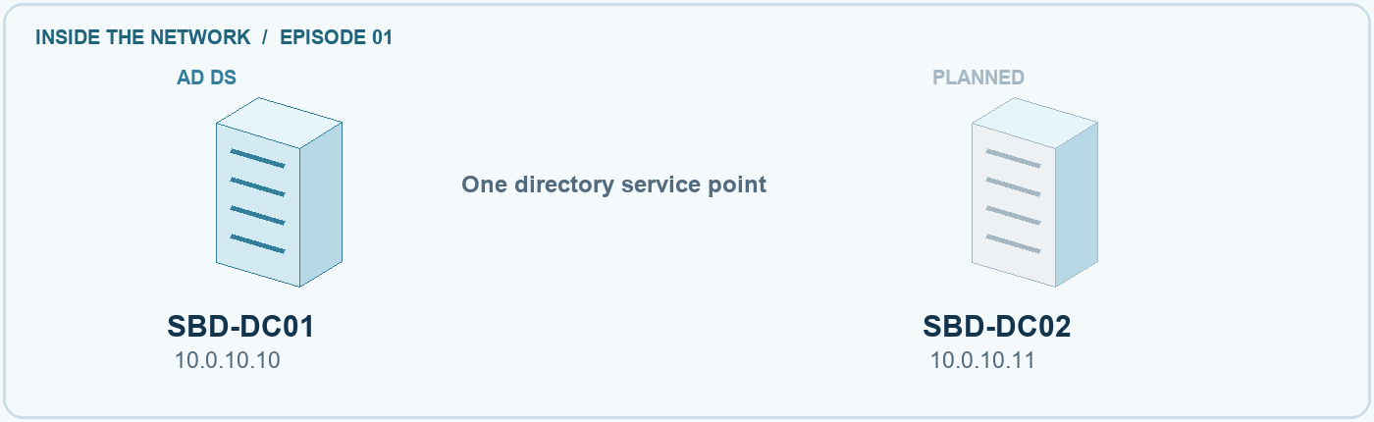
NETWORK STATE DC01 configured; DC02 planned.

Check your result
Get-ADDomain | Select-Object DNSRoot, NetBIOSName
Get-Service NTDS,Netlogon
Get-SmbShare -Name SYSVOL,NETLOGON
Expect the planned domain and running services, with both shares present. Investigate missing results before adding DC02.
CM-6 SETTINGS Record the promotion choices and why they fit the environment. Keep passwords out of evidence.
COMMON MISTAKE Role installation alone does not complete domain-controller promotion.

03 / EXTEND

Add DC02
WHY THIS MATTERS Add another writable controller to the same domain.

Follow the build
1. Point DC02 at DC01 (10.0.10.10) for DNS and leave it that way; course 1.2 explains the DNS design. Check network reachability and clock alignment.
2. Install AD DS, then choose Add a domain controller to an existing domain. Use sbd.test and authorized domain credentials. Leave DNS server and global catalog selected.
3. Review site, replication source, DSRM password, and prerequisites. Install and restart.
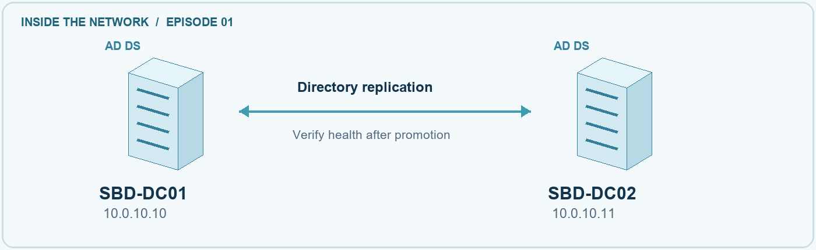
NETWORK STATE Two controllers with a replication relationship.

Check your result
Get-ADDomainController -Filter *
repadmin /replsummary
repadmin /showrepl SBD-DC02
Expect both controllers and successful recent replication. Record any unresolved errors.
CP-9 RECOVERY A second controller supports availability. Backups and tested recovery remain separate work.
COMMON MISTAKE Choose the existing-domain option. A new forest would create a separate directory.

04 / VERIFY

Verify the domain
WHY THIS MATTERS Ask each controller for an observable result.

Follow the build
1. On either controller, in elevated PowerShell, run DCDiag against SBD-DC01, then SBD-DC02.
2. Check replication both ways: the summary, then each controller's inbound partners.
3. Check the global catalogs, the five roles on SBD-DC01, and SYSVOL and NETLOGON on DC02.
4. Confirm the domain profile and the effective firewall policy on each controller.
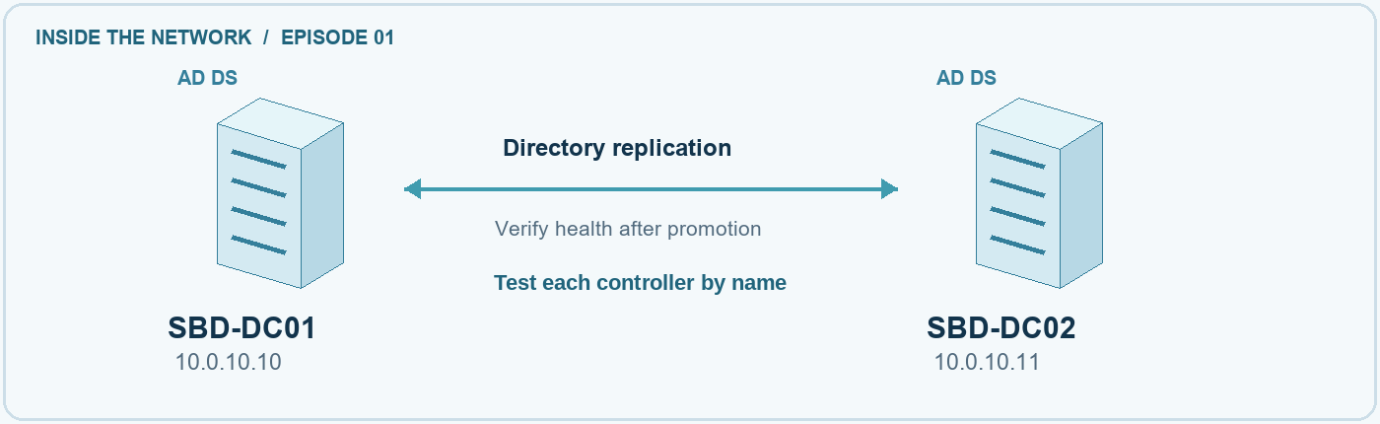
NETWORK STATE Check each controller and confirm replication both ways.

Check your result
dcdiag /s:SBD-DC01
dcdiag /s:SBD-DC02
repadmin /replsummary
repadmin /showrepl *
Get-ADDomainController -Filter * | Select-Object HostName, IsGlobalCatalog
netdom query fsmo
Get-SmbShare -Name SYSVOL,NETLOGON -CimSession SBD-DC02
Get-NetConnectionProfile | Select-Object InterfaceAlias, NetworkCategory
Get-NetFirewallProfile -PolicyStore ActiveStore |
Select-Object Name, Enabled, DefaultInboundAction
Expect each DCDiag test to pass or have a recorded cause, replication both ways, both shares on both controllers, and every firewall profile on and blocking. A command that ran is not a pass.
IA-2 SIGN-IN Healthy, replicating controllers are a precondition for domain sign-in. These checks do not establish all authentication requirements.
COMMON MISTAKE A successful ping does not show replication, SYSVOL, or sign-in health.
05 / EVIDENCE

Keep a useful build record
Use My evidence in the interactive guide to save chapter notes, confirm your checks, and answer each question. Export your record before moving to another browser or device.

Your evidence summary
Record the final domain and controllers, their segment and gateway, actual role holders, dated test output, and unresolved issues. Reference files stored in your own environment; do not record credentials.
RMF CONNECTION Implementation records what was configured. Assessment examines evidence. Monitoring revisits conclusions as the system changes.

Completion checklist
☐ I recorded actual settings and the reasons for them.
☐ I checked both controllers' health, replication, and host firewall.
☐ I kept dated evidence and described failures or limits.
☐ I listed recovery, hardening, and client checks still to do.

What did you observe
Evidence file names, collection time, key results, and the next action

GO FURTHER Explain why replication cannot recover every unwanted change. Identify a change that would trigger a new replication or health check.

REFERENCE / KEEP LEARNING

Continue the learning path
The workbook and interactive companion use the same five chapters. The recorded walkthrough is coming soon. Read the current sources before adapting the sample to another environment. Next in the path: course 1.2, Configure DNS and time.

Technical guidance
Install Active Directory Domain Services
https://learn.microsoft.com/en-us/windows-server/identity/ad-ds/deploy/install-active-directory-domain-services--level-100-
Diagnose Active Directory replication failures
https://learn.microsoft.com/en-us/troubleshoot/windows-server/active-directory/diagnose-replication-failures
DCDiag verification
https://learn.microsoft.com/en-us/windows-server/administration/windows-commands/dcdiag
Operations master role placement
https://learn.microsoft.com/en-us/windows-server/identity/ad-ds/plan/planning-operations-master-role-placement
Service overview and network port requirements
https://learn.microsoft.com/en-us/troubleshoot/windows-server/networking/service-overview-and-network-port-requirements
Securing domain controllers against attack
https://learn.microsoft.com/en-us/windows-server/identity/ad-ds/plan/security-best-practices/securing-domain-controllers-against-attack

Risk and control guidance
Risk Management Framework SP 800-37 Rev. 2
https://csrc.nist.gov/pubs/sp/800/37/r2/final
Security controls SP 800-53 Rev. 5
https://csrc.nist.gov/pubs/sp/800/53/r5/upd1/final

EDITION RECORD / RIGHTS AND ATTRIBUTIONS

Notices and permissions
Secure By Design · Promote Primary & Secondary Domain Controller
Windows Server · DC01 and DC02
Course 1.1 · sbd-dc01-dc02
Materials edition 0.6 · Updated 9 October 2026

Copyright and permissions
© 2026 Secure By Design Team LLC.
Copyright is claimed only in material eligible for protection and owned by Secure By Design Team LLC. Third-party materials and software remain subject to their respective rights and applicable licenses.
For reuse requiring permission from the rights holder, obtain permission from Secure By Design Team LLC. This notice does not replace third-party licenses or limit uses permitted by law.

Third-party notices
Microsoft, Active Directory, Windows, and Windows Server are trademarks of the Microsoft group of companies. Product names identify the technologies discussed in this training.
The interactive guide uses three.js under the MIT License. The complete copyright and license notice is included in THREE-LICENSE.txt in the learning package.

Companion materials
Open index.html for the interactive guide and network explorer. Choose Notices and permissions in the guide footer to view these notices and the third-party license. Keep the workbook, notices.html, and THREE-LICENSE.txt beside the guide when extracting the learning package.

