Automated Kubernetes Deployment Rollback on Amazon EKS

DOCUMENT TYPE | TARGET PLATFORM | WORKLOAD | RECOVERY MODE
POC Engineering Report | Amazon EKS / EC2 | NGINX Deployment | Automated Rollback

――――――――――――――――――――――――――――――――――――――――――――――――
1. Executive Summary & Objective
This technical Proof of Concept (POC) validates an enterprise-grade automated rollback mechanism for containerized workloads deployed on Amazon Elastic Kubernetes Service (Amazon EKS). Modern production deployments require resilient delivery pipelines capable of autonomously detecting release anomalies and rolling back changes without human intervention.
Key Deliverables & Objectives
- Zero-Downtime Releases: Ensure seamless updates using Kubernetes native RollingUpdate strategies.
- Real-Time Anomaly Detection: Rapidly detect broken images, pod startup errors, and failed health probes.
- Autonomous Self-Healing: Trigger automatic deployment rollbacks within 60 seconds of failure.
- Production Risk Mitigation: Eliminate prolonged downtime and minimize Mean Time to Recovery (MTTR).
2. Business Need & Challenges Addressed
Conventional Manual Recovery | Automated EKS Recovery (This Solution)
Requires active manual triage by on-call engineers. | Fully autonomous detection via rollout status & probes.
Extended MTTR: 15–45 minutes of potential downtime. | Sub-minute MTTR: automated rollback executes in <60s.
High risk of human error during urgent CLI operations. | Deterministic scripted rollback executed via standard APIs.
User traffic hits degraded or dead containers. | Rolling update retains healthy pods until verification passes.

3. Environment Specifications & Cluster Verification
The technical POC was deployed and validated within an Amazon Web Services (AWS) EKS cluster environment configured as follows:
Parameter | Specification
Cloud Infrastructure Provider | Amazon Web Services (AWS)
Kubernetes Platform | Amazon Elastic Kubernetes Service (EKS)
Target Namespace | poc
Sample Workload | NGINX Web Server
Compute Infrastructure | Amazon EC2 Worker Nodes
Ingress / Network Service | AWS Network Load Balancer (NLB)

Cluster Worker Node Health Audit
Command executed to inspect cluster worker nodes:
kubectl get nodes -o wide
Terminal Output: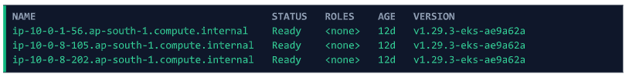
4. Architectural Workflow
The architectural state machine below highlights the end-to-end continuous validation cycle from manifest submission to automatic rollback:
+-------------------------------------+
| Developer / CI-CD Pipeline Git |
+-------------------------------------+
|
v kubectl apply -f manifest.yaml
+-------------------------------------+
| Amazon EKS Control Plane |
+-------------------------------------+
|
v RollingUpdate Strategy
+-------------------------------------+
| Kubernetes Deployment Engine |
+-------------------------------------+
|
[ Health & Readiness Audit ]
/ \
Probes Pass / \ Probes Fail / Timeout
v v
+-----------------------------+ +---------------------------------------+
| Rollout Succeeds (v2) | | Failure Detected: ImagePullBackOff |
| Promote New ReplicaSet | +---------------------------------------+
+-----------------------------+ |
v Trigger Rollback
+---------------------------------------+
| kubectl rollout undo |
+---------------------------------------+
|
v
+---------------------------------------+
| Previous Version (v1) Restored |
| Zero Service Interruption |
+---------------------------------------+

5. Project Repository Structure
All deployment manifests and operational automation scripts are maintained under the working repository:
/root/terraform-eks-poc
│
├── nginx-v1.yaml # Stable release configuration (nginx:1.27)
├── nginx-v2.yaml # Broken release simulation (nginx:doesnotexist)
└── auto-rollback.sh # Rollout health evaluation & recovery automation script

6. Step-by-Step Implementation & Failure Simulation
6.1 Deploy Stable Release (Version 1)
Manifest File: nginx-v1.yaml
The initial production configuration deploys a 3-replica NGINX cluster equipped with strict readiness and liveness probes.
apiVersion: apps/v1
kind: Deployment
metadata:
name: nginx
namespace: poc
spec:
replicas: 3
revisionHistoryLimit: 5
selector:
matchLabels:
app: nginx
strategy:
type: RollingUpdate
template:
metadata:
labels:
app: nginx
spec:
containers:
- name: nginx
image: nginx:1.27
ports:
- containerPort: 80
readinessProbe:
httpGet:
path: /
port: 80
initialDelaySeconds: 5
periodSeconds: 5
livenessProbe:
httpGet:
path: /
port: 80
initialDelaySeconds: 10
periodSeconds: 10

Command to deploy Version 1:
kubectl apply -f nginx-v1.yaml
Output :
6.2 Validate Stable Environment
Verify that all pods have reached the Ready state and are serving the expected image:
# 1. Verify Deployment Status
kubectl get deployment -n poc

# 2. Verify Pod Health
kubectl get pods -n poc
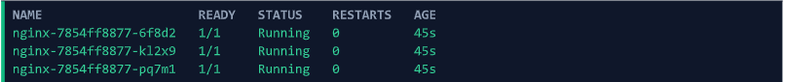
# 3. Verify Container Image
kubectl get deployment nginx -n poc -o=jsonpath='{.spec.template.spec.containers[0].image}'

6.3 Simulate Faulty Release (Version 2)
To simulate a broken release pipeline, a faulty image tag was injected into Version 2 (nginx:doesnotexist):
cp nginx-v1.yaml nginx-v2.yaml
sed -i 's/nginx:1.27/nginx:doesnotexist/g' nginx-v2.yaml
6.4 Failure Detection & Probe Verification
Applying the faulty deployment triggers Kubernetes container image pull failures:
kubectl apply -f nginx-v2.yaml
kubectl get pods -n poc
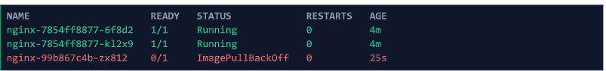
Rollout health audit timeout check:
kubectl rollout status deployment/nginx -n poc --timeout=60s
7. Automated Rollback Engine Implementation
Script Name: auto-rollback.sh
This self-healing automation script encapsulates the deployment, health check timeout, error interception, and automatic recovery routine.
#!/bin/bash
# ==================================================================
# Production Automated Rollback Script for Kubernetes on AWS EKS
# ==================================================================
set -e

NAMESPACE="poc"
DEPLOYMENT="nginx"
TIMEOUT="60s"

echo "[INFO] Initiating deployment for $DEPLOYMENT in namespace $NAMESPACE..."
kubectl apply -f nginx-v2.yaml -n $NAMESPACE

echo "[INFO] Monitoring rollout status (Threshold: $TIMEOUT)..."
if kubectl rollout status deployment/$DEPLOYMENT -n $NAMESPACE --timeout=$TIMEOUT; then
echo "[SUCCESS] Deployment rollout completed successfully."
exit 0
else
echo "[ERROR] Deployment failed to stabilize within $TIMEOUT!"
echo "[ACTION] Executing automated emergency rollback..."
kubectl rollout undo deployment/$DEPLOYMENT -n $NAMESPACE
echo "[SUCCESS] Rollback executed. Restoring previous stable release."
fi

Script execution command:
chmod +x auto-rollback.sh
./auto-rollback.sh

Output from auto-rollback.sh: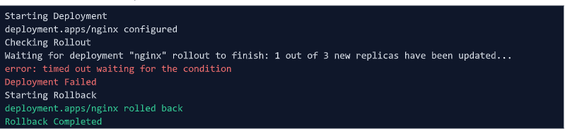
8. Verification & Restoration Audit
Following automated rollback execution, verify that the cluster has safely converged back to the stable baseline:
# 1. Verify all 3 pods are back to 1/1 Running state
kubectl get pods -n poc
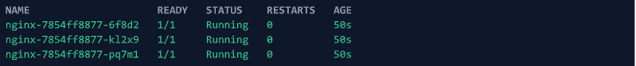
# 2. Confirm restored image is nginx:1.27
kubectl get deployment nginx -n poc -o=jsonpath='{.spec.template.spec.containers[0].image}'
# 3. Review deployment revision history
kubectl rollout history deployment/nginx -n poc
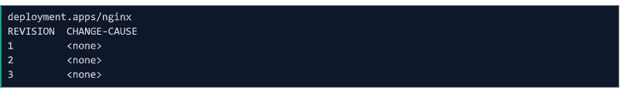

Figure: Terminal showing restored pods, active image 'nginx:1.27', and rollout revision history
9. Validation Summary & Key Takeaways
Validation Item | Status | Observed Behavior
EKS Worker Node Cluster | Ready | 3/3 EC2 nodes active and healthy
Target Namespace Isolation | Passed | Namespace 'poc' established
Stable Deployment Baseline (v1) | Passed | 3/3 pods active on nginx:1.27
Failure Injection Simulation (v2) | Passed | Triggered ImagePullBackOff on v2
Health Check & Rollout Monitor | Passed | Timeout intercepted at 60s
Automated Rollback Trigger | Passed | Autonomous 'rollout undo' executed
Workload Restoration Verification | Passed | Reverted cleanly to nginx:1.27
Service Availability (Zero Downtime) | Passed | Healthy pods maintained throughout

Summary of Business & Technical Results
- Zero Service Outage: The RollingUpdate strategy maintained existing healthy pods during failure, guaranteeing uninterrupted user availability.
- Rapid MTTR: Failure detection and recovery executed within 60 seconds, substantially outperforming manual intervention.
- Native Architecture: Fully leverages Kubernetes built-in ReplicaSet revision history and rollout primitives without requiring external heavy tooling.

