TECHNICAL PROOF OF CONCEPT REPORT
Automated Kubernetes Cluster Provisioning
Using Terraform & Amazon EKS

Target Region | Orchestration | Kubernetes Version | Validation Status
AWS ap-south-1 (Mumbai) | Terraform IaC | Amazon EKS v1.30 | 100% Validated & Tested

1. Project Overview
This Proof of Concept (POC) validates end-to-end automated Kubernetes cluster provisioning using Infrastructure as Code (IaC) with Terraform. The primary objective is to replace repetitive, drift-prone manual console workflows with a robust, version-controlled automation pipeline capable of spinning up enterprise-grade Kubernetes platforms on demand.
The complete automation lifecycle encompasses:
- Control Plane: Automated deployment and lifecycle management of Amazon EKS control plane.
- IAM & Security: Least-privilege IAM roles and cluster creator administrator permissions.
- Networking: Integration into multi-Availability Zone VPC topology and subnet routing.
- Worker Nodes: Self-bootstrapping, managed EC2 worker nodes using containerd runtime.
- Workload Delivery: Sample NGINX microservice deployed and exposed via AWS LoadBalancer.
- Scalability: Horizontal workload scaling and zero-downtime traffic validation.

2. Objectives & Business Context
Modern DevOps requirements demand rapid, reproducible, and compliant infrastructure. Traditional provisioning models introduce friction that impacts developer agility.

Traditional Challenges vs. IaC Solution
Operational Dimension | Traditional Manual Approach | Automated Terraform IaC
Provisioning Workflow | Manual AWS Console clicks; high cognitive load | Declarative code executed via single pipeline
Delivery Velocity | Hours or days dependent on platform engineering | Fully provisioned in minutes on demand
Configuration Consistency | Prone to human error, missed rules, and drift | Idempotent, repeatable, and version-controlled
Security & Compliance | Inconsistent inbound rules and access policies | Strict baseline security groups and IAM policies
Auditability & Rollback | Difficult to trace changes across environments | Full Git revision history and state tracking

3. Target AWS Environment Specifications
The POC was executed against dedicated AWS infrastructure within the Mumbai region:
Parameter | Configured Value | Operational Purpose
AWS Region | ap-south-1 | Asia Pacific (Mumbai) primary region
Automation Host | Ubuntu EC2 (t2.xlarge) | Instance ID: i-06167c53fb2623deb
Target VPC | vpc-0a15fa78fb8b199f6 | Pre-existing isolated VPC network
Subnet 1 (AZ-1) | subnet-01ff324c046abd0a6 | Public Subnet - Cluster & Workload Placement (ap-south-1b)
Subnet 2 (AZ-2) | subnet-00d252d42e6758655 | Public Subnet - Multi-AZ High Availability (ap-south-1a)
IAM Cluster Role | Prasad-Cluster | Control Plane Service Role
Cluster Identifier | poc-eks | EKS Cluster Name
Kubernetes Version | 1.30 | Target control plane & worker engine

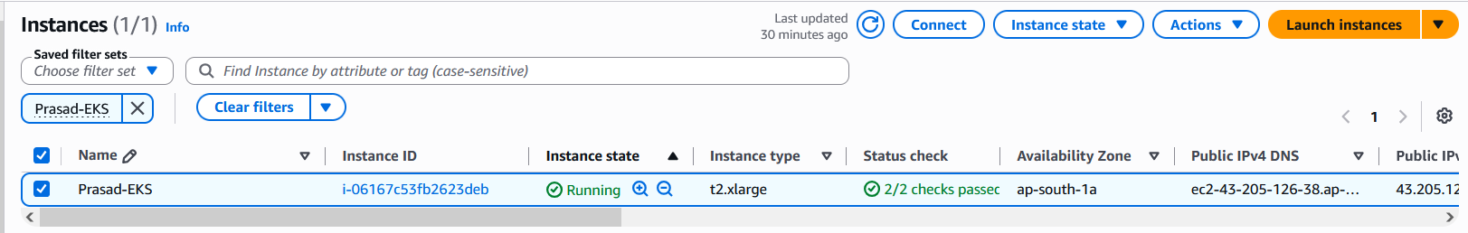
Screenshot: AWS Management Console: Automation Server (Prasad-EKS / i-06167c53fb2623deb) running on t2.xlarge in ap-south-1a with 2/2 status checks passed.

4. High-Level Solution Architecture
The diagram below represents the logical provisioning flow, networking separation, and ingress traffic path implemented during the project:
+-------------------------------------------------------------------------+
| Developer / CI-CD Automation Server |
| Ubuntu EC2 (t2.xlarge) |
+-------------------------------------------------------------------------+
|
[terraform apply]
v
+-------------------------------------------------------------------------+
| AWS REGION: ap-south-1 |
| +-------------------------------------------------------------------+ |
| | Amazon EKS Control Plane (poc-eks) | |
| | Kubernetes API Server (Version 1.30) | |
| +-------------------------------------------------------------------+ |
| | |
| v |
| +-------------------------------------------------------------------+ |
| | Managed Node Group (Auto Scaling Group 2 to 5) | |
| | +-----------------------------+ +-----------------------------+ | |
| | | EC2 Worker 1: 10.0.1.112 | | EC2 Worker 2: 10.0.8.217 | | |
| | | (t3.medium, containerd) | | (t3.medium, containerd) | | |
| | | - Pod: NGINX Replica 1 | | - Pod: NGINX Replica 2 | | |
| | | - Pod: NGINX Replica 3 | | - Pod: NGINX Replica 4 | | |
| | | - Pod: NGINX Replica 5 | | - Pod: Load Generator | | |
| | +-----------------------------+ +-----------------------------+ | |
| +-------------------------------------------------------------------+ |
+------------------------------------|------------------------------------+
|
v
+-------------------------------------------------------------------------+
| AWS Elastic Load Balancer |
| Endpoint: a203a428382204f71b4e1f84427062fa-598546995... |
+-------------------------------------------------------------------------+
^
|
Public Users

5. Prerequisites & Directory Structure
Pre-flight checks verified the environment readiness before deploying the Terraform stack:
# 1. Verify Installed Tooling
terraform version
aws --version
kubectl version --client
# 2. Verify Active AWS Authentication
aws configure
aws sts get-caller-identity

The project was structured modularly for maintainability and separation of concerns:
terraform-eks-poc/
├── provider.tf # AWS provider definition
├── variables.tf # Input variable declarations
├── terraform.tfvars # Environment-specific configuration values
├── eks.tf # Official AWS EKS module & node group config
└── outputs.tf # Cluster endpoints and generated outputs

6. Terraform Infrastructure Code
This section contains the complete declarative Terraform code used to provision the entire EKS cluster foundation.

6.1 Provider Configuration (provider.tf)
provider "aws" {
region = var.region
}

6.2 Variable Declarations (variables.tf)
variable "region" {
description = "AWS Target Region"
type = string
}
variable "cluster_name" {
description = "EKS Cluster Name"
type = string
}
variable "cluster_version" {
description = "EKS Kubernetes Version"
type = string
}
variable "vpc_id" {
description = "Existing VPC ID"
type = string
}
variable "public_subnets" {
description = "Existing Public Subnet IDs"
type = list(string)
}

6.3 Environment Configuration Values (terraform.tfvars)
region = "ap-south-1"
cluster_name = "poc-eks"
cluster_version = "1.30"
vpc_id = "vpc-0a15fa78fb8b199f6"
public_subnets = [
"subnet-01ff324c046abd0a6",
"subnet-00d252d42e6758655"
]

6.4 EKS Module Configuration (eks.tf)
module "eks" {
source = "terraform-aws-modules/eks/aws"
version = "~> 20.37"
cluster_name = var.cluster_name
cluster_version = var.cluster_version
vpc_id = var.vpc_id
subnet_ids = var.public_subnets
enable_cluster_creator_admin_permissions = true
cluster_endpoint_public_access = true
cluster_endpoint_private_access = true
cluster_security_group_additional_rules = {
vpc_https_access = {
description = "Allow VPC access to Kubernetes API"
protocol = "tcp"
from_port = 443
to_port = 443
type = "ingress"
cidr_blocks = [
"10.0.0.0/16"
]
}
}
eks_managed_node_groups = {
workers = {
desired_size = 2
min_size = 2
max_size = 5
instance_types = ["t3.medium"]
capacity_type = "ON_DEMAND"
}
}
tags = {
Environment = "POC"
Project = "Terraform-EKS"
}
}

6.5 Output Declarations (outputs.tf)
output "cluster_endpoint" {
description = "Endpoint for EKS control plane"
value = module.eks.cluster_endpoint
}
output "cluster_security_group_id" {
description = "Security group IDs attached to the cluster control plane"
value = module.eks.cluster_security_group_id
}
output "cluster_name" {
description = "Kubernetes Cluster Name"
value = module.eks.cluster_name
}

7. Deployment Execution & Validation
The complete end-to-end execution lifecycle was performed in five distinct operational steps:

7.1: Terraform Execution
Execute the standard Terraform workflow to plan and create the cluster:
# Initialize Terraform plugins
terraform init
# Validate configuration syntax
terraform validate
# Plan changes
terraform plan
# Apply changes automatically
terraform apply --auto-approve

7.2: Control Plane Verification
Query the AWS EKS API to confirm that the cluster control plane is ACTIVE:
aws eks describe-cluster --name poc-eks --region ap-south-1 --query "cluster.status"
# Output Result: "ACTIVE"

7.3: Kubeconfig Setup & Worker Node Health
Configure kubectl context and verify worker node registration:
aws eks update-kubeconfig --region ap-south-1 --name poc-eks
kubectl get nodes -o wide

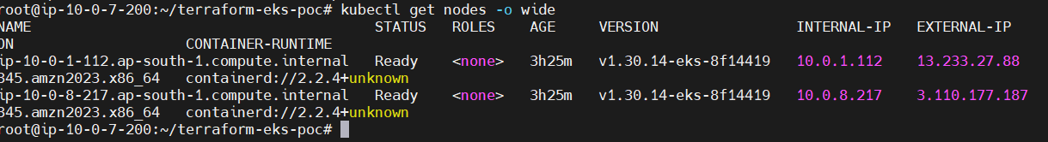
Screenshot: Worker Node Verification: kubectl get nodes -o wide confirms two worker nodes in 'Ready' state running Kubernetes v1.30.14 with containerd runtime.

7.4: Application Deployment & LoadBalancer Exposure
Deploy an NGINX sample workload and expose it externally via an AWS Elastic Load Balancer:
# Deploy NGINX web workload
kubectl create deployment nginx --image=nginx
# Expose workload via an AWS Elastic Load Balancer
kubectl expose deployment nginx --type=LoadBalancer --port=80
# Retrieve Load Balancer endpoint details
kubectl get svc nginx
# Test endpoint connectivity via curl
curl http://a203a428382204f71b4e1f84427062fa-598546995.ap-south-1.elb.amazonaws.com

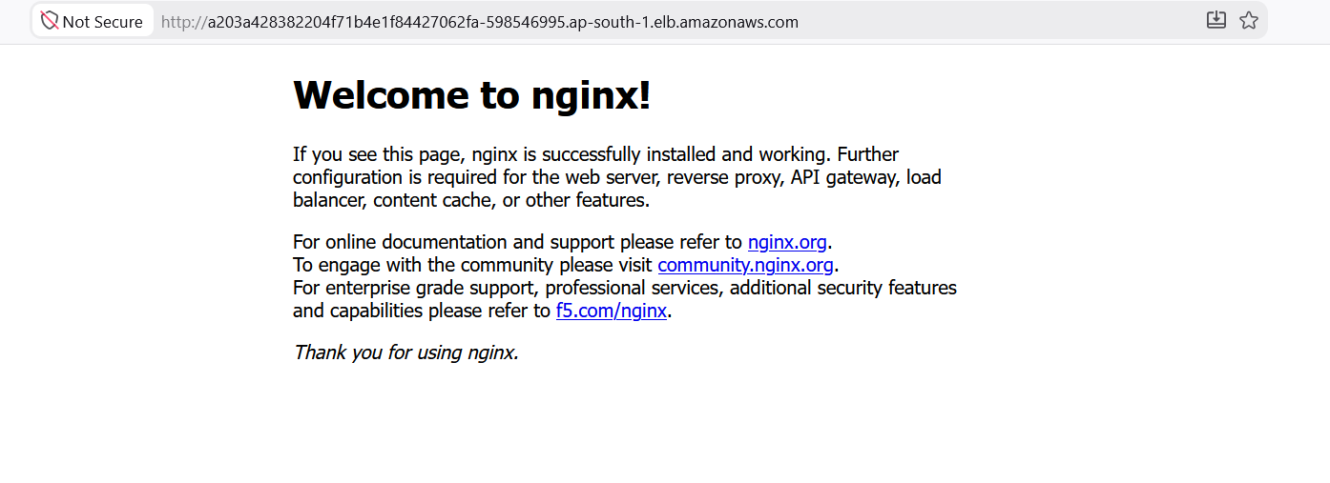
Screenshot: Application Validation: Web browser accessing http://a203a428382204f71b4e1f84427062fa-598546995.ap-south-1.elb.amazonaws.com displaying 'Welcome to nginx!'.

7.5: Scalability & Replicas Testing
Validate horizontal workload autoscaling by scaling replicas from 1 to 5 and generating traffic:
# Scale deployment to 5 replicas
kubectl scale deployment nginx --replicas=5
# Inspect active pods across worker nodes
kubectl get pods -o wide

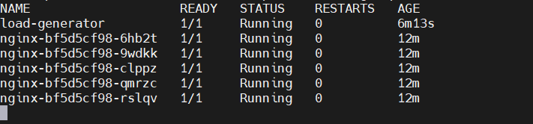
Screenshot: Scalability Testing: kubectl get pods confirming all 5 NGINX pod replicas running stably alongside load-generator across worker nodes.

8. Issues Encountered & Engineering Resolutions
During deployment, three critical operational issues were identified and successfully remediated:
Observed Issue | Root Cause Analysis | Remediation Applied
Terraform Duplicate Module | Node group definition was declared simultaneously in eks.tf and an obsolete nodegroup.tf file. | Removed obsolete definition file: rm nodegroup.tf
AWS Authentication Error (InvalidClientTokenId) | AWS CLI temporary session tokens on automation EC2 host expired. | Executed aws configure and refreshed current AWS IAM credentials.
kubectl API Timeout (dial tcp 10.0.1.75:443 timeout) | EKS cluster security group lacked ingress permission for traffic originating inside VPC CIDR. | Added inbound rule in eks.tf: Protocol TCP 443 from CIDR 10.0.0.0/16.

9. Validation Summary & Key Results
Validation Scope | Status | Technical Verification Criteria
Terraform Execution | Completed (Pass) | Zero errors during init, validate, plan, apply.
Amazon EKS Cluster | Created (Active) | API server responding on Kubernetes v1.30.
Worker Node Registration | Ready (Pass) | Both t3.medium nodes registered with containerd.
Cluster Management (kubectl) | Operational (Pass) | Full administrative control established.
Workload Deployment | Deployed (Pass) | NGINX pods running stably across nodes.
AWS Load Balancer | Routing Traffic (Pass) | External traffic served with HTTP 200 OK.
Horizontal Auto-Scaling | Validated (Pass) | Workload scaled from 1 to 5 pods smoothly.

Operational & Technical Benefits
- Delivery Velocity: Provisioning lead times reduced from hours of manual configuration to minutes.
- Repeatability: Zero configuration drift across environments using declarative Terraform definitions.
- Resilience & Scale: AWS-managed control plane and automated worker groups provide built-in high availability.
- Standardized Security: Security groups and IAM permissions are codified, auditable, and adhere to least privilege.

