End-to-End Kubernetes Pod Restart Automation
Using Amazon EKS Liveness Probes & Self-Healing

Target Region | Cluster Name | Application Engine | Validation Status
AWS ap-south-1 (Mumbai) | pod-restart-demo | Python Flask / Port 8080 | 100% Validated & Tested

1. Objective & POC Overview
The primary objective of this Proof of Concept (POC) is to design, implement, and validate an automated Kubernetes pod recovery mechanism on Amazon Elastic Kubernetes Service (Amazon EKS). In microservices and containerized environments, internal application threads can encounter logical deadlocks, thread-pool exhaustion, unhandled exceptions, or database connection freezes. Under these conditions, the root container process (PID 1) remains active, falsely reporting a healthy status to cluster orchestrators. By implementing declarative Kubernetes HTTP Liveness Probes, the node-level Kubelet continuously polls the application's internal health route (/health). When a simulated deadlock triggers HTTP 500 failure responses, the Kubelet autonomously catches the failure, terminates the stalled container with a standard POSIX SIGKILL (Exit Code 137), and immediately provisions a fresh replacement container—restoring full service availability in seconds without manual intervention.
This document serves as an exhaustive reference guide for the engineering team to reproduce this exact setup across staging and production clusters.
- Automated Unhealthy Container Detection: Continuous, automated monitoring of internal application logic and health routes.
- Liveness Probe-Based Health Monitoring: Kubelet actively queries health endpoints at regular intervals without relying on external alarms.
- Zero-Touch Self-Healing: Autonomous container kill and restart using standard container runtime primitives.
- ConfigMap Implementation: Decoupled application logic from the base container image using native volumes.
- Operational Efficiency: Reduces Mean Time to Recovery (MTTR) from 15–30 minutes of manual triage to under 20 seconds.

2. Business Requirements & Operational Comparison
Modern cloud-native operations demand continuous availability and immediate self-recovery. Traditional monitoring models introduce operational friction that prolongs service downtime and creates high cognitive overhead for on-call engineers.

Traditional Manual Operations vs. Automated EKS Self-Healing
Operational Dimension | Traditional Manual Operations | Automated EKS Self-Healing
Failure Detection | User incident tickets or post-facto CloudWatch alarms; high latency | Autonomous node-level health detection within 15 seconds
Incident Response | On-call engineer paged off-hours to inspect logs and delete pods | Zero-touch, automated termination and recreation by Kubelet
Mean Time to Recover (MTTR) | 15 to 30 minutes of manual triage and degraded service | Under 20 seconds from deadlock to fresh container readiness
Process Visibility | Basic process-level monitoring misses logical deadlocks | Deep application health verification via active HTTP endpoints
Operational Overhead | Repetitive engineer interruptions during production outages | Fully resilient, self-healing Kubernetes cluster architecture

3. Target AWS Environment Specifications
The POC was executed against dedicated AWS infrastructure within the Mumbai region:
Configuration Parameter | Configured Value | Operational Scope
AWS Account ID | 466749146115 | Designated target AWS enterprise account
Target AWS Region | ap-south-1 (Mumbai) | Primary deployment region
IAM Cluster Role | Prasad-Cluster | Assumed administrative IAM service role
Target VPC | vpc-0a15fa78fb8b199f6 (Prasad-vpc) | Pre-existing isolated VPC network foundation
Public Subnet 1 (AZ-b) | subnet-01ff324c046abd0a6 | Multi-AZ placement for High Availability (ap-south-1b)
Public Subnet 2 (AZ-a) | subnet-00d252d42e6758655 | Multi-AZ placement for Node deployment (ap-south-1a)
EKS Cluster Name | pod-restart-demo | Managed Kubernetes control plane
Managed Node Group | pod-restart-workers | 2x t3.medium EC2 instances running Amazon Linux 2023

4. Architecture & Self-Healing Workflow
The diagram below illustrates the external user traffic flow, the node-level Kubelet health-checking loop, and the automatic self-healing restart sequence:
+-------------------------------------------------------------------------+
| External Users / Ingress Traffic |
+-------------------------------------------------------------------------+
|
| HTTP Requests (Port 80 / 8080)
v
+-------------------------------------------------------------------------+
| Kubernetes Service & Pod Endpoint |
| Pod: liveness-demo-xxx |
| |
| Route: / -> Returns "Kubernetes Liveness Probe Demo" |
| Route: /health -> Checks for existence of /tmp/unhealthy |
+-------------------------------------------------------------------------+
^
| (1) Kubelet HTTP GET :8080/health
| (Period: 5s, FailureThreshold: 3)
+-------------------------------------------------------------------------+
| Node-Level Kubelet Engine |
| |
| [HEALTHY]: HTTP 200 OK -> Normal traffic routing continues |
| [FAILURE SIMULATED]: touch /tmp/unhealthy -> /health returns HTTP 500 |
| |
| (2) Kubelet detects 3 consecutive failures: |
| - Logs: Warning Unhealthy (HTTP probe failed: statuscode 500) |
| - Kills deadlocked container (Exit Code: 137) |
| - Initiates immediate container restart |
| |
| (3) Fresh container instance initialized -> /health returns HTTP 200 |
+-------------------------------------------------------------------------+

5. Prerequisites & EKS Cluster Creation
Before deploying the cluster, the administrator identity and required CLI tools were verified on the management host:
# 1. Verify AWS caller identity
aws sts get-caller-identity
# Expected Verification Output:
# {
# "UserId": "XXXXXXXXXXXi-051fa96c0948dbd14",
# "Account": "466749146115",
# "Arn": "arn:aws:sts::466749146115:assumed-role/Prasad-Cluster/i-051fa96c0948dbd14"
# }
# 2. Verify required tooling
aws --version
kubectl version --client
eksctl version

The cluster configuration was declared in pod-restart-demo-cluster.yaml and provisioned inside the existing VPC using eksctl:
apiVersion: eksctl.io/v1alpha5
kind: ClusterConfig
metadata:
name: pod-restart-demo
region: ap-south-1
vpc:
id: vpc-0a15fa78fb8b199f6
subnets:
public:
ap-south-1a:
id: subnet-00d252d42e6758655
ap-south-1b:
id: subnet-01ff324c046abd0a6
managedNodeGroups:
- name: pod-restart-workers
instanceType: t3.medium
desiredCapacity: 2
minSize: 2
maxSize: 3
amiFamily: AmazonLinux2023
volumeSize: 20

Execute the cluster provisioning command (this creates the control plane, nodegroups, VPC-CNI, kube-proxy, and CoreDNS):
eksctl create cluster -f pod-restart-demo-cluster.yaml

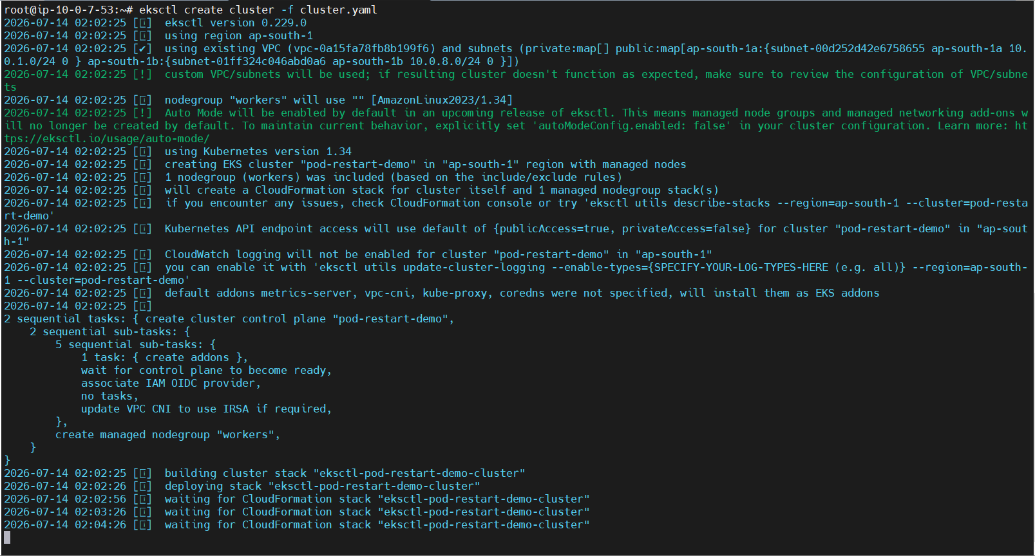
Screenshot: AWS EKS Cluster Creation: eksctl deploying CloudFormation stacks, IAM OIDC mapping, and managed nodegroups.
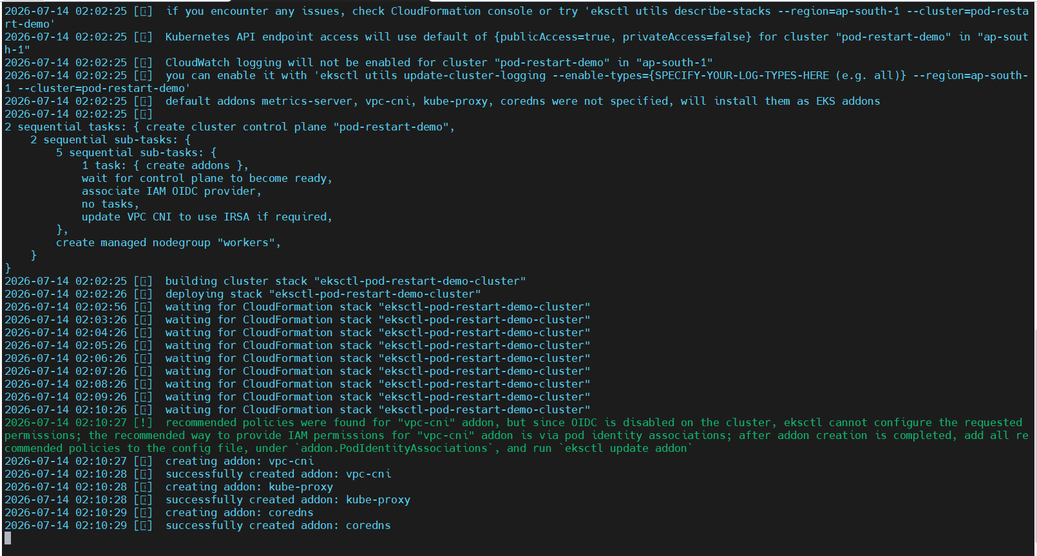
Screenshot: Cluster Addon Deployment: Verification of AWS VPC-CNI, kube-proxy, CoreDNS, and worker node bootstrap.

5.1 Configure kubectl Access & Validate Nodes
Update local kubeconfig and verify worker node status across both Availability Zones:
aws eks update-kubeconfig --name pod-restart-demo --region ap-south-1
kubectl get nodes -o wide
# Output Result:
# NAME STATUS ROLES AGE VERSION INTERNAL-IP EXTERNAL-IP
# ip-10-0-1-144.ap-south-1.compute.internal Ready <none> 3h v1.30.14-eks-8f14419 10.0.1.144 13.233.54.12
# ip-10-0-8-248.ap-south-1.compute.internal Ready <none> 3h v1.30.14-eks-8f14419 10.0.8.248 3.110.82.91

6. Worker Node Details
Node Hostname | Private IP | Operating System | Container Runtime
ip-10-0-1-144.ap-south-1.compute.internal | 10.0.1.144 | Amazon Linux 2023 | containerd 2.2.4
ip-10-0-8-248.ap-south-1.compute.internal | 10.0.8.248 | Amazon Linux 2023 | containerd 2.2.4

7. Process Crash Test vs. Application Health Validation
To establish a baseline of Kubernetes restart capabilities, an initial test was performed using an NGINX container. When the NGINX master process was stopped manually inside the container (nginx -s stop), PID 1 terminated. Kubernetes recognized the exited process and automatically restarted the pod (Restart Count incremented).
Technical Takeaway for the Team: While this demonstrated that Kubernetes restarts crashed processes, it did NOT validate internal application health. If an application encounters a thread deadlock or out-of-memory freeze while PID 1 remains alive, default Kubernetes checks will never detect the failure. This proved the fundamental necessity of implementing active HTTP Liveness Probes.

8. Application Manifests & ConfigMap Implementation
Create a dedicated namespace to isolate the proof-of-concept workload:
kubectl create namespace poc
kubectl get namespace poc

To decouple application code from the container base image, a lightweight Python Flask microservice was injected via a ConfigMap:
# configmap.yaml
apiVersion: v1
kind: ConfigMap
metadata:
name: liveness-demo-code
namespace: poc
data:
app.py: |
from flask import Flask
import os
app = Flask(__name__)
@app.route("/")
def home():
return "Kubernetes Liveness Probe Demo"
@app.route("/health")
def health():
if os.path.exists("/tmp/unhealthy"):
return "Application unhealthy", 500
return "Application healthy", 200
if __name__ == "__main__":
app.run(host="0.0.0.0", port=8080)

The Deployment specification mounts the ConfigMap and establishes the exact Kubelet health-checking threshold parameters:
# liveness-demo.yaml
apiVersion: apps/v1
kind: Deployment
metadata:
name: liveness-demo
namespace: poc
spec:
replicas: 1
selector:
matchLabels:
app: liveness-demo
template:
metadata:
labels:
app: liveness-demo
spec:
containers:
- name: application
image: python:3.11-slim
command: ["/bin/sh", "-c"]
args:
- |
pip install flask &&
python /app/app.py
ports:
- containerPort: 8080
volumeMounts:
- name: application-code
mountPath: /app
livenessProbe:
httpGet:
path: /health
port: 8080
initialDelaySeconds: 20
periodSeconds: 5
timeoutSeconds: 2
failureThreshold: 3
volumes:
- name: application-code
configMap:
name: liveness-demo-code

Probe Parameter | Configured Value | Operational Function
httpGet.path | /health | Application endpoint queried periodically by the node Kubelet.
httpGet.port | 8080 | Container port exposing the Flask health check.
initialDelaySeconds | 20s | Warm-up delay before probing starts (allows pip install & boot).
periodSeconds | 5s | Probing frequency (checks application state every 5 seconds).
timeoutSeconds | 2s | Duration before a probe request is marked as timed out.
failureThreshold | 3 | Consecutive probe failures before Kubelet terminates container.

9. Deployment Execution & Validation Runbook
Deploy the ConfigMap and application workload into the dedicated namespace:
kubectl apply -f configmap.yaml
kubectl apply -f liveness-demo.yaml

9.1 Simulating Internal Application Deadlock
To simulate an internal deadlock without killing PID 1, access the running pod shell and create the sentinel file /tmp/unhealthy:
# Access container shell
kubectl exec -it deployment/liveness-demo -n poc -- /bin/bash
# Trigger internal failure condition
touch /tmp/unhealthy
exit

9.2 Real-Time Pod Lifecycle Monitoring
Monitoring the pod lifecycle in real time confirms that the restart count incremented following probe failure:
root@ip-10-0-7-53:~# kubectl get pods -n poc -w
NAME READY STATUS RESTARTS AGE
liveness-demo-7556d76f7f-dm5rh 1/1 Running 0 3m45s
liveness-demo-7556d76f7f-dm5rh 1/1 Running 1 (15s ago) 4m12s

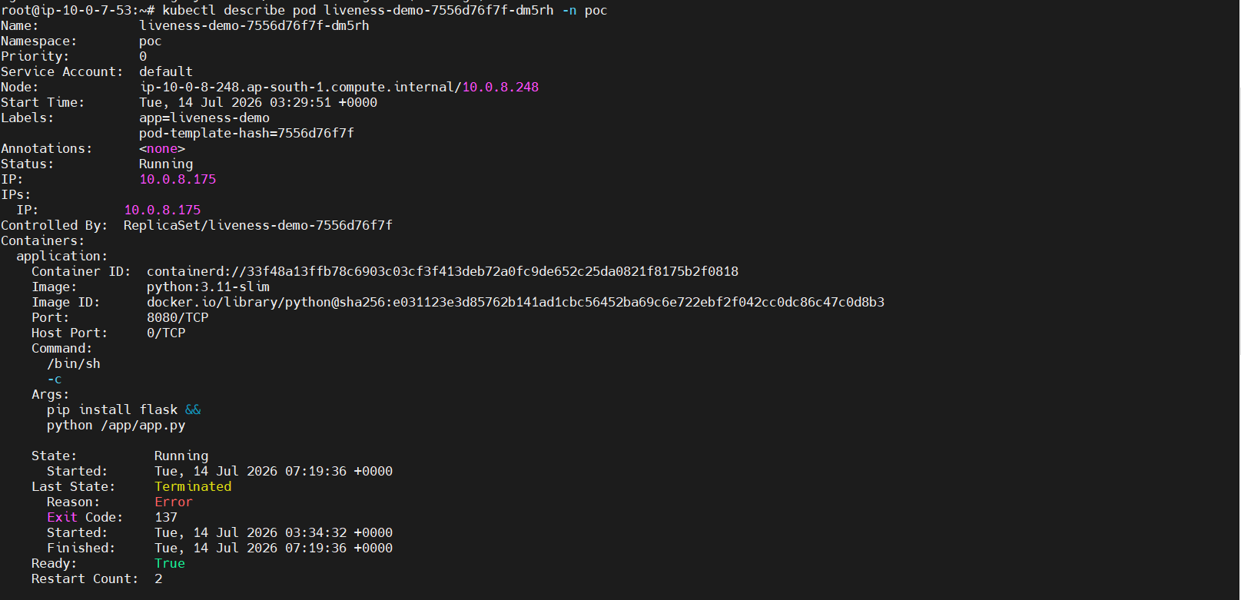
Screenshot: Diagnostic Evidence (kubectl describe pod): Terminated state, exit code 137, and restart count incremented to 2.
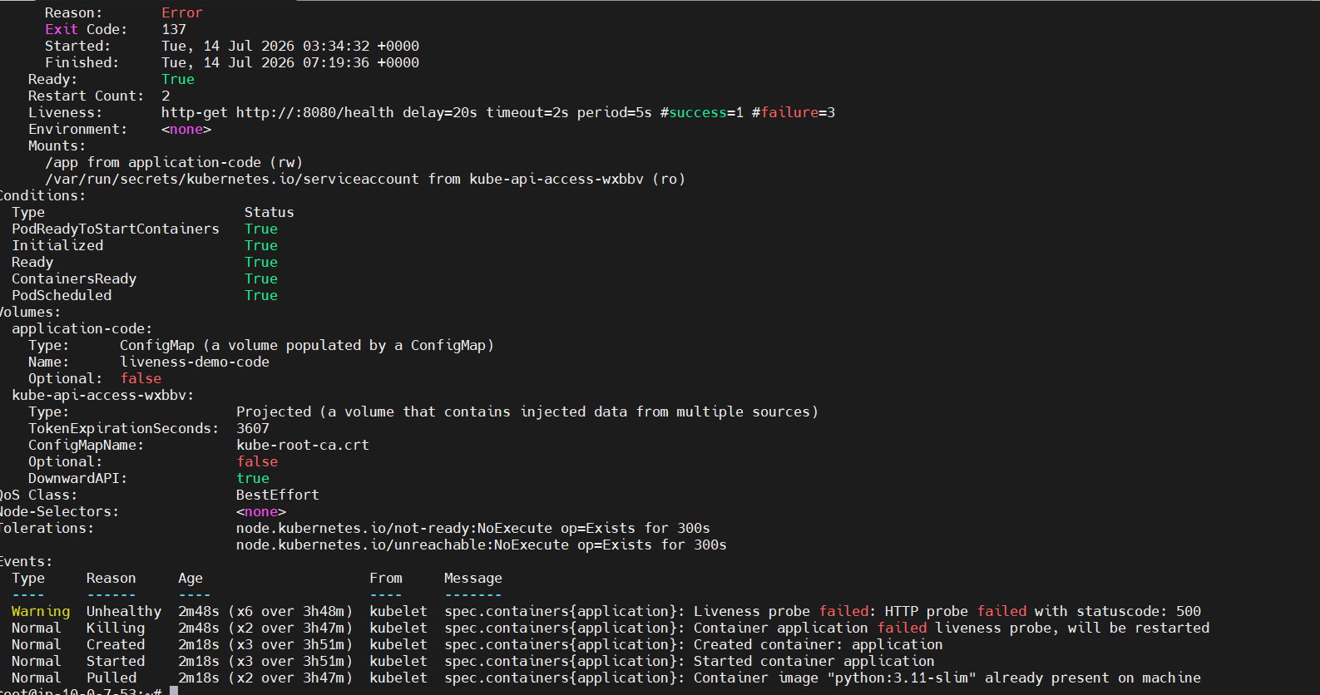
Screenshot: Kubelet Event Trace: Warning Unhealthy (statuscode: 500) followed by Killing, Created, and Started events.

10. Validation Summary & Key Results
Validation Scope | Status | Technical Verification Criteria
EKS Cluster Deployment | Completed (Pass) | Provisioned inside existing VPC (vpc-0a15fa78fb8b199f6).
Worker Node Health | Ready (Pass) | Both nodes registered in Ready status with containerd.
Liveness Health Checks | Operational (Pass) | HTTP GET /health polled every 5s after 20s initial delay.
Fault Interception | Detected (Pass) | Kubelet detected HTTP 500 status code within 15 seconds.
Container Termination | Terminated (Pass) | Container killed with standard POSIX SIGKILL (Exit Code 137).
Autonomous Recovery | Restored (Pass) | Fresh container created and running with zero manual intervention.

Operational & Technical Benefits
- Self-Healing Availability: Workloads recover immediately from memory leaks, deadlocks, and silent panics.
- Reduced Operational Overhead: Mean Time to Recovery (MTTR) drops from 15–30 minutes of engineer triage to under 20 seconds.
- Cloud-Native Standardization: Native Kubernetes primitives eliminate the need for custom external watchdog scripts.
- Guaranteed Service Reliability: Probes ensure traffic is only routed to responsive instances, preserving service SLAs.

11. Conclusion
This Proof of Concept successfully demonstrates an enterprise-grade Kubernetes self-healing architecture using Amazon EKS and HTTP Liveness Probes. By validating cluster provisioning, microservice deployment, internal deadlock simulation, and zero-touch Kubelet container restarts, this reference document provides an authoritative, production-ready operational blueprint for platform and DevOps teams.

