Differentiate between OSI Model and TCP/IP model.

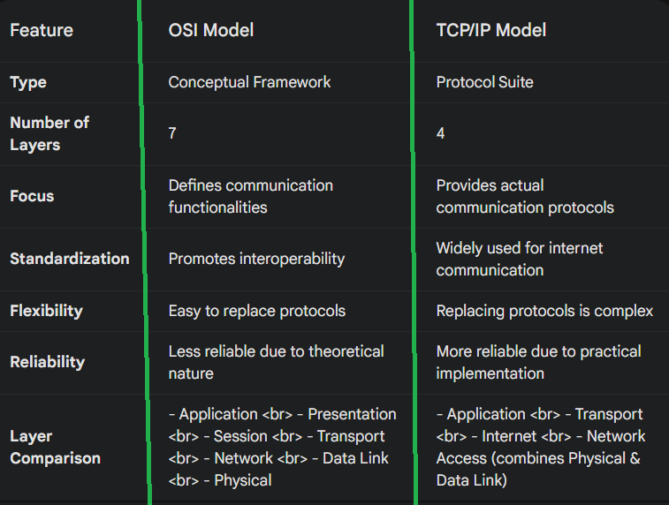

Differentiate between Client Server and Peer to peer Network.

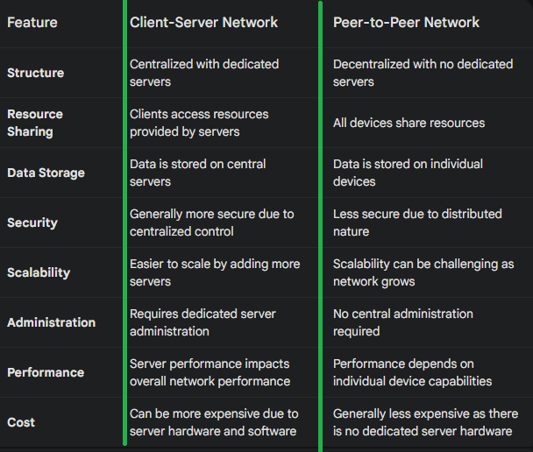

What are the seven layers of OSI Model. What are the functions of each layer?

What are the principles behind each layer?

The OSI Model (Open Systems Interconnection) is a conceptual framework that divides network communication into seven distinct layers. Each layer performs specific functions and interacts with the layers above and below it. This layered approach promotes interoperability between different network devices and software.

Here's a breakdown of each layer, its functions, and the principles behind its design:

1. Physical Layer:

Functions:

Transmits raw data bits across the physical medium (cables, Wi-Fi).

Defines physical characteristics like voltage, connectors, and signal types.

Principles:

Defines the electrical or optical specifications for transmitting data.

Standardizes physical connections to ensure compatibility between devices.

2. Data Link Layer:

Functions:

Packages data into frames with error detection (checksums).

Provides physical addressing for devices on the same network segment.

Controls data flow to avoid collisions (carrier sense multiple access).

Principles:

Ensures reliable and error-free transmission of data frames over a physical link.

Provides data link addressing for local network communication.

3. Network Layer:

Functions:

Routes packets based on network addresses (logical addresses).

Provides internetworking capabilities to connect different networks.

Decides the best path for data packets to reach their destination.

Principles:

Enables communication between devices on different networks.

Provides logical addressing for routing data packets across networks.

4. Transport Layer:

Functions:

Segments data from upper layers into manageable packets for reliable delivery.

Provides flow control to ensure the receiving device can handle the data rate.

Establishes connections between applications on different devices (TCP/UDP).

Principles:

Provides reliable and ordered delivery of data between applications.

Offers mechanisms for congestion control and error correction.

5. Session Layer:

Functions:

Establishes, manages, and terminates sessions between applications.

Provides mechanisms for data exchange and synchronization between applications.

Handles issues like session termination and recovery.

Principles:

Establishes, manages, and terminates communication sessions between applications.

Provides control mechanisms for data exchange and synchronization.

6. Presentation Layer:

Functions:

Formats and encrypts data for the application layer.

Handles data compression and decompression.

Ensures data is presented in a format understood by both applications.

Principles:

Provides a common format for data exchange between applications on different systems.

Ensures data integrity and confidentiality through encryption and decryption.

7. Application Layer:

Functions:

Provides network services directly to user applications (web browsing, email, file transfer).

Defines application-specific protocols and data formats.

Interacts with the user through interfaces like web browsers or email clients.

Principles:

Provides network services directly to user applications.

Defines application-specific protocols for data exchange and communication.

Overall Principles of the OSI Model:

Modularization: Each layer performs a specific function, promoting modularity and easier troubleshooting.

Standardization: The model defines standards for communication at each layer, facilitating interoperability.

Abstraction: Each layer provides an abstraction of the underlying layer, hiding the complexity from the upper layer.

Encapsulation: Data is passed down the layers with additional information added at each layer.

By understanding the OSI model, you gain a deeper understanding of how network communication works and how different components interact to facilitate data exchange across networks.