Django/Python 3.6

# Objective

To setup the back-end environment for SecurePortals. We will be doing all of our work through GitHub and the Terminal.

# Overview

* Setup GitHub
* Fork SecurePortals repository
* Follow instructions on GitHub

# Step-by-Step

If you already have a GitHub account, skip to step 3.

If you already have GitHub installed on your computer, skip to step 7 (after grabbing the link from step 3)

1. Go to <https://github.com/> and go through Sign up
2. Unlimited Public Repositories in Step 2 is fine for our purposes
3. Navigate to <https://github.com/SecurePortals>
4. Enter ‘setup’ repository
5. Open up Terminal
6. Install GitHub: <https://gist.github.com/derhuerst/1b15ff4652a867391f03#file-mac-md>
7. Type the code “git init” from the Terminal
8. Click on ‘Clone or download’, and then click on the little clipboard to copy the link

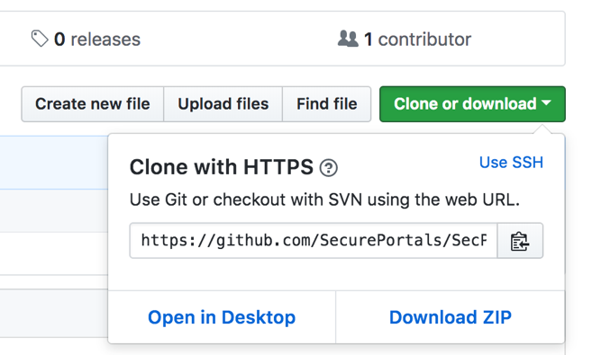

1. Go back to Terminal and enter ‘git clone <link>’ (instead of actually typing <link>, paste the address of the repository that we just copied)
2. Look in finder and in your home directory you should see a folder with the same name as the repository

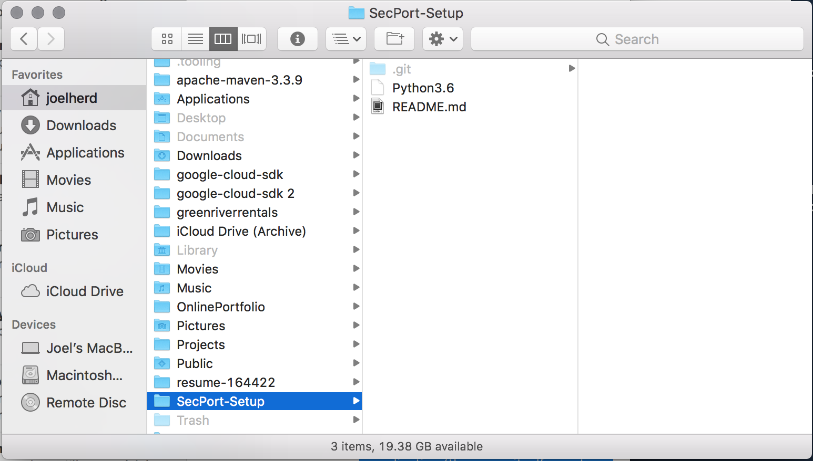

1. Done! Now follow the steps on <https://github.com/SecurePortals/SecPort-Setup> for the rest of the setup process