Table of Contents
Provisioning Google 2
Create Storage Bucket 2
Configuring the Agent 3
Azure Configuration 6
Setup Storage Account 6
Installing the Runbook 7
Admin Configuration & Reporting 10

Prerequisites
In order to make use of this cmdlet the firewall on the Azure SQL Server will need to be configured to "Allow Azure services and resources to access this server". If this is not configured then GatewayTimeout errors will be experienced.

Provisioning Google
If you don't already have a Google cloud account for your organization begin at https://console.cloud.google.com/

After entering your billing information etc:

Create Storage Bucket

Create a storage bucket in cloud storage:
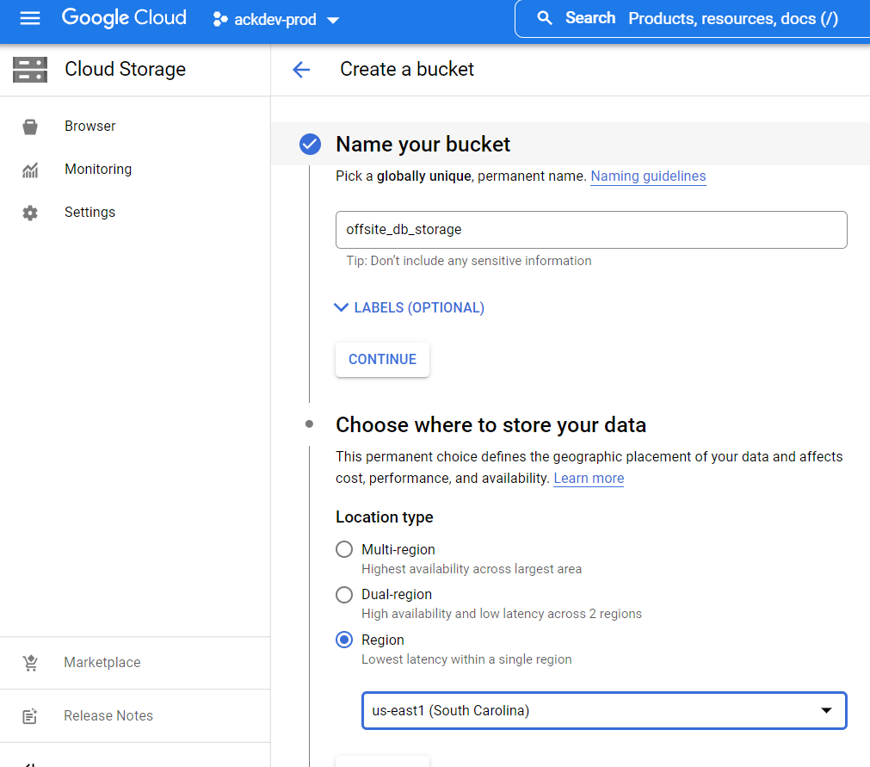
Be sure to pick a region away from your current storage location. For example if your main database is on the west coast, choose the east coast for your offsite backup location.

Choose coldline storage for lower costs while maintaining availability:
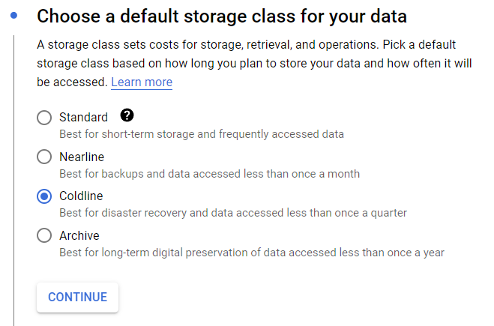

Configuring the Agent
Create a VM instance using Debian, again choose a location away from your databases in Azure:
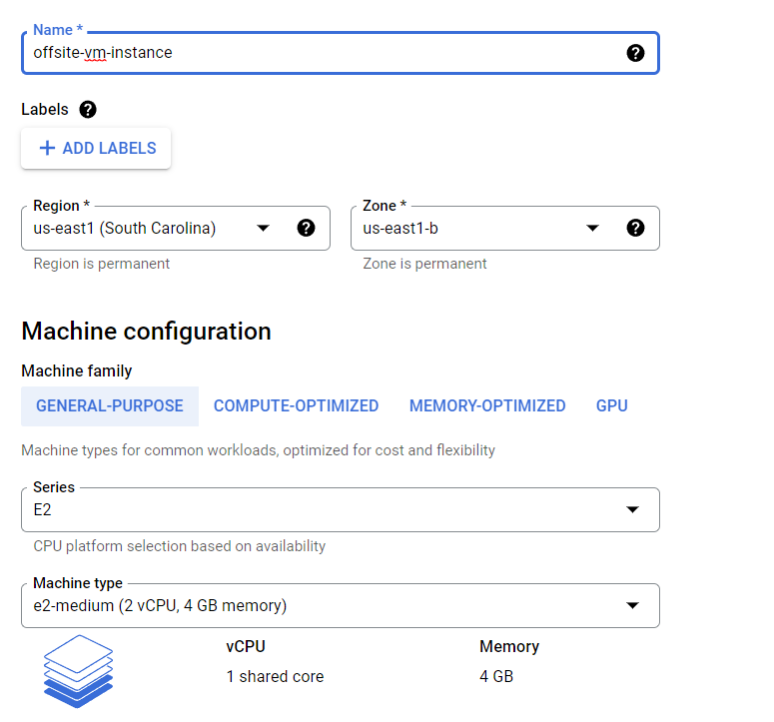
Start your new VM instance and SSH into it via the SSH button to the right on the instance:
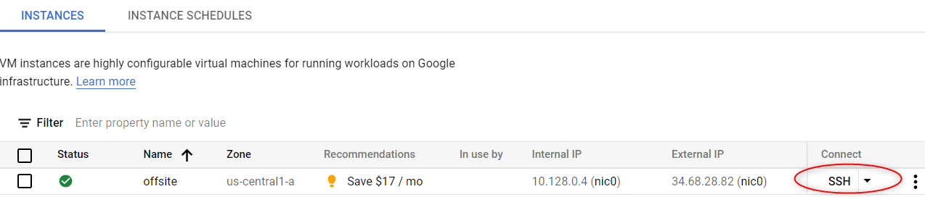
Install GCSFuse which mounts your storage account as a local directory.
Copy and paste the following commands:

sudo apt-get update -y
sudo apt-get install gcsfuse -y
mkdir /mnt/gcsfuse
gcsfuse {name of your storage bucket} /mnt/gcsfuse/
ex.
gcsfuse offsite_db_storage /mnt/gcsfuse/
Install Docker: https://docs.docker.com/engine/install/debian/
Install SecuritasMachina docker image
TODO

Run docker image
Several environmental variables are needed:
connectionString (Use your Azure Storage Access Keys ConnectionString)
topicName (Your customer GUID)
azureBlobEndpoint (Your Azure blob endpoint)
passPhrase (Override if you don't want us to have your encryption pass phrase)

Azure Configuration

Setup Storage Account
Choose LRS for lower costs:
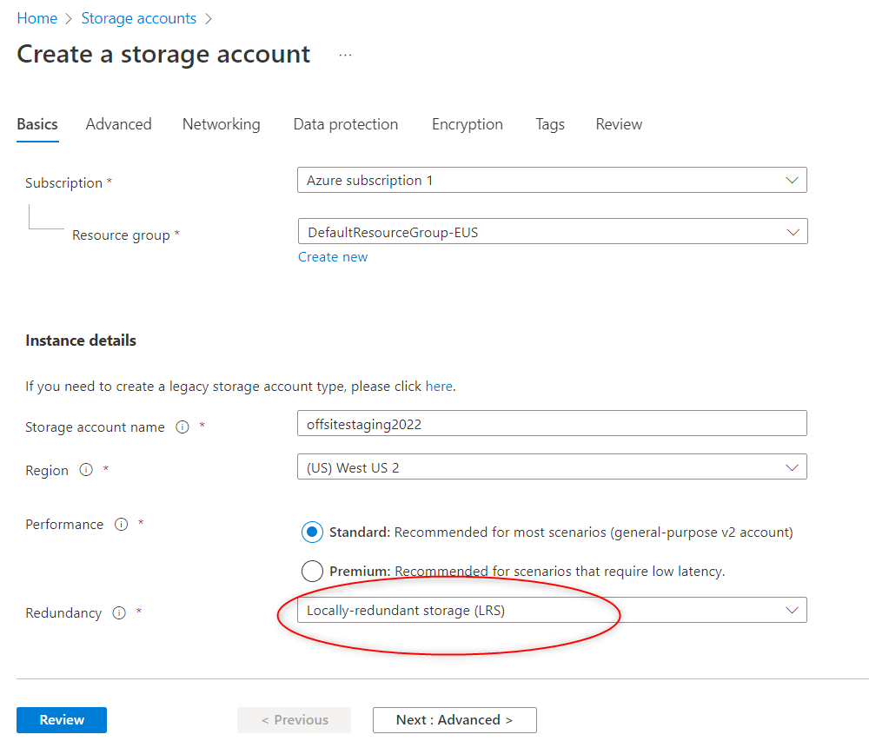
After creation, using the menu on the left, create a container, call it staging or similar.

Installing the Runbook
Create an automation account
Import the following powershell modules:
Az.Accounts
Az.Sql
AzureRM.Profile
AzureRM.Sql
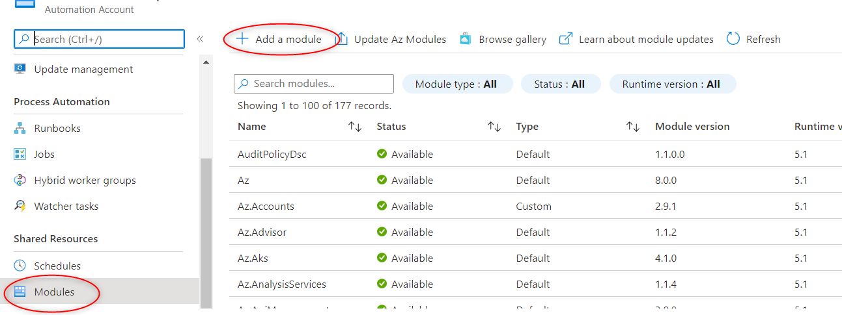
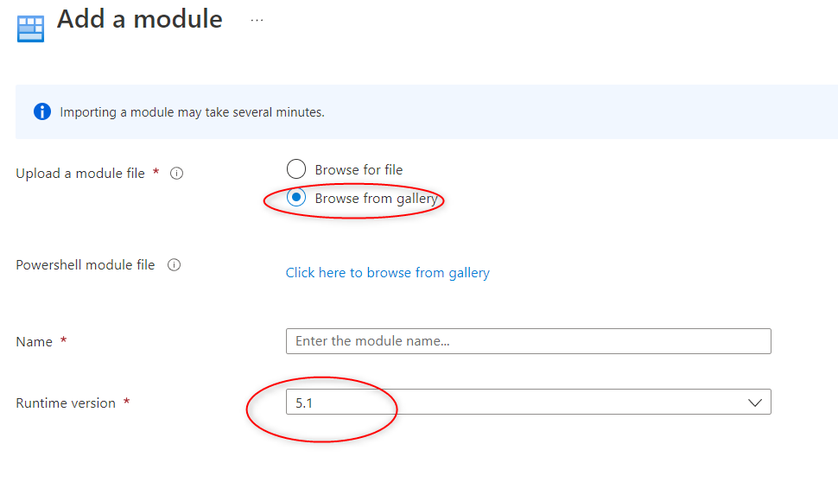

Download the runbook from https://storage.googleapis.com/www.ackdev.com/SecuritasMachina/OffSiteBackupRunbook.ps1
Import the runbook:
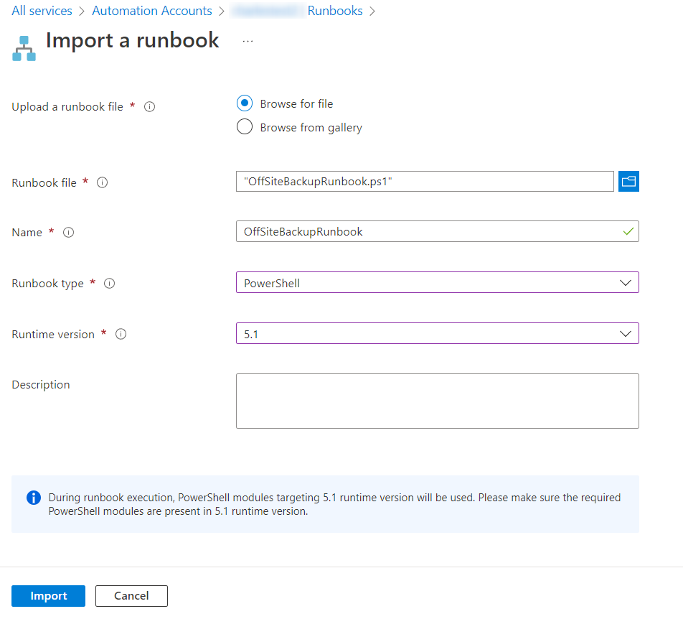
.PARAMETER ResourceGroupName
Specifies the name of the resource group where the Azure SQL Database server is located

.PARAMETER DatabaseServerName
Specifies the name of the Azure SQL Database Server which script will backup

.PARAMETER DatabaseAdminUsername
Specifies the administrator username of the Azure SQL Database Server

.PARAMETER DatabaseAdminPassword
Specifies the administrator password of the Azure SQL Database Server

.PARAMETER DatabaseNames
Comma separated list of databases script will backup

.PARAMETER StorageAccountName
Specifies the name of the storage account where backup file will be uploaded

.PARAMETER BlobStorageEndpoint
Specifies the base URL of the storage account

.PARAMETER StorageKey
Specifies the storage key of the storage account

.PARAMETER BlobContainerName
Specifies the container name of the storage account where backup file will be uploaded. Container will be created if it does not exist.

Admin Configuration & Reporting

Install runbook

Create automation account, add IAM permissions at subscription(narrow rights)
Az.Accounts
Az.Sql
AzureRM.Profile
add module AzureRM.Sql
https://docs.microsoft.com/en-us/azure/storage/common/storage-sas-overview
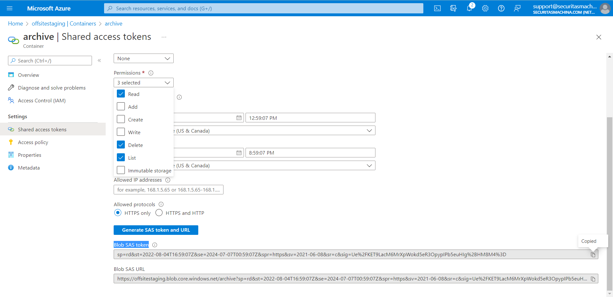
[!IMPORTANT] In order to make use of this cmdlet the firewall on the Azure SQL Server will need to be configured to "Allow Azure services and resources to access this server". If this is not configured then GatewayTimeout errors will be experienced.

dd
.PARAMETER ResourceGroupName db_eus2
Specifies the name of the resource group where the Azure SQL Database server is located

.PARAMETER DatabaseServerName test-offsite-server
Specifies the name of the Azure SQL Database Server which script will backup

.PARAMETER DatabaseAdminUsername support
Specifies the administrator username of the Azure SQL Database Server

.PARAMETER DatabaseAdminPassword OLtw8K7PkuJohb84h9vI
Specifies the administrator password of the Azure SQL Database Server

.PARAMETER DatabaseNames OffsiteTest1
Comma separated list of databases script will backup

.PARAMETER StorageAccountName offsitestaging
Specifies the name of the storage account where backup file will be uploaded

.PARAMETER BlobStorageEndpoint https://offsitestaging.blob.core.windows.net/archive
Specifies the base URL of the storage account

.PARAMETER StorageKey FBzxqBpxgT79Ze9fxe3GzZ1MVbkw0Tdj12pf/DMhpibLCtVoN3y1uo7W3n+YNsNWamQ6W0jbWsgY+AStAeLL8Q==
Specifies the storage key of the storage account

.PARAMETER BlobContainerName archive
Specifies the container name of the storage account where backup file will be uploaded. Container will be created if it does not exist.

.PARAMETER RetentionDays 3
Specifies the number of days how long backups are kept in blob storage. Script will remove all older files from container.
For this reason dedicated container should be only used for this script.

Installing Listener
Install GCSFuse
Create bucket
Install docker https://docs.docker.com/engine/install/debian/

