Table of Contents
Prerequisites 2
Azure Configuration 3
Setup Storage Accounts 3
Installing the Runbook 4
Provisioning Google 7
Configuring the Agent 8

Prerequisites
In order to make use of this cmdlet the firewall on the Azure SQL Server will need to be configured to "Allow Azure services and resources to access this server". If this is not configured then GatewayTimeout errors will be experienced.

Azure Configuration

Setup Storage Accounts
Choose LRS for lower costs:
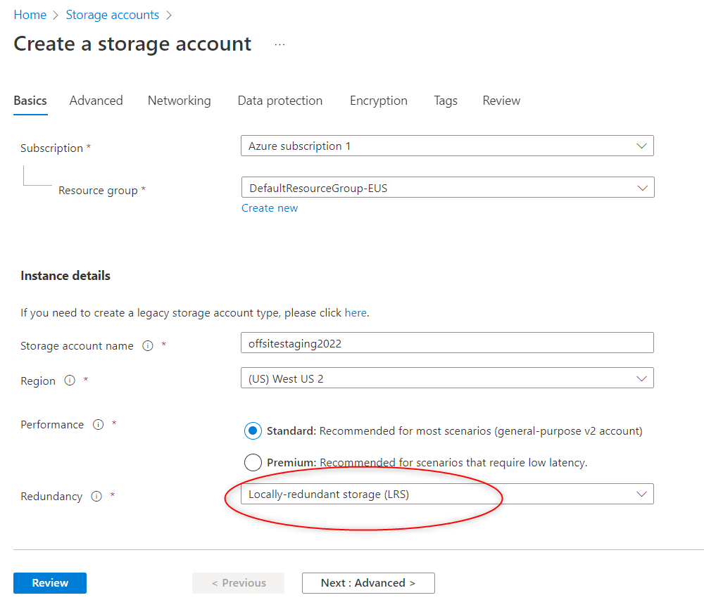
After creation, using the menu on the left, create a container, call it staging or similar.
Also create a storage container called “restored” or similar

Installing the Runbook
Create an automation account
Import the following powershell modules:
Az.Accounts
Az.Sql
AzureRM.Profile
AzureRM.Sql
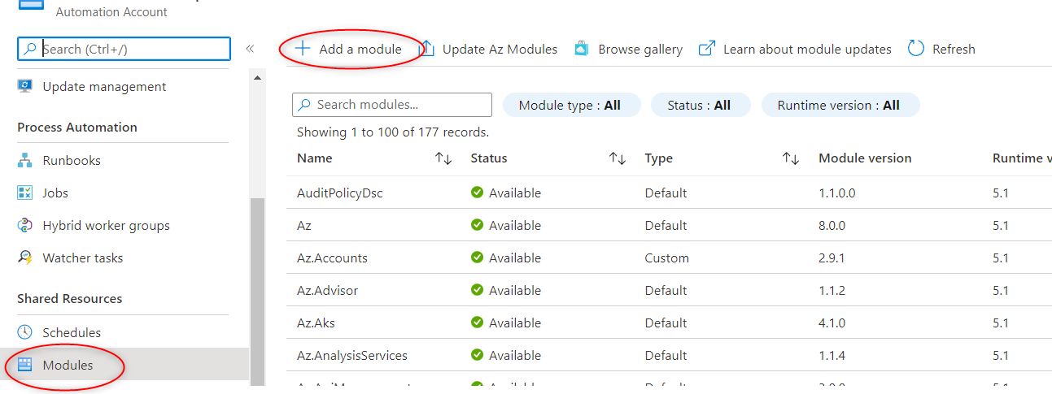
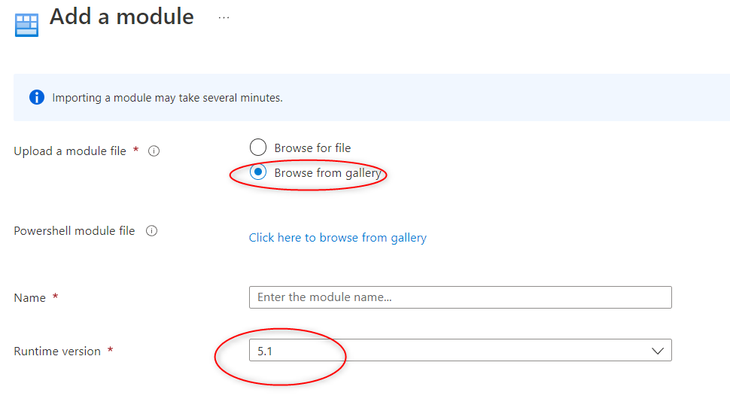

Download the runbook from https://storage.googleapis.com/www.ackdev.com/SecuritasMachina/OffSiteBackupRunbook.ps1
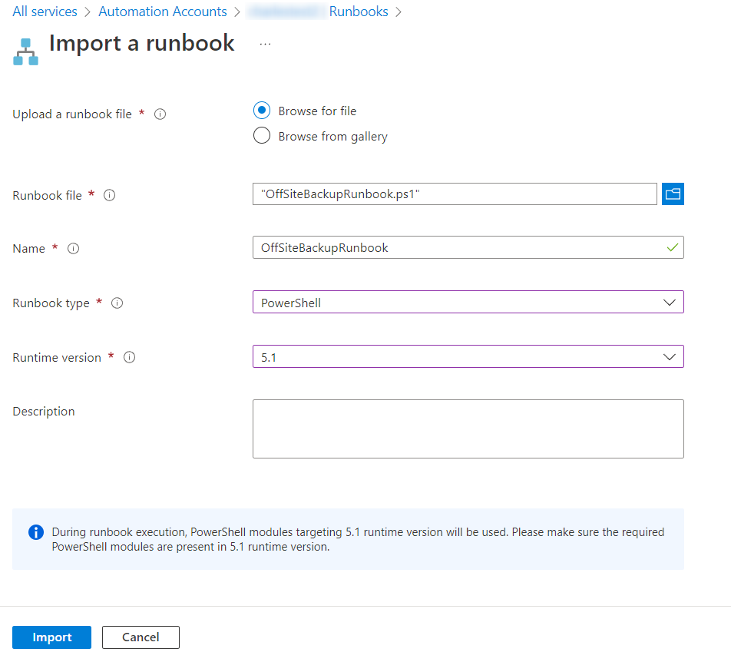
Import the runbook:
.PARAMETER ResourceGroupName
Specifies the name of the resource group where the Azure SQL Database server is located

.PARAMETER DatabaseServerName
Specifies the name of the Azure SQL Database Server which script will backup

.PARAMETER DatabaseAdminUsername
Specifies the administrator username of the Azure SQL Database Server

.PARAMETER DatabaseAdminPassword
Specifies the administrator password of the Azure SQL Database Server

.PARAMETER DatabaseNames
Comma separated list of databases script will backup

.PARAMETER StorageAccountName
Specifies the name of the storage account where backup file will be uploaded

.PARAMETER BlobStorageEndpoint
Specifies the base URL of the storage account

.PARAMETER StorageKey
Specifies the storage key of the storage account

.PARAMETER BlobContainerName
Specifies the container name of the storage account where backup file will be uploaded. Container will be created if it does not exist.

Provisioning Google
If you don't already have a Google cloud account for your organization begin at https://console.cloud.google.com/

After entering your billing information etc:

Create a storage bucket in cloud storage:
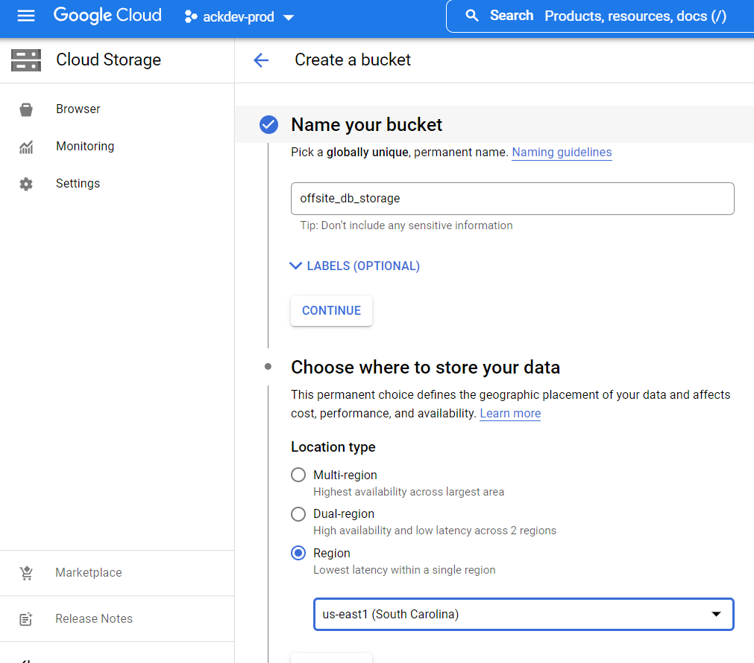
Be sure to pick a region away from your current storage location. For example if your main database is on the west coast, choose the east coast for your offsite backup location.

Choose coldline storage for lower costs while maintaining availability:
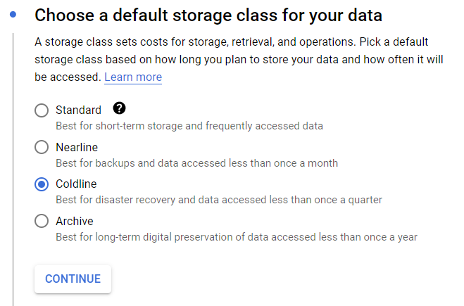

Configuring the Agent
Create a VM instance using Debian, again choose a location away from your databases in Azure:
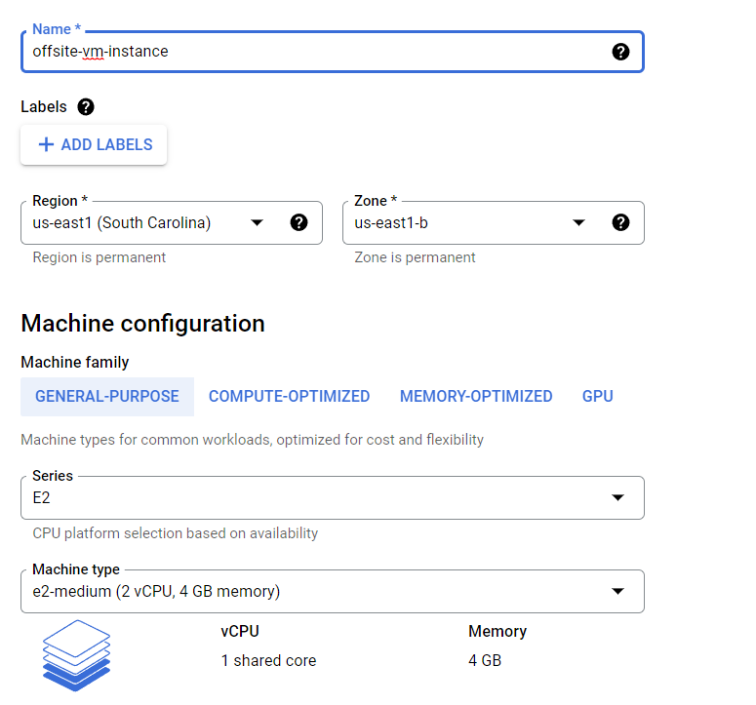
Under permissions, set full permissions for storage:
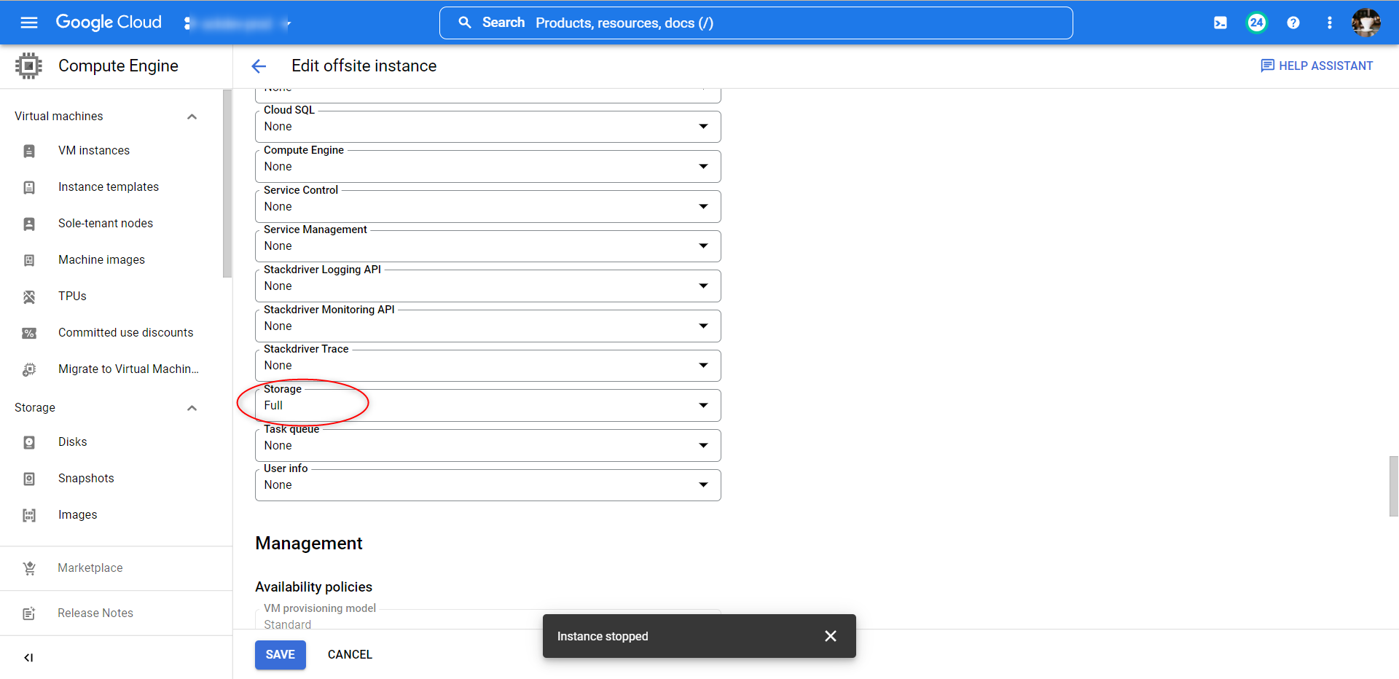

Disable the public IP, then start your new VM instance and SSH into it via the SSH button to the right on the instance:
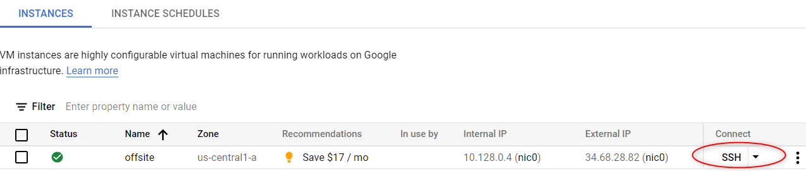
Install GCSFuse which mounts your storage account as a local directory.
Copy and paste the following commands:

sudo apt-get update -y
sudo apt-get install gcsfuse -y
mkdir -p /mnt/gcsfuse

edit /etc/fstab, add the following line:
{storage bucket} /mnt/gcsfuse gcsfuse rw,allow_other,file_mode=777,dir_mode=777
ex.
offsite_db_storage /mnt/gcsfuse gcsfuse rw,allow_other,file_mode=777,dir_mode=777
Install Docker: https://docs.docker.com/engine/install/debian/

Add your runtime user to the docker group:
sudo usermod -a -G docker $USER

Restart the VM instance to have the /etc/fstab changes take effect ex:
shutdown -r now
Install SecuritasMachina docker image:
docker pull securitasmachina2022/securitasmachinaoffsiteagent

Create a prod.env text file, fill it in with your values:
customerGuid
azureBlobEndpoint
azureBlobContainerName
azureBlobRestoreContainerName
passPhrase
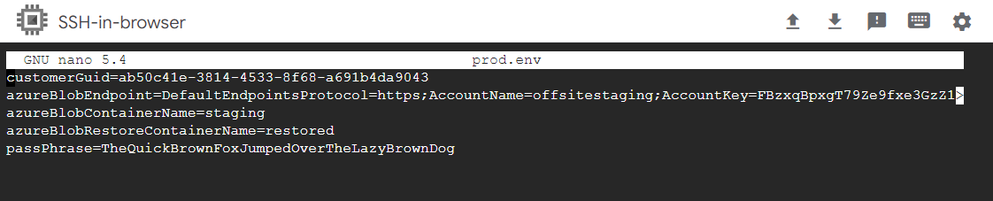
docker run -d --env-file prod.env securitasmachina2022/securitasmachinaoffsiteagent

Note we suggest running interactively the first time to validate your configuration:
docker run -it --env-file prod.env securitasmachina2022/securitasmachinaoffsiteagent

