Guide to use of libosdp

Project Summary

Purpose:
Implement OSDP protocol

Platform:
Linux (Debian, should be portable)
GCC or CLANG
GnuTLS, OpenSSL, Nettle, libtasn
Jansson

Project Home:
https://github.com/smithee-us/libosdp

Table of Contents
Intro 3
what it is 3
Components 3
using the libosdp tools 4
Building the Software 4
Directory Structure 4
Required Libraries 4
How to use 6
General program set-up 6
How to use it – 485 7
CP (RS-485) 7
PD (RS-485) 7
how to use it – tls 7
Certificates 7
CP (TLS) 8
Configuration File Set-up 8
Configuring an RS-485 PD 8
Configuring an RS-485 CP 8
Configuring a TLS PD (Server) 8
Configuring a TLS CP (Client) 9
Configuration Parameters 9
OSDP Protocol Monitoring 11
Set-up 11
libosdp internals 12
osdp protocol implementation 12
libosdp Control API 12
Appendix 13
A. Colophon 13
b. basic osdp end to end test 14
C. OSDP Interop Cable 15
Note 15
Cable Assembly 15
Parts List 15
Tools List 15
Cable Harness Assembly 15
about pins: 15
about wiring the connector: 15
Device Cable Assembly 16
Device Power Cable 16
Figure 1 OSDP Interop Cable 17
D. OSDP Testing 18
D.1 present card data 18
D.2 LED Testing 18
punchlist 19

Intro
t.b.d.

what it is
t.b.d. (use wiki page)

Components
The package consists of RS-485 and TLS variants of a program that runs on Linux and implements the OSDP protocol. CP and PD roles are both implemented. Also, for RS-485, there is a “monitor” mode that simply displays the messages read from the RS-485 interface.

RS-485: The program open-osdp implements OSDP using a RS-485 interface that supports the Linux (/dev/tty) interface.

TLS: the programs osdp-net-client and osdp-net-server implement OSDP using TLS over a network connection.

The OSPD programs run as background processes. You send JSON commands to control the program. A simple web-based user interface has been implemented.

The whole thing fits together in a small Linux system (like a Raspberry Pi) using Debian Linux and an Apache web server.

using the libosdp tools

Building the Software
Get the latest release from the github repo. Load it on a Debian linux system, preferrably with CLANG but GCC will work. Do “make clean” and “make build” in the top level directory to build the software. Do “make release” in the top level directory to create a tarball meant to be expanded from the root (as root) so as to create a /opt/open-osdp/... file structure. There isn't an install package, it's assumed you create the tarball and load it yourself.

Directory Structure
The built directory structure is
/opt/open-osdp/bin
/opt/open-osdp/etc
/opt/open-osdp/run/CP
/opt/open-osdp/run/PD

bin - programs osdp-net-client, osdp-net-server
etc - certificate files ca_keys.pem (for root key), key.pem (private key for server), cert.pem (certificate for server), client_key.pem (private key for client), client_cert.pem (cert for client.)
run/CP - directory where CP is run
run/PD - directory where PD is run
run/MON - directory where Monitoring is run

Required Libraries
Update Debian and add build-essential and some other packages.

apt-get update
apt-get upgrade
apt-get install build-essential

apt-get install clang lzip pkg-config libgmp3-dev libgmpxx4ldbl screen
apt-get install tcpdump gdb apache2 git

download jansson, libtasn, nettle, and gnutls.

build jansson
./configure --prefix=/opt
make
sudo make install

build tasn
./configure --prefix=/opt
make
sudo make install

build nettle
PKG_CONFIG_PATH=/opt/lib/pkgconfig ./configure --prefix=/opt
make
sudo make install

build gnutls

PKG_CONFIG_PATH=/opt/lib/pkgconfig/ ./configure --prefix=/opt --without-p11-kit
make
sudo make install

building libosdp

cd setup/libosdp
make clean
make CFLAGS="-I/opt/include" LDFLAGS="-L/opt/lib" release
cd /
sudo tar xzvf /home/osdp/setup/libosdp/release-libosdp.tgz

How to use

General program set-up
it writes to open_ospd.log in the current directory. it reads it's configuration from open-osdp-params.json in the current directory. The build process is set up to prepare /opt/open-osdp/run/CP (and PD and MON) as the directory to run in. The tools read configuration and command files from the current directory and write the log to the current directory.

How to use it – 485

CP (RS-485)
Check your RS-485 adapter and cable hardware.
cd to /opt/open-osdp/run/CP
set up a configuration file for CP use. Use the sample config files in the doc directoy as a guide. Be sure to set the PD address to match your PD.
Run /opt/open-osdp/bin/open-osdp

An example configuration is in doc/config-samples/ open-osdp-params-CP-485.json

Example. This runs the CP from /opt/open-ospd/run/CP. The parameter file has been set up there (open-ospd-params.json) After you start the program you can go to another command shell and "tail" the log file.

cd /opt/open-osdp/run/CP
ls -l open-osdp-params.json
sudo /opt/open-osdp/bin/open-osdp

(in a separate window)

cd /opt/open-ospd/run/CP
sudo tail -f ./open_osdp.log

PD (RS-485)
Check your RS-485 adapter and cable hardware.
cd to /opt/open-osdp/run/PD
set up a configuration file for PD use. Use the sample config files in the doc directoy as a guide. Be sure to set the PD address to match your CP.
Run /opt/open-osdp/bin/open-osdp

An example configuration is in doc/config-samples/ open-osdp-params-PD-485.json

how to use it – tls
osdp-net-server and osdp-net-client are the TLS server and client respectively. Each one runs the open-osdp code. Configuration details are read from open-osdp-params.json.

Certificates go in /opt/open-osdp/etc. For the server side it uses ca_keys.pem, key.pem, cert.pem. the key is not encrypted. For the client side it uses ca_keys.pem, client_key.pem, clietn_cert.pem. The key is not encrypted.

Certificates
Both sides need certificates and keys. Each side has to be configured to trust the root that issued the other end's cert. For the test program, the Common Name field of the Subject Name must be set in the config file as GnuTLS checks this.

set up test certificates

cd setup/test-ca
./0-init-ca
./1-create-certs

copy the appropriate certs to etc
cp root.pem osdp-pd-1_cert.pem osdp-pd-1_key.pem /opt/open-osdp/etc
cd /opt/open-osdp/etc
cp root.pem ca_certs.pem
cp osdp-pd-1_cert.pem cert.pem
cp osdp-pd-1_key.pem key.pem

CP (TLS)
Check your certificates, ip addresses, and port settings to match the PD.
cd to /opt/open-osdp/run/CP
set up a configuration file for CP use. Use the sample config files in the doc directoy as a guide. Be sure to set the PD address to match your CP.

To connect to a PD listening for an incoming connection (CP is the client, PD is the server.) There has to be something listening at the destination address or else the program fails.

run /opt/open-osdp/bin/osdp-net-client

To listen for TLS connections (PD is the client, CP is the server)
run /opt/open-osdp/bin/osdp-net-server

An example configuration is in doc/config-samples/ open-osdp-params-CP-TLS-Client.json

Configuration File Set-up
You set the OSDP role in the configuration file (open-osdp-params.json.) This is independent of whether it's RS-485 or which end of a TLS connection you configure. In the networking cases either the PD or the CP can be listening for a network connection from the other end.

Configuring an RS-485 PD

Configuring an RS-485 CP
"role" is "CP"
"serial_device" is "/dev/tty/USB0" (most likely, check this.)
"addr" is "02" (the address of the PD, must match PD address.)

Configuring a TLS PD (Server)
set it to be the PD
set the verbosity
set the fqdn to the CN field of the other end's certificate.
set the test card data

Configuring a TLS CP (Client)
set it to be the CP
set the verbosity
set the fqdn to the CN field of the other end's certificate.
set the ip address of the server

Configuration Parameters
These are specified in open-osdp-param.json.

address - PD address to use or to talk to. must be valid OSDP address value. Value is in hext.

bits - number of bits in RAW response. Value is in decimal.

disable_checking - disable certificate checking ("1") or not ("0")

fqdn - DN field of peeir's certificate if cert checking is turned on.

init_command - command to initialize serial device.

network_address - ipv4 address to use to connect (for TLS or TCP client.)

poll -- poll frequency (CP polling the PD.)

raw_value = value is hex, this is the card data. Note for 26 bit it is left justified (bottom 6 bits of last octet are not used.)

role - CP PD or MON

serial_device -- name of serial device for RS-485. Typically /dev/ttyUSB0

slow_timer -- in TLS (or TCP) causes the CP to wake up if PD traffic arrives before the poll interval.

timeout

verbosity -- logging verbosity. 1-3 are normal, 9 is loud, >9 is very loud.

OSDP Protocol Monitoring

Use the tool in monitor mode. Configure it like doc/config-samples/open-osdp-params-MON.json. Unlike the PD and CP, this is still set up for old-school log tailing. Start the program (need sudo to access serial device) and from another shell tail the log.

Using the directory layout in the release you create a MON directory under run, cd there, drop in the parameters file and run the tool as sudo, tailing the log in a second window.

Set-up
create /opt/open-osdp/run/MON
copy doc/open-osdp-params-MON.json to /opt/open-osdp/run/MON/open-osdp-params.json

shell 1:
cd /opt/open-osdp/run/MON
sudo /opt/open-osdp/bin/open-osdp

shell 2:
cd /opt/open-osdp/run/MON
sudo tail -f open_osdp.log

libosdp internals

osdp protocol implementation
t.b.d.

libosdp Control API
The main loop listens on a Unix socket (“open-osdp-control” in the current directory) for a “kick” (in the style of the POSIX “HUP” signal.) When it gets kicked it reads open_osdp_command.json and processes that command.

The format is
{
“command” : “<action>”
}

Where <action> is one of
capabilities
dump_status
identify
led
output
present_card
reset_power
send_poll

Note some of these have additional arguments.
command led
value (led color)

Appendix

A. Colophon
Revised for 1.00 Build 10 (summer 2016)

Written in OpenOffice and LibreOffice. The HACK font is available from http://sourcefoundry.org/hack/.

©2014-2016 Smithee,Spelvin,Agnew & Plinge, Inc.

Work funded in part by securityindustry.org

b. basic osdp end to end test
t.b.d.

C. OSDP Interop Cable

Note
- Picture attached at end of this document as Figure 1.
- twisted pair ignored due to short length
- termination resistors ignored due to short length
- happy to modify cable if someone can show up with a standard to follow.

Cable Assembly

Parts List
For convienence we use a 3-pin Molex connector. It's got 3 wires, it's easy to fabricate with a crimp tool you can buy in an electronics parts shop, and you can get the components in kits. We use the Waldom 1625-3PRT kit (brand is Molex.) This is the .062 inch pin format. The point is to show up to an interop event (or a job site) with interoperable connectors. Automotive-grade connectors would also work. (And there's a 2-wire version too so the same tools/parts can make 12 vdc power cables for many panels and readers.)

4x 3pin male molex
4x 3pin female molex
pins for each (assume you will mess up a few, get extras)
20 gauge solid core wire. red, white, black.

Tools List
pin crimp tool
wire stripper

Cable Harness Assembly
build 4-drop cable.
note 2 inner drops hav double the wires in the crimp.

cut cable 3x 0.3 meter lengths r,w,b
strip 3/16 inch each

about pins:
male pins go in female shell
female pins go in male shell

about wiring the connector:
red - pointy end
white - middle
black - square end

for inner connectors
insert 2 stripped cables in pin; crimp; insert in shell
for outer connectors
insert stripped cable in pin; crimp; insert in shell

Device Cable Assembly
for pigtails:
red is tx+
white is tx-
black is ground

Device Power Cable
power cables:
2-pin
DUT gets female shell
red is +12
black is -12 / ground

Figure 1 OSDP Interop Cable
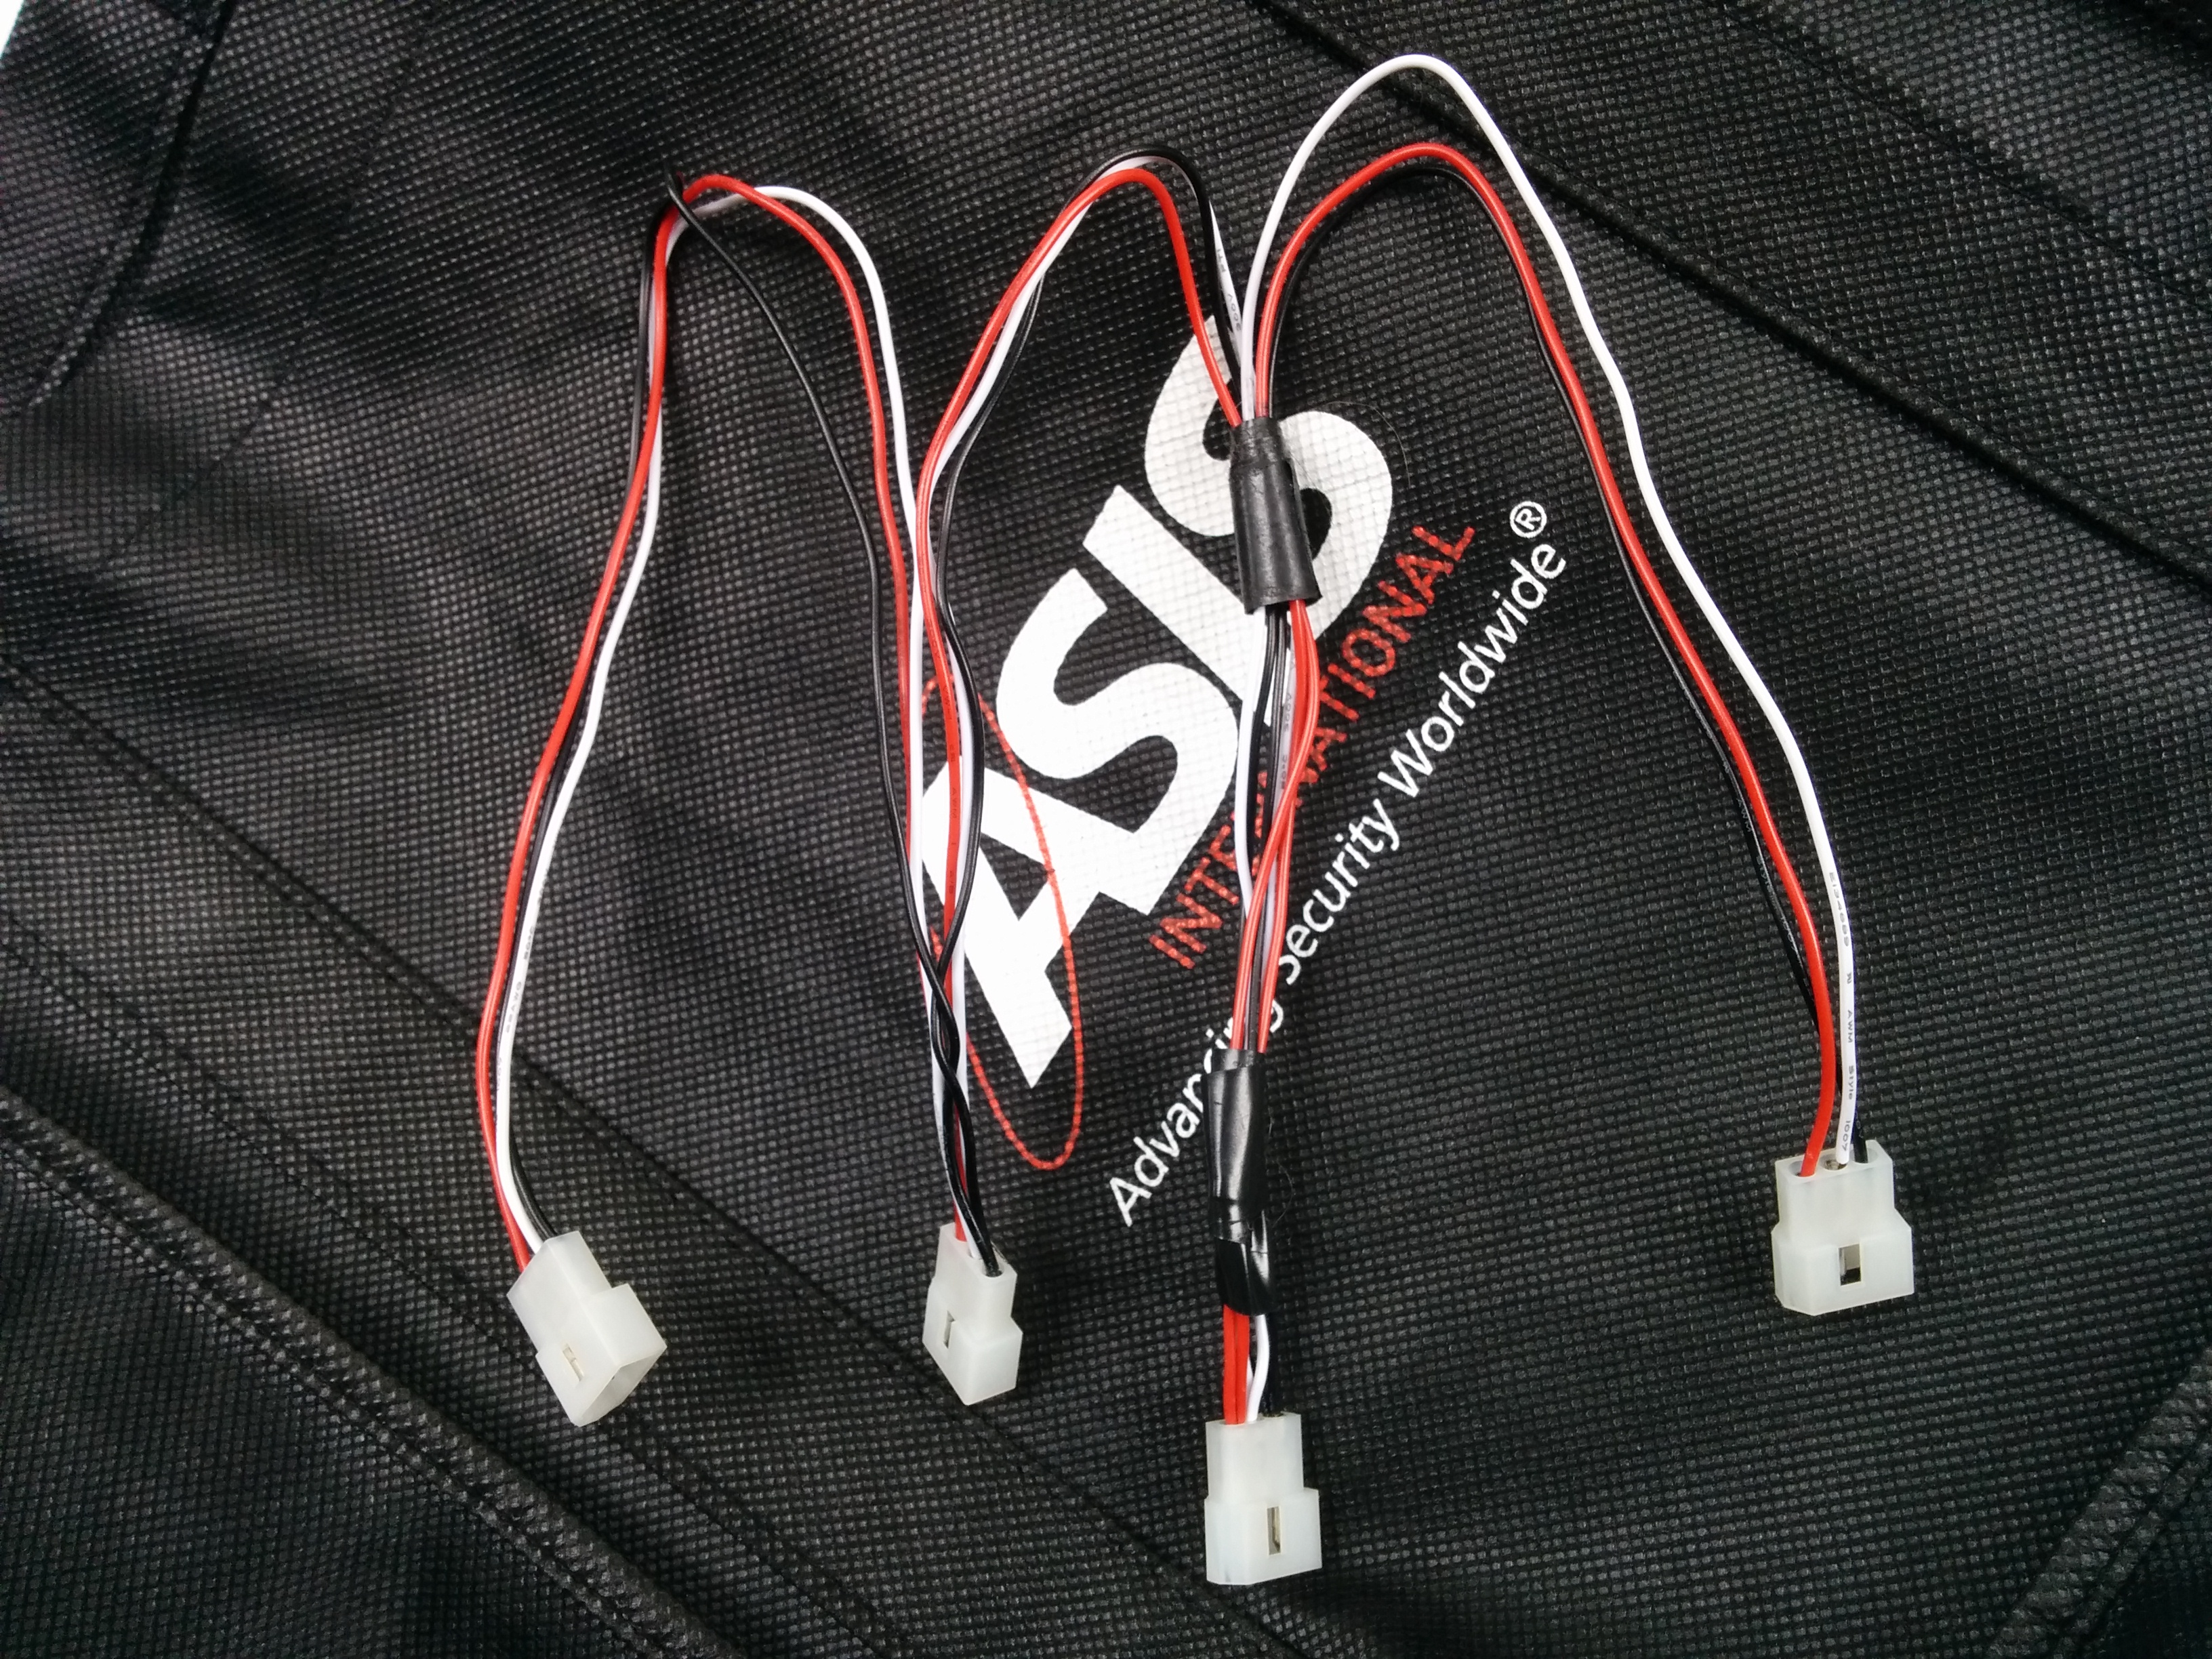

D. OSDP Testing

D.1 present card data
open-osdp as the PD
DUT as the CP
Create an appropriate command file. Copy it to /opt/open-osdp/run/PD. From the PD directory do

/opt/open-osdp/bin/write-osdp-PD-command present_card
/opt/open-osdp/bin/HUP-PD

D.2 LED Testing
open-osdp as the PD
DUT as the PD
Set the card data value in the osdp parameter file (open-osdp-params.json) and start open-osdp. Use the "102-led" command to set the LED color. "102-led" uses the "led" command, which sets some LED parameters to constant values (timers) and sets the LED color. doc/command-samples/example-led_open_osdp_command.json is a sample of the command file.

Example: Red LED

cd /opt/open-osdp/run/CP
/opt/open-osdp/bin/102-led 1

Example: Green LED

cd /opt/open-osdp/run/CP
/opt/open-osdp/bin/102-led 1

punchlist
pull wiki
pull from other sources

config samples fix ref make separate samples
cp 485
pd 485
cp tls client
pd tls server

